UNITED STATES
SECURITIES AND EXCHANGE COMMISSION
Washington, D.C. 20549

FORM 8-K
CURRENT REPORT
Pursuant to Section 13 or 15(d) of the Securities Exchange Act of 1934
August 6, 2026
Date of Report (date of Earliest Event Reported)
NEWTEKONE, INC.
(Exact Name of Company as Specified in its Charter)
Maryland |  |  | 814-01035 |  |  | 46-3755188
(State or Other Jurisdiction of Incorporation or Organization) |  |  | (Commission File No.) |  |  | (I.R.S. Employer Identification No.)

4800 T Rex Avenue, Suite 120, Boca Raton, Florida 33431
(Address of principal executive offices and zip code)

(212) 356-9500
(Company’s telephone number, including area code)

(Former name or former address, if changed from last report)

Securities registered pursuant to Section 12(b) of the Act:
Title of each class |  |  |  |  |  | Trading Symbol(s) |  |  |  |  |  | Name of each exchange on which registered
Common Stock, par value $0.02 per share |  |  |  |  |  | NEWT |  |  |  |  |  | Nasdaq Global Market LLC
8.00% Notes due 2028 |  |  |  |  |  | NEWTI |  |  |  |  |  | Nasdaq Global Market LLC
8.50% Notes due 2029 |  |  |  |  |  | NEWTG |  |  |  |  |  | Nasdaq Global Market LLC
8.625% Notes due 2029 |  |  |  |  |  | NEWTH |  |  |  |  |  | Nasdaq Global Market LLC
8.50% Notes due 2031 |  |  |  |  |  | NEWTO |  |  |  |  |  | Nasdaq Global Market LLC
Depositary Shares, each representing a 1/40th interest in a share of 8.500% Fixed-Rate Reset Non-Cumulative Perpetual Preferred Stock, Series B |  |  |  |  |  | NEWTP |  |  |  |  |  | Nasdaq Global Market LLC

Check the appropriate box below if the Form 8-K filing is intended to simultaneously satisfy the filing obligation of the registrant under any of the following provisions (see General Instruction A.2. below):
☐ Written communications pursuant to Rule 425 under the Securities Act (17 CFR 230.425)
☐ Soliciting material pursuant to Rule 14a-12 under the Exchange Act (17 CFR 240.14a-12)
☐ Pre-commencement communications pursuant to Rule 14d-2(b) under the Exchange Act (17 CFR 240.14d-2(b))
☐ Pre-commencement communications pursuant to Rule 13e-4(c) under the Exchange Act (17 CFR 240.13e-4(c))

Indicate by check mark whether the registrant is an emerging growth company as defined in Rule 405 of the Securities Act of 1933 (§230.405 of this chapter) or Rule 12b-2 of the Securities Exchange Act of 1934 (§240.12b-2 of this chapter).

Emerging growth company o

If an emerging growth company, indicate by check mark if the registrant has elected not to use the extended transition period for complying with any new or revised financial accounting standards provided pursuant to Section 13(a) of the Exchange Act. o

Forward-Looking Statements
Statements in NewtekOne, Inc.’s (“NewtekOne” or the “Company”) Current Report on Form 8-K and the Exhibit hereto contain forward-looking statements within the meaning of the Private Securities Litigation Reform Act of 1995. These statements are based on management’s current expectations and beliefs and are subject to significant risks and uncertainties. Actual results may differ materially from those set forth in the forward-looking statements. See “Note Regarding Forward-Looking Statements” and the sections entitled “Risk Factors” in the Company's filings with the Securities and Exchange Commission which are available on NewtekOne's website (https://investor.newtekbusinessservices.com/sec-filings) and on the Securities and Exchange Commission’s website (www.sec.gov). Any forward-looking statements made by or on behalf of NewtekOne speak only as to the date they are made, and NewtekOne does not undertake to update forward-looking statements to reflect the impact of circumstances or events that arise after the date the forward-looking statements were made.

Item 2.02. Results of Operations and Financial Condition.

On August 6, 2026, NewtekOne issued a press release announcing its financial and operating results for the quarter ended June 30, 2026. A copy of the press release is furnished as Exhibit 99.1 to this report.

In accordance with General Instruction B.2 of Form 8-K, the information in this Current Report on Form 8-K, including Exhibit 99.1, shall not be deemed to be “filed” for purposes of Section 18 of the Securities Exchange Act of 1934, as amended (the “Exchange Act”), or otherwise subject to the liability of that section, and shall not be incorporated by reference into any registration statement or other document filed under the Securities Act of 1933, as amended, or the Exchange Act, except as shall be expressly set forth by specific reference in such filing.

Item 9.01 Financial Statement and Exhibits
(d) Exhibits.

Exhibit Number |  |  |  |  |  | Description
99.1 |  |  |  |  |  | NewtekOne, Inc. Press Release dated August 6, 2026
104 |  |  |  |  |  | Cover Page Interactive Data File (formatted as Inline XBRL)

SIGNATURES

In accordance with the requirements of the Securities Exchange Act of 1934, the registrant has caused this report to be signed on its behalf by the undersigned, thereunto duly authorized.

 |  |  | NEWTEKONE, INC.
Date: August 6, 2026 |  |  | By: |  |  | /S/ BARRY SLOANE
 |  |  |  |  |  | Barry Sloane
 |  |  |  |  |  | Chief Executive Officer, President and Chairman of the Board

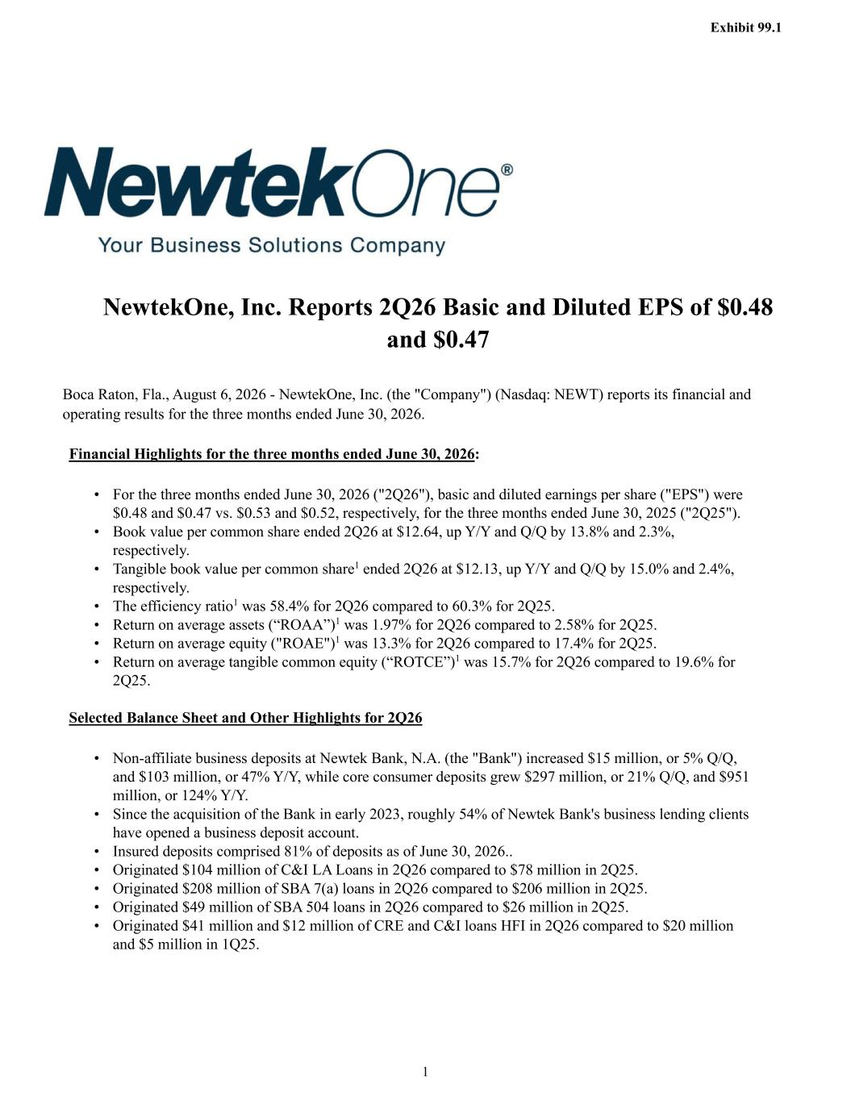

Exhibit 99.1 1 NewtekOne, Inc. Reports 2Q26 Basic and Diluted EPS of $0.48 and $0.47 Boca Raton, Fla., August 6, 2026 - NewtekOne, Inc. (the "Company") (Nasdaq: NEWT) reports its financial and operating results for the three months ended June 30, 2026. Financial Highlights for the three months ended June 30, 2026: • For the three months ended June 30, 2026 ("2Q26"), basic and diluted earnings per share ("EPS") were $0.48 and $0.47 vs. $0.53 and $0.52, respectively, for the three months ended June 30, 2025 ("2Q25"). • Book value per common share ended 2Q26 at $12.64, up Y/Y and Q/Q by 13.8% and 2.3%, respectively. • Tangible book value per common share1 ended 2Q26 at $12.13, up Y/Y and Q/Q by 15.0% and 2.4%, respectively. • The efficiency ratio1 was 58.4% for 2Q26 compared to 60.3% for 2Q25. • Return on average assets (“ROAA”)1 was 1.97% for 2Q26 compared to 2.58% for 2Q25. • Return on average equity ("ROAE")1 was 13.3% for 2Q26 compared to 17.4% for 2Q25. • Return on average tangible common equity (“ROTCE”)1 was 15.7% for 2Q26 compared to 19.6% for 2Q25. Selected Balance Sheet and Other Highlights for 2Q26 • Non-affiliate business deposits at Newtek Bank, N.A. (the "Bank") increased $15 million, or 5% Q/Q, and $103 million, or 47% Y/Y, while core consumer deposits grew $297 million, or 21% Q/Q, and $951 million, or 124% Y/Y. • Since the acquisition of the Bank in early 2023, roughly 54% of Newtek Bank's business lending clients have opened a business deposit account. • Insured deposits comprised 81% of deposits as of June 30, 2026.. • Originated $104 million of C&I LA Loans in 2Q26 compared to $78 million in 2Q25. • Originated $208 million of SBA 7(a) loans in 2Q26 compared to $206 million in 2Q25. • Originated $49 million of SBA 504 loans in 2Q26 compared to $26 million in 2Q25. • Originated $41 million and $12 million of CRE and C&I loans HFI in 2Q26 compared to $20 million and $5 million in 1Q25.

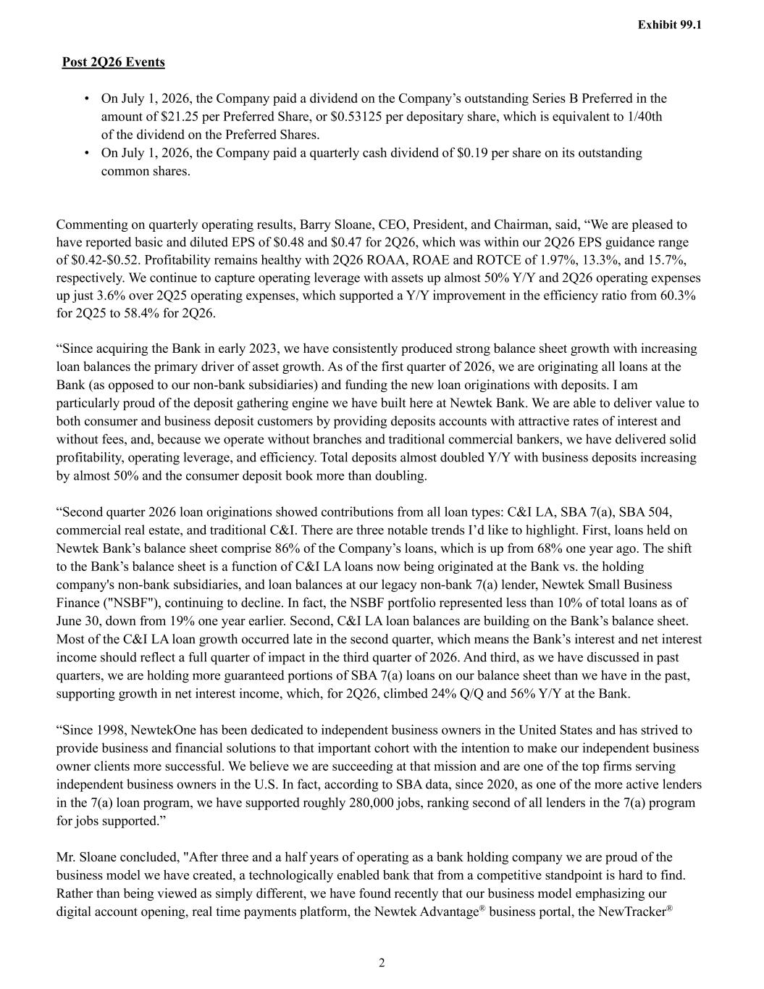
Exhibit 99.1 2 Post 2Q26 Events • On July 1, 2026, the Company paid a dividend on the Company’s outstanding Series B Preferred in the amount of $21.25 per Preferred Share, or $0.53125 per depositary share, which is equivalent to 1/40th of the dividend on the Preferred Shares. • On July 1, 2026, the Company paid a quarterly cash dividend of $0.19 per share on its outstanding common shares. Commenting on quarterly operating results, Barry Sloane, CEO, President, and Chairman, said, “We are pleased to have reported basic and diluted EPS of $0.48 and $0.47 for 2Q26, which was within our 2Q26 EPS guidance range of $0.42-$0.52. Profitability remains healthy with 2Q26 ROAA, ROAE and ROTCE of 1.97%, 13.3%, and 15.7%, respectively. We continue to capture operating leverage with assets up almost 50% Y/Y and 2Q26 operating expenses up just 3.6% over 2Q25 operating expenses, which supported a Y/Y improvement in the efficiency ratio from 60.3% for 2Q25 to 58.4% for 2Q26. “Since acquiring the Bank in early 2023, we have consistently produced strong balance sheet growth with increasing loan balances the primary driver of asset growth. As of the first quarter of 2026, we are originating all loans at the Bank (as opposed to our non-bank subsidiaries) and funding the new loan originations with deposits. I am particularly proud of the deposit gathering engine we have built here at Newtek Bank. We are able to deliver value to both consumer and business deposit customers by providing deposits accounts with attractive rates of interest and without fees, and, because we operate without branches and traditional commercial bankers, we have delivered solid profitability, operating leverage, and efficiency. Total deposits almost doubled Y/Y with business deposits increasing by almost 50% and the consumer deposit book more than doubling. “Second quarter 2026 loan originations showed contributions from all loan types: C&I LA, SBA 7(a), SBA 504, commercial real estate, and traditional C&I. There are three notable trends I’d like to highlight. First, loans held on Newtek Bank’s balance sheet comprise 86% of the Company’s loans, which is up from 68% one year ago. The shift to the Bank’s balance sheet is a function of C&I LA loans now being originated at the Bank vs. the holding company's non-bank subsidiaries, and loan balances at our legacy non-bank 7(a) lender, Newtek Small Business Finance ("NSBF"), continuing to decline. In fact, the NSBF portfolio represented less than 10% of total loans as of June 30, down from 19% one year earlier. Second, C&I LA loan balances are building on the Bank’s balance sheet. Most of the C&I LA loan growth occurred late in the second quarter, which means the Bank’s interest and net interest income should reflect a full quarter of impact in the third quarter of 2026. And third, as we have discussed in past quarters, we are holding more guaranteed portions of SBA 7(a) loans on our balance sheet than we have in the past, supporting growth in net interest income, which, for 2Q26, climbed 24% Q/Q and 56% Y/Y at the Bank. “Since 1998, NewtekOne has been dedicated to independent business owners in the United States and has strived to provide business and financial solutions to that important cohort with the intention to make our independent business owner clients more successful. We believe we are succeeding at that mission and are one of the top firms serving independent business owners in the U.S. In fact, according to SBA data, since 2020, as one of the more active lenders in the 7(a) loan program, we have supported roughly 280,000 jobs, ranking second of all lenders in the 7(a) program for jobs supported.” Mr. Sloane concluded, "After three and a half years of operating as a bank holding company we are proud of the business model we have created, a technologically enabled bank that from a competitive standpoint is hard to find. Rather than being viewed as simply different, we have found recently that our business model emphasizing our digital account opening, real time payments platform, the Newtek Advantage® business portal, the NewTracker®

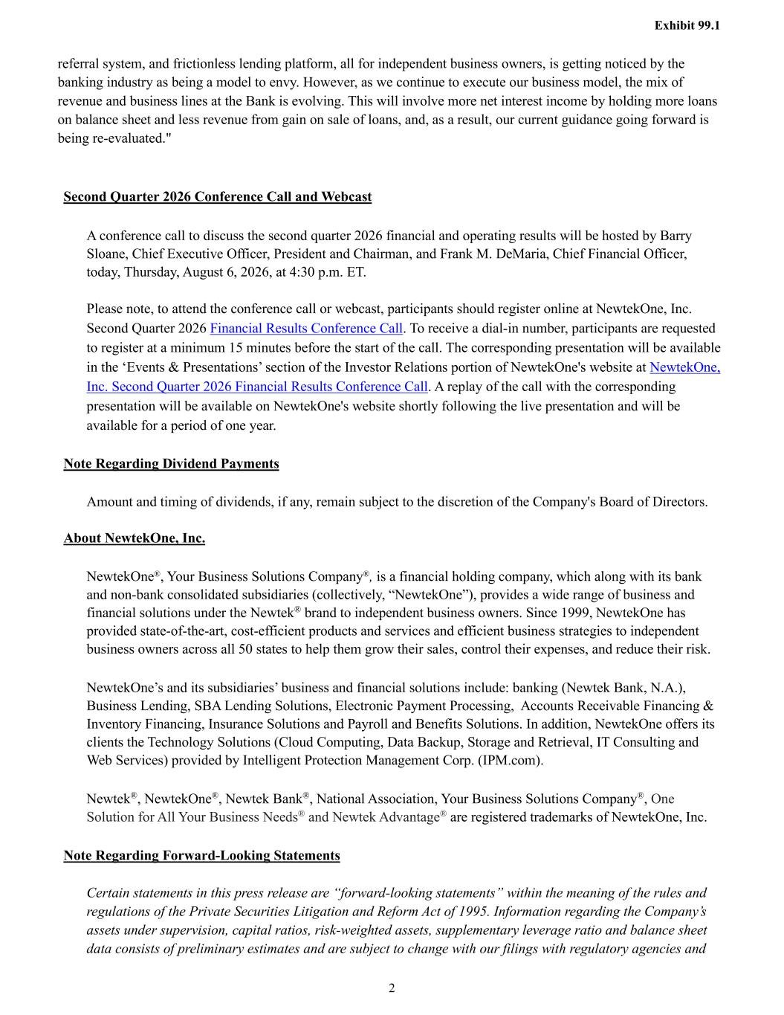
Exhibit 99.1 2 referral system, and frictionless lending platform, all for independent business owners, is getting noticed by the banking industry as being a model to envy. However, as we continue to execute our business model, the mix of revenue and business lines at the Bank is evolving. This will involve more net interest income by holding more loans on balance sheet and less revenue from gain on sale of loans, and, as a result, our current guidance going forward is being re-evaluated." Second Quarter 2026 Conference Call and Webcast A conference call to discuss the second quarter 2026 financial and operating results will be hosted by Barry Sloane, Chief Executive Officer, President and Chairman, and Frank M. DeMaria, Chief Financial Officer, today, Thursday, August 6, 2026, at 4:30 p.m. ET. Please note, to attend the conference call or webcast, participants should register online at NewtekOne, Inc. Second Quarter 2026 Financial Results Conference Call. To receive a dial-in number, participants are requested to register at a minimum 15 minutes before the start of the call. The corresponding presentation will be available in the ‘Events & Presentations’ section of the Investor Relations portion of NewtekOne's website at NewtekOne, Inc. Second Quarter 2026 Financial Results Conference Call. A replay of the call with the corresponding presentation will be available on NewtekOne's website shortly following the live presentation and will be available for a period of one year. Note Regarding Dividend Payments Amount and timing of dividends, if any, remain subject to the discretion of the Company's Board of Directors. About NewtekOne, Inc. NewtekOne®, Your Business Solutions Company®, is a financial holding company, which along with its bank and non-bank consolidated subsidiaries (collectively, “NewtekOne”), provides a wide range of business and financial solutions under the Newtek® brand to independent business owners. Since 1999, NewtekOne has provided state-of-the-art, cost-efficient products and services and efficient business strategies to independent business owners across all 50 states to help them grow their sales, control their expenses, and reduce their risk. NewtekOne’s and its subsidiaries’ business and financial solutions include: banking (Newtek Bank, N.A.), Business Lending, SBA Lending Solutions, Electronic Payment Processing, Accounts Receivable Financing & Inventory Financing, Insurance Solutions and Payroll and Benefits Solutions. In addition, NewtekOne offers its clients the Technology Solutions (Cloud Computing, Data Backup, Storage and Retrieval, IT Consulting and Web Services) provided by Intelligent Protection Management Corp. (IPM.com). Newtek®, NewtekOne®, Newtek Bank®, National Association, Your Business Solutions Company®, One Solution for All Your Business Needs® and Newtek Advantage® are registered trademarks of NewtekOne, Inc. Note Regarding Forward-Looking Statements Certain statements in this press release are “forward-looking statements” within the meaning of the rules and regulations of the Private Securities Litigation and Reform Act of 1995. Information regarding the Company’s assets under supervision, capital ratios, risk-weighted assets, supplementary leverage ratio and balance sheet data consists of preliminary estimates and are subject to change with our filings with regulatory agencies and

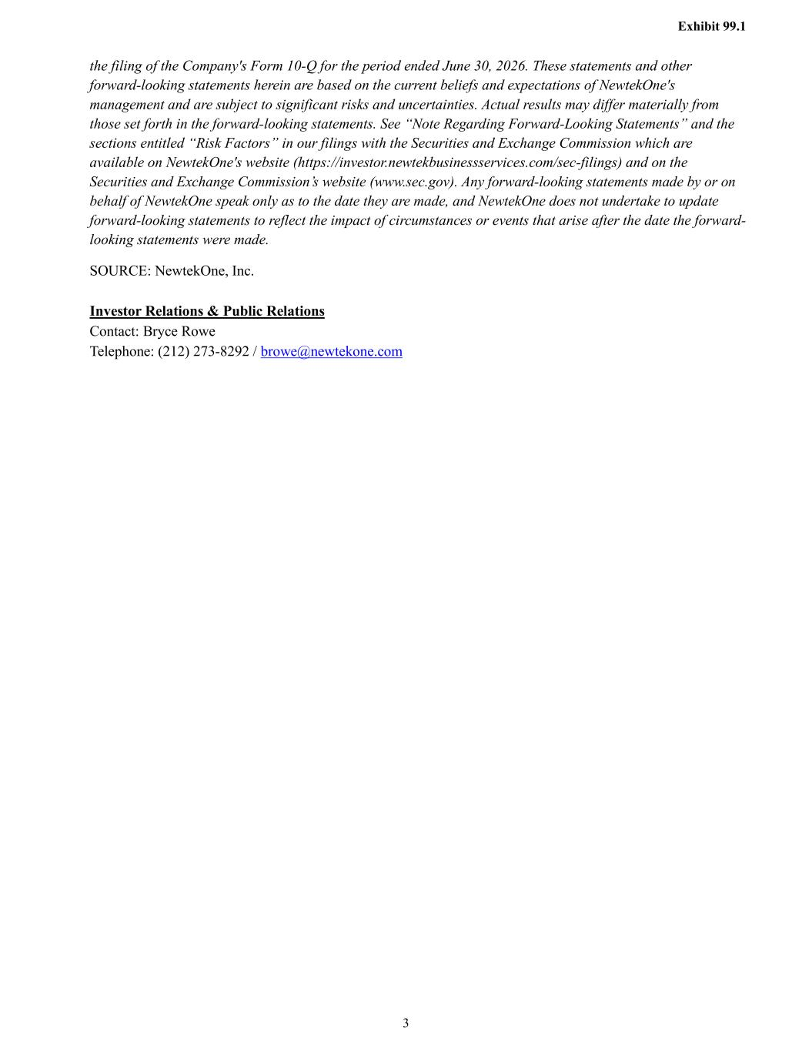
Exhibit 99.1 3 the filing of the Company's Form 10-Q for the period ended June 30, 2026. These statements and other forward-looking statements herein are based on the current beliefs and expectations of NewtekOne's management and are subject to significant risks and uncertainties. Actual results may differ materially from those set forth in the forward-looking statements. See “Note Regarding Forward-Looking Statements” and the sections entitled “Risk Factors” in our filings with the Securities and Exchange Commission which are available on NewtekOne's website (https://investor.newtekbusinessservices.com/sec-filings) and on the Securities and Exchange Commission’s website (www.sec.gov). Any forward-looking statements made by or on behalf of NewtekOne speak only as to the date they are made, and NewtekOne does not undertake to update forward-looking statements to reflect the impact of circumstances or events that arise after the date the forward- looking statements were made. SOURCE: NewtekOne, Inc. Investor Relations & Public Relations Contact: Bryce Rowe Telephone: (212) 273-8292 / browe@newtekone.com

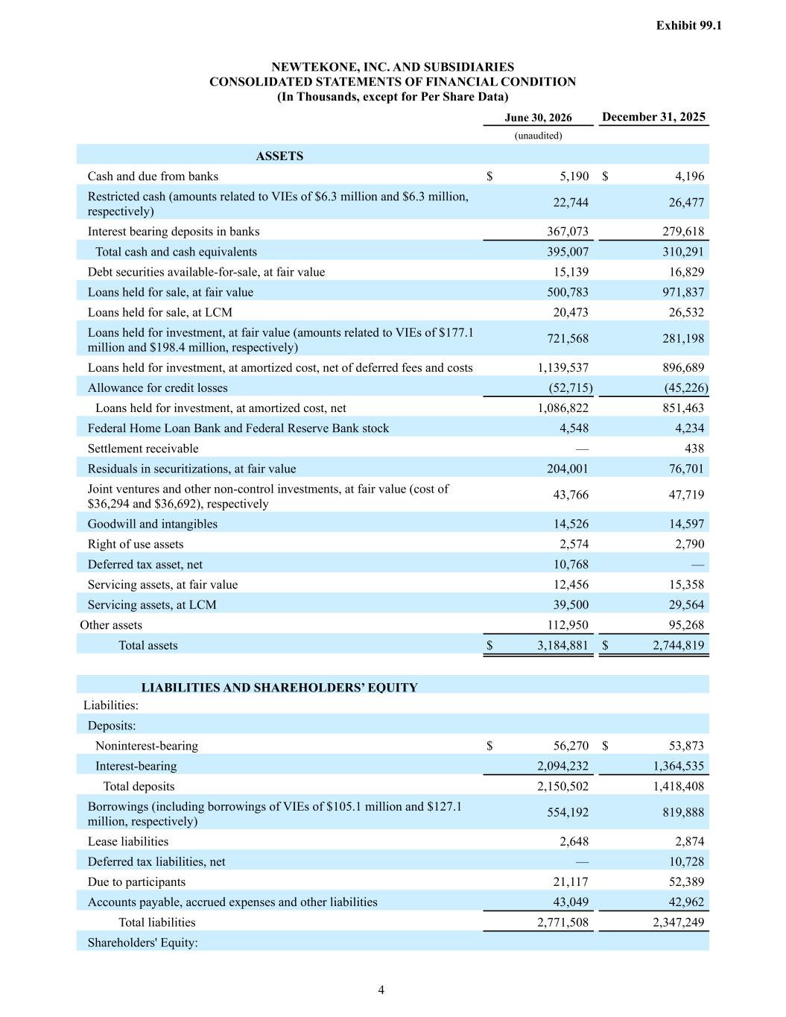
Exhibit 99.1 4 NEWTEKONE, INC. AND SUBSIDIARIES CONSOLIDATED STATEMENTS OF FINANCIAL CONDITION (In Thousands, except for Per Share Data) June 30, 2026 December 31, 2025 (unaudited) ASSETS Cash and due from banks $ 5,190 $ 4,196 Restricted cash (amounts related to VIEs of $6.3 million and $6.3 million, respectively) 22,744 26,477 Interest bearing deposits in banks 367,073 279,618 Total cash and cash equivalents 395,007 310,291 Debt securities available-for-sale, at fair value 15,139 16,829 Loans held for sale, at fair value 500,783 971,837 Loans held for sale, at LCM 20,473 26,532 Loans held for investment, at fair value (amounts related to VIEs of $177.1 million and $198.4 million, respectively) 721,568 281,198 Loans held for investment, at amortized cost, net of deferred fees and costs 1,139,537 896,689 Allowance for credit losses (52,715) (45,226) Loans held for investment, at amortized cost, net 1,086,822 851,463 Federal Home Loan Bank and Federal Reserve Bank stock 4,548 4,234 Settlement receivable — 438 Residuals in securitizations, at fair value 204,001 76,701 Joint ventures and other non-control investments, at fair value (cost of $36,294 and $36,692), respectively 43,766 47,719 Goodwill and intangibles 14,526 14,597 Right of use assets 2,574 2,790 Deferred tax asset, net 10,768 — Servicing assets, at fair value 12,456 15,358 Servicing assets, at LCM 39,500 29,564 Other assets 112,950 95,268 Total assets $ 3,184,881 $ 2,744,819 LIABILITIES AND SHAREHOLDERS’ EQUITY Liabilities: Deposits: Noninterest-bearing $ 56,270 $ 53,873 Interest-bearing 2,094,232 1,364,535 Total deposits 2,150,502 1,418,408 Borrowings (including borrowings of VIEs of $105.1 million and $127.1 million, respectively) 554,192 819,888 Lease liabilities 2,648 2,874 Deferred tax liabilities, net — 10,728 Due to participants 21,117 52,389 Accounts payable, accrued expenses and other liabilities 43,049 42,962 Total liabilities 2,771,508 2,347,249 Shareholders' Equity:

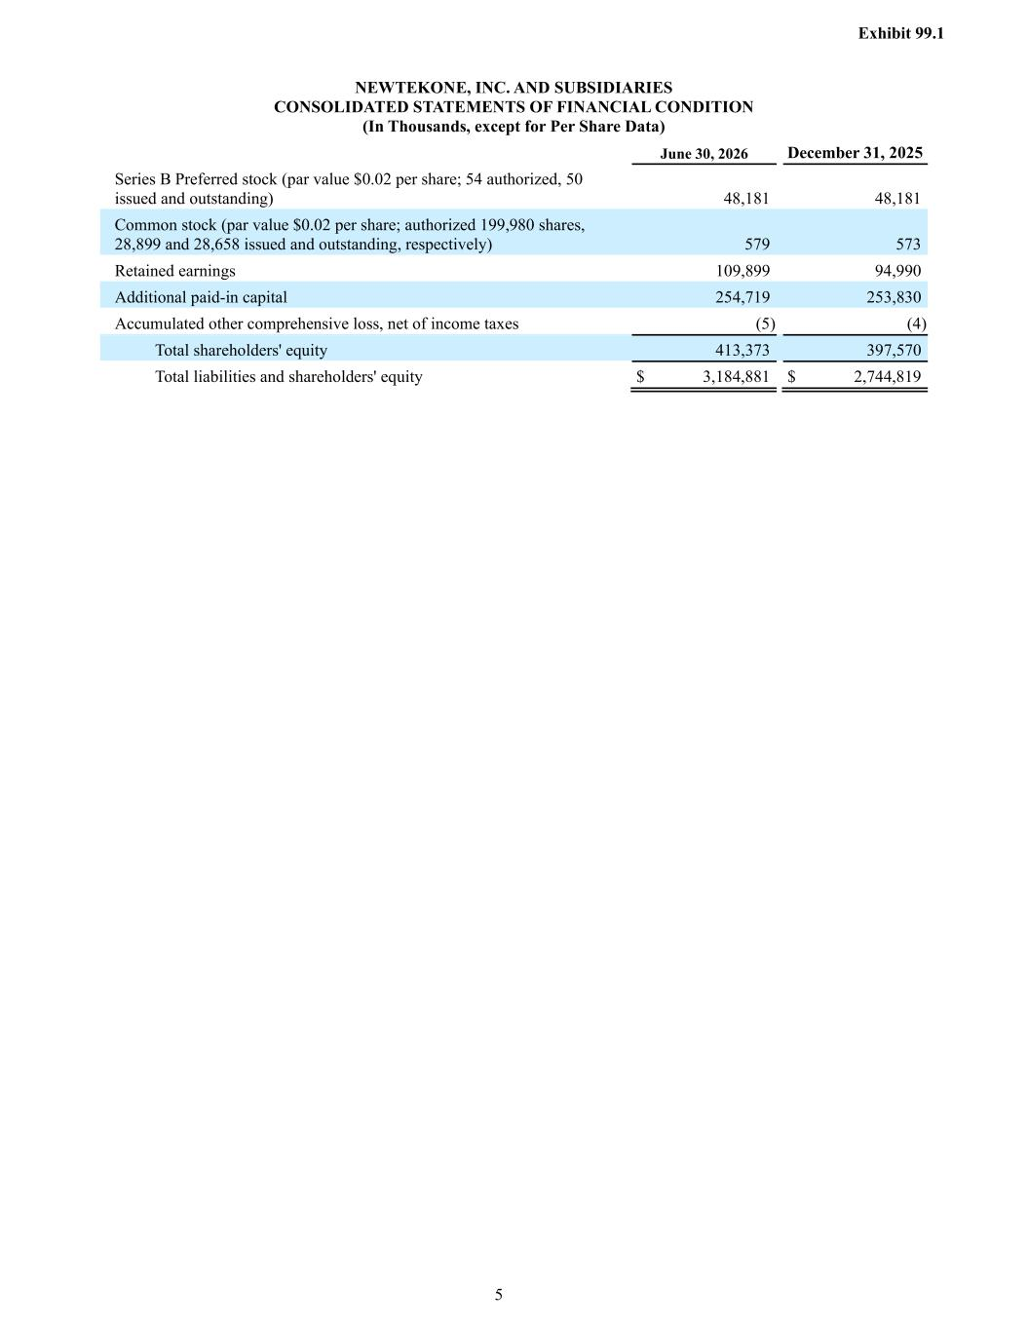
Exhibit 99.1 5 NEWTEKONE, INC. AND SUBSIDIARIES CONSOLIDATED STATEMENTS OF FINANCIAL CONDITION (In Thousands, except for Per Share Data) June 30, 2026 December 31, 2025 Series B Preferred stock (par value $0.02 per share; 54 authorized, 50 issued and outstanding) 48,181 48,181 Common stock (par value $0.02 per share; authorized 199,980 shares, 28,899 and 28,658 issued and outstanding, respectively) 579 573 Retained earnings 109,899 94,990 Additional paid-in capital 254,719 253,830 Accumulated other comprehensive loss, net of income taxes (5) (4) Total shareholders' equity 413,373 397,570 Total liabilities and shareholders' equity $ 3,184,881 $ 2,744,819

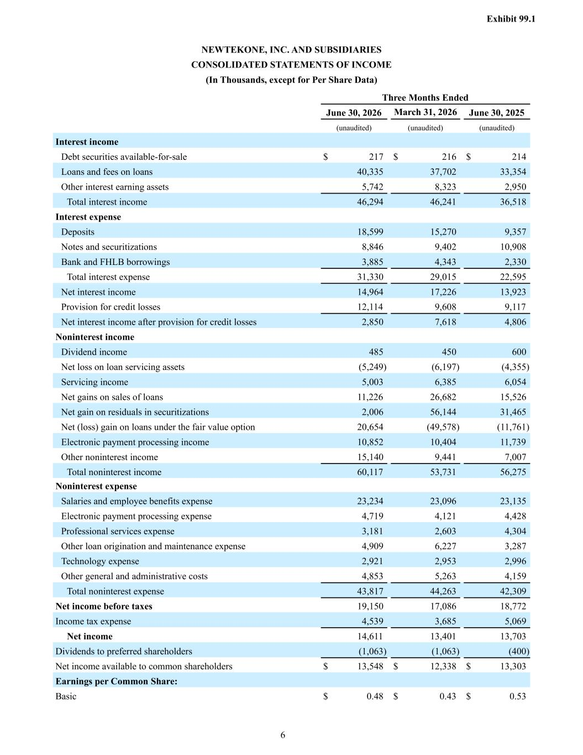
Exhibit 99.1 6 NEWTEKONE, INC. AND SUBSIDIARIES CONSOLIDATED STATEMENTS OF INCOME (In Thousands, except for Per Share Data) Three Months Ended June 30, 2026 March 31, 2026 June 30, 2025 (unaudited) (unaudited) (unaudited) Interest income Debt securities available-for-sale $ 217 $ 216 $ 214 Loans and fees on loans 40,335 37,702 33,354 Other interest earning assets 5,742 8,323 2,950 Total interest income 46,294 46,241 36,518 Interest expense Deposits 18,599 15,270 9,357 Notes and securitizations 8,846 9,402 10,908 Bank and FHLB borrowings 3,885 4,343 2,330 Total interest expense 31,330 29,015 22,595 Net interest income 14,964 17,226 13,923 Provision for credit losses 12,114 9,608 9,117 Net interest income after provision for credit losses 2,850 7,618 4,806 Noninterest income Dividend income 485 450 600 Net loss on loan servicing assets (5,249) (6,197) (4,355) Servicing income 5,003 6,385 6,054 Net gains on sales of loans 11,226 26,682 15,526 Net gain on residuals in securitizations 2,006 56,144 31,465 Net (loss) gain on loans under the fair value option 20,654 (49,578) (11,761) Electronic payment processing income 10,852 10,404 11,739 Other noninterest income 15,140 9,441 7,007 Total noninterest income 60,117 53,731 56,275 Noninterest expense Salaries and employee benefits expense 23,234 23,096 23,135 Electronic payment processing expense 4,719 4,121 4,428 Professional services expense 3,181 2,603 4,304 Other loan origination and maintenance expense 4,909 6,227 3,287 Technology expense 2,921 2,953 2,996 Other general and administrative costs 4,853 5,263 4,159 Total noninterest expense 43,817 44,263 42,309 Net income before taxes 19,150 17,086 18,772 Income tax expense 4,539 3,685 5,069 Net income 14,611 13,401 13,703 Dividends to preferred shareholders (1,063) (1,063) (400) Net income available to common shareholders $ 13,548 $ 12,338 $ 13,303 Earnings per Common Share: Basic $ 0.48 $ 0.43 $ 0.53

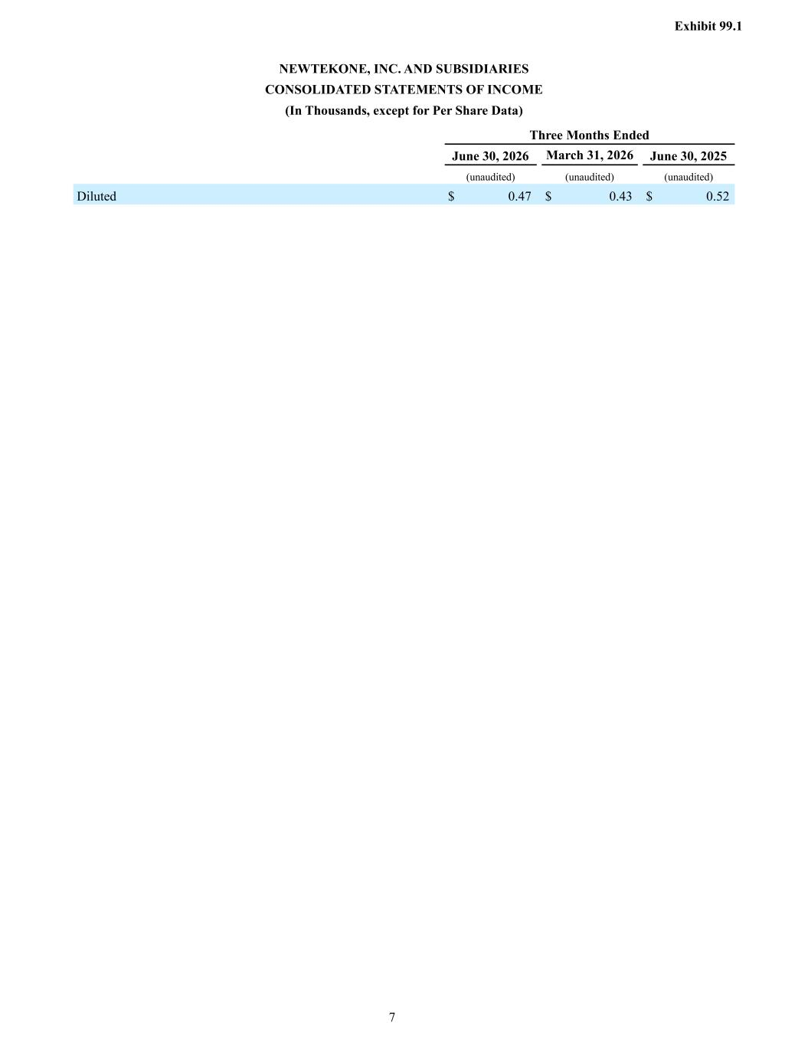
Exhibit 99.1 7 NEWTEKONE, INC. AND SUBSIDIARIES CONSOLIDATED STATEMENTS OF INCOME (In Thousands, except for Per Share Data) Three Months Ended June 30, 2026 March 31, 2026 June 30, 2025 (unaudited) (unaudited) (unaudited) Diluted $ 0.47 $ 0.43 $ 0.52


Exhibit 99.1 8 Reconciliation of GAAP to Non-GAAP Financial Measures (unaudited) The information provided below presents a reconciliation of each of our non-GAAP financial measures to the most directly comparable GAAP financial measure. Ratios for three month periods ended have been annualized based on calendar days.

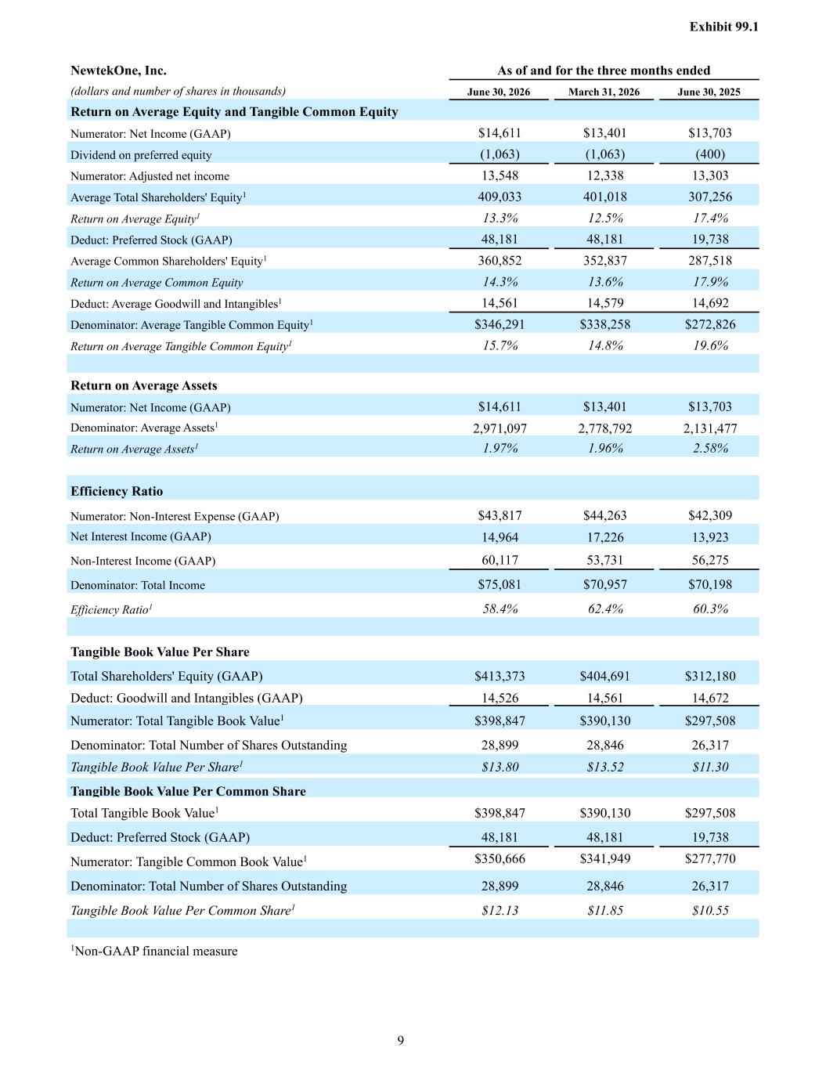
Exhibit 99.1 9 NewtekOne, Inc. As of and for the three months ended (dollars and number of shares in thousands) June 30, 2026 March 31, 2026 June 30, 2025 Return on Average Equity and Tangible Common Equity Numerator: Net Income (GAAP) $14,611 $13,401 $13,703 Dividend on preferred equity (1,063) (1,063) (400) Numerator: Adjusted net income 13,548 12,338 13,303 Average Total Shareholders' Equity1 409,033 401,018 307,256 Return on Average Equity1 13.3% 12.5% 17.4% Deduct: Preferred Stock (GAAP) 48,181 48,181 19,738 Average Common Shareholders' Equity1 360,852 352,837 287,518 Return on Average Common Equity 14.3% 13.6% 17.9% Deduct: Average Goodwill and Intangibles1 14,561 14,579 14,692 Denominator: Average Tangible Common Equity1 $346,291 $338,258 $272,826 Return on Average Tangible Common Equity1 15.7% 14.8% 19.6% Return on Average Assets Numerator: Net Income (GAAP) $14,611 $13,401 $13,703 Denominator: Average Assets1 2,971,097 2,778,792 2,131,477 Return on Average Assets1 1.97% 1.96% 2.58% Efficiency Ratio Numerator: Non-Interest Expense (GAAP) $43,817 $44,263 $42,309 Net Interest Income (GAAP) 14,964 17,226 13,923 Non-Interest Income (GAAP) 60,117 53,731 56,275 Denominator: Total Income $75,081 $70,957 $70,198 Efficiency Ratio1 58.4% 62.4% 60.3% Tangible Book Value Per Share Total Shareholders' Equity (GAAP) $413,373 $404,691 $312,180 Deduct: Goodwill and Intangibles (GAAP) 14,526 14,561 14,672 Numerator: Total Tangible Book Value1 $398,847 $390,130 $297,508 Denominator: Total Number of Shares Outstanding 28,899 28,846 26,317 Tangible Book Value Per Share1 $13.80 $13.52 $11.30 Tangible Book Value Per Common Share Total Tangible Book Value1 $398,847 $390,130 $297,508 Deduct: Preferred Stock (GAAP) 48,181 48,181 19,738 Numerator: Tangible Common Book Value1 $350,666 $341,949 $277,770 Denominator: Total Number of Shares Outstanding 28,899 28,846 26,317 Tangible Book Value Per Common Share1 $12.13 $11.85 $10.55 1Non-GAAP financial measure

