UNITED STATES
SECURITIES AND EXCHANGE COMMISSION
Washington, D.C. 20549
FORM 10-Q

☒ QUARTERLY REPORT PURSUANT TO SECTION 13 OR 15(d) OF THE SECURITIES EXCHANGE ACT OF 1934

For the quarterly period ended June 30, 2026

OR

o TRANSITION REPORT PURSUANT TO SECTION 13 OR 15(d) OF THE SECURITIES EXCHANGE ACT OF 1934

For the transition period from _____to_____
Commission file number: 814-01035
NEWTEKONE, INC.
(Exact name of registrant as specified in its charter)

Maryland |  |  |  |  |  | 46-3755188
(State or other jurisdiction of incorporation or organization) |  |  |  |  |  | (I.R.S. Employer Identification No.)
4800 T Rex Avenue, Suite 120, Boca Raton, Florida |  |  |  |  |  | 33431
(Address of principal executive offices) |  |  |  |  |  | (Zip Code)
(212) 356-9500
(Registrant’s telephone number, including area code)
Not Applicable
(Former name, former address and former fiscal year, if changed since last report)
Securities registered pursuant to Section 12(b) of the Act:
Title of each class |  |  |  |  |  | Trading Symbol(s) |  |  |  |  |  | Name of each exchange on which registered
Common Stock, par value $0.02 per share |  |  |  |  |  | NEWT |  |  |  |  |  | Nasdaq Global Market LLC
8.00% Notes due 2028 |  |  |  |  |  | NEWTI |  |  |  |  |  | Nasdaq Global Market LLC
8.50% Notes due 2029 |  |  |  |  |  | NEWTG |  |  |  |  |  | Nasdaq Global Market LLC
8.625% Notes due 2029 |  |  |  |  |  | NEWTH |  |  |  |  |  | Nasdaq Global Market LLC
8.50% Notes due 2031 |  |  |  |  |  | NEWTO |  |  |  |  |  | Nasdaq Global Market LLC
Depositary Shares, each representing a 1/40th interest in a share of 8.500% Fixed-Rate Reset Non-Cumulative Perpetual Preferred Stock, Series B |  |  |  |  |  | NEWTP |  |  |  |  |  | Nasdaq Global Market LLC

Indicate by check mark whether the registrant: (1) has filed all reports required to be filed by Section 13 or 15(d) of the Securities Exchange Act of 1934 during the past 12 months (or for such shorter period that the registrant was required to file such reports), and (2) has been subject to such filing requirements for the past 90 days. Yes x No ☐
Indicate by check mark whether the registrant has submitted electronically every Interactive Data File required to be submitted pursuant to Rule 405 of Regulation S-T (Section 232.405 of this chapter) during the preceding 12 months (or for such shorter period that the registrant was required to submit and post such files). Yes x No ☐

Indicate by check mark whether the registrant is a large accelerated filer, an accelerated filer, a non-accelerated filer, a smaller reporting company or an emerging growth company. See definitions of “large accelerated filer,” “accelerated filer,” “smaller reporting company,” and “emerging growth company” in Rule 12b-2 of the Exchange Act.
Large accelerated filer |  |  |  |  |  | o |  |  | Accelerated Filer |  |  |  |  |  | x
Non-accelerated filer |  |  |  |  |  | o |  |  | Smaller reporting company |  |  |  |  |  | o
 |  |  |  |  |  |  |  |  | Emerging growth company |  |  |  |  |  | o
If an emerging growth company, indicate by check mark if the registrant has elected not to use the extended transition period for complying with any new or revised financial or accounting standards provided pursuant to Section 13(a) of the Exchange Act. o

Indicate by check mark whether the registrant is a shell company (as defined in Rule 12b-2 of the Exchange Act). Yes ☐ No x

As of August 7, 2026, there were 28,884,731 shares outstanding of the registrant’s Common Stock, par value $0.02 per share.

TABLE OF CONTENTS

 |  |  |  |  |  | Page
 |  |  | Defined Terms |  |  | 4
PART I - FINANCIAL INFORMATION
Item 1. |  |  | Financial Statements:
 |  |  | Consolidated Statements of Financial Condition as of June 30, 2026 (Unaudited) and December 31, 2025 |  |  | 7
 |  |  | Consolidated Statements of Income for the three and six months ended June 30, 2026 and 2025 (Unaudited) |  |  | 9
 |  |  | Consolidated Statements of Comprehensive Income for the three and six months ended June 30, 2026 and 2025 (Unaudited) |  |  | 10
 |  |  | Consolidated Statements of Changes in Shareholders’ Equity for the three and six months ended June 30, 2026 and 2025 (Unaudited) |  |  | 11
 |  |  | Consolidated Statements of Cash Flows for six months ended June 30, 2026 and 2025 (Unaudited) |  |  | 15
 |  |  | Notes to Consolidated Financial Statements (Unaudited) |  |  | 17
Item 2. |  |  | Management’s Discussion and Analysis of Financial Condition and Results of Operations |  |  | 66
Item 3. |  |  | Quantitative and Qualitative Disclosures About Market Risk |  |  | 92
Item 4. |  |  | Controls and Procedures |  |  | 95
PART II - OTHER INFORMATION
Item 1. |  |  | Legal Proceedings |  |  | 96
Item 1A. |  |  | Risk Factors |  |  | 96
Item 2. |  |  | Unregistered Sales of Equity Securities and Use of Proceeds |  |  | 96
Item 3. |  |  | Defaults Upon Senior Securities |  |  | 96
Item 4. |  |  | Mine Safety Disclosures |  |  | 96
Item 5. |  |  | Other Information |  |  | 96
Item 6. |  |  | Exhibits |  |  | 97
 |  |  | Signatures |  |  | 98

Table of Contents
Defined Terms

We have used “we,” “us,” “our,” “our company,” and “the Company” to refer to NewtekOne, Inc. and its subsidiaries in this report. We also have used several other terms in this report, which are explained or defined below:
Terms
1940 Act |  |  | Investment Company Act of 1940, as amended
2021-1 Trust |  |  | Newtek Small Business Loan Trust, Series 2021-1
2022-1 Trust |  |  | Newtek Small Business Loan Trust, Series 2022-1
2023-1 Trust |  |  | Newtek Small Business Loan Trust, Series 2023-1
2025-1 Trust |  |  | NALP Business Loan Trust, Series 2025-1
2026-1 Trust |  |  | NALP Business Loan Trust, Series 2026-1
Unconsolidated Trusts |  |  | Collectively, the 2025-1 Trust and 2026-1 Trust
2024 Notes |  |  | 5.75% Notes due 2024, matured August 1, 2024
2025 5.00% Notes |  |  | 5.00% Notes due 2025, matured March 31, 2025
2025 8.125% Notes |  |  | 8.125% Notes due 2025, exchanged for 2027 Notes
2025 Notes |  |  | Collectively, the 2025 5.00% Notes and 2025 8.125% Notes
2026 Notes |  |  | 5.50% Notes due 2026, matured February 1, 2026
2027 Notes |  |  | 8.125% Notes due 2027
2028 Notes |  |  | 8.00% Notes due 2028
2029 8.50% Notes |  |  | 8.50% Notes due 2029
2029 8.625% Notes |  |  | 8.625% Notes due 2029
2029 Notes |  |  | Collectively, the 2029 8.50% Notes and 2029 8.625% Notes
2030 Notes |  |  | 8.375% Notes due 2030
2031 Notes |  |  | 8.50% Notes due 2031
2033 Notes |  |  | 8.375% Notes due 2033
ABL |  |  | Asset based lending
ACL |  |  | Allowance for credit losses
Acquisition |  |  | The Company’s Acquisition of NBNYC, pursuant to which the Company acquired from the NBNYC shareholders all of the issued and outstanding stock of NBNYC
ALP |  |  | Alternative Lending Program
ASC |  |  | Accounting Standards Codification, as issued by the FASB
ASU |  |  | Accounting Standards Updates, as issued by the FASB
Original ATM Equity Distribution Agreement |  |  | The Original ATM Equity Distribution Agreement, dated November 17, 2023, by and among the Company and the placement agents
Amended and Restated Equity Distribution Agreement |  |  | The Amended and Restated Equity Distribution Agreement, dated June 6, 2025, by and among the Company and the placement agents
BDC |  |  | Business Development Company under the 1940 Act
BHCA |  |  | Bank Holding Company Act of 1956
Board |  |  | The Company's board of directors
Capital One |  |  | Capital One Bank, National Association
C&I |  |  | Conventional commercial and industrial loans
C&I LA |  |  | Long amortizing C&I loans, also known as ALP loans
Code |  |  | Internal Revenue Code of 1986, as amended
CODM |  |  | Chief Operating Decision Maker
CRE |  |  | Commercial real estate
D2 |  |  | D2 Asset Services, LLC
Deutsche Bank |  |  | Deutsche Bank AG
EBITDA |  |  | Earnings before interest, taxes, depreciation and amortization
ESPP |  |  | Employee Stock Purchase Plan
Exchange Act |  |  | Securities Exchange Act of 1934, as amended
FASB |  |  | Financial Accounting Standards Board
4

Table of Contents
Federal Reserve |  |  | Board of Governors of the Federal Reserve System
FDIC |  |  | Federal Deposit Insurance Corporation
FV |  |  | Fair Value
HFI |  |  | Held for investment
HFS |  |  | Held for sale
LCM |  |  | Lower of amortized cost basis or fair value
LTV |  |  | Loan-to-Value
NAV |  |  | Net Asset Value
NBNYC |  |  | National Bank of New York City, renamed Newtek Bank, National Association
NOO |  |  | Non-owner occupied
OCC |  |  | Office of the Comptroller of the Currency
OREO |  |  | Other real estate owned
PCD |  |  | Purchased Financial Assets with Credit Deterioration
PLP |  |  | Preferred Lenders Program, as authorized by the SBA
RIC |  |  | Regulated investment company under the Code
S&P |  |  | Standard and Poor's
SBA |  |  | United States Small Business Administration
SEC |  |  | U.S. Securities and Exchange Commission
SMB |  |  | Small-and-medium sized businesses; revenue from $1.0 million to $100.0 million
SOFR |  |  | Secured Overnight Financing Rate
Trustee |  |  | U.S. Bank, National Association
TSO II |  |  | TSO II Booster Aggregator, L.P.
U.S. GAAP or GAAP |  |  | Generally accepted accounting principles in the United States
VIE |  |  | Variable Interest Entity
Webster |  |  | Webster Bank, N.A.
Bank borrowings |  |  | Collectively, the below facilities:
NMS Goldman Facility |  |  | Revolving Credit and Guaranty Agreement between NMS and its wholly-owned subsidiary, Mobil Money, LLC, together with NBSH Holding, LLC, the direct sole member of NMS
SPV I Capital One Facility |  |  | Revolving Credit and Security Agreement between NBL SPV I, LLC, a wholly-owned subsidiary of NALH, and Capital One (terminated March 25, 2026)
SPV II Deutsche Bank Facility |  |  | Revolving Credit and Security Agreement between NBL SPV II, LLC, a wholly-owned subsidiary of NALH, and Deutsche Bank (terminated May 20, 2026)
SPV III One Florida Bank Facility |  |  | Revolving Credit and Security Agreement between NBL SPV III, LLC, a wholly-owned subsidiary of NALH, and One Florida Bank
NH6/SPV IV D2 Facility |  |  | Term Loan Agreement between NBL SPV IV, LLC, a wholly-owned subsidiary of NALH and NALH (as co-borrowers) and D2 Asset Services, LLC
Consolidated Subsidiaries, Joint Ventures and Other Investments
NSBF |  |  | Newtek Small Business Finance, LLC
NCL |  |  | Newtek Commercial Lending, Inc., a former wholly-owned subsidiary of NewtekOne Inc., merged into NALH on May 13, 2025
Newtek Bank |  |  | Newtek Bank, National Association
NALH or Newtek ALP Holdings |  |  | Newtek Business Services Holdco 6, Inc.
NMS |  |  | Newtek Merchant Solutions, LLC, d/b/a Newtek Real-Time Payment Solutions (“NRTPS”), a wholly-owned subsidiary of NBC
Mobil Money |  |  | Mobil Money, LLC, a wholly-owned subsidiary of NMS
NTS |  |  | Newtek Technology Solutions, Inc., a former wholly-owned subsidiary of the Company, sold to IPM on January 2, 2025
NBC |  |  | CDS Business Services, Inc. dba Newtek Business Credit Solutions
SBL |  |  | Small Business Lending, LLC, a wholly-owned subsidiary of Newtek Bank
PMT |  |  | PMTWorks Payroll, LLC, dba Newtek Payroll and Benefits Solutions
NIA |  |  | Newtek Insurance Agency, LLC
5

Table of Contents
TAM |  |  | Titanium Asset Management, LLC
POS |  |  | POS on Cloud, LLC, dba Newtek Payment Systems, a 95.49% owned consolidated subsidiary
NCL JV |  |  | Newtek Conventional Lending, LLC, a former 50% owned joint venture, 100% Company owned as of August 27, 2025 and dissolved on September 30, 2025
TSO JV |  |  | Newtek-TSO II Conventional Credit Partners, LP, a 50% owned joint venture
IPM |  |  | Intelligent Protection Management Corp., formerly Paltalk, Inc.
IPM Preferred Stock |  |  | 4.0 million shares of IPM Series A Non-Voting Common Equivalent Stock

6

Table of Contents
PART I—FINANCIAL INFORMATION

ITEM 1. FINANCIAL STATEMENTS.

NEWTEKONE, INC. AND SUBSIDIARIES
CONSOLIDATED STATEMENTS OF FINANCIAL CONDITION
(In Thousands, except for Per Share Data)
 |  |  | June 30, 2026 |  |  |  |  |  | December 31, 2025
 |  |  | (Unaudited)
ASSETS
Cash and due from banks |  |  | $ | 5,190 |  |  |  |  | $ | 4,196
Restricted cash (amounts related to VIEs of $6.3 million and $6.3 million, respectively) |  |  | 22,744 |  |  |  |  |  | 26,477
Interest bearing deposits in banks |  |  | 367,073 |  |  |  |  |  | 279,618
Total cash and cash equivalents |  |  | 395,007 |  |  |  |  |  | 310,291
Debt securities available-for-sale, at fair value |  |  | 15,139 |  |  |  |  |  | 16,829
Loans held for sale, at fair value |  |  | 500,783 |  |  |  |  |  | 971,837
Loans held for sale, at LCM |  |  | 20,473 |  |  |  |  |  | 26,532
Loans held for investment, at fair value (amounts related to VIEs of $177.1 million and $198.4 million, respectively) |  |  | 721,568 |  |  |  |  |  | 281,198
Loans held for investment, at amortized cost, net of deferred fees and costs |  |  | 1,139,537 |  |  |  |  |  | 896,689
Allowance for credit losses |  |  | (52,715) |  |  |  |  |  | (45,226)
Loans held for investment, at amortized cost, net |  |  | 1,086,822 |  |  |  |  |  | 851,463
Federal Home Loan Bank and Federal Reserve Bank stock |  |  | 4,548 |  |  |  |  |  | 4,234
Settlement receivable |  |  | — |  |  |  |  |  | 438
Residuals in securitizations, at fair value |  |  | 204,001 |  |  |  |  |  | 76,701
Joint ventures and other investments, at fair value (cost of $36,294 and $36,692), respectively |  |  | 43,766 |  |  |  |  |  | 47,719
Goodwill and intangibles |  |  | 14,526 |  |  |  |  |  | 14,597
Right of use assets |  |  | 2,574 |  |  |  |  |  | 2,790
Deferred tax asset, net |  |  | 10,768 |  |  |  |  |  | —
Servicing assets, at fair value |  |  | 12,456 |  |  |  |  |  | 15,358
Servicing assets, at LCM |  |  | 39,500 |  |  |  |  |  | 29,564
Other assets |  |  | 112,950 |  |  |  |  |  | 95,268
Total assets |  |  | $ | 3,184,881 |  |  |  |  | $ | 2,744,819
F-7
See accompanying notes to consolidated financial statements.
Table of Contents
NEWTEKONE, INC. AND SUBSIDIARIES
CONSOLIDATED STATEMENTS OF FINANCIAL CONDITION
(In Thousands, except for Per Share Data)
 |  |  | June 30, 2026 |  |  |  |  |  | December 31, 2025
 |  |  | (Unaudited)
LIABILITIES AND SHAREHOLDERS’ EQUITY
Liabilities:
Deposits:
Noninterest-bearing |  |  | $ | 56,270 |  |  |  |  | $ | 53,873
Interest-bearing |  |  | 2,094,232 |  |  |  |  |  | 1,364,535
Total deposits |  |  | 2,150,502 |  |  |  |  |  | 1,418,408
Borrowings (including borrowings of VIEs of $105.1 million and $127.1 million, respectively) |  |  | 554,192 |  |  |  |  |  | 819,888
Lease liabilities |  |  | 2,648 |  |  |  |  |  | 2,874
Deferred tax liabilities, net |  |  | — |  |  |  |  |  | 10,728
Due to participants |  |  | 21,117 |  |  |  |  |  | 52,389
Accounts payable, accrued expenses and other liabilities |  |  | 43,049 |  |  |  |  |  | 42,962
Total liabilities |  |  | 2,771,508 |  |  |  |  |  | 2,347,249
Commitment and contingencies (Note 13)
Shareholders' Equity:
Series B Preferred stock (par value $0.02 per share; 54 authorized, 50 issued and outstanding) |  |  | 48,181 |  |  |  |  |  | 48,181
Common stock (par value $0.02 per share; 199,946 authorized, 28,899 and 28,658 issued and outstanding, respectively) |  |  | 579 |  |  |  |  |  | 573
Retained earnings |  |  | 109,899 |  |  |  |  |  | 94,990
Additional paid-in capital |  |  | 254,719 |  |  |  |  |  | 253,830
Accumulated other comprehensive loss, net of income taxes |  |  | (5) |  |  |  |  |  | (4)
Total shareholders' equity |  |  | 413,373 |  |  |  |  |  | 397,570
Total liabilities and shareholders' equity |  |  | $ | 3,184,881 |  |  |  |  | $ | 2,744,819

F-8
See accompanying notes to consolidated financial statements.
Table of Contents
NEWTEKONE, INC. AND SUBSIDIARIES
CONSOLIDATED STATEMENTS OF INCOME (UNAUDITED)
(In Thousands, except for Per Share Data)
 |  |  | Three Months Ended June 30, |  |  |  |  |  |  |  |  |  |  |  | Six Months Ended June 30,
 |  |  | 2026 |  |  |  |  |  | 2025 |  |  |  |  |  | 2026 |  |  |  |  |  | 2025
Interest income
Debt securities available-for-sale |  |  | $ | 217 |  |  |  |  | $ | 214 |  |  |  |  | $ | 433 |  |  |  |  | $ | 490
Loans and fees on loans |  |  | 40,335 |  |  |  |  |  | 33,354 |  |  |  |  |  | 78,037 |  |  |  |  |  | 67,837
Other interest earning assets |  |  | 5,742 |  |  |  |  |  | 2,950 |  |  |  |  |  | 14,065 |  |  |  |  |  | 6,081
Total interest income |  |  | 46,294 |  |  |  |  |  | 36,518 |  |  |  |  |  | 92,535 |  |  |  |  |  | 74,408
Interest expense
Deposits |  |  | 18,599 |  |  |  |  |  | 9,357 |  |  |  |  |  | 33,869 |  |  |  |  |  | 19,202
Notes and securitizations |  |  | 8,846 |  |  |  |  |  | 10,908 |  |  |  |  |  | 18,248 |  |  |  |  |  | 21,882
Bank and FHLB borrowings |  |  | 3,885 |  |  |  |  |  | 2,330 |  |  |  |  |  | 8,228 |  |  |  |  |  | 5,468
Total interest expense |  |  | 31,330 |  |  |  |  |  | 22,595 |  |  |  |  |  | 60,345 |  |  |  |  |  | 46,552
Net interest income |  |  | 14,964 |  |  |  |  |  | 13,923 |  |  |  |  |  | 32,190 |  |  |  |  |  | 27,856
Provision for credit losses |  |  | 12,114 |  |  |  |  |  | 9,117 |  |  |  |  |  | 21,722 |  |  |  |  |  | 22,622
Net interest income after provision for credit losses |  |  | 2,850 |  |  |  |  |  | 4,806 |  |  |  |  |  | 10,468 |  |  |  |  |  | 5,234
Noninterest income
Dividend income |  |  | 485 |  |  |  |  |  | 600 |  |  |  |  |  | 935 |  |  |  |  |  | 2,286
Net loss on loan servicing assets |  |  | (5,249) |  |  |  |  |  | (4,355) |  |  |  |  |  | (11,446) |  |  |  |  |  | (8,007)
Servicing income |  |  | 5,003 |  |  |  |  |  | 6,054 |  |  |  |  |  | 11,388 |  |  |  |  |  | 11,579
Net gains on sales of loans |  |  | 11,226 |  |  |  |  |  | 15,526 |  |  |  |  |  | 37,908 |  |  |  |  |  | 28,487
Net gain on residuals in securitizations |  |  | 2,006 |  |  |  |  |  | 31,465 |  |  |  |  |  | 58,150 |  |  |  |  |  | 31,465
Net (loss) gain on loans under the fair value option |  |  | 20,654 |  |  |  |  |  | (11,761) |  |  |  |  |  | (28,924) |  |  |  |  |  | 6,316
Electronic payment processing income |  |  | 10,852 |  |  |  |  |  | 11,739 |  |  |  |  |  | 21,256 |  |  |  |  |  | 22,348
Other noninterest income |  |  | 15,140 |  |  |  |  |  | 7,007 |  |  |  |  |  | 24,581 |  |  |  |  |  | 14,199
Total noninterest income |  |  | 60,117 |  |  |  |  |  | 56,275 |  |  |  |  |  | 113,848 |  |  |  |  |  | 108,673
Noninterest expense
Salaries and employee benefits expense |  |  | 23,234 |  |  |  |  |  | 23,135 |  |  |  |  |  | 46,330 |  |  |  |  |  | 44,451
Electronic payment processing expense |  |  | 4,719 |  |  |  |  |  | 4,428 |  |  |  |  |  | 8,840 |  |  |  |  |  | 8,875
Professional services expense |  |  | 3,181 |  |  |  |  |  | 4,304 |  |  |  |  |  | 5,784 |  |  |  |  |  | 7,739
Other loan origination and maintenance expense |  |  | 4,909 |  |  |  |  |  | 3,287 |  |  |  |  |  | 11,136 |  |  |  |  |  | 7,704
Technology expense |  |  | 2,921 |  |  |  |  |  | 2,996 |  |  |  |  |  | 5,874 |  |  |  |  |  | 5,724
Other general and administrative costs |  |  | 4,853 |  |  |  |  |  | 4,159 |  |  |  |  |  | 10,116 |  |  |  |  |  | 8,993
Total noninterest expense |  |  | 43,817 |  |  |  |  |  | 42,309 |  |  |  |  |  | 88,080 |  |  |  |  |  | 83,486
Net income before taxes |  |  | 19,150 |  |  |  |  |  | 18,772 |  |  |  |  |  | 36,236 |  |  |  |  |  | 30,421
Income tax expense |  |  | 4,539 |  |  |  |  |  | 5,069 |  |  |  |  |  | 8,224 |  |  |  |  |  | 7,351
Net income |  |  | 14,611 |  |  |  |  |  | 13,703 |  |  |  |  |  | 28,012 |  |  |  |  |  | 23,070
Dividends to preferred shareholders |  |  | (1,063) |  |  |  |  |  | (400) |  |  |  |  |  | (2,126) |  |  |  |  |  | (800)
Net income available to common shareholders |  |  | $ | 13,548 |  |  |  |  | $ | 13,303 |  |  |  |  | $ | 25,886 |  |  |  |  | $ | 22,270
Earnings per Common Share:
Basic |  |  | $ | 0.48 |  |  |  |  | $ | 0.53 |  |  |  |  | $ | 0.91 |  |  |  |  | $ | 0.89
Diluted |  |  | $ | 0.47 |  |  |  |  | $ | 0.52 |  |  |  |  | $ | 0.90 |  |  |  |  | $ | 0.87

F-9
See accompanying notes to consolidated financial statements.
Table of Contents
NEWTEKONE, INC. AND SUBSIDIARIES
CONSOLIDATED STATEMENTS OF COMPREHENSIVE INCOME (UNAUDITED)
(In Thousands)
 |  |  | Three Months Ended June 30, |  |  |  |  |  |  |  |  |  |  |  | Six Months Ended June 30,
 |  |  | 2026 |  |  |  |  |  | 2025 |  |  |  |  |  | 2026 |  |  |  |  |  | 2025
Net income |  |  | $ | 14,611 |  |  |  |  | $ | 13,703 |  |  |  |  | $ | 28,012 |  |  |  |  | $ | 23,070
Other comprehensive (loss) income before tax:
Net unrealized gain (loss) on debt securities available-for-sale during the period |  |  | 1 |  |  |  |  |  | (2) |  |  |  |  |  | (1) |  |  |  |  |  | 26
Other comprehensive income (loss) before tax |  |  | 1 |  |  |  |  |  | (2) |  |  |  |  |  | (1) |  |  |  |  |  | 26
Income tax expense |  |  | — |  |  |  |  |  | 1 |  |  |  |  |  | — |  |  |  |  |  | 3
Other comprehensive income (loss) net of tax |  |  | 1 |  |  |  |  |  | (1) |  |  |  |  |  | (1) |  |  |  |  |  | 29
Comprehensive income |  |  | $ | 14,612 |  |  |  |  | $ | 13,702 |  |  |  |  | $ | 28,011 |  |  |  |  | $ | 23,099

F-10
See accompanying notes to consolidated financial statements.
Table of Contents
NEWTEKONE, INC. AND SUBSIDIARIES
CONSOLIDATED STATEMENTS OF CHANGES IN SHAREHOLDERS’ EQUITY (UNAUDITED)
(In Thousands, except for Per Share Data)
 |  |  |  |  | Series B  Preferred stock |  |  |  |  |  |  |  | Common stock |  |  |  |  |  |  |  |  |  |  |  | Retained earnings |  |  |  |  |  | Additional paid-in capital |  |  |  |  |  | Accumulated other comprehensive loss, net of income taxes |  |  |  |  |  | Total shareholders' equity
 |  |  |  |  |  |  | Shares |  |  |  |  |  | Amount |  |  |  |  |  | Shares |  |  |  |  |  |  |  |  | Amount
Balance at March 31, 2026 |  |  |  |  |  |  | 50 |  |  |  |  |  | 48,181 |  |  |  |  |  | 28,846 |  |  |  |  |  | $ | 577 |  |  |  |  | $ | 101,838 |  |  |  |  | $ | 254,101 |  |  |  |  | $ | (6) |  |  |  |  | $ | 404,691
Stock-based compensation expense, net of forfeitures |  |  |  |  |  |  | — |  |  |  |  |  | — |  |  |  |  |  | — |  |  |  |  |  | — |  |  |  |  |  | — |  |  |  |  |  | 602 |  |  |  |  |  | — |  |  |  |  |  | 602
Dividends declared related to RSA, net of accrued dividends forfeited |  |  |  |  |  |  | — |  |  |  |  |  | — |  |  |  |  |  | 5 |  |  |  |  |  | — |  |  |  |  |  | (68) |  |  |  |  |  | 68 |  |  |  |  |  | — |  |  |  |  |  | —
Purchase of vested stock for employee payroll tax withholding |  |  |  |  |  |  | — |  |  |  |  |  | — |  |  |  |  |  | (11) |  |  |  |  |  | — |  |  |  |  |  | — |  |  |  |  |  | (149) |  |  |  |  |  | — |  |  |  |  |  | (149)
Restricted stock awards, net of forfeitures |  |  |  |  |  |  | — |  |  |  |  |  | — |  |  |  |  |  | 51 |  |  |  |  |  | 2 |  |  |  |  |  | — |  |  |  |  |  | — |  |  |  |  |  | — |  |  |  |  |  | 2
ESPP issuances |  |  |  |  |  |  | — |  |  |  |  |  | — |  |  |  |  |  | 8 |  |  |  |  |  | — |  |  |  |  |  | — |  |  |  |  |  | 97 |  |  |  |  |  | — |  |  |  |  |  | 97
Dividends declared common shares ($0.19/share) |  |  |  |  |  |  | — |  |  |  |  |  | — |  |  |  |  |  | — |  |  |  |  |  | — |  |  |  |  |  | (5,419) |  |  |  |  |  | — |  |  |  |  |  | — |  |  |  |  |  | (5,419)
Dividends declared preferred shares ($21.25/share) |  |  |  |  |  |  | — |  |  |  |  |  | — |  |  |  |  |  | — |  |  |  |  |  | — |  |  |  |  |  | (1,063) |  |  |  |  |  | — |  |  |  |  |  | — |  |  |  |  |  | (1,063)
Net income |  |  |  |  |  |  | — |  |  |  |  |  | — |  |  |  |  |  | — |  |  |  |  |  | — |  |  |  |  |  | 14,611 |  |  |  |  |  | — |  |  |  |  |  | — |  |  |  |  |  | 14,611
Other comprehensive income, net of tax |  |  |  |  |  |  | — |  |  |  |  |  | — |  |  |  |  |  | — |  |  |  |  |  | — |  |  |  |  |  | — |  |  |  |  |  | — |  |  |  |  |  | 1 |  |  |  |  |  | 1
Balance at June 30, 2026 |  |  |  |  |  |  | 50 |  |  |  |  |  | $ | 48,181 |  |  |  |  | 28,899 |  |  |  |  |  | $ | 579 |  |  |  |  | $ | 109,899 |  |  |  |  | $ | 254,719 |  |  |  |  | $ | (5) |  |  |  |  | $ | 413,373

F-11
See accompanying notes to consolidated financial statements.
Table of Contents
NEWTEKONE, INC. AND SUBSIDIARIES
CONSOLIDATED STATEMENTS OF CHANGES IN SHAREHOLDERS’ EQUITY (UNAUDITED)
(In Thousands, except for Per Share Data)
 |  |  | Series A  Preferred stock |  |  |  |  |  |  |  |  |  |  |  | Common stock |  |  |  |  |  |  |  |  |  |  |  | Retained earnings |  |  |  |  |  | Additional paid-in capital |  |  |  |  |  | Accumulated other comprehensive income (loss), net of income taxes |  |  |  |  |  | Total shareholders' equity
 |  |  | Shares |  |  |  |  |  | Amount |  |  |  |  |  | Shares |  |  |  |  |  | Amount
Balance at March 31, 2025 |  |  | 20 |  |  |  |  |  | $ | 19,738 |  |  |  |  | 26,342 |  |  |  |  |  | $ | 527 |  |  |  |  | $ | 61,538 |  |  |  |  | $ | 220,468 |  |  |  |  | $ | 9 |  |  |  |  | $ | 302,280
Stock-based compensation expense, net of forfeitures |  |  | — |  |  |  |  |  | — |  |  |  |  |  | — |  |  |  |  |  | — |  |  |  |  |  | — |  |  |  |  |  | 1,533 |  |  |  |  |  | — |  |  |  |  |  | 1,533
Dividends declared related to RSA, net of accrued dividends forfeited |  |  | — |  |  |  |  |  | — |  |  |  |  |  | (6) |  |  |  |  |  | — |  |  |  |  |  | — |  |  |  |  |  | — |  |  |  |  |  | — |  |  |  |  |  | —
Purchase of vested stock for employee payroll tax withholding |  |  | — |  |  |  |  |  | — |  |  |  |  |  | (2) |  |  |  |  |  | — |  |  |  |  |  | — |  |  |  |  |  | (24) |  |  |  |  |  | — |  |  |  |  |  | (24)
Restricted stock awards, net of forfeitures |  |  | — |  |  |  |  |  | — |  |  |  |  |  | (13) |  |  |  |  |  | (1) |  |  |  |  |  | — |  |  |  |  |  | — |  |  |  |  |  | — |  |  |  |  |  | (1)
ESPP issuances |  |  | — |  |  |  |  |  | — |  |  |  |  |  | 9 |  |  |  |  |  | — |  |  |  |  |  | — |  |  |  |  |  | 103 |  |  |  |  |  | — |  |  |  |  |  | 103
Amortization of offering costs |  |  | — |  |  |  |  |  | — |  |  |  |  |  | (13) |  |  |  |  |  | (1) |  |  |  |  |  | — |  |  |  |  |  | (166) |  |  |  |  |  | — |  |  |  |  |  | (167)
Dividends declared common shares ($0.19/share) |  |  | — |  |  |  |  |  | — |  |  |  |  |  | — |  |  |  |  |  | — |  |  |  |  |  | (4,846) |  |  |  |  |  | — |  |  |  |  |  | — |  |  |  |  |  | (4,846)
Dividends declared preferred shares ($20.00/share) |  |  | — |  |  |  |  |  | — |  |  |  |  |  | — |  |  |  |  |  | — |  |  |  |  |  | (400) |  |  |  |  |  | — |  |  |  |  |  | — |  |  |  |  |  | (400)
Net income |  |  | — |  |  |  |  |  | — |  |  |  |  |  | — |  |  |  |  |  | — |  |  |  |  |  | 13,703 |  |  |  |  |  | — |  |  |  |  |  | — |  |  |  |  |  | 13,703
Other comprehensive income, net of tax |  |  | — |  |  |  |  |  | — |  |  |  |  |  | — |  |  |  |  |  | — |  |  |  |  |  | — |  |  |  |  |  | — |  |  |  |  |  | (1) |  |  |  |  |  | (1)
Balance at June 30, 2025 |  |  | 20 |  |  |  |  |  | $ | 19,738 |  |  |  |  | 26,317 |  |  |  |  |  | $ | 525 |  |  |  |  | $ | 69,995 |  |  |  |  | $ | 221,914 |  |  |  |  | $ | 8 |  |  |  |  | $ | 312,180

F-12
See accompanying notes to consolidated financial statements.
Table of Contents
NEWTEKONE, INC. AND SUBSIDIARIES
CONSOLIDATED STATEMENTS OF CHANGES IN SHAREHOLDERS’ EQUITY
(In Thousands, except for Per Share Data)
 |  |  |  |  | Series B  Preferred stock |  |  |  |  |  |  |  | Common stock |  |  |  |  |  |  |  |  |  |  |  | Retained earnings |  |  |  |  |  | Additional paid-in capital |  |  |  |  |  | Accumulated other comprehensive loss, net of income taxes |  |  |  |  |  | Total shareholders' equity
 |  |  |  |  |  |  | Shares |  |  |  |  |  | Amount |  |  |  |  |  | Shares |  |  |  |  |  |  |  |  | Amount
Balance at December 31, 2025 |  |  |  |  |  |  | 50 |  |  |  |  |  | 48,181 |  |  |  |  |  | 28,658 |  |  |  |  |  | $ | 573 |  |  |  |  | $ | 94,990 |  |  |  |  | $ | 253,830 |  |  |  |  | $ | (4) |  |  |  |  | $ | 397,570
Stock-based compensation expense, net of forfeitures |  |  |  |  |  |  | — |  |  |  |  |  | — |  |  |  |  |  | — |  |  |  |  |  | — |  |  |  |  |  | — |  |  |  |  |  | 1,159 |  |  |  |  |  | — |  |  |  |  |  | 1,159
Dividends declared related to RSA, net of accrued dividends forfeited |  |  |  |  |  |  | — |  |  |  |  |  | — |  |  |  |  |  | 12 |  |  |  |  |  | — |  |  |  |  |  | (145) |  |  |  |  |  | 145 |  |  |  |  |  | — |  |  |  |  |  | —
Purchase of vested stock for employee payroll tax withholding |  |  |  |  |  |  | — |  |  |  |  |  | — |  |  |  |  |  | (41) |  |  |  |  |  | (1) |  |  |  |  |  | — |  |  |  |  |  | (581) |  |  |  |  |  | — |  |  |  |  |  | (582)
Restricted stock awards, net of forfeitures |  |  |  |  |  |  | — |  |  |  |  |  | — |  |  |  |  |  | 255 |  |  |  |  |  | 7 |  |  |  |  |  | — |  |  |  |  |  | (8) |  |  |  |  |  | — |  |  |  |  |  | (1)
ESPP issuances |  |  |  |  |  |  | — |  |  |  |  |  | — |  |  |  |  |  | 15 |  |  |  |  |  | — |  |  |  |  |  | — |  |  |  |  |  | 174 |  |  |  |  |  | — |  |  |  |  |  | 174
Dividends declared common shares ($0.38/share) |  |  |  |  |  |  | — |  |  |  |  |  | — |  |  |  |  |  | — |  |  |  |  |  | — |  |  |  |  |  | (10,832) |  |  |  |  |  | — |  |  |  |  |  | — |  |  |  |  |  | (10,832)
Dividends declared preferred shares ($42.50/share) |  |  |  |  |  |  | — |  |  |  |  |  | — |  |  |  |  |  | — |  |  |  |  |  | — |  |  |  |  |  | (2,126) |  |  |  |  |  | — |  |  |  |  |  | — |  |  |  |  |  | (2,126)
Net income |  |  |  |  |  |  | — |  |  |  |  |  | — |  |  |  |  |  | — |  |  |  |  |  | — |  |  |  |  |  | 28,012 |  |  |  |  |  | — |  |  |  |  |  | — |  |  |  |  |  | 28,012
Other comprehensive loss, net of tax |  |  |  |  |  |  | — |  |  |  |  |  | — |  |  |  |  |  | — |  |  |  |  |  | — |  |  |  |  |  | — |  |  |  |  |  | — |  |  |  |  |  | (1) |  |  |  |  |  | (1)
Balance at June 30, 2026 |  |  |  |  |  |  | 50 |  |  |  |  |  | $ | 48,181 |  |  |  |  | 28,899 |  |  |  |  |  | $ | 579 |  |  |  |  | $ | 109,899 |  |  |  |  | $ | 254,719 |  |  |  |  | $ | (5) |  |  |  |  | $ | 413,373

F-13
See accompanying notes to consolidated financial statements.
Table of Contents
NEWTEKONE, INC. AND SUBSIDIARIES
CONSOLIDATED STATEMENTS OF CHANGES IN SHAREHOLDERS’ EQUITY
(In Thousands, except for Per Share Data)
 |  |  | Series A  Preferred stock |  |  |  |  |  |  |  |  |  |  |  | Common stock |  |  |  |  |  |  |  |  |  |  |  | Retained earnings |  |  |  |  |  | Additional paid-in capital |  |  |  |  |  | Accumulated other comprehensive loss, net of income taxes |  |  |  |  |  | Total shareholders' equity
 |  |  | Shares |  |  |  |  |  | Amount |  |  |  |  |  | Shares |  |  |  |  |  | Amount
Balance at December 31, 2024 |  |  | 20 |  |  |  |  |  | $ | 19,738 |  |  |  |  | 26,291 |  |  |  |  |  | $ | 526 |  |  |  |  | $ | 57,773 |  |  |  |  | $ | 218,266 |  |  |  |  | $ | (21) |  |  |  |  | $ | 296,282
Stock-based compensation expense, net of forfeitures |  |  | — |  |  |  |  |  | — |  |  |  |  |  | — |  |  |  |  |  | — |  |  |  |  |  | — |  |  |  |  |  | 3,361 |  |  |  |  |  | — |  |  |  |  |  | 3,361
Dividends declared related to RSA, net of accrued dividends forfeited |  |  | — |  |  |  |  |  | — |  |  |  |  |  | 29 |  |  |  |  |  | 1 |  |  |  |  |  | (367) |  |  |  |  |  | 366 |  |  |  |  |  | — |  |  |  |  |  | —
Purchase of vested stock for employee payroll tax withholding |  |  | — |  |  |  |  |  | — |  |  |  |  |  | (5) |  |  |  |  |  | — |  |  |  |  |  | — |  |  |  |  |  | (70) |  |  |  |  |  | — |  |  |  |  |  | (70)
Restricted stock awards, net of forfeitures |  |  | — |  |  |  |  |  | — |  |  |  |  |  | 2 |  |  |  |  |  | (1) |  |  |  |  |  | — |  |  |  |  |  | — |  |  |  |  |  | — |  |  |  |  |  | (1)
Retirement of common shares |  |  | — |  |  |  |  |  | — |  |  |  |  |  | (13) |  |  |  |  |  | (1) |  |  |  |  |  | — |  |  |  |  |  | (166) |  |  |  |  |  | — |  |  |  |  |  | (167)
ESPP issuances |  |  | — |  |  |  |  |  | — |  |  |  |  |  | 13 |  |  |  |  |  | — |  |  |  |  |  | — |  |  |  |  |  | 157 |  |  |  |  |  | — |  |  |  |  |  | 157
Dividends declared common shares ($0.38/share) |  |  | — |  |  |  |  |  | — |  |  |  |  |  | — |  |  |  |  |  | — |  |  |  |  |  | (9,681) |  |  |  |  |  | — |  |  |  |  |  | — |  |  |  |  |  | (9,681)
Dividends declared preferred shares ($40.00/share) |  |  | — |  |  |  |  |  | — |  |  |  |  |  | — |  |  |  |  |  | — |  |  |  |  |  | (800) |  |  |  |  |  | — |  |  |  |  |  | — |  |  |  |  |  | (800)
Net income |  |  | — |  |  |  |  |  | — |  |  |  |  |  | — |  |  |  |  |  | — |  |  |  |  |  | 23,070 |  |  |  |  |  | — |  |  |  |  |  | — |  |  |  |  |  | 23,070
Other comprehensive income, net of tax |  |  | — |  |  |  |  |  | — |  |  |  |  |  | — |  |  |  |  |  | — |  |  |  |  |  | — |  |  |  |  |  | — |  |  |  |  |  | 29 |  |  |  |  |  | 29
Balance at June 30, 2025 |  |  | 20 |  |  |  |  |  | $ | 19,738 |  |  |  |  | 26,317 |  |  |  |  |  | $ | 525 |  |  |  |  | $ | 69,995 |  |  |  |  | $ | 221,914 |  |  |  |  | $ | 8 |  |  |  |  | $ | 312,180

F-14
See accompanying notes to consolidated financial statements.
Table of Contents
NEWTEKONE, INC. AND SUBSIDIARIES
CONSOLIDATED STATEMENTS OF CASH FLOWS (UNAUDITED)
(In Thousands)
 |  |  | Six Months Ended June 30,
 |  |  | 2026 |  |  |  |  |  | 2025
Cash flows from operating activities:
Net Income |  |  | $ | 28,012 |  |  |  |  | $ | 23,070
Adjustments to reconcile net income to net cash used in operating activities:
Net unrealized depreciation on joint ventures and other investments |  |  | 1,970 |  |  |  |  |  | 96
Net loss (gain) on loans accounted for under the fair value option |  |  | 28,924 |  |  |  |  |  | (6,316)
Net gain on residuals in securitizations |  |  | (58,150) |  |  |  |  |  | (31,465)
Net loss on loan servicing assets |  |  | 11,446 |  |  |  |  |  | 8,007
Net unrealized depreciation on warrants and derivative transactions |  |  | 828 |  |  |  |  |  | 1,468
Net gain on sales of loans |  |  | (37,908) |  |  |  |  |  | (28,487)
Net accretion of premium/discount on debt securities available-for-sale and loans |  |  | (264) |  |  |  |  |  | (1,051)
Amortization of deferred financing costs and deferred loan fees and costs |  |  | 1,183 |  |  |  |  |  | 2,096
Provision for credit losses |  |  | 21,722 |  |  |  |  |  | 22,622
Lower of cost or market adjustment on loans held for sale |  |  | — |  |  |  |  |  | (15)
Bad debt expense, net of recoveries |  |  | (227) |  |  |  |  |  | 85
Stock compensation expense |  |  | 1,159 |  |  |  |  |  | 3,390
Deferred income benefit expense |  |  | (21,496) |  |  |  |  |  | (2,439)
Depreciation and amortization |  |  | 291 |  |  |  |  |  | 420
Proceeds from sale of loans held for sale |  |  | 232,055 |  |  |  |  |  | 217,267
Purchase of loans held for sale |  |  | (22,179) |  |  |  |  |  | —
Funding of loans held for sale |  |  | (574,293) |  |  |  |  |  | (508,393)
Principal received on loans held for sale |  |  | 10,842 |  |  |  |  |  | 5,608
Other, net |  |  | (539) |  |  |  |  |  | (1,244)
Changes in operating assets and liabilities:
Settlement receivable |  |  | 438 |  |  |  |  |  | 32,759
Other assets |  |  | (11,858) |  |  |  |  |  | (1,351)
Due to participants |  |  | (31,272) |  |  |  |  |  | 4,354
Accounts payable, accrued expenses and other liabilities |  |  | (1,454) |  |  |  |  |  | (999)
Net cash used in operating activities |  |  | (420,770) |  |  |  |  |  | (260,518)
Cash flows from investing activities:
Principal received on loans held for investment, at fair value |  |  | 28,400 |  |  |  |  |  | 35,063
Repurchases of loans held for investment, at fair value |  |  | (2,987) |  |  |  |  |  | (1,071)
Net increase in loans held for investment, at cost |  |  | (254,111) |  |  |  |  |  | (171,609)
Proceeds from sales of Biller Genie and Newtek Technology Solutions, Inc. |  |  | 1,983 |  |  |  |  |  | 4,000
Contributions to joint ventures and other investments |  |  | — |  |  |  |  |  | (85)
Return of capital from joint ventures and other investments |  |  | — |  |  |  |  |  | 14
Purchase of fixed assets |  |  | (58) |  |  |  |  |  | (91)
Sales of Federal Home Loan Bank and Federal Reserve Bank stock |  |  | 48 |  |  |  |  |  | 315
Purchases of Federal Home Loan Bank and Federal Reserve Bank stock |  |  | (361) |  |  |  |  |  | (667)
Purchases of available-for-sale securities |  |  | (17,015) |  |  |  |  |  | (3,945)
Maturities of available-for-sale securities |  |  | 19,000 |  |  |  |  |  | 14,000
Net cash used in investing activities |  |  | (225,101) |  |  |  |  |  | (124,076)
F-15
See accompanying notes to consolidated financial statements.
Table of Contents
NEWTEKONE, INC. AND SUBSIDIARIES
CONSOLIDATED STATEMENTS OF CASH FLOWS (UNAUDITED)
(In Thousands)
 |  |  | Six Months Ended June 30,
 |  |  | 2026 |  |  |  |  |  | 2025
Cash flows from financing activities:
Borrowing on bank notes payable |  |  | 39,852 |  |  |  |  |  | 187,350
Repayment on bank notes payable |  |  | (211,394) |  |  |  |  |  | (202,638)
Net increase in deposits |  |  | 731,751 |  |  |  |  |  | 110,248
Repayment of Federal Home Loan Bank advances |  |  | (1,038) |  |  |  |  |  | (7,004)
Repurchase of common shares under share repurchase plan |  |  | — |  |  |  |  |  | (167)
Proceeds from 2033 8.375% Notes |  |  | 15,000 |  |  |  |  |  | —
Maturity of 2026 5.50% Notes |  |  | (87,123) |  |  |  |  |  | —
Maturity of 2025 5.00% Notes |  |  | — |  |  |  |  |  | (30,000)
Proceeds from 2023 Notes |  |  | — |  |  |  |  |  | 30,000
Payments on Notes Payable - Securitization Trusts |  |  | (22,255) |  |  |  |  |  | (29,596)
Proceeds related to residuals in securitizations |  |  | 279,379 |  |  |  |  |  | 169,421
Dividends paid, net of dividend reinvestment plan |  |  | (12,958) |  |  |  |  |  | (10,468)
Payments of deferred financing costs |  |  | (218) |  |  |  |  |  | (724)
Proceeds from common stock issued under ESPP, net of discount, and restricted stock awards, net of forfeitures |  |  | 173 |  |  |  |  |  | 157
Purchase of vested stock for employee payroll tax withholding |  |  | (582) |  |  |  |  |  | (70)
Net cash provided by financing activities |  |  | 730,587 |  |  |  |  |  | 216,509
Net increase (decrease) in cash and restricted cash |  |  | 84,716 |  |  |  |  |  | (168,085)
Cash and restricted cash—beginning of period (NOTE 2) |  |  | 310,291 |  |  |  |  |  | 381,374
Cash and restricted cash—end of period (NOTE 2) |  |  | $ | 395,007 |  |  |  |  | $ | 213,289
Non-cash operating, investing and financing activities:
Foreclosed real estate acquired |  |  | $ | 5,250 |  |  |  |  | $ | 3,994
Reclass of loans from HFS to HFI |  |  | $ | 442,613 |  |  |  |  | $ | —
Dividends declared but not paid during the period |  |  | $ | — |  |  |  |  | $ | 5,246
IPM stock acquired |  |  | $ | — |  |  |  |  | $ | 8,200
IPM earn-out |  |  | $ | — |  |  |  |  | $ | 2,268
Supplemental disclosure of cash flow information:
Interest paid |  |  | $ | 60,946 |  |  |  |  | $ | 46,237
Income taxes paid |  |  | $ | 14,969 |  |  |  |  | $ | 927

F-16
See accompanying notes to consolidated financial statements.
Table of Contents
NEWTEKONE, INC. AND SUBSIDIARIES
NOTES TO CONSOLIDATED FINANCIAL STATEMENTS (UNAUDITED)

NOTE 1—DESCRIPTION OF BUSINESS AND BASIS OF PRESENTATION:

The Company is a financial holding company that is a leading provider of business and financial solutions to independent business owners and provides SMBs with the following Newtek® branded business and financial solutions: Newtek Banking, Newtek Lending, Newtek Payments, Newtek Real-Time Solutions, Newtek Insurance and Newtek Payroll.

NewtekOne reports on a consolidated basis the financial condition and results of operations for the following consolidated subsidiaries: Newtek Bank; NSBF; NMS (and its subsidiary Mobil Money); NBC; PMT; NIA; TAM; POS; and NALH.

Except as otherwise noted, all financial information included in the tables in the following footnotes is stated in thousands, except per share data.

The accompanying notes to the consolidated financial statements should be read in conjunction with the Company’s Annual Report on Form 10-K for the year ended December 31, 2025, filed on March 10, 2026 (the “2025 Form 10-K”). The unaudited consolidated financial statements of the Company have been prepared in accordance with U.S. GAAP and pursuant to the requirements for reporting on Form 10-Q and Article 10 of Regulation S-X and, therefore, do not include all information and footnotes necessary for a fair presentation of the consolidated financial statements in accordance with U.S. GAAP. In the opinion of management, the consolidated financial statements reflect all adjustments and reclassifications that are necessary for the fair presentation of financial results as of and for the periods presented. The annualized results of operations for the three and six months ended June 30, 2026, are not necessarily indicative of the results of operations that may be expected for the entire fiscal year. The December 31, 2025 consolidated statements of financial condition has been derived from the audited financial statements as of that date. All intercompany balances and transactions have been eliminated in consolidation.

Consolidation

The consolidated financial statements include the accounts of NewtekOne, its subsidiaries and certain VIEs. Significant intercompany balances and transactions have been eliminated. The Company consolidates a subsidiary if the Company has a controlling financial interest in the entity as a result of holding a majority of the voting rights. VIEs are consolidated if NewtekOne has the power to direct the activities of the VIE that significantly impact financial performance and has the obligation to absorb losses or the right to receive benefits that could potentially be significant to the VIE (i.e., NewtekOne is the primary beneficiary). The determination of whether the Company is the primary beneficiary of a VIE is reassessed on an ongoing basis. Investments in companies which are not VIEs, but in which the Company has more than minor influence over the operating and financial policies, are accounted for using the equity method of accounting. Investments in VIEs where NewtekOne is not the primary beneficiary of a VIE are accounted for using the equity method of accounting. The maximum potential exposure to losses relative to investments in VIEs is generally limited to the investment balance. Refer to NOTE 3—SECURITIZATIONS AND VARIABLE INTEREST ENTITIES.

Reclassifications

Certain prior period amounts, which are normal and reoccurring in nature, to the extent comparable, have been reclassified to conform to the current period presentation.

The previous net presentation of cash flows from investing and financing activities within the consolidated statements of cash flows has been revised to reflect a gross presentation of principal received on and repurchases of loans held for investment, at fair value, purchases and redemptions of Federal Home Loan Bank stock and Federal Reserve Bank stock, borrowing and repayment on bank notes payable, as well as proceeds related to residuals in securitizations for all comparative periods.

These reclassifications did not result in any changes to previously reported net income or shareholder’s equity or net cash used in investing or financing activities.

F-17
Table of Contents
NOTE 2—SIGNIFICANT ACCOUNTING POLICIES:

A more detailed description of our accounting policies is included in the Company’s 2025 Form 10-K, which accounting policies remain significantly unchanged. There have been no other significant changes to our accounting policies, or the estimates made pursuant to those policies as described in our 2025 Form 10-K.

Cash and due from banks

The Company considers all highly liquid instruments with maturities of three months or less when purchased to be cash equivalents. Invested cash is held exclusively at financial institutions of high credit quality. As of June 30, 2026, cash deposits in excess of insured amounts totaled $108.1 million. The Company has not experienced any losses with respect to cash balances in excess of insured amounts and management does not believe there was a significant concentration of risk with respect to cash balances as of June 30, 2026.

Restricted cash

Restricted cash includes amounts due on SBA loan-related remittances to third parties, cash reserves established as part of agreements with the SBA, cash reserves associated with consolidated securitization transactions, cash margin as collateral for derivative instruments and accounts the Company maintains to facilitate repurchase agreement transactions.

Interest bearing deposits in banks

The Company’s interest bearing deposits in banks reflects cash held at other financial institutions that earn interest.

The following table provides a reconciliation of cash, restricted cash, and interest bearing deposits in banks as of June 30, 2026 and December 31, 2025:

 |  |  | June 30, 2026 |  |  |  |  |  | December 31, 2025
Cash and due from banks |  |  | $ | 5,190 |  |  |  |  | 4,196
Restricted cash |  |  | 22,744 |  |  |  |  |  | 26,477
Interest bearing deposits in banks |  |  | 367,073 |  |  |  |  |  | 279,618
Total cash and cash equivalents |  |  | $ | 395,007 |  |  |  |  | $ | 310,291

 |  |  | June 30, 2026 |  |  |  |  |  | December 31, 2025
Cash held at Federal Reserve Bank1 |  |  | $ | 366,225 |  |  |  |  | 277,828
Cash held at other financial institutions |  |  | 28,782 |  |  |  |  |  | 32,463
Total cash and cash equivalents |  |  | $ | 395,007 |  |  |  |  | $ | 310,291
1 Subject to changes in the Federal Funds rate set by the Federal Open Market Committee

Allowance for Credit Losses – Loans HFI at amortized cost

Accounting Standards Update (“ASU”) 2016-13, Financial Instruments - Credit Losses (Topic 326): Measurement of Credit Losses on Financial Instruments (“CECL”) approach requires an estimate of the credit losses expected over the life of a loan (or pool of loans). The allowance for credit losses is a valuation account that is deducted from the loans’ amortized cost basis to present the net, lifetime amount expected to be collected on the loans. Loan losses are charged off against the allowance when management believes a loan balance is uncollectible. Expected recoveries do not exceed the aggregate of amounts previously charged-off and expected to be charged-off.

The allowance is comprised of reserves measured on a collective (pool) basis based on a lifetime loss-rate model when similar risk characteristics exist. Loans that do not share risk characteristics are evaluated on an individual basis, which generally includes larger non-accruing loans.

The discounted cash flow (“DCF”) method is used to estimate expected credit losses for all loan portfolio segments measured on a collective (pool) basis. For each loan segment, cash flow projections are generated at the instrument level wherein payment expectations are adjusted for estimated prepayment speeds, probability of default, and loss given default. The modeling of prepayment speeds is based on a combination of historical internal data and peer data.

F-18
Table of Contents
Regression analysis of historical internal and peer data is used to determine suitable loss drivers to utilize when modeling lifetime probability of default. This analysis also determines how expected probability of default and loss given default will react to forecasted levels of the loss drivers. For all loan pools utilizing the DCF method, management utilizes various economic indicators such as changes in unemployment rates, gross domestic product, real estate values, and other relevant factors as loss drivers. For all DCF models, management has determined that due to historic volatility in economic data, four quarters currently represents a reasonable and supportable forecast period, followed by a four-quarter reversion to historical mean levels for each of the various economic indicators.

The combination of adjustments for credit expectations (default and loss) and timing expectations (prepayment, curtailment, and time to recovery) produces an expected cash flow stream at the instrument level. Specific instrument effective yields are calculated, net of the impacts of prepayment assumptions, and the instrument expected cash flows are then discounted at that effective yield to produce an instrument-level Net Present Value (“NPV”). An allowance is established for the difference between the instrument’s NPV and amortized cost basis.

The allowance evaluation also considers various qualitative factors, such as: (i) changes to lending policies, underwriting standards and/or management personnel performing such functions, (ii) delinquency and other credit quality trends, (iii) credit risk concentrations, if any, (iv) changes to the nature of the Company's business impacting the loan portfolio, and (v) other external factors, that may include, but are not limited to, results of internal loan reviews, stress testing, examinations by bank regulatory agencies, or other events such as a natural disaster. Significant management judgment is required at each point in the measurement process.

Arriving at an appropriate level of allowance involves a high degree of judgment. The determination of the adequacy of the allowance and provisioning for estimated losses is evaluated regularly based on review of loans, with particular emphasis on non-performing and other loans that management believes warrant special consideration. While management uses available information to recognize losses on loans, changing economic conditions and the economic prospects of the borrowers may necessitate future additions or reductions to the allowance. Management estimates the allowance balance using relevant available information, from internal and external sources, related to past events, current conditions, and reasonable and supportable forecasts. The Company’s historical credit loss experience provides the basis for the estimation of expected credit losses, supplemented with peer loss information, and results in expected probabilities of default and expected losses given default. Adjustments to historical loss information are made for differences in current loan-specific risk characteristics such as differences in underwriting standards, portfolio mix, delinquency level, or term as well as changes in environmental conditions, such as changes in unemployment rates, production metrics, property values, or other relevant factors.

Expected losses are applied to loans grouped in portfolio segments, which are pools of loans aggregated based on type of borrower and collateral, generally based upon federal call report segmentation. Portfolio segments have been combined or sub-segmented as needed to ensure loans of similar risk profiles are appropriately pooled. These portfolio segments are as follows:

CRE: The CRE portfolio is comprised of loans to borrowers on small offices, owner-occupied commercial buildings, industrial/warehouse properties, income producing/investor real estate properties, and multi-family loans secured by first mortgages. The Company’s underwriting standards generally target a loan-to-value ratio of 75%, depending on the type of collateral, and requires debt service coverage of a minimum of 1.2 times.

C&I: The C&I portfolio consists of loans made for general business purposes consisting of short-term working capital loans, equipment loans and unsecured business lines.

SBA 7(a): The SBA 7(a) portfolio includes loans originated under the federal Section 7(a) loan program (the “SBA 7(a) Program”), i.e., SBA 7(a) loans. The SBA is an independent government agency that facilitates one of the nation’s largest sources of SMB financing by providing credit guarantees for its loan programs. SBA 7(a) loans are partially guaranteed by the SBA, with SBA guarantees typically ranging between 50% and 90% of the principal and interest due. Under the SBA 7(a) Program, a bank or other lender licensed by the SBA may underwrite loans between $5.0 thousand and $5.0 million for a variety of general business purposes based on the SBA 7(a) Program requirements. The Company applies the zero loss expectation exemption under CECL to the guaranteed portion of the SBA 7(a) loans. The unguaranteed portion of the SBA 7(a) loans that are held on balance sheet at amortized cost are subject to an ACL. In the context of CECL, these SBA 7(a) loans are held at Newtek Bank.

F-19
Table of Contents
Individually Evaluated Loans. Loans that do not share risk characteristics with existing pools are evaluated on an individual basis. Management defines these loans as nonaccrual loans with exposure above $100 thousand. In the first quarter of 2025, management began evaluating the remaining PCD loans individually, regardless of accrual status. For loans that are individually evaluated and collateral dependent, financial loans where management has determined that foreclosure of the collateral is probable, or where the borrower is experiencing financial difficulty and management expects repayment of the financial asset to be provided substantially through the sale of the collateral, the ACL is measured based on the difference between the fair value of the collateral and the amortized cost basis of the asset as of the measurement date. When repayment is expected to be from the operation of the collateral or going concern, the specific credit loss reserve is calculated as the amount by which the amortized cost basis of the financial asset exceeds the NPV from the operation of the collateral. When repayment is expected to be from the sale of the collateral, the specific credit loss reserve is calculated as the amount by which the amortized costs basis of the financial asset exceeds the fair value of the underlying collateral less estimated cost to sell. The allowance may be zero if the fair value of the collateral at the measurement date exceeds the amortized cost basis of the financial asset.

Accrued Interest. Upon the Acquisition and adoption of CECL, the Company made the following elections regarding accrued interest receivable: (1) presented accrued interest receivable balances separately within other assets balance sheet line item; (2) excluded interest receivable that is included in amortized cost of financing receivables from related disclosures requirements and (3) continued our policy to write off accrued interest receivable by reversing interest income. For loans, write off typically occurs upon becoming over 90 to 120 days past due. Generally, accrued interest is reversed when a loan is placed on non-accrual or is written-off. Current year accrued interest is reversed through interest income while accrued interest from prior years is written-off through the ACL. Historically, the Company has not experienced uncollectible accrued interest receivable on investment securities.

Allowance for off-balance sheet credit exposures. The exposure is a component of other liabilities in the consolidated balance sheet and represents the estimate for probable credit losses inherent in unfunded commitments to extend credit. Unfunded commitments to extend credit include unused portions of lines of credit and standby and commercial letters of credit. The process used to determine the allowance for these exposures is consistent with the process for determining the allowance for loans, as adjusted for estimated funding probabilities or loan equivalency factors. A charge (credit) to provision for credit losses on the consolidated statements of income is made to account for the change in the allowance on off-balance sheet exposures between reporting periods.

Allowance for Credit Losses – Available-for Sale (“AFS”) Debt Securities

The impairment model for AFS debt securities differs from the CECL approach utilized for financial instruments measured at amortized cost because AFS debt securities are measured at fair value. For AFS debt securities in an unrealized loss position, Newtek Bank first assesses whether it intends to sell, or it is more likely than not that it will be required to sell the security before recovery of its amortized cost basis. If either of the criteria regarding intent or requirement to sell is met, the security’s amortized cost basis is written down to fair value through income. For debt securities AFS that do not meet the aforementioned criteria, in making this assessment, management considers the extent to which fair value is less than amortized cost, any changes to the rating of the security by a rating agency, adverse conditions specifically related to the security, failure of the issuer of the debt security to make scheduled interest or principal payments, among other factors. If this assessment indicates that a credit loss exists, the present value of cash flows expected to be collected from the security are compared to the amortized cost basis of the security. The cash flows should be estimated using information relevant to the collectability of the security, including information about past events, current conditions and reasonable and supportable forecasts. If the present value of cash flows expected to be collected is less than the amortized cost basis, a credit loss exists and an allowance for credit losses is recorded for the credit loss, limited by the amount that the fair value is less than the amortized cost basis. Any impairment that has not been recorded through an allowance for credit losses is recognized in other comprehensive income.

Changes in the allowance for credit losses are recorded as provision for (or reversal of) credit loss expense. Losses are charged against the allowance when management believes the AFS security is uncollectible or when either of the criteria regarding intent or requirement to sell is met. As of June 30, 2026 and 2025, the Company determined that the unrealized loss positions in the AFS securities were not the result of credit losses, and therefore, an allowance for credit losses was not recorded.

F-20
Table of Contents
Variable Interest Entities

A variable interest entity (“VIE”) is an entity in which equity investors lack the characteristics of a controlling financial interest, do not have sufficient equity at risk for the entity to finance its activities without additional subordinated financial support, or substantially all of the activities of the entity are conducted on behalf of an investor with disproportionally few voting rights. VIEs are consolidated by the primary beneficiary, which is the party who has the power to direct the activities of a VIE that most significantly impact the VIE’s economic performance and who has an obligation to absorb losses of the VIE or a right to receive benefits from the VIE that could potentially be significant to the VIE. The Company determines whether it is the primary beneficiary of a VIE upon initial involvement with a VIE and reassesses whether it is the primary beneficiary of a VIE on an ongoing basis. The determination of whether an entity is a VIE and whether the Company is the primary beneficiary of a VIE is based upon the facts and circumstances for the VIE and requires significant judgments such as whether the Company’s interest in a VIE is a variable interest, whether the Company controls the activities that most significantly impact the economic performance of the VIE, and whether the Company has the obligation to absorb losses or the right to receive benefits of the VIE that could be significant to the VIE. A VIE is consolidated if management determines the Company, is the primary beneficiary.

Residuals in Securitizations, at Fair Value

The residuals in securitizations, at fair value, arise from the NALP Business Loan Trust 2025-1 and 2026-1 ALP securitizations that the Company closed on April 23, 2025 and January 21, 2026, respectively. Residuals in securitizations were $204.0 million and $76.7 million as of June 30, 2026 and December 31, 2025, respectively. Both the 2025-1 and 2026-1 Trusts (collectively “the Unconsolidated Trusts”) meet the definition of a VIE. The Company holds a variable interest in the VIE, however, the Company is not considered the primary beneficiary of the VIE, because the power over the activities that have the most significant impact on the economic performance of the Unconsolidated Trusts is held by the owners of the Class C Notes issued by the respective Unconsolidated Trust, and therefore, the Company is not required to consolidate the Unconsolidated Trusts. The Company’s beneficial interest in the Unconsolidated Trusts is evidenced by NALH’s sole ownership of the Ownership Certificates and its beneficial interest in the credit risk of the securitized ALP Loans. As the Sponsor (NALH) is a wholly owned subsidiary of the Company, the Company effectively owns 100% of the equity interest in the Unconsolidated Trusts. Refer to NOTE 3—SECURITIZATIONS AND VARIABLE INTEREST ENTITIES in the accompanying notes to the consolidated financial statements for additional information.

Derivative Instruments
The Company uses derivative instruments primarily to economically manage the fair value variability of fixed rate assets and liabilities caused by interest rate fluctuations. Derivative instruments consist of interest rate futures and are held at fair value on the balance sheet. Collateral posted with our futures counterparties is segregated in the Company’s books and records. Interest rate futures are centrally cleared by the Chicago Mercantile Exchange (“CME”) through a futures commission merchant. Interest rate futures that are governed by an ISDA agreement provide for bilateral collateral pledging based on the counterparties’ market value. The counterparties have the right to re-pledge the collateral posted but have the obligation to return the pledged collateral, or, if the Company agrees, substantially the same collateral as the market value of the interest rate futures change.
The Company is required to post initial margin and daily variation margin for interest rate futures that are centrally cleared by CME. CME determines the fair value of our centrally cleared futures, including daily variation margin. Effective January 3, 2017, CME amended its rulebooks to legally characterize daily variation margin payments for centrally cleared interest rate futures as settlement rather than collateral. As a result of this rule change, variation margin pledged on the Company’s centrally cleared interest rate futures is settled against the realized results of these futures.

Repurchase Agreements
The Company uses repurchase agreements to finance certain of its general business activities. Under a repurchase agreement, the Company sells an asset to a counterparty and agrees to repurchase it at a future date for a predetermined price equal to the original sales price plus interest. The Company accounts for these transactions as secured financings in accordance with ASC 860-10-40.

F-21
Table of Contents
Income Taxes

Deferred tax assets and liabilities are computed based upon the differences between the financial statement and income tax basis of assets and liabilities using the enacted tax rates in effect for the year in which those temporary differences are expected to be realized or settled. If available evidence suggests that it is more likely than not that some portion or all of the deferred tax assets will not be realized, a valuation allowance is required to reduce the deferred tax assets to the amount that is more likely than not to be realized. See NOTE 17—INCOME TAXES.

Our income tax expense, deferred tax assets and liabilities, and reserves for unrecognized tax benefits reflect management’s best assessment of estimated current and future taxes to be paid. We are subject to income taxes in the United States and its political subdivisions. Significant judgments and estimates are required in determining the consolidated income tax expense.

The Company’s U.S. federal and state income tax returns prior to fiscal year 2022 are generally closed, and management continually evaluates expiring statutes of limitations, audits, proposed settlements, changes in tax law and new authoritative rulings. Interest and penalties assessed by tax jurisdictions for income tax matters are presented as income tax expense on the consolidated statements of income.

Recently Adopted Accounting Pronouncements

Debt—Debt with Conversion and Other Options (Subtopic 470-20) Induced Conversions of Convertible Debt Instruments (ASU 2024-04): In November 2024, the FASB issued ASU 2024-04, which clarifies the requirements for determining whether certain settlements of convertible debt instruments should be accounted for as induced conversions rather than as debt extinguishments. This update is effective for annual periods beginning after December 15, 2025, including interim periods within those fiscal years, though early adoption is permitted. The Company adopted this guidance as of January 1, 2026 and the adoption of the standard did not have a material impact on its consolidated financial statements.

Financial Instruments—Credit Losses (Topic 326): Measurement of Credit Losses for Accounts Receivable and Contract Assets: In July 2025, the FASB issued ASU No. 2025-05, which provides a practical expedient when estimating expected credit losses on current accounts receivable and/or current contract assets arising from Transactions under Topic 606, including those assets acquired in a transaction accounted for under Topic 805, Business Combinations. The amendments require that an entity may elect a practical expedient that assumes that current conditions as of the balance sheet date do not change for the remaining life of the asset. ASU 2025-05 is effective for the Company’s annual reporting periods beginning after December 15, 2025, and interim reporting periods within those annual reporting periods, with early adoption permitted. ASU 2025-05 is required to be applied prospectively. The Company adopted this guidance as of January 1, 2026 and the adoption of the standard did not have a material impact on its consolidated financial statements.

New Accounting Standards

Business Combinations (Topic 805) and Consolidation (Topic 810)—Determining the Accounting Acquirer in the Acquisition of a Variable Interest Entity (ASU 2025-03): In May 2025, the FASB issued ASU No. 2025-03, which revises current guidance for determining the accounting acquirer for a transaction effected primarily by exchanging equity interests in which the legal acquiree is a variable interest entity that meets the definition of a business. The amendments require that an entity consider the same factors that are currently required for determining which entity is the accounting acquirer in other acquisition transactions. ASU 2025-03 is effective for the Company’s annual reporting periods beginning after December 15, 2026, and interim reporting periods within those annual reporting periods, with early adoption permitted. ASU 2025-03 is required to be applied prospectively. The Company does not intend to early adopt. ASU 2025-03 is required to be applied prospectively to business combinations with an acquisition date on or after the date of initial application. Because the amendments apply only to transactions occurring on or after adoption, the Company cannot reasonably estimate the effect of ASU 2025-03 on its consolidated financial statements, which will depend on the nature and terms of any future acquisitions of variable interest entities effected primarily by exchanging equity interests.

F-22
Table of Contents
Financial Instruments—Credit Losses (Topic 326): Purchased Loans. In November 2025, the FASB issued ASU 2025-08 which amended guidance related to the accounting for purchased loans. Under this new guidance, loans acquired without credit deterioration and deemed “seasoned” will be considered purchased seasoned loans and accounted for using the gross-up approach at acquisition (i.e., record the loan at its purchase price and separately record an allowance for expected credit losses). Seasoned loans include all loans acquired in a business combination, that do not have “more-than-insignificant” deterioration of credit quality since origination, as well as loans purchased at least 90 days after origination, where the purchaser was not involved in the origination of the loans. This new guidance is effective for annual and interim periods beginning after December 15, 2026 with early adoption permitted. The Company does not intend to early adopt. The guidance is required to be applied prospectively to loans acquired on or after the date of initial application. Because the amendments apply only to loans acquired on or after adoption, the Company cannot reasonably estimate the effect of ASU 2025-08 on its consolidated financial statements, which will depend on the volume and credit characteristics of loans the Company acquires in future periods.

Derivatives and Hedging (Topic 815): Hedge Accounting Improvements. In November 2025, the FASB issues ASU 2025-09, which includes amendments to more closely align hedge accounting with the economics of an entities risk management activities. This new guidance is effective for fiscal years beginning after December 15, 2026 and interim periods within those fiscal years, with early adoption permitted, and should be applied prospectively. The Company has no designated hedging relationships and does not expect the adoption of ASU 2025-09 to have a material effect on its consolidated financial statements or related disclosures.

Interim Reporting (Topic 270): Narrow-Scope Improvements. In December 2025, the FASB issued ASU 2025-11, relating to interim disclosure requirements. The amendments in this update clarify certain interim disclosure requirements and provide a comprehensive list of required interim disclosures. The ASU also incorporates a disclosure principle that requires entities to disclose events that occur after the end of the last annual reporting period. The ASU is effective for interim periods within annual periods beginning after December 15, 2027, though early adoption is permitted. The Company does not intend to early adopt and has not yet selected a transition method. Because the amendments affect disclosure only, adoption will not affect the Company's financial statements. The Company is evaluating the effect of ASU 2025-11 on its interim disclosures.

NOTE 3—SECURITIZATIONS AND VARIABLE INTEREST ENTITIES:
SBA 7(a) Loan Securitizations
From 2010 through June 2023, NSBF engaged in thirteen (13) securitizations of the unguaranteed portions of its SBA 7(a) loans. In each of these SBA 7(a) loan securitizations, the unguaranteed portions of the SBA 7(a) loans were transferred to a special purpose vehicle (a “Trust”), which in turn issued notes against the Trust’s assets in private placements. The Trust’s primary source of income for repaying the securitization notes is the cash flows generated from the unguaranteed portion of SBA 7(a) loans owned by the Trust. A Trust is considered to be a VIE.
Assets owned by the securitization Trusts, which are VIEs, have been included in the Company’s consolidated financial statements as a result of the Company concluding that it is (or was) the primary beneficiary of the Trust. The Company therefore consolidated the entities using the carrying amounts of the Trusts’ assets and liabilities and reflects the assets in Restricted cash and Loans held for investment, at fair value and reflects the associated financing in Borrowings on the Consolidated Statements of Financial Condition. The creditors or other beneficial interest holders of Trusts for which the Company is the primary beneficiary generally have recourse only to the assets and cash flows of the Trust and do not have recourse to the Company.
Three (3) of these NSBF 7(a) loan securitization Trusts remain consolidated as of June 30, 2026. Risks associated with the Company’s involvement with the consolidated Trusts includes potential losses of residual interests in the Trusts.
F-23
Table of Contents
The following table presents the total assets and total liabilities associated with the Company’s variable interests in consolidated Trusts, as classified in the consolidated statements of financial condition:
 |  |  | June 30, 2026 |  |  |  |  |  | December 31, 2025
Restricted cash |  |  | $ | 6,303 |  |  |  |  | $ | 6,303
Loans held for investment, at fair value |  |  | 177,065 |  |  |  |  |  | 198,434
Total assets |  |  | $ | 183,368 |  |  |  |  | $ | 204,737
Borrowings |  |  | $ | 105,099 |  |  |  |  | $ | 127,050
Total liabilities |  |  | $ | 105,099 |  |  |  |  | $ | 127,050
ALP Loan Securitizations
Assets owned by securitization Trusts, which are VIEs, are not included in the Company’s consolidated financial statements when the Company has concluded that it is not the primary beneficiary of the Trust and the transfer of the financial assets meet the sale criteria of ASC 860. As the beneficial interests in these securitizations meet the definition of a debt security, pertain to securitized financial assets and based on other criteria met, it falls under the scope of ASC 325-40. This guidance also permits an entity to elect to account for the beneficial interests under the fair value option. The Company has made the irrevocable decision to measure the beneficial interests using the fair value option under ASC 825 with changes in fair value recognized in earnings each reporting period.
On April 23, 2025, the Company’s subsidiary Newtek ALP Holdings closed a securitization pursuant to which it sold $155.9 million of Class A Notes, $23.8 million of Class B Notes, and $4.3 million of a Class C Note (collectively, the “2025-1 Notes”) issued by NALP Business Loan Trust 2025-1 (the “Securitization Trust”). The 2025-1 Notes were backed by $216.6 million of collateral, consisting of Newtek ALP Holdings originated ALP loans. The Class A Notes received a Morningstar DBRS rating of “A (low) (sf)” and were priced at a yield of 6.338%; the Class B Notes received a Morningstar DBRS rating of “BBB (sf)” and were priced at a yield of 7.838%; and the Class C Note received a Morningstar DBRS rating of “BB (sf)” and was priced at a yield of 10.338%. The 2025-1 Notes had a weighted average yield of 6.62% and an 85% advance rate.
On January 21, 2026, Newtek ALP Holdings closed a securitization pursuant to which it sold $251.9 million of Class A Notes, $35.9 million of Class B Notes, and $6.8 million of a Class C Note (collectively, the “2026-1 Notes”) issued by NALP Business Loan Trust 2026-1. The Notes were backed by $341.8 million of collateral, consisting of $284.4 million of Company originated ALP loans and a prefunding account to acquire additional ALP loans originated by the Company. The Class A Notes received a Morningstar DBRS rating of “A (low) (sf)” and were priced at a yield of 5.796%; the Class B Notes received a Morningstar DBRS rating of “BBB (sf)” and were priced at a yield of 7.296%; and the Class C Note received a Morningstar DBRS rating of “BB (sf)” and was priced at a yield of 10.146%. The 2026-1 Notes had a weighted average yield of 6.08% and an 86% advance rate.
Both the 2025-1 and 2026-1 Trusts (collectively “the Unconsolidated Trusts”) meet the definition of a VIE and the Company holds a variable interest in the Unconsolidated Trusts, however, the Company is not considered the primary beneficiary of the Unconsolidated Trusts, because the power over the activities that have the most significant impact on the economic performance of each Securitization Trust is held by a single noteholder who has the unilateral ability to remove the Company, without cause, as decision maker over the activities that most significantly impact the economic performance of the Unconsolidated Trusts. Consequently the Company is not required to consolidate the Unconsolidated Trusts. The Company’s beneficial interest in the Unconsolidated Trusts is evidenced by sole ownership of the Ownership Certificates and its beneficial interest in the credit risk of the securitized ALP Loans. Newtek ALP Holdings, the sponsor of the Securitization Trusts, is a wholly owned subsidiary of the Company, therefore the Company effectively owns 100% of the equity interest in the Unconsolidated Trusts.
The Company’s continuing involvement with and exposure to loss from the VIEs includes the carrying value of the retained interest, and obligations under representations and warranties contained in the loan sale agreements. Creditors of the Unconsolidated Trusts have no recourse to the Company’s assets or general credit. The underlying performance of the ALP loans transferred to the Unconsolidated Trusts have a direct impact on the fair values and cash flows of the beneficial interests held and the servicing asset recognized.
F-24
Table of Contents
The Company’s investments in the Unconsolidated Trusts are accounted for using the fair value option under ASC 825, with changes in fair value recognized in earnings each reporting period, and is classified in Residuals in securitizations, at fair value in the Company’s consolidated statements of financial condition, and consisted of the following:

 |  |  | June 30, 2026
 |  |  | Carrying Value |  |  |  |  |  |  |  |  |  |  |  | Maximum Exposure to Loss |  |  |  |  |  | Total Assets in VIE
 |  |  | Assets |  |  |  |  |  | Liabilities
Transfer of loans - sale treatment
Retained interests |  |  | $ | 204,001 |  |  |  |  | $ | — |  |  |  |  | $ | 204,001 |  |  |  |  | $ | 505,954
 |  |  | December 31, 2025
 |  |  | Carrying Value |  |  |  |  |  |  |  |  |  |  |  | Maximum Exposure to Loss |  |  |  |  |  | Total Assets in VIE
 |  |  | Assets |  |  |  |  |  | Liabilities
Transfer of loans - sale treatment
Retained interests |  |  | $ | 76,701 |  |  |  |  | $ | — |  |  |  |  | $ | 76,701 |  |  |  |  | $ | 202,015

NOTE 4—INVESTMENTS:

Investments consisted of the following at:
 |  |  |  |  |  | June 30, 2026 |  |  |  |  |  |  |  |  |  |  |  | December 31, 2025
 |  |  |  |  |  | Cost |  |  |  |  |  | Fair Value |  |  |  |  |  | Cost |  |  |  |  |  | Fair Value
Residuals in securitizations, at fair value (NOTE 3) |  |  |  |  |  | $ | 79,657 |  |  |  |  | $ | 204,001 |  |  |  |  | $ | 32,481 |  |  |  |  | $ | 76,701
Joint ventures and other investments |  |  |  |  |  | 36,294 |  |  |  |  |  | 43,766 |  |  |  |  |  | 36,692 |  |  |  |  |  | 47,719
Debt securities available-for-sale, at fair value |  |  |  |  |  | 15,147 |  |  |  |  |  | 15,139 |  |  |  |  |  | 16,836 |  |  |  |  |  | 16,829
Federal Home Loan Bank and Federal Reserve Bank stock |  |  |  |  |  | 4,548 |  |  |  |  |  | 4,548 |  |  |  |  |  | 4,234 |  |  |  |  |  | 4,234
Total investments |  |  |  |  |  | $ | 135,646 |  |  |  |  | $ | 267,454 |  |  |  |  | $ | 90,243 |  |  |  |  | $ | 145,483

The Company’s Investments in Joint Ventures (JV) and Other Investments

On May 20, 2019, the Company and its joint venture partner launched NCL JV to provide ALP loans to U.S. middle-market companies and small businesses. NCL JV was a 50/50 joint venture between NCL, a wholly-owned subsidiary of the Company, and Conventional Lending TCP Holding, LLC (“TCP”), a wholly-owned, indirect subsidiary of BlackRock TCP Capital Corp. (Nasdaq: TCPC). On January 28, 2022, NCL JV closed a securitization with the sale of $56.3 million of Class A Notes, NCL Business Loan Trust 2022-1, Business Loan-Backed Notes, Series 2022-1, secured by a segregated asset pool consisting primarily of NCL JV’s portfolio of ALP loans secured by liens on commercial or residential mortgaged properties, originated by NCL JV and NBL. The Notes were rated “A” (sf) by DBRS Morningstar. The Notes were priced at a yield of 3.209%. On August 25, 2025, the Class A Noteholders were re-paid in full, the assets owned by the NCL Business Loan Trust 2022-1 were distributed to NCL JV and the NCL Business Loan Trust 2022-1 was subsequently terminated. On August 27, 2025, NALH entered into an interest purchase agreement with TCP to acquire TCP’s 50% ownership interest in NCL JV for $15.75 million, resulting in NALH owning 100% of NCL JV. Since the assets acquired did not meet the definition of a business under ASC 805-10-55, the transaction was accounted for as an asset acquisition under ASC 805-50. On September 30, 2025, NALH dissolved NCL JV.

TSO JV: On August 5, 2022, NCL and TSO II Booster Aggregator, L.P. (“TSO II”) entered into a joint venture, TSO JV, and began making investments in ALP loans during the fourth quarter of 2022. NCL and TSO II each committed to contribute an equal share of equity funding to the TSO JV and each have equal voting rights on all material matters. On July 23, 2024, TSO JV closed a securitization backed by ALP loans, selling $137.2 million of Class A Notes and $17.2 million of Class B Notes (collectively, the “TSO Notes”) issued by NALP Business Loan Trust 2024-1. The TSO Notes were backed by $190.5 million of collateral, consisting of Company originated ALP loans. The Class A and Class B Notes received Morningstar DBRS ratings of “A (sf)” and “BBB (high) (sf),” respectively. TSO JV ceased investing in new ALP loans in July 2023.

F-25
Table of Contents
Intelligent Protection Management Corp.

On January 2, 2025, the Company completed the sale of its wholly owned subsidiary Newtek Technology Solutions, Inc. (“NTS”) to Paltalk, Inc. (subsequently renamed Intelligent Protection Management Corp. (“IPM”)) (Nasdaq: IPM) (the “NTS Sale”). In connection with the NTS Sale, the Company received the Closing Consideration consisting of $4.0 million Cash Consideration and 4.0 million shares of IPM Preferred Stock. Upon the occurrence of certain specified transfers of the IPM Preferred Stock, each share of IPM Preferred Stock will automatically convert into one share of common stock of IPM, subject to certain anti-dilution adjustments. In addition to the Closing Consideration, the Company may be entitled to receive an earn-out in an amount of up to $5.0 million, payable in cash, IPM Preferred Stock, or a combination thereof (as determined in IPM’s discretion), based on IPM’s achievement of certain cumulative average Adjusted EBITDA thresholds for the 2025 and 2026 fiscal years. The Company assesses the likelihood of the earn-out being achieved on a quarterly basis and records the resulting fair value, as disclosed in the table below. As of June 30, 2026, the fair value of the earn-out was zero. The Company is entitled to appoint one representative to the IPM board of directors and Barry Sloane, the Company’s Chief Executive Officer, serves on the IPM board of directors as the Company’s representative. The Company has accounted for its investment in IPM under ASC 321 beginning in the first quarter of 2025 and as such management measured the equity investment at fair value and the carrying amount will be remeasured at each reporting period with changes in fair value recorded in earnings.

Investments related to our joint ventures and other investments as of June 30, 2026 and December 31, 2025 were as follows:
 |  |  |  |  |  | June 30, 2026 |  |  |  |  |  |  |  |  |  |  |  | December 31, 2025
Company |  |  |  |  |  | Cost |  |  |  |  |  | Fair Value |  |  |  |  |  | Cost |  |  |  |  |  | Fair Value
Joint Ventures
TSO JV |  |  |  |  |  | 25,520 |  |  |  |  |  | 36,500 |  |  |  |  |  | 25,520 |  |  |  |  |  | 37,250
Other Investments
EMCAP Loan Holdings, LLC |  |  |  |  |  | $ | 306 |  |  |  |  | $ | 306 |  |  |  |  | $ | 306 |  |  |  |  | $ | 306
Biller Genie Software, LLC |  |  |  |  |  | — |  |  |  |  |  | — |  |  |  |  |  | 398 |  |  |  |  |  | 1,983
Intelligent Protection Management Corp.
IPM Earnout |  |  |  |  |  | — |  |  |  |  |  | — |  |  |  |  |  | — |  |  |  |  |  | 1,300
IPM Stock1 |  |  |  |  |  | 10,468 |  |  |  |  |  | 6,960 |  |  |  |  |  | 10,468 |  |  |  |  |  | 6,880
Total Other Investments |  |  |  |  |  | $ | 10,774 |  |  |  |  | $ | 7,266 |  |  |  |  | $ | 11,172 |  |  |  |  | $ | 10,469
Total |  |  |  |  |  | $ | 36,294 |  |  |  |  | $ | 43,766 |  |  |  |  | $ | 36,692 |  |  |  |  | $ | 47,719
1 Four million shares of IPM Preferred Stock with net gains/(losses) calculated based on a closing price of $1.74 and $1.72 on June 30, 2026 and December 31, 2025, respectively.

Debt Securities Available-for-Sale

The following tables summarize the amortized cost and fair value of debt securities available-for-sale by major type as of June 30, 2026 and December 31, 2025:

 |  |  | June 30, 2026 |  |  |  |  |  |  |  |  |  |  |  |  |  |  |  |  |  |  |  |  |  |  |  | December 31, 2025
 |  |  | Amortized |  |  |  |  |  | Unrealized |  |  |  |  |  | Unrealized |  |  |  |  |  | Fair |  |  |  |  |  | Amortized |  |  |  |  |  | Unrealized |  |  |  |  |  | Unrealized |  |  |  |  |  | Fair
 |  |  | Cost |  |  |  |  |  | Gains |  |  |  |  |  | Losses |  |  |  |  |  | Value |  |  |  |  |  | Cost |  |  |  |  |  | Gains |  |  |  |  |  | Losses |  |  |  |  |  | Value
U.S. Treasury notes |  |  | $ | 15,147 |  |  |  |  | $ | — |  |  |  |  | $ | 8 |  |  |  |  | $ | 15,139 |  |  |  |  | $ | 16,836 |  |  |  |  | $ | — |  |  |  |  | $ | 7 |  |  |  |  | $ | 16,829

As of June 30, 2026 and December 31, 2025, there was no accrued interest receivable on available-for-sale securities included in Other assets in the accompanying Consolidated Statements of Financial Condition.

There were no proceeds from sales of AFS securities for the three and six months ended June 30, 2026 and 2025.

F-26
Table of Contents
Unrealized Losses

The following tables summarize the gross unrealized losses and fair value of debt securities available-for-sale by length of time each major security type has been in a continuous unrealized loss position:

 |  |  | June 30, 2026
 |  |  | Less Than 12 Months |  |  |  |  |  |  |  |  |  |  |  | 12 Months or More |  |  |  |  |  |  |  |  |  |  |  |  |  | Total
 |  |  | Fair Value |  |  |  |  |  | Unrealized Losses |  |  |  |  |  | Fair Value |  |  |  |  |  | Unrealized Losses |  |  |  |  |  |  |  | Fair Value |  |  |  |  |  | Unrealized Losses
U.S. Treasury notes |  |  | $ | 15,139 |  |  |  |  | $ | 8 |  |  |  |  | $ | — |  |  |  |  | $ | — |  |  |  |  |  |  | $ | 15,139 |  |  |  |  | $ | 8

 |  |  | December 31, 2025
 |  |  | Less Than 12 Months |  |  |  |  |  |  |  |  |  |  |  | 12 Months or More |  |  |  |  |  |  |  |  |  |  |  | Total
 |  |  | Fair Value |  |  |  |  |  | Unrealized Losses |  |  |  |  |  | Fair Value |  |  |  |  |  | Unrealized Losses |  |  |  |  |  | Number of Holdings |  |  |  |  |  | Fair Value |  |  |  |  |  | Unrealized Losses
U.S. Treasury notes |  |  | $ | 16,829 |  |  |  |  | $ | 7 |  |  |  |  | $ | — |  |  |  |  | $ | — |  |  |  |  | 3 |  |  |  |  |  | $ | 16,829 |  |  |  |  | $ | 7

Management evaluates debt securities available-for-sale debt to determine whether the unrealized loss is due to credit-related factors or non-credit-related factors. The evaluation considers the extent to which the security’s fair value is less than cost, the financial condition and near-term prospects of the issuer, and intent and ability of the Company to retain its investment in the security for a period of time sufficient to allow for any anticipated recovery in fair value. These unrealized losses are primarily the result of non-credit-related volatility in the market and market interest rates. Since none of the unrealized losses relate to marketability of the securities or the issuers' ability to honor redemption obligations and the Company has the intent and ability to hold the securities for a sufficient period of time to recover unrealized losses, none of the losses have been recognized in the Company’s Consolidated Statements of Income.

Contractual Maturities

The following table summarizes the amortized cost and fair value of debt securities available-for-sale by contractual maturity:

 |  |  | June 30, 2026 |  |  |  |  |  |  |  |  |  |  |  | At December 31, 2025
 |  |  | Amortized Cost |  |  |  |  |  | Fair Value |  |  |  |  |  | Amortized Cost |  |  |  |  |  | Fair Value
Maturing within 1 year |  |  | $ | 15,147 |  |  |  |  | $ | 15,139 |  |  |  |  | $ | 16,836 |  |  |  |  | $ | 16,829
After 1 year through 5 years |  |  | — |  |  |  |  |  | — |  |  |  |  |  | — |  |  |  |  |  | —
After 5 through 10 years |  |  | — |  |  |  |  |  | — |  |  |  |  |  | — |  |  |  |  |  | —
After 10 years |  |  | — |  |  |  |  |  | — |  |  |  |  |  | — |  |  |  |  |  | —
Total |  |  | $ | 15,147 |  |  |  |  | $ | 15,139 |  |  |  |  | $ | 16,836 |  |  |  |  | $ | 16,829

Other information

The following table summarizes Newtek Bank’s debt securities available-for-sale pledged for deposits, borrowings, and other purposes:
 |  |  | June 30, 2026 |  |  |  |  |  | December 31, 2025
Pledged for deposits |  |  | $ | — |  |  |  |  | $ | —
Pledged for borrowings and other:
FRB borrowings |  |  | 7,377 |  |  |  |  |  | 7,383
FHLB borrowings |  |  | 7,762 |  |  |  |  |  | 9,446
Total pledged |  |  | $ | 15,139 |  |  |  |  | $ | 16,829

F-27
Table of Contents
NOTE 5—LOANS:

Loans held for investment (HFI), at fair value

Loans HFI, at fair value, includes SBA 7(a) loans originated by NSBF and C&I LA loans and 504 loans held by SPV IV, a wholly-owned subsidiary of NALH. On occasion, NSBF has distributed loans to NewtekOne that were originated as SBA 7(a) loans and the SBA guarantee has been subsequently repurchased by NSBF. The following table shows the Company’s loan portfolio by collateral type for loans HFI, at fair value:

 |  |  | Loans HFI, at Fair Value
 |  |  | June 30, 2026 |  |  |  |  |  |  |  |  |  |  |  | December 31, 2025
 |  |  | Cost |  |  |  |  |  | Fair Value |  |  |  |  |  | Cost |  |  |  |  |  | Fair Value
CRE |  |  | $ | 276,121 |  |  |  |  | $ | 281,084 |  |  |  |  | $ | 131,015 |  |  |  |  | $ | 138,110
Residential Real Estate |  |  | 160,024 |  |  |  |  |  | 159,011 |  |  |  |  |  | 52,229 |  |  |  |  |  | 50,539
Machinery and Equipment |  |  | 100,537 |  |  |  |  |  | 96,223 |  |  |  |  |  | 46,552 |  |  |  |  |  | 43,266
Accounts Receivable and Inventory |  |  | 95,716 |  |  |  |  |  | 88,249 |  |  |  |  |  | 43,944 |  |  |  |  |  | 38,670
Unsecured |  |  | 75,966 |  |  |  |  |  | 76,064 |  |  |  |  |  | 4,295 |  |  |  |  |  | 4,259
Other |  |  | 22,457 |  |  |  |  |  | 20,937 |  |  |  |  |  | 8,619 |  |  |  |  |  | 6,354
Total |  |  | $ | 730,821 |  |  |  |  | $ | 721,568 |  |  |  |  | $ | 286,654 |  |  |  |  | $ | 281,198

Loans HFI, at amortized cost, net of deferred fees and costs
Loans HFI, at amortized cost, net of deferred fees and costs, includes unguaranteed portions of SBA 7(a) loans, guaranteed portions of SBA 7(a) loans repurchased from the SBA and the secondary market, CRE, and C&I loans originated and held by Newtek Bank. The following table shows the Company’s loan portfolio by loan type for loans HFI, at amortized cost:
 |  |  | Loans HFI, at Amortized Cost
 |  |  | June 30, 2026 |  |  |  |  |  | December 31, 2025
SBA |  |  | $ | 689,897 |  |  |  |  | $ | 539,746
CRE |  |  | 337,327 |  |  |  |  |  | 274,194
C&I |  |  | 109,786 |  |  |  |  |  | 80,380
Total Loans |  |  | 1,137,010 |  |  |  |  |  | 894,320
Deferred fees and costs, net |  |  | 2,527 |  |  |  |  |  | 2,369
Loans held for investment, at amortized cost, net of deferred fees and costs |  |  | $ | 1,139,537 |  |  |  |  | $ | 896,689

Past Due and Non-Accrual Loans HFI

Loans HFI, at fair value

The following tables summarize the aging of accrual and non-accrual loans HFI, at fair value by class:
 |  |  |  |  |  | As of June 30, 2026
 |  |  |  |  |  | Past Due and Accruing |  |  |  |  |  |  |  |  |  |  |  |  |  |  |  |  |  | Non- accrual |  |  |  |  |  | Total Past Due and Non-accrual |  |  |  |  |  | Current |  |  |  |  |  |  |  | Total Accounted for Under the FV Option
 |  |  |  |  |  | 30-59 Days |  |  |  |  |  | 60-89 Days |  |  |  |  |  | 90+ Days
SBA, at fair value |  |  |  |  |  | $ | 9,992 |  |  |  |  | $ | 19,962 |  |  |  |  | $ | 5,920 |  |  |  |  | $ | 99,671 |  |  |  |  | $ | 135,545 |  |  |  |  | $ | 576,079 |  |  |  |  |  |  | $ | 711,624
C&I LA, at fair value |  |  |  |  |  | — |  |  |  |  |  | — |  |  |  |  |  | — |  |  |  |  |  | 9,944 |  |  |  |  |  | 9,944 |  |  |  |  |  | — |  |  |  |  |  |  |  | 9,944
Total, at fair value |  |  |  |  |  | $ | 9,992 |  |  |  |  | $ | 19,962 |  |  |  |  | $ | 5,920 |  |  |  |  | $ | 109,615 |  |  |  |  | $ | 145,489 |  |  |  |  | $ | 576,079 |  |  |  |  |  |  | $ | 721,568
 |  |  |  |  |  | As of December 31, 2025
 |  |  |  |  |  | Past Due and Accruing |  |  |  |  |  |  |  |  |  |  |  |  |  |  |  |  |  | Non- accrual |  |  |  |  |  | Total Past Due and Non-accrual |  |  |  |  |  | Current |  |  |  |  |  |  |  | Total Accounted for Under the FV Option
 |  |  |  |  |  | 30-59 Days |  |  |  |  |  | 60-89 Days |  |  |  |  |  | 90+ Days
SBA, at fair value |  |  |  |  |  | $ | 10,843 |  |  |  |  | $ | 5,903 |  |  |  |  | $ | 2,732 |  |  |  |  | $ | 72,543 |  |  |  |  | $ | 92,021 |  |  |  |  | $ | 189,177 |  |  |  |  |  |  | $ | 281,198

F-28
Table of Contents
Loans HFI, at amortized cost, net of deferred fees and costs

The following tables summarize the aging of accrual and non-accrual loans HFI, at amortized cost by class:
 |  |  |  |  |  | As of June 30, 2026
 |  |  |  |  |  | Past Due and Accruing |  |  |  |  |  |  |  |  |  |  |  |  |  |  |  |  |  | Non- accrual |  |  |  |  |  | Total Past Due and Non-accrual |  |  |  |  |  | Current |  |  |  |  |  | Total Carried at Amortized Cost
 |  |  |  |  |  | 30-59 Days |  |  |  |  |  | 60-89 Days |  |  |  |  |  | 90+ Days
At amortized cost
SBA |  |  |  |  |  | $ | 27,151 |  |  |  |  | $ | 25,351 |  |  |  |  | $ | 3,284 |  |  |  |  | $ | 132,870 |  |  |  |  | $ | 188,656 |  |  |  |  | $ | 501,241 |  |  |  |  | $ | 689,897
CRE |  |  |  |  |  | 732 |  |  |  |  |  | — |  |  |  |  |  | 440 |  |  |  |  |  | 2,729 |  |  |  |  |  | 3,901 |  |  |  |  |  | 333,426 |  |  |  |  |  | 337,327
C&I |  |  |  |  |  | 1,102 |  |  |  |  |  | 591 |  |  |  |  |  | — |  |  |  |  |  | 1,405 |  |  |  |  |  | 3,098 |  |  |  |  |  | 106,688 |  |  |  |  |  | 109,786
Total, at amortized cost |  |  |  |  |  | $ | 28,985 |  |  |  |  | $ | 25,942 |  |  |  |  | $ | 3,724 |  |  |  |  | $ | 137,004 |  |  |  |  | $ | 195,655 |  |  |  |  | $ | 941,355 |  |  |  |  | $ | 1,137,010
Deferred fees and costs |  |  |  |  |  |  |  |  |  |  |  |  |  |  |  |  |  |  |  |  |  |  |  |  |  |  |  |  |  |  |  |  |  |  |  |  |  |  |  |  |  | 2,527
Total, at amortized cost net of deferred fees and costs |  |  |  |  |  |  |  |  |  |  |  |  |  |  |  |  |  |  |  |  |  |  |  |  |  |  |  |  |  |  |  |  |  |  |  |  |  |  |  |  |  | $ | 1,139,537
Allowance for credit losses |  |  |  |  |  |  |  |  |  |  |  |  |  |  |  |  |  |  |  |  |  |  |  |  |  |  |  |  |  |  |  |  |  |  |  |  |  |  |  |  |  | (52,715)
Total, at amortized cost, net |  |  |  |  |  |  |  |  |  |  |  |  |  |  |  |  |  |  |  |  |  |  |  |  |  |  |  |  |  |  |  |  |  |  |  |  |  |  |  |  |  | $ | 1,086,822
 |  |  |  |  |  | As of December 31, 2025
 |  |  |  |  |  | Past Due and Accruing |  |  |  |  |  |  |  |  |  |  |  |  |  |  |  |  |  | Non- accrual |  |  |  |  |  | Total Past Due and Non-accrual |  |  |  |  |  | Current |  |  |  |  |  | Total Carried at Amortized Cost
 |  |  |  |  |  | 30-59 Days |  |  |  |  |  | 60-89 Days |  |  |  |  |  | 90+ Days
At amortized cost
SBA |  |  |  |  |  | $ | 9,740 |  |  |  |  | $ | 5,628 |  |  |  |  | $ | — |  |  |  |  | $ | 74,008 |  |  |  |  | $ | 89,376 |  |  |  |  | $ | 450,370 |  |  |  |  | $ | 539,746
CRE |  |  |  |  |  | — |  |  |  |  |  | — |  |  |  |  |  | — |  |  |  |  |  | 2,976 |  |  |  |  |  | 2,976 |  |  |  |  |  | 271,218 |  |  |  |  |  | 274,194
C&I |  |  |  |  |  | 5,089 |  |  |  |  |  | 98 |  |  |  |  |  | — |  |  |  |  |  | 1,830 |  |  |  |  |  | 7,017 |  |  |  |  |  | 73,363 |  |  |  |  |  | 80,380
Total, at amortized cost |  |  |  |  |  | $ | 14,829 |  |  |  |  | $ | 5,726 |  |  |  |  | $ | — |  |  |  |  | $ | 78,814 |  |  |  |  | $ | 99,369 |  |  |  |  | $ | 794,951 |  |  |  |  | $ | 894,320
Deferred fees and costs |  |  |  |  |  |  |  |  |  |  |  |  |  |  |  |  |  |  |  |  |  |  |  |  |  |  |  |  |  |  |  |  |  |  |  |  |  |  |  |  |  | 2,369
Total, at amortized cost net of deferred fees and costs |  |  |  |  |  |  |  |  |  |  |  |  |  |  |  |  |  |  |  |  |  |  |  |  |  |  |  |  |  |  |  |  |  |  |  |  |  |  |  |  |  | $ | 896,689
Allowance for credit losses |  |  |  |  |  |  |  |  |  |  |  |  |  |  |  |  |  |  |  |  |  |  |  |  |  |  |  |  |  |  |  |  |  |  |  |  |  |  |  |  |  | (45,226)
Total, at amortized cost, net |  |  |  |  |  |  |  |  |  |  |  |  |  |  |  |  |  |  |  |  |  |  |  |  |  |  |  |  |  |  |  |  |  |  |  |  |  |  |  |  |  | $ | 851,463

Credit Quality Indicators

The Company uses internal loan reviews to assess the performance of individual loans. In addition, an independent review of the loan portfolio is performed annually by an external firm. The goal of the Company’s annual review of each borrower’s financial performance is to validate the adequacy of the risk grade assigned.

The Company uses a grading system to rank the quality of each loan. The grade is periodically evaluated and adjusted as performance dictates. Loan grades 1 through 4 are passing grades and grade 5 is special mention. Collectively, grades 6 through 7 represent classified loans in Newtek Bank’s portfolio. The following guidelines govern the assignment of these risk grades:

Exceptional (1 Rated): These loans are of the highest quality, with strong, well-documented sources of repayment. These loans will typically have multiple demonstrated sources of repayment with no significant identifiable risk to collection, exhibit well-qualified management, and have liquid financial statements relative to both direct and indirect obligations.

Quality (2 Rated): These loans are of very high credit quality, with strong, well-documented sources of repayment. These loans exhibit very strong, well defined primary and secondary sources of repayment, with no significant identifiable risk of collection and have internally generated cash flow that more than adequately covers current maturities of long-term debt.

Satisfactory (3 Rated): These loans exhibit satisfactory credit risk and have excellent sources of repayment, with no significant identifiable risk of collection. These loans have documented historical cash flow that meets or exceeds required minimum Bank guidelines, or that can be supplemented with verifiable cash flow from other sources. They have adequate secondary sources to liquidate the debt, including combinations of liquidity, liquidation of collateral, or liquidation value to the net worth of the borrower or guarantor.

F-29
Table of Contents
Acceptable (4 Rated): These loans show signs of weakness in either adequate sources of repayment or collateral but have demonstrated mitigating factors that minimize the risk of delinquency or loss. These loans may have unproved, insufficient or marginal primary sources of repayment that appear sufficient to service the debt at this time. These loans also include loans underwritten using projected and/or proforma financial information provided by the borrower. Repayment weaknesses may be due to minor operational issues, financial trends, or reliance on projected performance. They may also contain marginal or unproven secondary sources to liquidate the debt, including combinations of liquidation of collateral and
liquidation value to the net worth of the borrower or guarantor.

Special mention (5 Rated): These loans show signs of weaknesses in either adequate sources of repayment or collateral. These loans may contain underwriting guideline tolerances and/or exceptions with no mitigating factors; and/or instances where adverse economic conditions develop subsequent to origination that do not jeopardize liquidation of the debt but substantially increase the level of risk.

Substandard (6 Rated): Loans graded Substandard are inadequately protected by current sound net worth, paying capacity of the obligor, or pledged collateral. Loans classified as Substandard must have a well-defined weakness or weaknesses that jeopardize the liquidation of the debt; are characterized by the distinct possibility that the Bank will sustain some loss if the deficiencies are not corrected. These loans are consistently not meeting the repayment schedule.

Doubtful (7 Rated): Loans graded Doubtful have all the weaknesses inherent in those classified as Substandard, plus the added characteristic that the weaknesses make collection or liquidation in full on the basis of currently existing facts, conditions, and values highly questionable and improbable. The ability of the borrower to service the debt is extremely weak, overdue status is constant, the debt has been placed on non-accrual status, and no definite repayment schedule exists. Once the loss position is determined, the amount is charged off.

Loss (8 Rated): Loss rated loans are considered uncollectible and of such little value that their continuance as assets is not warranted. This classification does not mean that the asset has absolutely no recovery or salvage value, but rather that it is not practical or desirable to defer writing off this credit even though partial recovery may be affected in the future.

F-30
Table of Contents
The following tables present asset quality indicators by portfolio class and origination year at June 30, 2026 and December 31, 2025:
June 30, 2026 |  |  | Term Loans HFI by Origination Year
 |  |  | 2026 |  |  |  |  |  | 2025 |  |  |  |  |  | 2024 |  |  |  |  |  | 2023 |  |  |  |  |  | 2022 |  |  |  |  |  | Prior |  |  |  |  |  | Total
SBA, at fair value
Risk Grades 1-4 |  |  | $ | 325,312 |  |  |  |  | $ | 93,805 |  |  |  |  | $ | 6,273 |  |  |  |  | $ | 12,682 |  |  |  |  | $ | 58,465 |  |  |  |  | $ | 83,148 |  |  |  |  | $ | 579,685
Risk Grades 5-6 |  |  | 447 |  |  |  |  |  | 6,329 |  |  |  |  |  | 10,447 |  |  |  |  |  | 12,918 |  |  |  |  |  | 44,122 |  |  |  |  |  | 56,964 |  |  |  |  |  | 131,227
Risk Grade 7 |  |  | — |  |  |  |  |  | — |  |  |  |  |  | — |  |  |  |  |  | 110 |  |  |  |  |  | 26 |  |  |  |  |  | 180 |  |  |  |  |  | 316
Risk Grade 8 |  |  | — |  |  |  |  |  | — |  |  |  |  |  | — |  |  |  |  |  | — |  |  |  |  |  | 126 |  |  |  |  |  | 270 |  |  |  |  |  | 396
Total |  |  | $ | 325,759 |  |  |  |  | $ | 100,134 |  |  |  |  | $ | 16,720 |  |  |  |  | $ | 25,710 |  |  |  |  | $ | 102,739 |  |  |  |  | $ | 140,562 |  |  |  |  | $ | 711,624
C&I LA, at fair value
Risk Grades 5-6 |  |  | $ | — |  |  |  |  | $ | — |  |  |  |  | $ | — |  |  |  |  | $ | — |  |  |  |  | $ | — |  |  |  |  | $ | 9,944 |  |  |  |  | $ | 9,944
Total |  |  | $ | — |  |  |  |  | $ | — |  |  |  |  | $ | — |  |  |  |  | $ | — |  |  |  |  | $ | — |  |  |  |  | $ | 9,944 |  |  |  |  | $ | 9,944
SBA, at amortized cost, net of deferred fees and costs
Risk Grades 1-4 |  |  | $ | 105,913 |  |  |  |  | $ | 169,178 |  |  |  |  | $ | 130,757 |  |  |  |  | $ | 59,732 |  |  |  |  | $ | — |  |  |  |  | $ | — |  |  |  |  | $ | 465,580
Risk Grades 5-6 |  |  | 278 |  |  |  |  |  | 21,931 |  |  |  |  |  | 84,644 |  |  |  |  |  | 60,055 |  |  |  |  |  | — |  |  |  |  |  | — |  |  |  |  |  | 166,908
Risk Grade 7 |  |  | — |  |  |  |  |  | 9,189 |  |  |  |  |  | 21,556 |  |  |  |  |  | 10,233 |  |  |  |  |  | — |  |  |  |  |  | — |  |  |  |  |  | 40,978
Risk Grade 8 |  |  | — |  |  |  |  |  | 2,179 |  |  |  |  |  | 5,373 |  |  |  |  |  | 8,879 |  |  |  |  |  | — |  |  |  |  |  | — |  |  |  |  |  | 16,431
Total |  |  | $ | 106,191 |  |  |  |  | $ | 202,477 |  |  |  |  | $ | 242,330 |  |  |  |  | $ | 138,899 |  |  |  |  | $ | — |  |  |  |  | $ | — |  |  |  |  | $ | 689,897
CRE, at amortized cost, net of deferred fees and costs
Risk Grades 1-4 |  |  | $ | 82,073 |  |  |  |  | $ | 93,206 |  |  |  |  | $ | 44,348 |  |  |  |  | $ | 24,483 |  |  |  |  | $ | 30,171 |  |  |  |  | $ | 48,810 |  |  |  |  | $ | 323,091
Risk Grades 5-6 |  |  | — |  |  |  |  |  | 8,788 |  |  |  |  |  | 849 |  |  |  |  |  | — |  |  |  |  |  | 1,725 |  |  |  |  |  | 2,874 |  |  |  |  |  | 14,236
Total |  |  | $ | 82,073 |  |  |  |  | $ | 101,994 |  |  |  |  | $ | 45,197 |  |  |  |  | $ | 24,483 |  |  |  |  | $ | 31,896 |  |  |  |  | $ | 51,684 |  |  |  |  | $ | 337,327
C&I, at amortized cost, net of deferred fees and costs
Risk Grades 1-4 |  |  | $ | 37,772 |  |  |  |  | $ | 51,989 |  |  |  |  | $ | 10,141 |  |  |  |  | $ | 2,884 |  |  |  |  | $ | — |  |  |  |  | $ | — |  |  |  |  | $ | 102,786
Risk Grades 5-6 |  |  | — |  |  |  |  |  | 1,052 |  |  |  |  |  | 5,853 |  |  |  |  |  | 29 |  |  |  |  |  | — |  |  |  |  |  | — |  |  |  |  |  | 6,934
Risk Grade 7 |  |  | — |  |  |  |  |  | — |  |  |  |  |  | 66 |  |  |  |  |  | — |  |  |  |  |  | — |  |  |  |  |  | — |  |  |  |  |  | 66
Total |  |  | $ | 37,772 |  |  |  |  | $ | 53,041 |  |  |  |  | $ | 16,060 |  |  |  |  | $ | 2,913 |  |  |  |  | $ | — |  |  |  |  | $ | — |  |  |  |  | $ | 109,786
Total |  |  | $ | 551,795 |  |  |  |  | $ | 457,646 |  |  |  |  | $ | 320,307 |  |  |  |  | $ | 192,005 |  |  |  |  | $ | 134,635 |  |  |  |  | $ | 202,190 |  |  |  |  | $ | 1,858,578
F-31
Table of Contents
December 31, 2025 |  |  |  | Term Loans HFI by Origination Year
 |  |  |  | 2025 |  |  |  |  |  | 2024 |  |  |  |  |  | 2023 |  |  |  |  |  | 2022 |  |  |  |  |  | 2021 |  |  |  |  |  | Prior |  |  |  |  |  | Total
SBA, at fair value
Risk Grades 1-4 |  |  |  | $ | — |  |  |  |  | $ | — |  |  |  |  | $ | 17,823 |  |  |  |  | $ | 78,437 |  |  |  |  | $ | 27,409 |  |  |  |  | $ | 82,954 |  |  |  |  | $ | 206,623
Risk Grades 5-6 |  |  |  | — |  |  |  |  |  | — |  |  |  |  |  | 3,861 |  |  |  |  |  | 19,677 |  |  |  |  |  | 7,498 |  |  |  |  |  | 43,431 |  |  |  |  |  | 74,467
Risk Grade 7 |  |  |  | — |  |  |  |  |  | — |  |  |  |  |  | 33 |  |  |  |  |  | 50 |  |  |  |  |  | — |  |  |  |  |  | — |  |  |  |  |  | 83
Risk Grade 8 |  |  |  | — |  |  |  |  |  | — |  |  |  |  |  | — |  |  |  |  |  | 25 |  |  |  |  |  | — |  |  |  |  |  | — |  |  |  |  |  | 25
Total |  |  |  | $ | — |  |  |  |  | $ | — |  |  |  |  | $ | 21,717 |  |  |  |  | $ | 98,189 |  |  |  |  | $ | 34,907 |  |  |  |  | $ | 126,385 |  |  |  |  | $ | 281,198
SBA, at amortized cost, net of deferred fees and costs
Risk Grades 1-4 |  |  |  | $ | 189,147 |  |  |  |  | $ | 168,558 |  |  |  |  | $ | 74,500 |  |  |  |  | $ | — |  |  |  |  | $ | — |  |  |  |  | $ | — |  |  |  |  | $ | 432,205
Risk Grades 5-6 |  |  |  | 3,454 |  |  |  |  |  | 39,769 |  |  |  |  |  | 35,032 |  |  |  |  |  | — |  |  |  |  |  | — |  |  |  |  |  | — |  |  |  |  |  | 78,255
Risk Grade 7 |  |  |  | 332 |  |  |  |  |  | 11,069 |  |  |  |  |  | 10,205 |  |  |  |  |  | — |  |  |  |  |  | — |  |  |  |  |  | — |  |  |  |  |  | 21,606
Risk Grade 8 |  |  |  | 46 |  |  |  |  |  | 2,371 |  |  |  |  |  | 5,263 |  |  |  |  |  | — |  |  |  |  |  | — |  |  |  |  |  | — |  |  |  |  |  | 7,680
Total |  |  |  | $ | 192,979 |  |  |  |  | $ | 221,767 |  |  |  |  | $ | 125,000 |  |  |  |  | $ | — |  |  |  |  | $ | — |  |  |  |  | $ | — |  |  |  |  | $ | 539,746
CRE, at amortized cost, net of deferred fees and costs
Risk Grades 1-4 |  |  |  | $ | 100,724 |  |  |  |  | $ | 52,167 |  |  |  |  | $ | 25,429 |  |  |  |  | $ | 30,508 |  |  |  |  | $ | 15,753 |  |  |  |  | $ | 42,090 |  |  |  |  | $ | 266,671
Risk Grades 5-6 |  |  |  | 1,800 |  |  |  |  |  | 885 |  |  |  |  |  | — |  |  |  |  |  | 1,742 |  |  |  |  |  | — |  |  |  |  |  | 3,096 |  |  |  |  |  | 7,523
Total |  |  |  | $ | 102,524 |  |  |  |  | $ | 53,052 |  |  |  |  | $ | 25,429 |  |  |  |  | $ | 32,250 |  |  |  |  | $ | 15,753 |  |  |  |  | $ | 45,186 |  |  |  |  | $ | 274,194
C&I, at amortized cost, net of deferred fees and costs
Risk Grades 1-4 |  |  |  | $ | 58,284 |  |  |  |  | $ | 12,367 |  |  |  |  | $ | 3,315 |  |  |  |  | $ | — |  |  |  |  | $ | — |  |  |  |  | $ | — |  |  |  |  | $ | 73,966
Risk Grades 5-6 |  |  |  | 711 |  |  |  |  |  | 5,383 |  |  |  |  |  | 36 |  |  |  |  |  | — |  |  |  |  |  | — |  |  |  |  |  | — |  |  |  |  |  | 6,130
Risk Grade 7 |  |  |  | — |  |  |  |  |  | 284 |  |  |  |  |  | — |  |  |  |  |  | — |  |  |  |  |  | — |  |  |  |  |  | — |  |  |  |  |  | 284
Total |  |  |  | $ | 58,995 |  |  |  |  | $ | 18,034 |  |  |  |  | $ | 3,351 |  |  |  |  | $ | — |  |  |  |  | $ | — |  |  |  |  | $ | — |  |  |  |  | $ | 80,380
Total |  |  |  | $ | 354,498 |  |  |  |  | $ | 292,853 |  |  |  |  | $ | 175,497 |  |  |  |  | $ | 130,439 |  |  |  |  | $ | 50,660 |  |  |  |  | $ | 171,571 |  |  |  |  | $ | 1,175,518

Allowance for Credit Losses

See NOTE 2—SIGNIFICANT ACCOUNTING POLICIES for a description of the methodologies used to estimate the ACL.

The following table details activity in the ACL for the three months ended June 30, 2026 and 2025:

 |  |  | June 30, 2026 |  |  |  |  |  |  |  |  |  |  |  |  |  |  |  |  |  |  |  |  |  |  |  | June 30, 2025
 |  |  | CRE |  |  |  |  |  | C&I |  |  |  |  |  | SBA |  |  |  |  |  | Total |  |  |  |  |  | CRE |  |  |  |  |  | C&I |  |  |  |  |  | SBA |  |  |  |  |  | Total
Beginning balance |  |  | $ | 2,180 |  |  |  |  | $ | 3,172 |  |  |  |  | $ | 41,369 |  |  |  |  | $ | 46,721 |  |  |  |  | $ | 1,837 |  |  |  |  | $ | 609 |  |  |  |  | $ | 36,203 |  |  |  |  | $ | 38,649
Charge offs |  |  | (81) |  |  |  |  |  | (296) |  |  |  |  |  | (5,642) |  |  |  |  |  | (6,019) |  |  |  |  |  | — |  |  |  |  |  | (267) |  |  |  |  |  | (4,815) |  |  |  |  |  | (5,082)
Recoveries |  |  | — |  |  |  |  |  | 1 |  |  |  |  |  | 199 |  |  |  |  |  | 200 |  |  |  |  |  | — |  |  |  |  |  | — |  |  |  |  |  | 13 |  |  |  |  |  | 13
Provision for credit losses1 |  |  | 536 |  |  |  |  |  | 403 |  |  |  |  |  | 10,874 |  |  |  |  |  | 11,813 |  |  |  |  |  | 208 |  |  |  |  |  | 1,198 |  |  |  |  |  | 7,639 |  |  |  |  |  | 9,045
Total |  |  | $ | 2,635 |  |  |  |  | $ | 3,280 |  |  |  |  | $ | 46,800 |  |  |  |  | $ | 52,715 |  |  |  |  | $ | 2,045 |  |  |  |  | $ | 1,540 |  |  |  |  | $ | 39,040 |  |  |  |  | $ | 42,625
1 Excludes $0.3 million and $72 thousand of Provision for credit losses relating to unfunded commitments for the three months ended June 30, 2026 and 2025, respectively, which is recorded within Accounts payable, accrued expenses and other liabilities in accordance with ASC 326.

The following table details activity in the ACL for the six months ended June 30, 2026 and 2025:

 |  |  | June 30, 2026 |  |  |  |  |  |  |  |  |  |  |  |  |  |  |  |  |  |  |  |  |  |  |  | June 30, 2025
 |  |  | CRE |  |  |  |  |  | C&I |  |  |  |  |  | SBA |  |  |  |  |  | Total |  |  |  |  |  | CRE |  |  |  |  |  | C&I |  |  |  |  |  | SBA |  |  |  |  |  | Total
Beginning balance |  |  | $ | 1,873 |  |  |  |  | $ | 3,282 |  |  |  |  | $ | 40,071 |  |  |  |  | $ | 45,226 |  |  |  |  | $ | 1,430 |  |  |  |  | $ | 315 |  |  |  |  | $ | 28,488 |  |  |  |  | $ | 30,233
Charge offs |  |  | (211) |  |  |  |  |  | (880) |  |  |  |  |  | (13,436) |  |  |  |  |  | (14,527) |  |  |  |  |  | — |  |  |  |  |  | (267) |  |  |  |  |  | (9,946) |  |  |  |  |  | (10,213)
Recoveries |  |  | — |  |  |  |  |  | 488 |  |  |  |  |  | 385 |  |  |  |  |  | 873 |  |  |  |  |  | — |  |  |  |  |  | — |  |  |  |  |  | 17 |  |  |  |  |  | 17
Provision for credit losses1 |  |  | 973 |  |  |  |  |  | 390 |  |  |  |  |  | 19,780 |  |  |  |  |  | 21,143 |  |  |  |  |  | 615 |  |  |  |  |  | 1,492 |  |  |  |  |  | 20,481 |  |  |  |  |  | 22,588
Ending balance |  |  | $ | 2,635 |  |  |  |  | $ | 3,280 |  |  |  |  | $ | 46,800 |  |  |  |  | $ | 52,715 |  |  |  |  | $ | 2,045 |  |  |  |  | $ | 1,540 |  |  |  |  | $ | 39,040 |  |  |  |  | $ | 42,625

F-32
Table of Contents
1 Excludes $579 thousand and $34 thousand of Provision for credit losses relating to unfunded commitments for the six months ended June 30, 2026 and June 30, 2025, respectively, which is recorded within Accounts payable, accrued expenses and other liabilities in accordance with ASC 326.

The amortized cost basis of loans on nonaccrual status and the associated ACL are as follows:

 |  |  | June 30, 2026 |  |  |  |  |  |  |  |  |  |  |  |  |  |  |  |  |  | December 31, 2025
 |  |  | Nonaccrual without Allowance |  |  |  |  |  | Nonaccrual with Allowance |  |  |  |  |  | ACL |  |  |  |  |  | Nonaccrual without Allowance |  |  |  |  |  | Nonaccrual with Allowance |  |  |  |  |  | ACL
SBA |  |  | $ | 64,087 |  |  |  |  | $ | 68,783 |  |  |  |  | $ | 15,644 |  |  |  |  | $ | 34,058 |  |  |  |  | $ | 39,950 |  |  |  |  | $ | 12,311
CRE |  |  | 1,880 |  |  |  |  |  | 849 |  |  |  |  |  | 300 |  |  |  |  |  | 2,979 |  |  |  |  |  | — |  |  |  |  |  | —
C&I |  |  | 644 |  |  |  |  |  | 761 |  |  |  |  |  | 201 |  |  |  |  |  | 419 |  |  |  |  |  | 1,408 |  |  |  |  |  | 1,328
Total |  |  | $ | 66,611 |  |  |  |  | $ | 70,393 |  |  |  |  | $ | 16,145 |  |  |  |  | $ | 37,456 |  |  |  |  | $ | 41,358 |  |  |  |  | $ | 13,639

The unpaid contractual principal balance and recorded investment for the loans individually assessed is shown in the table below by type:

 |  |  | June 30, 2026 |  |  |  |  |  |  |  |  |  |  |  |  |  |  |  | December 31, 2025
 |  |  | Real Estate Collateral |  |  |  |  |  |  |  |  |  | Non-Real Estate Collateral |  |  |  |  |  | Total |  |  |  |  |  | ACL |  |  |  |  |  | Real Estate Collateral |  |  |  |  |  |  |  |  |  | Non-Real Estate Collateral |  |  |  |  |  | Total |  |  |  |  |  | ACL
SBA |  |  | $ | 80,409 |  |  |  |  |  |  |  |  | $ | 52,461 |  |  |  |  | $ | 132,870 |  |  |  |  | $ | 15,644 |  |  |  |  | $ | 44,066 |  |  |  |  |  |  |  |  | $ | 29,942 |  |  |  |  | $ | 74,008 |  |  |  |  | $ | 12,311
CRE |  |  | 16,118 |  |  |  |  |  |  |  |  |  | — |  |  |  |  |  | 16,118 |  |  |  |  |  | 300 |  |  |  |  |  | 18,487 |  |  |  |  |  |  |  |  |  | — |  |  |  |  |  | 18,487 |  |  |  |  |  | —
C&I |  |  | 1,182 |  |  |  |  |  |  |  |  |  | 223 |  |  |  |  |  | 1,405 |  |  |  |  |  | 201 |  |  |  |  |  | 419 |  |  |  |  |  |  |  |  |  | 1,408 |  |  |  |  |  | 1,827 |  |  |  |  |  | 1,328
Total |  |  | $ | 97,709 |  |  |  |  |  |  |  |  | $ | 52,684 |  |  |  |  | $ | 150,393 |  |  |  |  | $ | 16,145 |  |  |  |  | $ | 62,972 |  |  |  |  |  |  |  |  | $ | 31,350 |  |  |  |  | $ | 94,322 |  |  |  |  | $ | 13,639

Accrued interest on loans totaled $25.0 million and $22.4 million as of June 30, 2026 and December 31, 2025, respectively, and is excluded from the estimate of credit losses. The Company writes off accrued interest receivable by reversing interest income and typically occurs upon loans becoming 90 to 120 days past due.

Loan Modifications Made to Borrowers Experiencing Financial Difficulty

During the three months ended June 30, 2026, the Company executed 11 loan modification involving borrowers experiencing financial difficulty. The following table summarizes the amortized cost basis of loans that were modified:

 |  |  |  |  |  | Three Months Ended June 30, 2026
 |  |  |  |  |  | Other-Than-Insignificant Payment Delay |  |  |  |  |  | Term Extension |  |  |  |  |  |  |  |  |  |  |  | Combination - Other-Than-Insignificant Payment Delay and Term Extension |  |  |  |  |  |  |  |  |  | of Total Class of Financing Receivable
SBA |  |  |  |  |  | $ | 426 |  |  |  |  | $ | — |  |  |  |  |  |  |  |  |  |  | $ | 1,814 |  |  |  |  |  |  |  |  | 0.3 |  | %
CRE |  |  |  |  |  | — |  |  |  |  |  | — |  |  |  |  |  |  |  |  |  |  |  | — |  |  |  |  |  |  |  |  |  | —
C&I |  |  |  |  |  | — |  |  |  |  |  | — |  |  |  |  |  |  |  |  |  |  |  | — |  |  |  |  |  |  |  |  |  | —
Total |  |  |  |  |  | $ | 426 |  |  |  |  | $ | — |  |  |  |  |  |  |  |  |  |  | $ | 1,814 |  |  |  |  |  |  |  |  | 0.2 |  | %

As of June 30, 2026, the amortized cost basis of modified loans was $2.2 million.

F-33
Table of Contents
During the three months ended June 30, 2025, the Company executed 1 loan modification involving borrowers experiencing financial difficulty. The following table summarizes the amortized cost basis of loans that were modified:

 |  |  |  |  |  | Three Months Ended June 30, 2025
 |  |  |  |  |  | Other-Than-Insignificant Payment Delay |  |  |  |  |  | Term Extension |  |  |  |  |  |  |  |  |  |  |  | Combination - Other-Than-Insignificant Payment Delay and Principal Forgiveness |  |  |  |  |  |  |  |  |  | of Total Class of Financing Receivable
SBA |  |  |  |  |  | $ | 248 |  |  |  |  | $ | — |  |  |  |  |  |  |  |  |  |  | $ | — |  |  |  |  |  |  |  |  | — |  | %
CRE |  |  |  |  |  | — |  |  |  |  |  | — |  |  |  |  |  |  |  |  |  |  |  | — |  |  |  |  |  |  |  |  |  | —
C&I |  |  |  |  |  | — |  |  |  |  |  | — |  |  |  |  |  |  |  |  |  |  |  | — |  |  |  |  |  |  |  |  |  | —
Total |  |  |  |  |  | $ | 248 |  |  |  |  | $ | — |  |  |  |  |  |  |  |  |  |  | $ | — |  |  |  |  |  |  |  |  | — |  | %

As of June 30, 2025, the amortized cost basis of modified loans was $248 thousand.

The following table presents the financial effect of the loan modifications presented above to borrowers experiencing financial difficulty during the three months ended June 30, 2026 and 2025:

During the six months ended June 30, 2026, the Company executed 11 loan modification involving borrowers experiencing financial difficulty. The following table summarizes the amortized cost basis of loans that were modified:

 |  |  |  |  |  | Six Months Ended June 30, 2026
 |  |  |  |  |  | Other-Than-Insignificant Payment Delay |  |  |  |  |  | Term Extension |  |  |  |  |  |  |  |  |  |  |  | Combination - Other-Than-Insignificant Payment Delay and Term Extension |  |  |  |  |  |  |  |  |  | of Total Class of Financing Receivable
SBA |  |  |  |  |  | $ | 426 |  |  |  |  | $ | — |  |  |  |  |  |  |  |  |  |  | $ | 1,814 |  |  |  |  |  |  |  |  | 0.3 |  | %
CRE |  |  |  |  |  | — |  |  |  |  |  | — |  |  |  |  |  |  |  |  |  |  |  | — |  |  |  |  |  |  |  |  |  | —
C&I |  |  |  |  |  | — |  |  |  |  |  | — |  |  |  |  |  |  |  |  |  |  |  | — |  |  |  |  |  |  |  |  |  | —
Total |  |  |  |  |  | $ | 426 |  |  |  |  | $ | — |  |  |  |  |  |  |  |  |  |  | $ | 1,814 |  |  |  |  |  |  |  |  | 0.2 |  | %

As of June 30, 2026, the amortized cost basis of modified loans was $2.2 million.

During the six months ended June 30, 2025, the Company executed 1 loan modification involving borrowers experiencing financial difficulty. The following table summarizes the amortized cost basis of loans that were modified:

 |  |  |  |  |  | Six Months Ended June 30, 2025
 |  |  |  |  |  | Other-Than-Insignificant Payment Delay |  |  |  |  |  | Term Extension |  |  |  |  |  |  |  |  |  |  |  | Combination - Other-Than-Insignificant Payment Delay and Principal Forgiveness |  |  |  |  |  |  |  |  |  | of Total Class of Financing Receivable
SBA |  |  |  |  |  | $ | 248 |  |  |  |  | $ | — |  |  |  |  |  |  |  |  |  |  | $ | — |  |  |  |  |  |  |  |  | — |  | %
CRE |  |  |  |  |  | — |  |  |  |  |  | — |  |  |  |  |  |  |  |  |  |  |  | — |  |  |  |  |  |  |  |  |  | —
C&I |  |  |  |  |  | — |  |  |  |  |  | — |  |  |  |  |  |  |  |  |  |  |  | — |  |  |  |  |  |  |  |  |  | —
Total |  |  |  |  |  | $ | 248 |  |  |  |  | $ | — |  |  |  |  |  |  |  |  |  |  | $ | — |  |  |  |  |  |  |  |  | — |  | %

As of June 30, 2025, the amortized cost basis of modified loans was $248 thousand.

There were no modifications for borrowers experiencing financial difficulty that subsequently defaulted within twelve months of the modification date in the first six months of 2026 or 2025.

F-34
Table of Contents
Loans held for sale, at fair value
 |  |  |  |  |  | June 30, 2026 |  |  |  |  |  | December 31, 2025
SBA 504 First Lien |  |  |  |  |  | $ | 239,449 |  |  |  |  | $ | 201,013
SBA 504 Second Lien |  |  |  |  |  | 30,002 |  |  |  |  |  | 31,207
SBA 7(a)1 |  |  |  |  |  | — |  |  |  |  |  | 324,469
C&I LA2 |  |  |  |  |  | 220,627 |  |  |  |  |  | —
ALP |  |  |  |  |  | 10,705 |  |  |  |  |  | 415,148
Loans held for sale, at fair value |  |  |  |  |  | $ | 500,783 |  |  |  |  | $ | 971,837
1 As a result of an agreement with the SBA with respect to Newtek Bank’s participation in the SBA Secondary Market, $442.6 million of loans held for sale, at fair value, as of June 30, 2026, were reclassified to loans held for investment, at fair value.
2 C&I LA loans originated by Newtek Bank, which began during the first quarter of 2026.

The following tables summarize the aging of accrual and non-accrual loans HFS, at fair value by class:
 |  |  |  |  |  | As of June 30, 2026
 |  |  |  |  |  | Past Due and Accruing |  |  |  |  |  |  |  |  |  |  |  |  |  |  |  |  |  | Non- accrual |  |  |  |  |  | Total Past Due and Non-accrual |  |  |  |  |  | Current |  |  |  |  |  | Total Accounted for Under the FV Option
 |  |  |  |  |  | 30-59 Days |  |  |  |  |  | 60-89 Days |  |  |  |  |  | 90+ Days1
SBA, at fair value |  |  |  |  |  | $ | — |  |  |  |  | $ | 1,120 |  |  |  |  | $ | — |  |  |  |  | $ | 20,470 |  |  |  |  | $ | 21,590 |  |  |  |  | $ | 247,861 |  |  |  |  | $ | 269,451
C&I LA, at fair value1 |  |  |  |  |  | — |  |  |  |  |  | — |  |  |  |  |  | — |  |  |  |  |  | — |  |  |  |  |  | — |  |  |  |  |  | 220,627 |  |  |  |  |  | 220,627
ALP, at fair value |  |  |  |  |  | 8,896 |  |  |  |  |  | — |  |  |  |  |  | — |  |  |  |  |  | — |  |  |  |  |  | 8,896 |  |  |  |  |  | 1,809 |  |  |  |  |  | 10,705
Total |  |  |  |  |  | $ | 8,896 |  |  |  |  | $ | 1,120 |  |  |  |  | $ | — |  |  |  |  | $ | 20,470 |  |  |  |  | $ | 30,486 |  |  |  |  | $ | 470,297 |  |  |  |  | $ | 500,783
1 C&I LA loans originated by Newtek Bank, which began during the first quarter of 2026.

 |  |  |  |  |  | As of December 31, 2025
 |  |  |  |  |  | Past Due and Accruing |  |  |  |  |  |  |  |  |  |  |  |  |  |  |  |  |  | Non- accrual |  |  |  |  |  | Total Past Due and Non-accrual |  |  |  |  |  | Current |  |  |  |  |  | Total Accounted for Under the FV Option
 |  |  |  |  |  | 30-59 Days |  |  |  |  |  | 60-89 Days |  |  |  |  |  | 90+ Days
SBA, at fair value |  |  |  |  |  | $ | 21,441 |  |  |  |  | $ | 5,018 |  |  |  |  | $ | 8,713 |  |  |  |  | $ | 12,580 |  |  |  |  | $ | 47,752 |  |  |  |  | $ | 508,937 |  |  |  |  | $ | 556,689
ALP, at fair value |  |  |  |  |  | 9,049 |  |  |  |  |  | — |  |  |  |  |  | — |  |  |  |  |  | 11,634 |  |  |  |  |  | 20,683 |  |  |  |  |  | 394,465 |  |  |  |  |  | 415,148
Total |  |  |  |  |  | $ | 30,490 |  |  |  |  | $ | 5,018 |  |  |  |  | $ | 8,713 |  |  |  |  | $ | 24,214 |  |  |  |  | $ | 68,435 |  |  |  |  | $ | 903,402 |  |  |  |  | $ | 971,837

Loans held for sale, at LCM
 |  |  | June 30, 2026 |  |  |  |  |  | December 31, 2025
SBA 504 First Lien |  |  | $ | 15,837 |  |  |  |  | $ | 19,075
SBA 504 Second Lien |  |  | 4,636 |  |  |  |  |  | 7,457
Loans held for sale, at LCM |  |  | $ | 20,473 |  |  |  |  | $ | 26,532

The following tables summarize the aging of accrual and non-accrual loans HFS, at LCM by class:
 |  |  | As of June 30, 2026
 |  |  | Past Due and Accruing |  |  |  |  |  |  |  |  |  |  |  |  |  |  |  |  |  | Non- accrual |  |  |  |  |  | Total Past Due and Non-accrual |  |  |  |  |  | Current |  |  |  |  |  | Total Carried at Amortized Cost
 |  |  | 30-59 Days |  |  |  |  |  | 60-89 Days |  |  |  |  |  | 90+ Days
SBA |  |  | $ | — |  |  |  |  | $ | — |  |  |  |  | $ | — |  |  |  |  | $ | 2,413 |  |  |  |  | 2,413 |  |  |  |  |  | $ | 18,060 |  |  |  |  | $ | 20,473
 |  |  | As of December 31, 2025
 |  |  | Past Due and Accruing |  |  |  |  |  |  |  |  |  |  |  |  |  |  |  |  |  | Non- accrual |  |  |  |  |  | Total Past Due and Non-accrual |  |  |  |  |  | Current |  |  |  |  |  | Total Carried at Amortized Cost
 |  |  | 30-59 Days |  |  |  |  |  | 60-89 Days |  |  |  |  |  | 90+ Days
SBA |  |  | $ | — |  |  |  |  | $ | — |  |  |  |  | $ | — |  |  |  |  | $ | 2,435 |  |  |  |  | $ | 2,435 |  |  |  |  | $ | 24,097 |  |  |  |  | $ | 26,532

F-35
Table of Contents
NOTE 6—TRANSACTIONS WITH AFFILIATED COMPANIES AND RELATED PARTY TRANSACTIONS:

Due to/from affiliated companies

The following table summarizes the amounts due to and due from affiliated companies as of June 30, 2026 and December 31, 2025:

 |  |  | June 30, 2026 |  |  |  |  |  | December 31, 2025
Due from affiliated companies1 |  |  | 80 |  |  |  |  |  | 100
Due to affiliated companies2 |  |  | — |  |  |  |  |  | —
Total due to/due from affiliated companies, net |  |  | $ | 80 |  |  |  |  | $ | 100
1 Included within Other assets
2 Included within Accounts payable, accrued expenses, and other liabilities

Transactions with joint ventures and other investments

Refer to NOTE 4—INVESTMENTS for a schedule of transactions with our joint ventures and other equity investments.

The following table summarizes the income earned from our joint ventures and other investments for the three and six months ended June 30, 2026 and 2025:

 |  |  | Three Months Ended June 30, |  |  |  |  |  |  |  |  |  |  |  | Six Months Ended June 30,
 |  |  | 2026 |  |  |  |  |  | 2025 |  |  |  |  |  | 2026 |  |  |  |  |  | 2025
Servicing income |  |  | $ | 250 |  |  |  |  | $ | 441 |  |  |  |  | $ | 546 |  |  |  |  | $ | 935
Dividend income |  |  | 450 |  |  |  |  |  | 600 |  |  |  |  |  | 900 |  |  |  |  |  | 2,286
Total income |  |  | $ | 700 |  |  |  |  | $ | 1,041 |  |  |  |  | $ | 1,446 |  |  |  |  | $ | 3,221
Expenses |  |  | — |  |  |  |  |  | 2,563 |  |  |  |  |  | — |  |  |  |  |  | 3,892
Net income/(expense) |  |  | $ | 700 |  |  |  |  | $ | (1,522) |  |  |  |  | $ | 1,446 |  |  |  |  | $ | (671)

There were no expenses related to our joint ventures and other investments for the three and six months ended June 30, 2026.

Newtek Bank Deposits

In the normal course of business, Newtek Bank holds FDIC insured deposits from certain of the Company’s officers, directors and their associated companies. The following table summarizes the amounts due of deposits from related parties and their affiliated companies as of June 30, 2026 and December 31, 2025:

 |  |  | June 30, 2026 |  |  |  |  |  | December 31, 2025
FDIC insured deposits |  |  | $ | 3,720 |  |  |  |  | $ | 4,054
Non-FDIC insured deposits |  |  | 338 |  |  |  |  |  | 322
Total deposits from related parties and their affiliated companies |  |  | $ | 4,058 |  |  |  |  | $ | 4,376

F-36
Table of Contents
NOTE 7—SERVICING ASSETS:
Servicing assets held by NSBF are measured at fair value and the Company performs valuations on a quarterly basis. Servicing assets held by Newtek Bank, including Newtek Bank’s subsidiary SBL, and Newtek ALP Holdings are measured at lower of cost or market where the assets are initially recorded at fair value, then subsequently amortized, and assessed for impairment each reporting period.
The Company earns servicing fees from the guaranteed portions of SBA 7(a) loans it originates and sells, for the unguaranteed portions of SBA 7(a) loans in the NSBF sponsored securitizations, for SBA 504 loans sold where servicing is retained, and for the loan portfolios held by the TSO JV sponsored securitization and Newtek ALP Holdings and its sponsored securitizations.
The following table summarizes the unpaid principal balance of loans serviced at June 30, 2026 and December 31, 2025:
 |  |  | June 30, 2026 |  |  |  |  |  | December 31, 2025
SBA 7(a) |  |  | $ | 1,598,679 |  |  |  |  | $ | 1,698,866
ALP |  |  | 643,809 |  |  |  |  |  | 345,856
504 |  |  | 48,134 |  |  |  |  |  | 48,302
Total loans serviced |  |  | $ | 2,290,622 |  |  |  |  | $ | 2,093,024

The following table summarizes the fair value and valuation assumptions related to servicing assets at June 30, 2026 and December 31, 2025:
 |  |  |  |  |  | June 30, 2026 |  |  |  |  |  |  |  |  |  |  |  |  |  |  |  |  |  |  |  |  |  |  |  | December 31, 2025
 |  |  |  |  |  |  |  |  |  |  |  | Weighted |  |  |  |  |  | Range |  |  |  |  |  |  |  |  |  |  |  |  |  |  |  |  |  | Weighted |  |  |  |  |  | Range
Unobservable Input |  |  |  |  |  | Amount |  |  |  |  |  | Average |  |  |  |  |  | Minimum |  |  |  |  |  | Maximum |  |  |  |  |  | Amount |  |  |  |  |  | Average |  |  |  |  |  | Minimum |  |  |  |  |  | Maximum
Servicing assets at FV: |  |  |  |  |  | $ | 12,456 |  |  |  |  |  |  |  |  |  |  |  |  |  |  |  |  |  |  |  |  |  |  | $ | 15,358
Discount factor1 |  |  |  |  |  |  |  |  |  |  |  | 11.25 |  | % |  |  |  | 11.25 |  | % |  |  |  | 11.25 |  | % |  |  |  |  |  |  |  |  |  | 11.25 |  | % |  |  |  | 11.25 |  | % |  |  |  | 11.25 |  | %
Cumulative prepayment rate |  |  |  |  |  |  |  |  |  |  |  | 22.50 |  | % |  |  |  | 22.50 |  | % |  |  |  | 22.50 |  | % |  |  |  |  |  |  |  |  |  | 22.50 |  | % |  |  |  | 22.50 |  | % |  |  |  | 22.50 |  | %
Average cumulative default rate |  |  |  |  |  |  |  |  |  |  |  | 21.00 |  | % |  |  |  | 21.00 |  | % |  |  |  | 21.00 |  | % |  |  |  |  |  |  |  |  |  | 21.00 |  | % |  |  |  | 21.00 |  | % |  |  |  | 21.00 |  | %
Servicing assets at LCM: |  |  |  |  |  | 39,500 |  |  |  |  |  |  |  |  |  |  |  |  |  |  |  |  |  |  |  |  |  |  |  | 29,564
Discount factor1 |  |  |  |  |  |  |  |  |  |  |  | 10.67 |  | % |  |  |  | 10.25 |  | % |  |  |  | 11.25 |  | % |  |  |  |  |  |  |  |  |  | 11.27 |  | % |  |  |  | 10.75 |  | % |  |  |  | 12.00 |  | %
Cumulative prepayment rate |  |  |  |  |  |  |  |  |  |  |  | 32.90 |  | % |  |  |  | 22.50 |  | % |  |  |  | 50.00 |  | % |  |  |  |  |  |  |  |  |  | 33.72 |  | % |  |  |  | 22.50 |  | % |  |  |  | 50.00 |  | %
Average cumulative default rate |  |  |  |  |  |  |  |  |  |  |  | 17.31 |  | % |  |  |  | 5.00 |  | % |  |  |  | 21.00 |  | % |  |  |  |  |  |  |  |  |  | 16.95 |  | % |  |  |  | 5.00 |  | % |  |  |  | 21.00 |  | %
Total |  |  |  |  |  | $ | 51,956 |  |  |  |  |  |  |  |  |  |  |  |  |  |  |  |  |  |  |  |  |  |  | $ | 44,922
1 Determined based on risk spreads and observable secondary market transactions.

Refer to NOTE 9—FAIR VALUE MEASUREMENTS for a rollforward of servicing assets, at fair value. The following tables show a rollforward of servicing assets, at LCM for the six months ended June 30, 2026 and 2025:
Servicing Assets, at LCM |  |  | June 30, 2026 |  |  |  |  |  | June 30, 2025
Balance at beginning of the period |  |  | $ | 29,564 |  |  |  |  | $ | 24,195
Amortization1 |  |  | (8,544) |  |  |  |  |  | (4,329)
Additions2 |  |  | 18,480 |  |  |  |  |  | 11,965
Impairment assessment |  |  | — |  |  |  |  |  | —
Balance at end of the period |  |  | $ | 39,500 |  |  |  |  | $ | 31,831
1 Included within Net loss on loan servicing assets in the Consolidated Statements of Income
2 Included within Net gains on sales of loans in the Consolidated Statements of Income

F-37
Table of Contents
Servicing income earned for the three and six months ended June 30, 2026 and 2025 was as follows:

 |  |  | Three Months Ended June 30, |  |  |  |  |  |  |  |  |  |  |  | Six Months Ended June 30,
 |  |  | 2026 |  |  |  |  |  | 2025 |  |  |  |  |  | 2026 |  |  |  |  |  | 2025
Servicing income |  |  | $5,003 |  |  |  |  |  | $6,054 |  |  |  |  |  | $11,388 |  |  |  |  |  | $11,579

NOTE 8—GOODWILL AND INTANGIBLE ASSETS:

Goodwill

In accordance with U.S. GAAP, the Company performs an annual test as of October 1 to identify potential impairment of goodwill, or more frequently if events or circumstances indicate a potential impairment may exist. If the carrying amount of a reporting unit, including goodwill, exceeds its fair value, an impairment loss is recognized in an amount equal to that excess up to the amount of the recorded goodwill. The Company performed its annual test based upon market data as of October 1, 2025 and estimates and assumptions that the Company believes most appropriate for the analysis. Based on the qualitative analysis performed in accordance with ASC 350, the Company determined it more likely than not that goodwill was not impaired as of October 1, 2025. Changes in certain assumptions used in the Company's assessment could result in significant differences in the results of the impairment test. Should market conditions or management’s assumptions change significantly in the future, an impairment to goodwill is possible.

The Company considers the following to be some examples of indicators that may trigger an impairment review outside of its annual impairment review: (i) significant under-performance or loss of key contracts acquired in an acquisition relative to expected historical or projected future operating results; (ii) significant changes in the manner or use of the acquired assets or in the Company’s overall strategy with respect to the manner or use of the acquired assets or changes in the Company’s overall business strategy; (iii) significant negative industry or economic trends; (iv) increased competitive pressures; (v) a significant decline in the Company’s fair value for a sustained period of time; and (vi) regulatory changes. In assessing the recoverability of the Company’s goodwill and customer merchant accounts, the Company must make assumptions regarding estimated future cash flows and other factors to determine the fair value of the respective assets. These include estimation of future cash flows, which is dependent on internal forecasts, estimation of the long-term rate of growth for the Company, the period over which cash flows will occur, and determination of the Company’s cost of capital. Changes in these estimates and assumptions could materially affect the determination of fair value and conclusions on impairment.

The following table summarizes the carrying amount of goodwill:

 |  |  | June 30, 2026 |  |  |  |  |  | December 31, 2025
Banking |  |  | $ | 271 |  |  |  |  | $ | 271
Payments |  |  | 13,814 |  |  |  |  |  | 13,814
Total goodwill |  |  | $ | 14,085 |  |  |  |  | $ | 14,085

Banking: The goodwill in the banking segment was generated from the Acquisition, representing the excess of the purchase price over the fair value of the net assets acquired.

Payments: The goodwill in the payments segment was generated from acquisitions by the legal entities within this segment prior to the consolidation of those entities into NewtekOne following the Acquisition.

Intangible Assets

The following table summarizes intangible assets:

 |  |  | At June 30, 2026 |  |  |  |  |  |  |  |  |  |  |  |  |  |  |  |  |  | At December 31, 2025
 |  |  | Gross carrying Amount |  |  |  |  |  | Accumulated Amortization |  |  |  |  |  | Net Carrying amount |  |  |  |  |  | Gross carrying Amount |  |  |  |  |  | Accumulated Amortization |  |  |  |  |  | Net Carrying amount
Banking - Core Deposits |  |  | $ | 1,040 |  |  |  |  | $ | 599 |  |  |  |  | $ | 441 |  |  |  |  | $ | 1,040 |  |  |  |  | $ | 528 |  |  |  |  | $ | 512

F-38
Table of Contents

Core Deposits Intangible. CDI is a measure of the value of noninterest-bearing and interest-bearing checking accounts, savings accounts, and money market accounts that are acquired in a business combination. The fair value of the CDI stemming from any given business combination is based on the present value of the expected cost savings attributable to the core deposit funding, relative to an alternative source of funding. The CDI relating to the NBNYC Acquisition will be amortized over an estimated useful life of 10 years using the sum of years digits depreciation method. The Company evaluates such identifiable intangibles for impairment when an indication of impairment exists.

Amortization expense for the three and six months ended June 30, 2026 and 2025 is as follows, and is included in Depreciation and amortization on the Consolidated Statements of Income:

 |  |  | Three Months Ended June 30, |  |  |  |  |  |  |  |  |  |  |  | Six Months Ended June 30,
 |  |  | 2026 |  |  |  |  |  | 2025 |  |  |  |  |  | 2026 |  |  |  |  |  | 2025
Amortization expense |  |  | $ | 35 |  |  |  |  | $ | 43 |  |  |  |  | $ | 71 |  |  |  |  | $ | 86

The remaining estimated aggregate future amortization expense for intangible assets as of June 30, 2026 is as follows:

 |  |  | Amortization Expense
2026 |  |  | $ | 65
2027 |  |  | 114
2028 |  |  | 94
2029 |  |  | 73
2030 |  |  | 52
Thereafter |  |  | 43
Total |  |  | $ | 441

F-39
Table of Contents
NOTE 9—FAIR VALUE MEASUREMENTS:

The following tables present fair value measurements of certain of the Company’s assets and liabilities measured at fair value and indicates the fair value hierarchy of the valuation techniques utilized by the Company to determine such fair values as of June 30, 2026 and December 31, 2025:
 |  |  | Fair Value Measurements at June 30, 2026
 |  |  | Total |  |  |  |  |  | Level 1 |  |  |  |  |  | Level 2 |  |  |  |  |  | Level 3
Assets:
Debt securities available-for-sale, at fair value
U.S. Treasury notes |  |  | $ | 15,139 |  |  |  |  | $ | 15,139 |  |  |  |  | $ | — |  |  |  |  | $ | —
Government agency debentures |  |  | — |  |  |  |  |  | — |  |  |  |  |  | — |  |  |  |  |  | —
Loans held for sale, at fair value1 |  |  | 500,783 |  |  |  |  |  | — |  |  |  |  |  | — |  |  |  |  |  | 500,783
Loans held for investment, at fair value1 |  |  | 721,568 |  |  |  |  |  | — |  |  |  |  |  | — |  |  |  |  |  | 721,568
Residuals in securitizations, at fair value1 |  |  | 204,001 |  |  |  |  |  | — |  |  |  |  |  | — |  |  |  |  |  | 204,001
Servicing assets, at fair value1 |  |  | 12,456 |  |  |  |  |  | — |  |  |  |  |  | — |  |  |  |  |  | 12,456
Joint ventures and other investments, at fair value1 |  |  | 43,766 |  |  |  |  |  | 6,960 |  |  | 2 |  |  | — |  |  |  |  |  | 36,806
Total assets measured at fair value |  |  | $ | 1,497,713 |  |  |  |  | $ | 22,099 |  |  |  |  | $ | — |  |  |  |  | $ | 1,475,614
Liabilities:
Equity warrants1,3 |  |  | $ | 168 |  |  |  |  | $ | — |  |  |  |  | $ | — |  |  |  |  | $ | 168
Derivative instruments1,3 |  |  | 4 |  |  |  |  |  | — |  |  |  |  |  | 4 |  |  |  |  |  | —
Total liabilities measured at fair value |  |  | $ | 172 |  |  |  |  | $ | — |  |  |  |  | $ | 4 |  |  |  |  | $ | 168
1 Measured at fair value on a recurring basis with the net unrealized gains or losses recorded in current period earnings.
2 Includes four million shares of IPM Preferred Stock valued at the closing price per share of IPM common stock of $1.74 on June 30, 2026.
3 Included in Accounts payable, accrued expenses, and other liabilities on the Consolidated Statements of Financial Condition.

 |  |  | Fair Value Measurements at December 31, 2025
 |  |  | Total |  |  |  |  |  | Level 1 |  |  |  |  |  | Level 2 |  |  |  |  |  | Level 3
Assets:
Debt securities available-for-sale
U.S. Treasury notes |  |  | $ | 16,829 |  |  |  |  | $ | 16,829 |  |  |  |  | $ | — |  |  |  |  | $ | —
Government agency debentures |  |  | — |  |  |  |  |  | — |  |  |  |  |  | — |  |  |  |  |  | —
Loans held for sale, at fair value1 |  |  | 971,837 |  |  |  |  |  | — |  |  |  |  |  | 324,467 |  |  |  |  |  | 647,370
Loans held for investment, at fair value1 |  |  | 281,198 |  |  |  |  |  | — |  |  |  |  |  | — |  |  |  |  |  | 281,198
Residuals in securitizations, at fair value1 |  |  | 76,701 |  |  |  |  |  |  |  |  |  |  |  |  |  |  |  |  |  | 76,701
Servicing assets, at fair value1 |  |  | 15,358 |  |  |  |  |  | — |  |  |  |  |  | — |  |  |  |  |  | 15,358
Joint ventures and other investments1 |  |  | 47,719 |  |  |  |  |  | 6,880 |  |  | 3 |  |  | 1,983 |  |  | 4 |  |  | 38,856
Derivative instruments1,2 |  |  | 737 |  |  |  |  |  | — |  |  |  |  |  | 737 |  |  |  |  |  | —
Total assets measured at fair value |  |  | $ | 1,410,379 |  |  |  |  | $ | 23,709 |  |  |  |  | $ | 327,187 |  |  |  |  | $ | 1,059,483
Liabilities:
Equity warrants1,5 |  |  | $ | 81 |  |  |  |  | $ | — |  |  |  |  | $ | — |  |  |  |  | $ | 81
Total liabilities measured at fair value |  |  | $ | 81 |  |  |  |  | $ | — |  |  |  |  | $ | — |  |  |  |  | $ | 81
1 Measured at fair value on a recurring basis with the net unrealized gains or losses recorded in current period earnings.
2 Included in Other assets on the Consolidated Statements of Financial Condition.
3 Includes four million shares of IPM Preferred Stock valued at the closing price per share of IPM common stock of $1.72 on December 31, 2025.
4 Includes the Biller Genie investment valued at the price that settled in January 2026.
5 Included in Accounts payable, accrued expenses, and other liabilities on the Consolidated Statements of Financial Condition.

F-40
Table of Contents

The following tables represents the changes in the assets and liabilities measured at fair value on a recurring basis using Level 3 inputs for the six months ended June 30, 2026 and 2025:
 |  |  | Six Months Ended June 30, 2026
 |  |  | Loans HFI,  at FV |  |  |  |  |  | Loans HFS,  at FV |  |  |  |  |  | Joint Ventures and Other Investments |  |  |  |  |  | Residuals in Securitizations, at FV |  |  |  |  |  | Servicing Assets,  at FV |  |  |  |  |  | Equity Warrants1
Fair value, December 31, 2025 |  |  | $ | 281,198 |  |  |  |  | $ | 647,370 |  |  |  |  | $ | 38,856 |  |  |  |  | $ | 76,701 |  |  |  |  | $ | 15,358 |  |  |  |  | $ | 81
Reclasses between loans HFS and HFI |  |  | 34,596 |  |  |  |  |  | (34,596) |  |  |  |  |  | — |  |  |  |  |  | — |  |  |  |  |  | — |  |  |  |  |  | —
Sales |  |  | 308 |  |  |  |  |  | (366,387) |  |  |  |  |  | — |  |  |  |  |  | — |  |  |  |  |  | — |  |  |  |  |  | —
Principal payments received |  |  | (28,400) |  |  |  |  |  | (5,283) |  |  |  |  |  | — |  |  |  |  |  | — |  |  |  |  |  | — |  |  |  |  |  | —
Foreclosed real estate acquired |  |  | (2,725) |  |  |  |  |  | — |  |  |  |  |  | — |  |  |  |  |  | — |  |  |  |  |  | — |  |  |  |  |  | —
SBA loans, funded |  |  | — |  |  |  |  |  | 83,666 |  |  |  |  |  | — |  |  |  |  |  | — |  |  |  |  |  | — |  |  |  |  |  | —
C&I LA loans, funded2 |  |  | — |  |  |  |  |  | 189,800 |  |  |  |  |  | — |  |  |  |  |  | — |  |  |  |  |  | — |  |  |  |  |  | —
Purchases and repurchases of loans |  |  | 2,987 |  |  |  |  |  | 22,179 |  |  |  |  |  | — |  |  |  |  |  | — |  |  |  |  |  | — |  |  |  |  |  | —
Residuals in securitizations, notional |  |  | — |  |  |  |  |  | — |  |  |  |  |  | — |  |  |  |  |  | 47,176 |  |  |  |  |  | — |  |  |  |  |  | —
Change in valuation due to:
Changes in valuation inputs or assumptions |  |  | 1,834 |  |  |  |  |  | (35,966) |  |  |  |  |  | (2,050) |  |  |  |  |  | 80,124 |  |  |  |  |  | — |  |  |  |  |  | 87
Other factors |  |  | (10,843) |  |  |  |  |  | — |  |  |  |  |  | — |  |  |  |  |  | — |  |  |  |  |  | (2,902) |  |  |  |  |  | —
Transfers into Level 33 |  |  | 442,613 |  |  |  |  |  | — |  |  |  |  |  | — |  |  |  |  |  | — |  |  |  |  |  | — |  |  |  |  |  | —
Fair value, June 30, 2026 |  |  | $ | 721,568 |  |  |  |  | $ | 500,783 |  |  |  |  | $ | 36,806 |  |  |  |  | $ | 204,001 |  |  |  |  | $ | 12,456 |  |  |  |  | $ | 168
1 Included in Accounts payable, accrued expenses, and other liabilities on the Consolidated Statements of Financial Condition.
2 Newtek Bank began originating C&I LA loans, also known as ALP loans, during the first quarter of 2026.
3 As a result of an agreement with the SBA with respect to Newtek Bank’s participation in the SBA Secondary Market, $442.6 million of loans held for sale, at fair value, as of June 30, 2026, were reclassified to loans held for investment, at fair value.
 |  |  | Six Months Ended June 30, 2025
 |  |  | Loans HFI, at FV |  |  |  |  |  | Loans HFS,  at FV |  |  |  |  |  | Joint Ventures and Other Investments |  |  |  |  |  | Residuals in Securitizations, at FV |  |  |  |  |  | Servicing Assets,  at FV |  |  |  |  |  | Equity Warrants1
Fair value, December 31, 2024 |  |  | $ | 369,746 |  |  |  |  | $ | 372,286 |  |  |  |  | $ | 57,678 |  |  |  |  | $ | — |  |  |  |  | $ | 22,062 |  |  |  |  | $ | 133
Reclass between loans at FV and LCM |  |  | — |  |  |  |  |  | 7,133 |  |  |  |  |  | — |  |  |  |  |  | — |  |  |  |  |  | — |  |  |  |  |  | —
Reclass between loans HFS and HFI |  |  | — |  |  |  |  |  | — |  |  |  |  |  | — |  |  |  |  |  | — |  |  |  |  |  | — |  |  |  |  |  | —
Sales |  |  | 130 |  |  |  |  |  | (251,089) |  |  |  |  |  | — |  |  |  |  |  | — |  |  |  |  |  | — |  |  |  |  |  | —
Principal payments received |  |  | (35,061) |  |  |  |  |  | (1,703) |  |  |  |  |  | — |  |  |  |  |  | — |  |  |  |  |  | — |  |  |  |  |  | —
Foreclosed real estate acquired |  |  | (2,425) |  |  |  |  |  | — |  |  |  |  |  | — |  |  |  |  |  | — |  |  |  |  |  | — |  |  |  |  |  | —
SBA loans, funded |  |  | — |  |  |  |  |  | 47,411 |  |  |  |  |  | — |  |  |  |  |  | — |  |  |  |  |  | — |  |  |  |  |  | —
ALP loans, funded |  |  | — |  |  |  |  |  | 146,775 |  |  |  |  |  | — |  |  |  |  |  | — |  |  |  |  |  | — |  |  |  |  |  | —
Purchases and repurchases of loans |  |  | 1,071 |  |  |  |  |  | — |  |  |  |  |  | — |  |  |  |  |  | — |  |  |  |  |  | — |  |  |  |  |  | —
Residuals in securitizations, notional |  |  | — |  |  |  |  |  | — |  |  |  |  |  | — |  |  |  |  |  | 32,481 |  |  |  |  |  | — |  |  |  |  |  | —
Additions2 |  |  | — |  |  |  |  |  | — |  |  |  |  |  | 2,908 |  |  |  |  |  | — |  |  |  |  |  | — |  |  |  |  |  | —
Capital contributions/(distributions) |  |  | — |  |  |  |  |  | — |  |  |  |  |  | 71 |  |  |  |  |  | — |  |  |  |  |  | — |  |  |  |  |  | —
Change in valuation due to:
Changes in valuation inputs or assumptions |  |  | (22) |  |  |  |  |  | (4,934) |  |  |  |  |  | (96) |  |  |  |  |  | 45,220 |  |  |  |  |  | — |  |  |  |  |  | (69)
Other factors |  |  | (7,326) |  |  |  |  |  | — |  |  |  |  |  | — |  |  |  |  |  | — |  |  |  |  |  | (3,678) |  |  |  |  |  | —
Transfers out of Level 33 |  |  | — |  |  |  |  |  | (4,856) |  |  |  |  |  | — |  |  |  |  |  | — |  |  |  |  |  | — |  |  |  |  |  | —
Fair Value, June 30, 2025 |  |  | $ | 326,113 |  |  |  |  | $ | 311,023 |  |  |  |  | $ | 60,561 |  |  |  |  | $ | 77,701 |  |  |  |  | $ | 18,384 |  |  |  |  | $ | 64
1 Included in Accounts payable, accrued expenses, and other liabilities on the Consolidated Statements of Financial Condition.
2 Investment in IPM.
3 As of April 1, 2025, the Company is using broker quotes to calculate the fair value of its unguaranteed portions of its SBA 7(a) loans moving them from Level 3 to Level 2.
F-41
Table of Contents

The following tables provide a summary of quantitative information about the Company’s Level 3 fair value measurements as of June 30, 2026 and December 31, 2025. In addition to the inputs noted in the table below, according to our valuation policy we may also use other valuation techniques and methodologies when determining our fair value measurements. The tables below are not intended to be all-inclusive but rather provide information on the significant Level 3 inputs as they relate to the Company’s fair value measurements at June 30, 2026 and December 31, 2025.

 |  |  |  |  |  | Fair Value as of |  |  |  |  |  |  |  |  |  |  |  | Weighted |  |  |  |  |  | Range
 |  |  |  |  |  | June 30, 2026 |  |  |  |  |  | Unobservable Input |  |  |  |  |  | Average |  |  |  |  |  | Minimum |  |  |  |  |  | Maximum
Assets:
Loans HFI, at FV - accrual |  |  |  |  |  | $ | 611,953 |  |  |  |  | Market yields |  |  |  |  |  | 5.57 |  | % |  |  |  | 5.40 |  | % |  |  |  | 6.00 |  | %
 |  |  |  |  |  |  |  |  |  |  |  | Cumulative prepayment rate |  |  |  |  |  | 22.50 |  | % |  |  |  | 22.50 |  | % |  |  |  | 22.50 |  | %
 |  |  |  |  |  |  |  |  |  |  |  | Average cumulative default rate |  |  |  |  |  | 21.00 |  | % |  |  |  | 21.00 |  | % |  |  |  | 21.00 |  | %
Loans HFI, at FV - non-accrual |  |  |  |  |  | $ | 109,615 |  |  |  |  | Market yields |  |  |  |  |  | 7.26 |  | % |  |  |  | 7.00 |  | % |  |  |  | 8.59 |  | %
 |  |  |  |  |  |  |  |  |  |  |  | Average cumulative default rate |  |  |  |  |  | 30.00 |  | % |  |  |  | 30.00 |  | % |  |  |  | 30.00 |  | %
Loans HFS, at FV |  |  |  |  |  | $ | 500,783 |  |  |  |  | Market yields |  |  |  |  |  | 7.66 |  | % |  |  |  | 6.89 |  | % |  |  |  | 9.04 |  | %
 |  |  |  |  |  |  |  |  |  |  |  | Cumulative prepayment rate |  |  |  |  |  | 54.82 |  | % |  |  |  | 50.00 |  | % |  |  |  | 60.00 |  | %
 |  |  |  |  |  |  |  |  |  |  |  | Average cumulative default rate |  |  |  |  |  | 9.82 |  | % |  |  |  | 5.00 |  | % |  |  |  | 15.00 |  | %
Joint ventures and other investments |  |  |  |  |  | $ | 36,806 |  |  |  |  | Market yields |  |  |  |  |  | 8.15 |  | % |  |  |  | 8.09 |  | % |  |  |  | 8.59 |  | %
 |  |  |  |  |  |  |  |  |  |  |  | Cost of equity |  |  |  |  |  | 14.00 |  | % |  |  |  | 12.00 |  | % |  |  |  | 16.00 |  | %
 |  |  |  |  |  |  |  |  |  |  |  | Weighted average cost of capital |  |  |  |  |  | 8.00 |  | % |  |  |  | 6.00 |  | % |  |  |  | 10.00 |  | %
Residuals in securitizations, at FV |  |  |  |  |  | $ | 204,001 |  |  |  |  | Market yields |  |  |  |  |  | 8.11 |  | % |  |  |  | 8.09 |  | % |  |  |  | 8.59 |  | %
 |  |  |  |  |  |  |  |  |  |  |  | Cost of equity |  |  |  |  |  | 14.00 |  | % |  |  |  | 12.00 |  | % |  |  |  | 16.00 |  | %
 |  |  |  |  |  |  |  |  |  |  |  | Weighted average cost of capital |  |  |  |  |  | 8.00 |  | % |  |  |  | 6.00 |  | % |  |  |  | 10.00 |  | %
Servicing assets, at FV |  |  |  |  |  | $ | 12,456 |  |  |  |  | Market yields |  |  |  |  |  | 11.25 |  | % |  |  |  | 11.25 |  | % |  |  |  | 11.25 |  | %
 |  |  |  |  |  |  |  |  |  |  |  | Cumulative prepayment rate |  |  |  |  |  | 22.50 |  | % |  |  |  | 22.50 |  | % |  |  |  | 22.50 |  | %
 |  |  |  |  |  |  |  |  |  |  |  | Average cumulative default rate |  |  |  |  |  | 21.00 |  | % |  |  |  | 21.00 |  | % |  |  |  | 21.00 |  | %
Liabilities:
Equity warrants |  |  |  |  |  | $ | 168 |  |  |  |  | Expected volatility |  |  |  |  |  | 45.00 |  | % |  |  |  | 45.00 |  | % |  |  |  | 45.00 |  | %
 |  |  |  |  |  |  |  |  |  |  |  | Dividend yield |  |  |  |  |  | 6.70 |  | % |  |  |  | 6.70 |  | % |  |  |  | 6.70 |  | %
 |  |  |  |  |  |  |  |  |  |  |  | Risk free rate |  |  |  |  |  | 3.95 |  | % |  |  |  | 3.95 |  | % |  |  |  | 3.95 |  | %

F-42
Table of Contents
 |  |  |  |  |  | Fair Value as of |  |  |  |  |  |  |  |  |  |  |  |  |  | Weighted |  |  |  |  |  | Range
 |  |  |  |  |  | December 31, 2025 |  |  |  |  |  |  |  | Unobservable Input |  |  |  |  |  | Average |  |  |  |  |  | Minimum |  |  |  |  |  | Maximum
Assets:
Loans HFI, at FV - accrual |  |  |  |  |  | $ | 208,655 |  |  |  |  |  |  | Market yields |  |  |  |  |  | 6.55 |  | % |  |  |  | 6.55 |  | % |  |  |  | 6.55 |  | %
 |  |  |  |  |  |  |  |  |  |  |  |  |  | Cumulative prepayment rate |  |  |  |  |  | 22.50 |  | % |  |  |  | 22.50 |  | % |  |  |  | 22.50 |  | %
 |  |  |  |  |  |  |  |  |  |  |  |  |  | Average cumulative default rate |  |  |  |  |  | 21.00 |  | % |  |  |  | 21.00 |  | % |  |  |  | 21.00 |  | %
Loans HFI, at FV - non-accrual |  |  |  |  |  | $ | 72,543 |  |  |  |  |  |  | Market yields |  |  |  |  |  | 7.00 |  | % |  |  |  | 7.00 |  | % |  |  |  | 7.00 |  | %
 |  |  |  |  |  |  |  |  |  |  |  |  |  | Average cumulative default rate |  |  |  |  |  | 30.00 |  | % |  |  |  | 30.00 |  | % |  |  |  | 30.00 |  | %
Loans HFS, at FV |  |  |  |  |  | $ | 647,370 |  |  |  |  |  |  | Market yields |  |  |  |  |  | 7.19 |  | % |  |  |  | 6.43 |  | % |  |  |  | 8.13 |  | %
 |  |  |  |  |  |  |  |  |  |  |  |  |  | Cumulative prepayment rate |  |  |  |  |  | 56.17 |  | % |  |  |  | 50.00 |  | % |  |  |  | 60.00 |  | %
 |  |  |  |  |  |  |  |  |  |  |  |  |  | Average cumulative default rate |  |  |  |  |  | 11.17 |  | % |  |  |  | 5.00 |  | % |  |  |  | 15.00 |  | %
Joint ventures and other investments |  |  |  |  |  | $ | 38,856 |  |  |  |  |  |  | Market yields |  |  |  |  |  | 7.40 |  | % |  |  |  | 6.71 |  | % |  |  |  | 12.49 |  | %
 |  |  |  |  |  |  |  |  |  |  |  |  |  | Cost of equity |  |  |  |  |  | 14.00 |  | % |  |  |  | 12.00 |  | % |  |  |  | 16.00 |  | %
 |  |  |  |  |  |  |  |  |  |  |  |  |  | Weighted average cost of capital |  |  |  |  |  | 9.00 |  | % |  |  |  | 7.00 |  | % |  |  |  | 11.00 |  | %
Residuals in securitizations, at FV |  |  |  |  |  | $ | 76,701 |  |  |  |  |  |  | Market yields |  |  |  |  |  | 7.58 |  | % |  |  |  | 7.58 |  | % |  |  |  | 7.58 |  | %
 |  |  |  |  |  |  |  |  |  |  |  |  |  | Cost of equity |  |  |  |  |  | 14.00 |  | % |  |  |  | 12.00 |  | % |  |  |  | 16.00 |  | %
 |  |  |  |  |  |  |  |  |  |  |  |  |  | Weighted average cost of capital |  |  |  |  |  | 9.00 |  | % |  |  |  | 7.00 |  | % |  |  |  | 11.00 |  | %
Servicing assets, at FV |  |  |  |  |  | $ | 15,358 |  |  |  |  |  |  | Market yields |  |  |  |  |  | 11.25 |  | % |  |  |  | 11.25 |  | % |  |  |  | 11.25 |  | %
 |  |  |  |  |  |  |  |  |  |  |  |  |  | Cumulative prepayment rate |  |  |  |  |  | 22.50 |  | % |  |  |  | 22.50 |  | % |  |  |  | 22.50 |  | %
 |  |  |  |  |  |  |  |  |  |  |  |  |  | Average cumulative default rate |  |  |  |  |  | 21.00 |  | % |  |  |  | 21.00 |  | % |  |  |  | 21.00 |  | %
Liabilities:
Equity warrants |  |  |  |  |  | $ | 81 |  |  |  |  |  |  | Expected volatility |  |  |  |  |  | 45.00 |  | % |  |  |  | 45.00 |  | % |  |  |  | 45.00 |  | %
 |  |  |  |  |  |  |  |  |  |  |  |  |  | Dividend yield |  |  |  |  |  | 6.70 |  | % |  |  |  | 6.70 |  | % |  |  |  | 6.70 |  | %
 |  |  |  |  |  |  |  |  |  |  |  |  |  | Risk free rate |  |  |  |  |  | 3.95 |  | % |  |  |  | 3.95 |  | % |  |  |  | 3.95 |  | %

F-43
Table of Contents
Estimated Fair Value of Other Financial Instruments

GAAP also requires disclosure of the fair value of financial instruments carried at book value on the Consolidated Statements of Financial Condition. The carrying amounts and estimated fair values of the Company’s financial instruments not measured at fair value on a recurring or non-recurring basis are as follows:

 |  |  | June 30, 2026
 |  |  | Carrying Amount |  |  |  |  |  | Fair Value Amount by Level: |  |  |  |  |  |  |  |  |  |  |  |  |  |  |  |  |  | Total Fair Value
 |  |  |  |  |  |  |  |  | Level 1 |  |  |  |  |  | Level 2 |  |  |  |  |  | Level 3
Financial Assets:
Cash and due from banks |  |  | $ | 5,190 |  |  |  |  | $ | 5,190 |  |  |  |  | $ | — |  |  |  |  | $ | — |  |  |  |  | $ | 5,190
Restricted cash |  |  | 22,744 |  |  |  |  |  | 22,744 |  |  |  |  |  | — |  |  |  |  |  | — |  |  |  |  |  | 22,744
Interest bearing deposits in banks |  |  | 367,073 |  |  |  |  |  | 367,073 |  |  |  |  |  | — |  |  |  |  |  | — |  |  |  |  |  | 367,073
Loans HFS, at LCM |  |  | 20,473 |  |  |  |  |  | — |  |  |  |  |  | — |  |  |  |  |  | 20,473 |  |  |  |  |  | 20,473
Loans HFI, at amortized cost, net of deferred fees and costs |  |  | 1,139,537 |  |  |  |  |  | — |  |  |  |  |  | — |  |  |  |  |  | 1,158,268 |  |  |  |  |  | 1,158,268
OREO, at LCM |  |  | 12,080 |  |  |  |  |  | — |  |  |  |  |  | — |  |  |  |  |  | 12,047 |  |  |  |  |  | 12,047
Servicing assets, at LCM |  |  | 39,500 |  |  |  |  |  | — |  |  |  |  |  | — |  |  |  |  |  | 48,158 |  |  |  |  |  | 48,158
Federal Home Loan Bank and Federal Reserve Bank stock |  |  | 4,548 |  |  |  |  |  | — |  |  |  |  |  | 4,548 |  |  |  |  |  | — |  |  |  |  |  | 4,548
Financial Liabilities:
Time deposits |  |  | 636,376 |  |  |  |  |  | — |  |  |  |  |  | 635,793 |  |  |  |  |  | — |  |  |  |  |  | 635,793
Borrowings |  |  | 554,192 |  |  |  |  |  | — |  |  |  |  |  | 198,110 |  |  |  |  |  | 364,623 |  |  |  |  |  | 562,733
 |  |  | December 31, 2025
 |  |  | Carrying Amount |  |  |  |  |  | Fair Value Amount by Level: |  |  |  |  |  |  |  |  |  |  |  |  |  |  |  |  |  | Total Fair Value
 |  |  |  |  |  |  |  |  | Level 1 |  |  |  |  |  | Level 2 |  |  |  |  |  | Level 3
Financial Assets:
Cash and due from banks |  |  | $ | 4,196 |  |  |  |  | $ | 4,196 |  |  |  |  | $ | — |  |  |  |  | $ | — |  |  |  |  | $ | 4,196
Restricted cash |  |  | 26,477 |  |  |  |  |  | 26,477 |  |  |  |  |  | — |  |  |  |  |  | — |  |  |  |  |  | 26,477
Interest bearing deposits in banks |  |  | 279,618 |  |  |  |  |  | 279,618 |  |  |  |  |  | — |  |  |  |  |  | — |  |  |  |  |  | 279,618
Loans HFS, at LCM |  |  | 26,532 |  |  |  |  |  | — |  |  |  |  |  | — |  |  |  |  |  | 26,532 |  |  |  |  |  | 26,532
Loans HFI, at amortized cost, net of deferred fees and costs |  |  | 896,689 |  |  |  |  |  | — |  |  |  |  |  | — |  |  |  |  |  | 1,012,200 |  |  |  |  |  | 1,012,200
OREO, at LCM |  |  | 8,856 |  |  |  |  |  | — |  |  |  |  |  | — |  |  |  |  |  | 8,969 |  |  |  |  |  | 8,969
Servicing assets, at LCM |  |  | 29,564 |  |  |  |  |  | — |  |  |  |  |  | — |  |  |  |  |  | 34,957 |  |  |  |  |  | 34,957
Federal Home Loan Bank and Federal Reserve Bank stock |  |  | 4,234 |  |  |  |  |  | — |  |  |  |  |  | 4,234 |  |  |  |  |  | — |  |  |  |  |  | 4,234
Financial Liabilities:
Time deposits |  |  | 439,805 |  |  |  |  |  | — |  |  |  |  |  | 440,688 |  |  |  |  |  | — |  |  |  |  |  | 440,688
Borrowings |  |  | 819,888 |  |  |  |  |  | — |  |  |  |  |  | 283,999 |  |  |  |  |  | 543,999 |  |  |  |  |  | 827,998

F-44
Table of Contents
The fair values of the components of Borrowings are included in the chart below:
 |  |  |  |  |  | June 30, 2026 |  |  |  |  |  |  |  |  |  |  |  | December 31, 2025
 |  |  |  |  |  | Closing Price |  |  |  |  |  | Fair Value |  |  |  |  |  | Closing Price |  |  |  |  |  | Fair Value
Public Parent Company Notes1:
2026 Notes (5.50%)2 |  |  |  |  |  | $ | — |  |  |  |  | $ | — |  |  |  |  | $ | 25.19 |  |  |  |  | $ | 95,722
2028 Notes (8.00%) |  |  |  |  |  | 25.27 |  |  |  |  |  | 40,432 |  |  |  |  |  | 25.20 |  |  |  |  |  | 40,320
2029 Notes (8.50%) |  |  |  |  |  | 25.55 |  |  |  |  |  | 73,387 |  |  |  |  |  | 25.16 |  |  |  |  |  | 72,267
2029 Notes (8.625%) |  |  |  |  |  | 25.34 |  |  |  |  |  | 76,020 |  |  |  |  |  | 25.23 |  |  |  |  |  | 75,690
2031 Notes (8.50%) |  |  |  |  |  | 26.25 |  |  |  |  |  | 8,271 |  |  |  |  |  | — |  |  |  |  |  | —
Subtotal (Level 2) |  |  |  |  |  |  |  |  |  |  |  | $ | 198,110 |  |  |  |  |  |  |  |  |  |  | $ | 283,999
Private Parent Company Notes3 |  |  |  |  |  |  |  |  |  |  |  | $ | 117,555 |  |  |  |  |  |  |  |  |  |  | $ | 102,758
Securitizations4 |  |  |  |  |  |  |  |  |  |  |  | 105,099 |  |  |  |  |  |  |  |  |  |  |  | 127,050
FHLB Borrowings4 |  |  |  |  |  |  |  |  |  |  |  | 6,310 |  |  |  |  |  |  |  |  |  |  |  | 7,349
Other Bank Borrowings4 |  |  |  |  |  |  |  |  |  |  |  | 135,659 |  |  |  |  |  |  |  |  |  |  |  | 306,842
Subtotal (Level 3) |  |  |  |  |  |  |  |  |  |  |  | $ | 364,623 |  |  |  |  |  |  |  |  |  |  | $ | 543,999
Total Borrowings |  |  |  |  |  |  |  |  |  |  |  | $ | 562,733 |  |  |  |  |  |  |  |  |  |  | $ | 827,998
1 Fair values are based on the closing public share price on the date of measurement.
2 On February 1, 2026, the 2026 Notes matured.
3 Not recorded at fair value on a recurring basis. The fixed rate private Notes are held at par as of June 30, 2026 and December 31, 2025. Fair value calculations are performed based on implied treasury rates as of year end.
4 Fair value is calculated as the Borrowings Outstanding. Refer to NOTE 11—BORROWINGS.

F-45
Table of Contents
NOTE 10—DEPOSITS:

The following table summarizes deposits by type:
 |  |  |  |  |  | June 30, 2026 |  |  |  |  |  | December 31, 2025
Noninterest-bearing:
Demand |  |  |  |  |  | $ | 56,270 |  |  |  |  | $ | 53,873
Interest-bearing:
Checking |  |  |  |  |  | 182,881 |  |  |  |  |  | 150,025
Money market |  |  |  |  |  | 100,245 |  |  |  |  |  | 93,341
Savings |  |  |  |  |  | 1,174,730 |  |  |  |  |  | 681,364
Time deposits |  |  |  |  |  | 636,376 |  |  |  |  |  | 439,805
Total interest-bearing |  |  |  |  |  | 2,094,232 |  |  |  |  |  | 1,364,535
Total deposits |  |  |  |  |  | $ | 2,150,502 |  |  |  |  | $ | 1,418,408

Time deposits, money market, and interest-bearing checking obtained through brokers |  |  |  |  |  | $ | 65,591 |  |  |  |  | $ | 70,015
Aggregate amount of deposit accounts that exceeded the FDIC limit |  |  |  |  |  | $ | 419,039 |  |  |  |  | $ | 394,346
Deposit overdrafts reclassified as loan balances |  |  |  |  |  | $ | 267 |  |  |  |  | $ | 142
Certificates of deposit in excess of $250,000 |  |  |  |  |  | $ | 149,449 |  |  |  |  | $ | 92,372

The following table summarizes the scheduled maturities of time deposits:
2026 |  |  | $ | 345,019
2027 |  |  | 242,626
2028 |  |  | 22,923
2029 |  |  | 16,754
2030 |  |  | 8,975
Thereafter |  |  | 79
Total time deposits |  |  | $ | 636,376

F-46
Table of Contents
NOTE 11—BORROWINGS:

At June 30, 2026 and December 31, 2025, the Company had borrowings composed of the following:
 |  |  | June 30, 2026 |  |  |  |  |  |  |  |  |  |  |  |  |  |  |  |  |  | December 31, 2025
 |  |  | Commitments |  |  |  |  |  | Net Carrying Amount |  |  |  |  |  | Weighted Avg Interest Rate |  |  |  |  |  | Commitments |  |  |  |  |  | Net Carrying Amount |  |  |  |  |  | Weighted Avg Interest Rate
Secured Borrowings:
Notes payable - Securitization Trusts1,2 |  |  | $ | 106,573 |  |  |  |  | $ | 105,099 |  |  |  |  | 6.27 |  | % |  |  |  | $ | 128,827 |  |  |  |  | $ | 127,050 |  |  |  |  | 6.42 |  | %
NMS Goldman Facility2 |  |  | 95,000 |  |  |  |  |  | 88,009 |  |  |  |  |  | 9.16 |  | % |  |  |  | 95,000 |  |  |  |  |  | 88,352 |  |  |  |  |  | 9.42 |  | %
SPV I Capital One Facility2,3 |  |  | — |  |  |  |  |  | — |  |  |  |  |  | — |  | % |  |  |  | 100,000 |  |  |  |  |  | 16,085 |  |  |  |  |  | 6.59 |  | %
SPV II Deutsche Bank Facility2,4 |  |  | — |  |  |  |  |  | — |  |  |  |  |  | — |  | % |  |  |  | 170,000 |  |  |  |  |  | 169,146 |  |  |  |  |  | 7.32 |  | %
SPV III One Florida Bank Facility2 |  |  | 35,000 |  |  |  |  |  | 28,116 |  |  |  |  |  | 7.75 |  | % |  |  |  | 35,000 |  |  |  |  |  | 33,259 |  |  |  |  |  | 7.75 |  | %
NH6/SPV IV D2 Facility2 |  |  | 20,000 |  |  |  |  |  | 19,534 |  |  |  |  |  | 11.50 |  | % |  |  |  | — |  |  |  |  |  | — |  |  |  |  |  | — |  | %
FHLB Advances |  |  | 14,000 |  |  |  |  |  | 6,310 |  |  |  |  |  | 2.65 |  | % |  |  |  | 14,000 |  |  |  |  |  | 7,349 |  |  |  |  |  | 2.75 |  | %
Total Secured Borrowings |  |  | 270,573 |  |  |  |  |  | 247,068 |  |  |  |  |  | 7.79 |  | % |  |  |  | 542,827 |  |  |  |  |  | 441,241 |  |  |  |  |  | 7.82 |  | %
Unsecured Borrowings2:
2026 Notes5,7 |  |  | — |  |  |  |  |  | — |  |  |  |  |  | — |  | % |  |  |  | 95,000 |  |  |  |  |  | 95,000 |  |  |  |  |  | 5.50 |  | %
2027 Notes6 |  |  | 50,000 |  |  |  |  |  | 49,982 |  |  |  |  |  | 8.125 |  | % |  |  |  | 50,000 |  |  |  |  |  | 49,967 |  |  |  |  |  | 8.125 |  | %
2028 Notes |  |  | 40,000 |  |  |  |  |  | 39,247 |  |  |  |  |  | 8.00 |  | % |  |  |  | 40,000 |  |  |  |  |  | 39,073 |  |  |  |  |  | 8.00 |  | %
2029 Notes |  |  | 71,808 |  |  |  |  |  | 70,321 |  |  |  |  |  | 8.50 |  | % |  |  |  | 71,808 |  |  |  |  |  | 70,066 |  |  |  |  |  | 8.50 |  | %
2029 Notes |  |  | 75,000 |  |  |  |  |  | 73,393 |  |  |  |  |  | 8.625 |  | % |  |  |  | 75,000 |  |  |  |  |  | 73,150 |  |  |  |  |  | 8.625 |  | %
2030 Notes5 |  |  | 52,000 |  |  |  |  |  | 51,463 |  |  |  |  |  | 8.375 |  | % |  |  |  | 52,000 |  |  |  |  |  | 51,391 |  |  |  |  |  | 8.375 |  | %
2031 Notes7 |  |  | 7,922 |  |  |  |  |  | 7,836 |  |  |  |  |  | 8.50 |  | % |  |  |  | — |  |  |  |  |  | — |  |  |  |  |  | — |  | %
2033 Notes8 |  |  | 15,000 |  |  |  |  |  | 14,882 |  |  |  |  |  | 8.375 |  | % |  |  |  | — |  |  |  |  |  | — |  |  |  |  |  | — |  | %
Total Unsecured Borrowings |  |  | 311,730 |  |  |  |  |  | 307,124 |  |  |  |  |  | 8.379 |  | % |  |  |  | 383,808 |  |  |  |  |  | 378,647 |  |  |  |  |  | 7.35 |  | %
Total Borrowings |  |  | $ | 582,303 |  |  |  |  | $ | 554,192 |  |  |  |  | 8.12 |  | % |  |  |  | $ | 926,635 |  |  |  |  | $ | 819,888 |  |  |  |  | 7.53 |  | %

F-47
Table of Contents
At June 30, 2026 and December 31, 2025, outstanding borrowings that are presented net of deferred financing costs consisted of the following:
 |  |  |  | June 30, 2026 |  |  |  |  |  |  |  |  |  |  |  |  |  |  |  |  |  | December 31, 2025
 |  |  |  | Principal balance |  |  |  |  |  | Unamortized deferred financing costs |  |  |  |  |  | Net carrying amount1 |  |  |  |  |  | Principal balance |  |  |  |  |  | Unamortized deferred financing costs |  |  |  |  |  | Net carrying amount1
Secured Borrowings:
Notes Payable - Securitization Trusts1,2 |  |  |  | $ | 106,573 |  |  |  |  | $ | (1,474) |  |  |  |  | $ | 105,099 |  |  |  |  | $ | 128,828 |  |  |  |  | $ | (1,778) |  |  |  |  | $ | 127,050
NMS Goldman Facility2 |  |  |  | 89,325 |  |  |  |  |  | (1,316) |  |  |  |  |  | 88,009 |  |  |  |  |  | 89,775 |  |  |  |  |  | (1,423) |  |  |  |  |  | 88,352
SPV I Capital One Facility2,3 |  |  |  | — |  |  |  |  |  | — |  |  |  |  |  | — |  |  |  |  |  | 16,600 |  |  |  |  |  | (515) |  |  |  |  |  | 16,085
SPV II Deutsche Bank Facility2,4 |  |  |  | — |  |  |  |  |  | — |  |  |  |  |  | — |  |  |  |  |  | 169,791 |  |  |  |  |  | (645) |  |  |  |  |  | 169,146
SPV III One Florida Bank Facility2 |  |  |  | 28,149 |  |  |  |  |  | (33) |  |  |  |  |  | 28,116 |  |  |  |  |  | 33,300 |  |  |  |  |  | (41) |  |  |  |  |  | 33,259
NH6/SPV IV D2 Facility2 |  |  |  | 20,000 |  |  |  |  |  | (466) |  |  |  |  |  | 19,534 |  |  |  |  |  | — |  |  |  |  |  | — |  |  |  |  |  | —
Unsecured Borrowings:
2026 Notes (5.50%)5,7 |  |  |  | — |  |  |  |  |  | — |  |  |  |  |  | — |  |  |  |  |  | 95,000 |  |  |  |  |  | — |  |  |  |  |  | 95,000
2027 Notes (8.125%)6 |  |  |  | 50,000 |  |  |  |  |  | (18) |  |  |  |  |  | 49,982 |  |  |  |  |  | 50,000 |  |  |  |  |  | (33) |  |  |  |  |  | 49,967
2028 Notes (8.00%) |  |  |  | 40,000 |  |  |  |  |  | (753) |  |  |  |  |  | 39,247 |  |  |  |  |  | 40,000 |  |  |  |  |  | (927) |  |  |  |  |  | 39,073
2029 Notes (8.50%) |  |  |  | 71,808 |  |  |  |  |  | (1,487) |  |  |  |  |  | 70,321 |  |  |  |  |  | 71,808 |  |  |  |  |  | (1,742) |  |  |  |  |  | 70,066
2029 Notes (8.625%) |  |  |  | 75,000 |  |  |  |  |  | (1,607) |  |  |  |  |  | 73,393 |  |  |  |  |  | 75,000 |  |  |  |  |  | (1,850) |  |  |  |  |  | 73,150
2030 Notes (8.375%)5 |  |  |  | 52,000 |  |  |  |  |  | (537) |  |  |  |  |  | 51,463 |  |  |  |  |  | 52,000 |  |  |  |  |  | (609) |  |  |  |  |  | 51,391
2031 Notes (8.50%)7 |  |  |  | 7,922 |  |  |  |  |  | (86) |  |  |  |  |  | 7,836 |  |  |  |  |  | — |  |  |  |  |  | — |  |  |  |  |  | —
2033 Notes (8.375%)8 |  |  |  | 15,000 |  |  |  |  |  | (118) |  |  |  |  |  | 14,882 |  |  |  |  |  | — |  |  |  |  |  | — |  |  |  |  |  | —
1 Non-recourse.
2 Net of deferred financing costs.
3 On March 25, 2026 the SPV I Capital One Facility was fully repaid and terminated.
4 On May 20, 2026, the SPV II Deutsche Bank Facility was fully repaid and terminated.
5 On October 21, 2025, the Company entered into agreements with two institutional investors that were existing holders of the Company’s 2026 Notes to exchange $20.0 million in total principal amount of the Company’s 2026 Notes held by such investors for an equal principal amount of the Company’s 2030 Notes. One of the investors also agreed to purchase $2.0 million in newly issued additional principal amount of the Company’s 2030 Notes. The transactions were conducted pursuant to exemptions from the registration requirements of the Securities Act. On February 1, 2026, the 2026 Notes matured.
6 Effective December 11, 2024, the Company entered into the Amendment and Exchange Agreements with each of the holders of the 2025 8.125% Notes, pursuant to which the Company and the holders of the 2025 8.125% Notes agreed to exchange the 2025 8.125% Notes for the 2027 Notes, effecting amendments solely to (i) extend the February 1, 2025 maturity date of the 2025 8.125% Notes to the new maturity date of February 1, 2027 (the “New Maturity Date”) and (ii) provide that the 2027 Notes will be redeemable in whole, but not in part, at any time, at the option of the Company, from November 1, 2026 to the New Maturity Date, at a redemption price of 100% of the outstanding principal amount being redeemed plus any accrued but unpaid interest, to but excluding the redemption date.
7 On January 28, 2026, $7.9 million of 2026 Notes were tendered and exchanged for 2031 Notes in response to the Company’s offer to exchange the 2026 Notes for newly issued 2031 Notes. The 2031 Notes bear interest at a rate of 8.50% per year payable quarterly on February 1, May 1, August 1 and November 1 of each year, will mature on February 1, 2031. On February 1, 2026, the Company repaid the remaining $87.1 million aggregate principal amount of 2026 Notes outstanding on the 2026 Notes maturity date.
8 On February 18, 2026, the Company completed an exempt offering of $15.0 million aggregate principal amount of its 8.375% Notes due 2033. The 2033 Notes will mature on March 1, 2033. The 2033 Notes may be redeemed by the Company, at its option, at a make-whole price at any time prior to January 1, 2033, or at a price equal to 100% of the principal amount of the 2033 Notes to be redeemed, plus accrued and unpaid interest, if any, thereafter. The 2033 Notes bear interest at a rate of 8.375% per year payable semiannually on February 1 and August 1 each year, beginning on August 1, 2026.

F-48
Table of Contents
2033 Notes

On February 18, 2026, the Company completed an exempt offering of $15.0 million aggregate principal amount of its 8.375% Notes due 2033 (the “ 2033 Notes” and the "Offering"). The Offering was consummated pursuant to the terms of a purchase agreement (the “Purchase Agreement”) dated February 17, 2026 between the Company and an institutional accredited investor (the “Purchaser”). The Purchase Agreement provided for the Note to be issued to the Purchaser in a private placement in reliance on Section 4(a)(2) of the Securities Act of 1933, as amended (the “Securities Act”). The Company relied upon this exemption from registration based in part on representations made by the Purchaser. The 2033 Notes have not been registered under the Securities Act and may not be offered or sold in the United States absent registration or an applicable exemption from registration. The net proceeds from the sale of the 2033 Notes were approximately $14.9 million. The Company intends to use the net proceeds from the sale of the 2033 Notes for general corporate purposes.

The 2033 Notes will mature on March 1, 2033. The 2033 Notes may be redeemed by the Company, at its option, at a make-whole price at any time prior to January 1, 2033, or at a price equal to 100% of the principal amount of the 2033 Notes to be redeemed, plus accrued and unpaid interest, if any, thereafter. The 2033 Notes bear interest at a rate of 8.375% per year payable semiannually on February 1 and August 1 each year, beginning on August 1, 2026. The 2033 Notes will be the Company’s direct unsecured obligation and ranks pari passu, or equal, with all outstanding and future unsecured unsubordinated indebtedness issued by the Company. The 2033 Notes will be effectively subordinated to the Company’s existing and future secured indebtedness to the extent of the value of the assets securing such indebtedness, and structurally subordinated to all existing and future indebtedness and other obligations of any of the Company’s subsidiaries. At June 30, 2026, the Company was in compliance with all covenants related to the 2033 Notes.
2031 Notes
On January 28, 2026, the Company closed on its offer to exchange any and all of its 2026 Notes for its newly issued 2031 Notes, and thereby exchanged $7.9 million in aggregate principal amount of outstanding 2026 Notes for an equal principal amount of 2031 Notes. The 2031 Notes bear interest at a rate of 8.50% per year payable quarterly on February 1, May 1, August 1 and November 1 of each year, will mature on February 1, 2031, and may be redeemed at the Company’s option, in whole or in part at any time or from time to time on or after February 1, 2028 at a redemption price of 100% of the outstanding principal amount of the 2031 Notes to be redeemed plus accrued and unpaid interest payments otherwise payable thereon for the then-current quarterly interest period accrued to, but excluding, the date fixed for redemption. The 2031 Notes trade on the Nasdaq Global Market under the trading symbol “NEWTO.” At June 30, 2026, the Company was in compliance with all covenants related to the 2031 Notes.
2026 Notes

In January 2021, the Company closed a public offering of $115.0 million aggregate principal amount of 5.50% Notes due 2026. The sale of the 2026 Notes generated proceeds of approximately $111.3 million, net of underwriter's fees and expenses. On October 21, 2025, the Company entered into agreements with two institutional investors that were existing holders of the Company’s 2026 Notes to exchange $20.0 million in total principal amount of the Company’s 2026 Notes held by such investors for an equal principal amount of the Company’s 2030 Notes. The transactions were conducted pursuant to exemptions from the registration requirements of the Securities Act. On January 28, 2026, $7.9 million of 2026 Notes were tendered and exchanged for 2031 Notes in response to the Company’s offer to exchange the 2026 Notes for newly issued 2031 Notes. Refer to 2031 Notes above for further detail.

On February 1, 2026, the Company repaid the remaining $87.1 million aggregate principal amount of 2026 Notes outstanding on the 2026 Notes maturity date.
F-49
Table of Contents
SPV I, II, III, and IV Facilities
Newtek ALP Holdings’ subsidiaries (our indirect subsidiaries) SPV I, II, III, and IV maintain credit facilities with third party lenders. SPV I had a Capital One facility with maximum borrowings of $100.0 million. Capital One’s commitment was scheduled to terminate in July 2027, with all amounts due under the SPV I Facility maturing in August 2028. On March 25, 2026 the SPV I Capital One Facility was fully repaid and terminated. SPV II had a Deutsche Bank facility with maximum borrowings of $170.0 million. The Deutsche Bank Facility was scheduled to mature in December 2027. On May 20, 2026 the SPV II Deutsche Bank Facility was repaid and terminated. SPV III has a One Florida Bank facility with maximum borrowings of $35.0 million. One Florida Bank’s facility matures in August 7, 2028. At June 30, 2026, total principal owed by SPV III was $28.1 million. On April 28, 2026, NH6 and SPV IV (as co-borrowers) entered into a Term Loan Agreement with D2 Asset Services, LLC with maximum borrowings of $20.0 million and a maturity in April 28, 2029. At June 30, 2026, total principal owed by NH6 and SPV IV (as co-borrowers) was $20.0 million.

Total interest expense including unused line fees and amortization of deferred financing costs related to borrowings for the three and six months ended June 30, 2026 and 2025 were as follows:
 |  |  | Three Months Ended |  |  |  |  |  |  |  |  |  |  |  | Six Months Ended
 |  |  | June 30, 2026 |  |  |  |  |  | June 30, 2025 |  |  |  |  |  | June 30, 2026 |  |  |  |  |  | June 30, 2025
Total interest expense |  |  | $ | 12,731 |  |  |  |  | $ | 13,238 |  |  |  |  | $ | 26,476 |  |  |  |  | $ | 27,350

NOTE 12—DERIVATIVE INSTRUMENTS:

The Company historically uses derivative instruments primarily to economically manage the fair value variability of certain fixed rate assets caused by interest rate fluctuations and overall portfolio market risk. The following is a breakdown of the derivatives outstanding as of June 30, 2026 and December 31, 2025:
 |  |  |  |  |  | June 30, 2026 |  |  |  |  |  |  |  |  |  |  |  |  |  |  |  |  |  |  |  |  |  |  |  | December 31, 2025
 |  |  |  |  |  |  |  |  |  |  |  | Fair Value |  |  |  |  |  |  |  |  |  |  |  | Remaining |  |  |  |  |  |  |  |  |  |  |  | Fair Value |  |  |  |  |  |  |  |  |  |  |  | Remaining
Contract Type |  |  |  |  |  | Notional1 |  |  |  |  |  | Asset2 |  |  |  |  |  | Liability3 |  |  |  |  |  | Maturity (years) |  |  |  |  |  | Notional1 |  |  |  |  |  | Asset2 |  |  |  |  |  | Liability3 |  |  |  |  |  | Maturity (years)
5-year Treasury Futures |  |  |  |  |  | $ | (175,018) |  |  |  |  | $ | — |  |  |  |  | $ | 4 |  |  |  |  | 0.25 years |  |  |  |  |  | $ | (211,805) |  |  |  |  | $ | 737 |  |  |  |  | $ | — |  |  |  |  | 0.25 years
1 Shown as a negative number when the position is sold short.
2 Shown in Other assets in the accompanying Consolidated Statements of Financial Condition.
3 Shown in Accounts payable, accrued expenses, and other liabilities in the accompanying Consolidated Statements of Financial Condition.

F-50
Table of Contents
The following table indicates the net realized gains (losses) and unrealized appreciation (depreciation) on derivatives as included in Other Noninterest Income in the consolidated statements of income for the three and six months ended June 30, 2026, and 2025:

 |  |  | Three Months Ended |  |  |  |  |  |  |  |  |  |  |  |  |  |  |  |  |  |  |  |  |  |  |  | Six Months Ended
 |  |  | June 30, 2026 |  |  |  |  |  |  |  |  |  |  |  | June 30, 2025 |  |  |  |  |  |  |  |  |  |  |  | June 30, 2026 |  |  |  |  |  |  |  |  |  |  |  | June 30, 2025
Contract Type |  |  | Unrealized Appreciation/(Depreciation) |  |  |  |  |  | Realized Gain/(Loss) |  |  |  |  |  | Unrealized Appreciation/(Depreciation) |  |  |  |  |  | Realized Gain/(Loss) |  |  |  |  |  | Unrealized Appreciation/(Depreciation) |  |  |  |  |  | Realized Gain/(Loss) |  |  |  |  |  | Unrealized Appreciation/(Depreciation) |  |  |  |  |  | Realized Gain/(Loss)
5-year Treasury Futures |  |  | $ | (981) |  |  |  |  | $ | 1,986 |  |  |  |  | $ | 219 |  |  |  |  | $ | (1,322) |  |  |  |  | $ | (741) |  |  |  |  | $ | 2,401 |  |  |  |  | $ | (1,536) |  |  |  |  | $ | (2,190)
Collateral posted with our futures counterparty is segregated in the Company’s books and records. Historically, the Company’s counterparty has held cash margin as collateral for derivatives, which is included in restricted cash in the consolidated balance sheets. Interest rate futures are centrally cleared by the Chicago Mercantile Exchange (“CME”) through a futures commission merchant. The Company is required to post initial margin and daily variation margin for interest rate futures that are centrally cleared by CME. CME determines the fair value of our centrally cleared futures, including daily variation margin. Variation margin pledged on the Company’s centrally cleared interest rate futures is settled against the realized results of these futures.

NOTE 13—COMMITMENTS AND CONTINGENCIES:
Operating and Employment Commitments
The Company leases office space and other office equipment in several states under operating lease agreements which expire at various dates through 2030. Those office space leases which are for more than one year generally contain scheduled rent increases or escalation clauses. In addition, during 2026, the Company entered into one-year employment agreements with its named executive officers.
Lease Terminations

On April 10, 2025, NSBF entered into a Lease Termination and Surrender Agreement with respect to office space leased at 1981 Marcus Avenue, Lake Success, NY 11042, which lease had an expiration date of March 31, 2027, to terminate the lease effective April 30, 2025. In addition, on April 11, 2025, NSBF entered into an Early Termination Agreement to terminate an additional lease for office space at 1985 Marcus Avenue, Lake Success, NY 11042, which lease had an expiration date of March 31, 2027, to terminate the lease effective April 11, 2025.
The following summarizes the Company’s obligations and commitments, as of June 30, 2026 for future minimum cash payments required under operating leases and employment agreements with the Company’s named executive officers:

Year |  |  | Operating Leases |  |  |  |  |  | Employment Agreements |  |  |  |  |  | Total
2026 |  |  | $ | 329 |  |  |  |  | $ | 1,404 |  |  |  |  | $ | 1,733
2027 |  |  | 552 |  |  |  |  |  | 702 |  |  |  |  |  | 1,254
2028 |  |  | 476 |  |  |  |  |  | — |  |  |  |  |  | 476
2029 |  |  | 367 |  |  |  |  |  | — |  |  |  |  |  | 367
2030 |  |  | 225 |  |  |  |  |  | — |  |  |  |  |  | 225
Thereafter |  |  | 2,012 |  |  |  |  |  | — |  |  |  |  |  | 2,012
Total |  |  | $ | 3,961 |  |  |  |  | $ | 2,106 |  |  |  |  | $ | 6,067

Legal Matters

The Company and its subsidiaries are routinely subject to actual or threatened legal proceedings, including litigation and regulatory matters, arising in the ordinary course of business. Litigation matters range from individual actions involving a single plaintiff to class action lawsuits and can involve claims for substantial or indeterminate alleged damages or for injunctive or other relief. Regulatory investigations and enforcement matters may involve formal or informal proceedings and other inquiries initiated by various governmental agencies, law enforcement authorities, and self-regulatory organizations, and can result in fines, penalties, restitution, changes to the Company’s business practices, and other related costs, including reputational damage. At any given time, these legal proceedings are at varying stages of adjudication, arbitration, or investigation, and may relate to a variety of topics.
F-51
Table of Contents

Assessment of exposure that could result from legal proceedings is complex because these proceedings often involve inherently unpredictable factors, including, but not limited to, the following: whether the proceeding is in early stages; whether damages or the amount of potential fines, penalties, and restitution are unspecified, unsupported, or uncertain; whether there is a potential for punitive or other pecuniary damages; whether the matter involves legal uncertainties, including novel issues of law; whether the matter involves multiple parties and/or jurisdictions; whether discovery or other investigation has begun or is not complete; whether material facts may be disputed or unsubstantiated; whether meaningful settlement discussions have commenced; and whether the matter involves class allegations. As a result of these complexities, the Company may be unable to develop an estimate or range of loss.

The Company evaluates legal proceedings based on information currently available, including advice of counsel. The Company establishes accruals for those matters, pursuant to ASC 450, when a loss is considered probable and the related amount is reasonably estimable. While the final outcomes of legal proceedings are inherently unpredictable, management is currently of the opinion that the outcomes of pending and threatened matters will not have a material effect on the Company’s business, consolidated financial position, results of operations or cash flows as a whole.

As available information changes, the matters for which the Company is able to estimate, as well as the estimates themselves, will be adjusted accordingly. The Company’s estimates are subject to significant judgment and uncertainties, and the matters underlying the estimates will change from time to time. In the event of unexpected future developments, it is possible that an adverse outcome in any such matter could be material to the Company’s business, consolidated financial position, results of operations, or cash flows as a whole for any particular reporting period of occurrence.

In addition. as a result of a litigation brought by the Federal Trade Commission (the “FTC”) in October 2012, NMS voluntarily entered into, and continues to operate under, a permanent injunction with respect to certain of its business practices.

Unfunded Commitments

At June 30, 2026 and 2025, the Company had unfunded commitments as follows that the Company anticipates funding from the same sources it used to fund its other loan commitments:

 |  |  | June 30, 2026 |  |  |  |  |  | December 31, 2025
SBA 7(a) loans |  |  | $ | 50,335 |  |  |  |  | $ | 37,162
SBA 504 loans |  |  | 66,230 |  |  |  |  |  | 66,503
C&I loans |  |  | 5,130 |  |  |  |  |  | 5,048
Total unfunded commitments |  |  | $ | 121,695 |  |  |  |  | $ | 108,713

F-52
Table of Contents
NOTE 14—SHAREHOLDERS EQUITY:

Preferred Stock

Series A Preferred Stock

On February 3, 2023, the Company entered into a Securities Purchase Agreement (the “Securities Purchase Agreement”) with Patriot Financial Partners IV, L.P., and Patriot Financial Partners Parallel IV, L.P. (collectively, “Patriot”) in respect of 20 thousand shares of the Company’s Series A Convertible Preferred Stock, par value $0.02 per share (the “Series A Preferred Stock”), in a private placement transaction. The aggregate purchase price was $20.0 million. Each share of Series A Preferred Stock was issued at a price of $1.0 thousand per share and was convertible at Patriot’s option into 47.54 shares of the Company’s Common Stock. The Company had not issued preferred stock prior to February 3, 2023.

On September 16, 2025, the Company entered into a Securities Purchase and Exchange Agreement (the “Purchase and Exchange Agreement”) with Patriot, pursuant to which Patriot exchanged (i) the 20 thousand outstanding shares of the Company’s Series A Preferred Stock originally issued to Patriot for an aggregate purchase price of $20.0 million and (ii) $10 million in cash, for 2,307,692 shares of the Company’s Common Stock (the “Shares”). Patriot is subject to restrictions on transferring the Shares for two years following the date of the Purchase and Exchange Agreement without the Company’s consent, subject to certain customary exceptions.

Series B Preferred Stock

On August 20, 2025, the Company closed an offering of 2,000,000 depository shares (the “Depository Shares”), each representing a 1/40th interest in a share of the Company’s 8.50% Fixed-Rate Reset Non-Cumulative Perpetual Preferred Stock, Series B (the “Series B Preferred Stock”), with a liquidation preference of $1,000 per share (equivalent to $25.00 per Depositary Share). The offering generated approximately $48.357 million in net proceeds to the Company. The newly issued Series B Preferred Stock will pay (and the holders of the Depository Shares will correspondingly receive) a non-cumulative 8.50% per annum cash dividend (payable quarterly when, as and if declared by the Company’s Board, on January 1, April 1, July 1 and October 1 of each year, beginning on October 1, 2025) through October 1, 2030, at which time the dividend rate will reset based on the five-year US treasury rate on the relevant determination date plus a fixed spread and thereafter will reset on the fifth anniversary of the preceding reset date, with the dividend rate determined in the same manner. The Depository Shares are listed on the Nasdaq Global Market® under the ticker symbol “NEWTP.” The Company has not subsequently issued any preferred stock.

Warrants for Common Stock

On February 3, 2023, pursuant to the Securities Purchase Agreement, the Company issued warrants to Patriot to purchase, in the aggregate, 47.54 thousand shares of Common Stock for $21.03 per share. The Warrants are exercisable in whole or in part until the ten year anniversary of the entry into the Securities Purchase Agreement and may be exercised for cash or on a “net share” basis, with the number of shares withheld determined based on the closing price of the Common Stock on the date of such exercise. Warrants are included in Accounts payable, accrued expenses and other liabilities on the Consolidated Statements of Financial Condition.

Common Stock

Equity ATM Program

The Company’s shelf registration statement on Form S-3 was declared effective by the SEC on July 27, 2023 and was renewed effective July 21, 2026. On November 17, 2023, the Company entered into an ATM equity distribution agreement (the “Original ATM Equity Distribution Agreement”), which provided that the Company may offer and sell up to 3.0 million shares of Common Stock from time to time through the placement agents thereunder (the “Equity ATM Program”). The Original ATM Equity Distribution Agreement was amended and restated on June 6, 2025 (the “Amended and Restated Equity Distribution Agreement”) and provides that the Company may offer and sell up to 5.0 million shares of Common Stock from time to time through the placement agents thereunder (inclusive of shares of Common Stock sold under the Original ATM Distribution Agreement) and added certain additional placement agents. The Company may, subject to market conditions, engage in activity under the Equity ATM Program.

There was no activity under the Equity ATM Program during the six months ended June 30, 2026 and 2025.

F-53
Table of Contents
Debt ATM Program

On March 13, 2026, the Company entered into a Securities Distribution Agreement (the “Securities Distribution Agreement”), by and among the Company and the Placement Agents defined therein. Pursuant to the Securities Distribution Agreement, the Company may offer and sell up to $50.0 million aggregate principal amount (with respect to the Notes (as defined below)) and liquidation preference (with respect to the Depositary Shares (as defined below)) of its 8.50% Fixed Rate Senior Notes due 2029 (the “8.50% 2029 Notes”), 8.625% Fixed Rate Senior Notes due 2029 (the “8.625% 2029 Notes”) and/or 8.50% Fixed Rate Senior Notes due 2031 (the “2031 Notes,” and, together with the 8.50% 2029 Notes and the 8.625% 2029 Notes, the “Notes”) and its Depositary Shares, each representing a 1/40th interest in a share of 8.50% Fixed-Rate Reset Non-Cumulative Perpetual Preferred Stock (the “Depositary Shares,” and, together with the Notes, the “Securities”) from time to time through the Placement Agents acting as its sales agents in “at the market offerings” as defined in Rule 415 under the Securities Act of 1933, as amended, including sales made directly on or through Nasdaq Global Market® or any other existing trading market in the United States for the Company’s Securities, sales made to or through a market maker other than on an exchange or otherwise, directly to the Placement Agents as principals, in negotiated transactions at market prices prevailing at the time of sale or at prices related to such prevailing market prices and/or in any other method permitted by law. The Securities Distribution Agreement became effective as of March 12, 2026.

Pursuant to the Securities Distribution Agreement, the Company sold 1,747 shares of its 2031 Notes during the three and six months ended June 30, 2026 resulting in net proceeds of $44.1 thousand.

Stock and Debt Repurchase Programs

On November 1, 2024, the Company’s Board of Directors approved a new stock repurchase program granting the Company authority to repurchase up to 1.0 million shares of Company common stock during the following twelve months. On November 7, 2025, the Company’s Board of Directors approved a twelve month extension of the stock repurchase program. The actual timing and amount of any repurchases under the plan will be determined by the Company in its discretion, and will depend on a number of factors, including market conditions, applicable legal requirements, the Company's capital needs and whether there is a better alternative use of capital. The Company has no obligation to repurchase any amount of its common stock under its new stock repurchase program.

There was no activity under the stock repurchase program during the six months ended June 30, 2026 and 2025.

In addition, on September 11, 2025, the Board approved a debt repurchase program granting the Company authority to repurchase up to $5.0 million aggregate principal amount of the Company’s 2029 Notes during the following six months. The actual timing and amount of any repurchases under the plan will be determined by the Company in its discretion, and will depend on a number of factors, including market conditions, applicable legal requirements, the Company's capital needs and whether there is a better alternative use of capital. The Company has no obligation to repurchase any amount of its debt securities under this debt repurchase program.

On April 24, 2026, the Board approved a debt repurchase program granting the Company authority to repurchase up to $5.0 million aggregate principal amount of the Company’s 2028 Notes and 2029 Notes during the following twelve months.

There was no activity under the debt repurchase program during the six months ended June 30, 2026.

F-54
Table of Contents
Dividends and Distributions

Preferred Stock

The Company’s dividends and distributions on its Preferred Stock are recorded on the declaration date. The following table summarizes dividend declarations and distributions on the Series A and Series B Preferred Stock during the six months ended June 30, 2026 and 2025:

Date Declared |  |  |  |  |  | Series1 |  |  |  |  |  | Record Date |  |  |  |  |  | Payment Date |  |  |  |  |  | Amount Per Share |  |  |  |  |  | Cash Distribution
Six months ended June 30, 2026
March 13, 2026 |  |  |  |  |  | B |  |  |  |  |  | March 30, 2026 |  |  |  |  |  | April 1, 2026 |  |  |  |  |  | $ | 21.25 |  |  |  |  | $ | 1,063
June 12, 2026 |  |  |  |  |  | B |  |  |  |  |  | June 24, 2026 |  |  |  |  |  | July 1, 2026 |  |  |  |  |  | $ | 21.25 |  |  |  |  | $ | 1,063
Six months ended June 30, 2025
March 31, 2025 |  |  |  |  |  | A |  |  |  |  |  | March 30, 2025 |  |  |  |  |  | April 1, 2025 |  |  |  |  |  | $ | 20.00 |  |  |  |  | $ | 400
June 30, 2025 |  |  |  |  |  | A |  |  |  |  |  | June 30, 2025 |  |  |  |  |  | July 1, 2025 |  |  |  |  |  | $ | 20.00 |  |  |  |  | $ | 400
1 Series A Preferred Stock exchanged for Common Stock and cash on September 16, 2025.

Common Stock

The Company’s dividends and distributions on the Common Stock are recorded on the declaration date. The following table summarizes the Company’s dividend declarations and distributions, including dividend shares issued on vested restricted stock awards, during the six months ended June 30, 2026 and 2025:
 |  |  |  |  |  | Record Date |  |  |  |  |  | Payment Date |  |  |  |  |  | Amount Per Share |  |  |  |  |  | Cash Distribution |  |  |  |  |  | Dividend Shares Issued on Unvested RSAs
Date Declared |  |  |  |  |  |  |  |  |  |  |  |  |  |  |  |  |  |  |  |  |  |  |  |  |  |  |  |  |  | # |  |  |  |  |  | $
Six months ended June 30, 2026
March 13, 2026 |  |  |  |  |  | March 24, 2026 |  |  |  |  |  | April 1, 2026 |  |  |  |  |  | $ | 0.19 |  |  |  |  | $ | 5,413 |  |  |  |  | 7 |  |  |  |  |  | $ | 74
June 12, 2026 |  |  |  |  |  | June 24, 2026 |  |  |  |  |  | July 1, 2026 |  |  |  |  |  | $ | 0.19 |  |  |  |  | $ | 5,419 |  |  |  |  | 5 |  |  |  |  |  | $ | 75
Six months ended June 30, 2025
March 31, 2025 |  |  |  |  |  | April 15, 2025 |  |  |  |  |  | April 30, 2025 |  |  |  |  |  | $ | 0.19 |  |  |  |  | $ | 4,835 |  |  |  |  | 35 |  |  |  |  |  | $ | 367
June 25, 2025 |  |  |  |  |  | July 9, 2025 |  |  |  |  |  | July 21, 2025 |  |  |  |  |  | $ | 0.19 |  |  |  |  | $ | 4,846 |  |  |  |  | — |  |  |  |  |  | $ | —

F-55
Table of Contents
NOTE 15—EARNINGS PER SHARE:

Basic and diluted earnings per share are computed based on the weighted average number of shares outstanding during each period. Diluted earnings per share reflects the potential dilution that could occur upon the exercise of stock options, to the extent outstanding, or upon the vesting of restricted stock grants, any of which would result in the issuance of Common Stock that would then share in the net income of the Company.

 |  |  | Three Months Ended June 30, |  |  |  |  |  |  |  |  |  |  |  | Six Months Ended June 30,
 |  |  | 2026 |  |  |  |  |  | 2025 |  |  |  |  |  | 2026 |  |  |  |  |  | 2025
Basic earnings per share:
Net income available to common shareholders |  |  | $ | 13,548 |  |  |  |  | $ | 13,303 |  |  |  |  | $ | 25,886 |  |  |  |  | $ | 22,270
Weighted-average basic shares outstanding |  |  | 28,504 |  |  |  |  |  | 25,167 |  |  |  |  |  | 28,483 |  |  |  |  |  | 25,162
Basic earnings per share |  |  | $ | 0.48 |  |  |  |  | $ | 0.53 |  |  |  |  | $ | 0.91 |  |  |  |  | $ | 0.89
Diluted earnings per share:
Net income, for diluted earnings per share1,2 |  |  | $ | 13,548 |  |  |  |  | $ | 13,303 |  |  |  |  | $ | 25,886 |  |  |  |  | $ | 22,270
Total weighted-average basic shares outstanding |  |  | 28,504 |  |  |  |  |  | 25,167 |  |  |  |  |  | 28,483 |  |  |  |  |  | 25,162
Add effect of dilutive restricted stock awards3 |  |  | 150 |  |  |  |  |  | 481 |  |  |  |  |  | 232 |  |  |  |  |  | 446
Total weighted-average diluted shares outstanding4,5 |  |  | 28,654 |  |  |  |  |  | 25,648 |  |  |  |  |  | 28,715 |  |  |  |  |  | 25,608
Diluted earnings per share |  |  | $ | 0.47 |  |  |  |  | $ | 0.52 |  |  |  |  | $ | 0.90 |  |  |  |  | $ | 0.87
Anti-dilutive warrants, restricted stock awards, and Series A convertible preferred stock |  |  | 48 |  |  |  |  |  | 998 |  |  |  |  |  | 48 |  |  |  |  |  | 998
1 For periods presented the Series A convertible preferred stock was anti-dilutive and, therefore, the preferred dividends have not been added back to the numerator of Net income, for diluted earnings per share.
2 Series A Preferred Stock exchanged for Common Stock and cash on September 16, 2025.
3 Incremental diluted shares from restricted stock awards under the treasury stock method.
4 For the three and six months ended June 30, 2026 and 2025, the incremental diluted shares from Series A convertible preferred stock and Series B preferred stock were not included in the diluted earnings per share count because the results would have been anti-dilutive under the treasury stock method.
5 For the three and six months ended June 30, 2026 and 2025, the warrants were not included in the diluted share count because the results would have been anti-dilutive under the if-converted method.

NOTE 16—BENEFIT PLANS:
Defined Contribution Plan
The Company’s employees participate in a defined contribution 401(k) plan (the “Plan”) adopted in 2004 which covers substantially all employees based on eligibility. The Plan is designed to encourage savings on the part of eligible employees and qualifies under Section 401(k) of the Code. Under the Plan, eligible employees may elect to have a portion of their pay, including overtime and bonuses, reduced each pay period, as pre-tax contributions up to the maximum allowed by law. The Company may elect to make a matching contribution equal to a specified percentage of the participant’s contribution, on their behalf as a pre-tax contribution.

Stock-based Compensation Plans

Restricted Stock Awards

The Company accounts for its stock-based compensation plan using the fair value method, as prescribed by ASC 718, Compensation—Stock Compensation. Accordingly, for restricted stock awards, the Company measures the grant date fair value based upon the market price of its Common Stock on the date of the grant and amortizes the fair value of the awards as stock-based compensation expense over the requisite service period, which is generally the vesting term.

F-56
Table of Contents
The Compensation, Corporate Governance and Nominating Committee of the Board approves the issuance of awards of restricted stock to employees and non-employee directors pursuant to the Company’s 2023 Stock Incentive Plan, which was approved by the Board in April 2023 and the Company’s shareholders on June 14, 2023. No new awards may be granted under the Company’s 2015 Stock Incentive Plan, which was terminated by the Board in April 2023. The following table summarizes the restricted stock issuances under the Company’s 2015 and 2023 Stock Incentive Plans, net of shares forfeited, if any:

 |  |  |  |  |  | 2023 Plan1 |  |  |  |  |  | 2015 Plan
Restricted Stock authorized under the plan2 |  |  |  |  |  | 3.0 million |  |  |  |  |  | 1.5 million
Net restricted stock (granted)/forfeited during:
Year ended December 31, 2021 and prior |  |  |  |  |  | — |  |  |  |  |  | (438)
Year ended December 31, 2022 |  |  |  |  |  | — |  |  |  |  |  | (251)
Year ended December 31, 2023 |  |  |  |  |  | (82) |  |  |  |  |  | 28
Year ended December 31, 2024 |  |  |  |  |  | (497) |  |  |  |  |  | —
Year ended December 31, 2025 |  |  |  |  |  | 18 |  |  |  |  |  | 25
Six months ended June 30, 2026 |  |  |  |  |  | (255) |  |  |  |  |  | —
Total net restricted stock (granted)/forfeited |  |  |  |  |  | (816) |  |  |  |  |  | (636)
1 The Company’s 2023 Stock Incentive Plan provides for an initial share reserve of up to 3.0 million shares of Common Stock.
2 No stock options were granted under the Company’s 2015 or 2023 Stock Incentive Plans.

Awards of restricted stock granted under the Company’s 2015 and 2023 Stock Incentive Plans generally vest over a one- to three-year periods from the grant date; awards of restricted stock granted under the Company’s 2023 Stock Incentive Plan to non-employee directors generally vest over a one-year period. The grant date fair value is expensed over the service period, starting on the grant date.

Details of the Company’s outstanding shares related to restricted stock awards as of June 30, 2026 and December 31, 2025 are outlined below:

 |  |  | June 30, 2026 |  |  |  |  |  | December 31, 2025
Shares outstanding related to grants of restricted stock awards |  |  | 382 |  |  |  |  |  | 245
Weighted average grant date fair value of awards |  |  | $13.42 |  |  |  |  |  | $13.41
Additional shares outstanding related to dividends on awards |  |  | 24 |  |  |  |  |  | 31

As of June 30, 2026 and December 31, 2025, the Company’s total unrecognized compensation expense related to unvested shares of restricted stock granted was as follows:

 |  |  | June 30, 2026 |  |  |  |  |  | December 31, 2025
Unrecognized compensation expense on unvested awards |  |  | $5,219 |  |  |  |  |  | $2,680
Weighted-average period of unrecognized compensation expense |  |  | 1.4 years |  |  |  |  |  | 1.3 years

Employee Stock Purchase Plan (ESPP)

On June 14, 2023, the Company's stockholders approved the ESPP. The initial aggregate number of shares of Common Stock that may be purchased under the ESPP will not exceed 0.2 million shares. Under the terms of the ESPP, employees may authorize the withholding of up to 15% of their eligible compensation to purchase our shares of Common Stock, not to exceed $25 thousand of Common Stock for any calendar year. The purchase price per shares acquired under the ESPP will never be less than 85% of the fair market value of the lesser of our Common Stock on the offering date or purchase date. The Compensation, Corporate Governance and Nominating Committee of our Board, in its discretion, may terminate the ESPP at any time with respect to any shares for which options have not been granted and has the right to amend the ESPP with stockholder approval within 12 months before or after the adoption of the amendment. The difference between the Common Stock’s fair value and the employee’s discounted purchase price is expensed at the time of purchase.

F-57
Table of Contents
The following table summarizes the Company’s ESPP activity from inception through June 30, 2026:

 |  |  |  |  |  |  |  |  | Three Months Ended June 30, |  |  |  |  |  |  |  |  |  |  |  |  |  |  |  |  |  | Year Ended December 31,
 |  |  |  |  |  |  |  |  | 2026 |  |  |  |  |  |  |  |  |  |  |  |  |  |  |  |  |  | 2025 |  |  |  |  |  |  |  |  |  |  |  |  |  |  |  |  |  | 2024 |  |  |  |  |  |  |  |  |  |  |  |  |  |  |  |  |  | 2023
Offering Period Dates |  |  |  |  |  |  |  |  | Shares purchased |  |  |  |  |  | Weighted avg share price |  |  |  |  |  | Total purchased, net of discount |  |  |  |  |  | Shares purchased |  |  |  |  |  | Weighted avg share price |  |  |  |  |  | Total purchased, net of discount |  |  |  |  |  | Shares purchased |  |  |  |  |  | Weighted avg share price |  |  |  |  |  | Total purchased, net of discount |  |  |  |  |  | Shares purchased |  |  |  |  |  | Weighted avg share price |  |  |  |  |  | Total purchased, net of discount
Commencement |  |  | End
10/1/2023 |  |  | 3/15/2024 |  |  |  |  |  | — |  |  |  |  |  | $ | — |  |  |  |  | $ | — |  |  |  |  | — |  |  |  |  |  | $ | — |  |  |  |  | $ | — |  |  |  |  | 5 |  |  |  |  |  | $ | 9.83 |  |  |  |  | $ | 51 |  |  |  |  | 4 |  |  |  |  |  | $ | 13.05 |  |  |  |  | 51
4/1/2024 |  |  | 9/15/2024 |  |  |  |  |  | — |  |  |  |  |  | $ | — |  |  |  |  | — |  |  |  |  |  | — |  |  |  |  |  | $ | — |  |  |  |  | — |  |  |  |  |  | 10 |  |  |  |  |  | $ | 10.21 |  |  |  |  | $ | 101 |  |  |  |  | — |  |  |  |  |  | $ | — |  |  |  |  | —
10/1/2024 |  |  | 3/15/2025 |  |  |  |  |  | — |  |  |  |  |  | $ | — |  |  |  |  | $ | — |  |  |  |  | 4 |  |  |  |  |  | $ | 10.97 |  |  |  |  | $ | 48 |  |  |  |  | 5 |  |  |  |  |  | $ | 11.03 |  |  |  |  | $ | 55 |  |  |  |  | — |  |  |  |  |  | $ | — |  |  |  |  | —
4/1/2025 |  |  | 9/15/2025 |  |  |  |  |  | — |  |  |  |  |  | $ | — |  |  |  |  | $ | — |  |  |  |  | 14 |  |  |  |  |  | $ | 9.95 |  |  |  |  | $ | 142 |  |  |  |  | — |  |  |  |  |  | $ | — |  |  |  |  | $ | — |  |  |  |  | — |  |  |  |  |  | $ | — |  |  |  |  | —
10/1/2025 |  |  | 3/15/2026 |  |  |  |  |  | 7 |  |  |  |  |  | $ | 10.23 |  |  |  |  | $ | 70 |  |  |  |  | 8 |  |  |  |  |  | $ | 10.23 |  |  |  |  | $ | 77 |  |  |  |  | — |  |  |  |  |  | $ | — |  |  |  |  | — |  |  |  |  |  | — |  |  |  |  |  | $ | — |  |  |  |  | —
4/1/2026 |  |  | 6/15/2026 |  |  |  |  |  | 8 |  |  |  |  |  | $ | 9.98 |  |  |  |  | $ | 84 |  |  |  |  | — |  |  |  |  |  | — |  |  |  |  |  | — |  |  |  |  |  | — |  |  |  |  |  | $ | — |  |  |  |  | — |  |  |  |  |  | — |  |  |  |  |  | $ | — |  |  |  |  | —
 |  |  |  |  |  |  |  |  | 15 |  |  |  |  |  | $ | 20.21 |  |  |  |  | $ | 154 |  |  |  |  | 26 |  |  |  |  |  | $ | 31.15 |  |  |  |  | $ | 267 |  |  |  |  | 20 |  |  |  |  |  | $ | 31.07 |  |  |  |  | $ | 207 |  |  |  |  | 4 |  |  |  |  |  | $ | 13.05 |  |  |  |  | $ | 51

The ESPP share activity is as follows:
 |  |  |  |  |  | Shares
ESPP shares authorized under the plan |  |  |  |  |  | 200
ESPP shares purchased during:
Year ended December 31, 2023 |  |  |  |  |  | (4)
Year ended December 31, 2024 |  |  |  |  |  | (20)
Year ended December 31, 2025 |  |  |  |  |  | (26)
Period ended June 30, 2026 |  |  |  |  |  | (15)
Available for future purchases, June 30, 2026 |  |  |  |  |  | 135

The Company’s total stock-based compensation expense included within Salaries and employee benefits expense in the Consolidated Statements of Income for the three and six months ended June 30, 2026 and 2025 is summarized below:

 |  |  | Three Months Ended June 30, |  |  |  |  |  |  |  |  |  |  |  | Six Months Ended June 30,
 |  |  | 2026 |  |  |  |  |  | 2025 |  |  |  |  |  | 2026 |  |  |  |  |  | 2025
Restricted stock awards |  |  | $ | 602 |  |  |  |  | $ | 1,533 |  |  |  |  | $ | 1,159 |  |  |  |  | $ | 3,361
ESPP |  |  | 9 |  |  |  |  |  | 23 |  |  |  |  |  | 17 |  |  |  |  |  | 29
Total compensation cost recognized for stock-based compensation plans |  |  | $ | 611 |  |  |  |  | $ | 1,556 |  |  |  |  | $ | 1,176 |  |  |  |  | $ | 3,390

NOTE 17—INCOME TAXES:

Effective Tax Rate

The effective tax rate was 23.70% and 27.00% for the three months ended June 30, 2026 and June 30, 2025, respectively. The effective tax rate differs from the federal tax rate of 21% for the three months ended June 30, 2026 and June 30, 2025, primarily due to state taxes.

The effective tax rate was 22.70% and 24.16% for the six months ended June 30, 2026 and June 30, 2025, respectively. The effective tax rate differs from the federal tax rate of 21% for the six months ended June 30, 2026, due to stock compensation and investments. The effective tax rate differs from the federal tax rate of 21% for the six months ended June 30, 2025, due primarily to the recognition of the difference in basis in the Company’s investment in NTS.

F-58
Table of Contents
NOTE 18—SEGMENTS:

The Company's management reporting process measures the performance of its operating segments based on internal operating structure, which is subject to change from time to time. The Company's segment reporting process begins with the assignment of all loans directly to the segments where these products are originated and/or serviced. All deposit accounts are allocated to the Banking segment as our wholly owned FDIC insured depository is included within the Banking segment. Equity capital is assigned to each segment based on the risk profile of their assets and liabilities. With the exception of goodwill, which is assigned a 100% weighting, equity capital allocations ranged from 0% to 25% during the year. Any excess or deficient equity not allocated to segments based on risk is assigned to Corporate & Other.

Net interest income, provision for credit losses, and noninterest expense amounts are recorded in their respective segments to the extent the amounts are directly attributable to those segments. The net income amount for each reportable segment is further derived by the use of expense allocations. Certain expenses not directly attributable to a specific segment are allocated across all segments based on key metrics, such as number of employees. These types of expenses include information technology, operations, human resources, finance, risk management, credit administration, legal, and marketing.

The assignment and allocation methodologies used in the segment reporting process discussed above change from time to time as systems are enhanced, methods for evaluating segment performance or product lines change or as business segments are realigned.

The Company operates four reportable segments for management reporting purposes with their operating and financial results reviewed by the chief operating decision maker, which is the Chief Executive Officer of the Company. The CODM assesses overall segment performance based on pre-tax income and uses this metric to allocate resources for each segment, focusing on budgeting and forecasting. The Company has four segments, as discussed below:

Banking

Newtek Bank originates, services and sells SBA 7(a) loans in a similar manner to NSBF’s historic business model (see NSBF below) and originates and services SBA 504 loans, C&I loans, CRE loans and ABL loans. Beginning in the first quarter of 2026, Newtek Bank began originating C&I LA Loans. In addition, Newtek Bank offers depository services.

Alternative Lending

Alternative Lending includes NALH (Newtek ALP Holdings) and its subsidiaries. The Company originated loans under its Alternative Lending Program (ALP) from 2019 to December 2025. Prior to July 1, 2024, the Company originated ALP loans with the intent to sell to a JV, and from 2024 until December 2025, NALH originated ALP loans HFS with the intent to securitize its ALP loan portfolio, e.g., the NALP Business Loan Trust 2025-1 securitization transaction that closed in April 2025 and the NALP Business Loan Trust 2026-1 securitization transaction that closed in January 2026. Beginning in January 2026, all ALP (C&I LA) loan originations have been moved to the Bank; no new loan originations are anticipated in this segment,

NSBF

NSBF relates to NSBF’s legacy portfolio of SBA 7(a) loans held outside Newtek Bank; no new loan origination activity takes place. A material portion of NSBF’s legacy portfolio of SBA 7(a) loans reside in three securitization trusts.
Payments

Payments includes NMS, POS and Mobil Money. NMS markets credit and debit card processing services, check approval services, processing equipment, and software and:

–Assist merchants with initial installation of equipment and on-going service, as well as any other special processing needs that they may have.
–Handles payment processing for Mobil Money’s merchant portfolio of taxi cabs and related licensed payment processing software.
–POS is a provider of a cloud based Point of Sale (POS) system for a variety of restaurant, retail, assisted living, parks and golf course businesses, which provides not only payments and purchase technology solutions, but also inventory, customer management, reporting, employee time clock, table and menu layouts, and ecommerce solutions as the central operating system for an SMB.
F-59
Table of Contents

Corporate and Other

The information provided under the caption “Corporate and Other” represents operations not considered to be reportable segments and/or general operating expenses of the Company, and includes the parent company, other non-bank subsidiaries including NIA and PMT, and elimination adjustments to reconcile the results of the operating segments to the condensed consolidated financial statements prepared in conformity with GAAP.

F-60
Table of Contents
The following tables provide financial information for the Company's segments:

As of and for the six months ended June 30, 2026
 |  |  | Banking |  |  |  |  |  |  |  |  | Alternative Lending |  |  |  |  |  |  |  |  | NSBF |  |  |  |  |  |  |  |  | Payments |  |  |  |  |  |  |  |  | Corporate & Other |  |  |  |  |  |  |  |  | Consolidated
 |  |  | Segment |  |  | Elim |  |  |  |  |  | Segment |  |  | Elim |  |  |  |  |  | Segment |  |  | Elim |  |  |  |  |  | Segment |  |  | Elim |  |  |  |  |  | Segment |  |  | Elim
Interest income |  |  | $ | 75,349 |  | $ | — |  |  |  |  | $ | 9,796 |  | $ | (110) |  |  |  |  | $ | 7,526 |  | $ | (227) |  |  |  |  | $ | 3,624 |  | $ | (3,624) |  |  |  |  | $ | 444 |  | $ | (243) |  |  |  |  | $ | 92,535
Interest expense |  |  | 34,475 |  |  | (516) |  |  |  |  |  | 3,838 |  |  | — |  |  |  |  |  | 4,053 |  |  | — |  |  |  |  |  | 4,300 |  |  | — |  |  |  |  |  | 17,882 |  |  | (3,687) |  |  |  |  |  | 60,345
Net interest income/(loss) |  |  | 40,874 |  |  | 516 |  |  |  |  |  | 5,958 |  |  | (110) |  |  |  |  |  | 3,473 |  |  | (227) |  |  |  |  |  | (676) |  |  | (3,624) |  |  |  |  |  | (17,438) |  |  | 3,444 |  |  |  |  |  | 32,190
Provision for loan credit losses |  |  | 21,722 |  |  | — |  |  |  |  |  | — |  |  | — |  |  |  |  |  | — |  |  | — |  |  |  |  |  | — |  |  | — |  |  |  |  |  | — |  |  | — |  |  |  |  |  | 21,722
Net interest income after provision for loan credit losses |  |  | 19,152 |  |  | 516 |  |  |  |  |  | 5,958 |  |  | (110) |  |  |  |  |  | 3,473 |  |  | (227) |  |  |  |  |  | (676) |  |  | (3,624) |  |  |  |  |  | (17,438) |  |  | 3,444 |  |  |  |  |  | 10,468
Noninterest income |  |  | 97,548 |  |  | (7,705) |  |  |  |  |  | 6,222 |  |  | — |  |  |  |  |  | (6,959) |  |  | — |  |  |  |  |  | 22,299 |  |  | (725) |  |  |  |  |  | 19,957 |  |  | (16,789) |  |  |  |  |  | 113,848
Salaries and employee benefits expense |  |  | 33,049 |  |  | (2,540) |  |  |  |  |  | 391 |  |  | (391) |  |  |  |  |  | 250 |  |  | (250) |  |  |  |  |  | 3,852 |  |  | (699) |  |  |  |  |  | 8,788 |  |  | 3,880 |  |  |  |  |  | 46,330
Electronic payment processing expense |  |  | — |  |  | — |  |  |  |  |  | — |  |  | — |  |  |  |  |  | — |  |  | — |  |  |  |  |  | 9,483 |  |  | (725) |  |  |  |  |  | 82 |  |  | — |  |  |  |  |  | 8,840
Professional services expense |  |  | 2,110 |  |  | — |  |  |  |  |  | 191 |  |  | — |  |  |  |  |  | 533 |  |  | — |  |  |  |  |  | 198 |  |  | — |  |  |  |  |  | 2,752 |  |  | — |  |  |  |  |  | 5,784
Other loan origination and maintenance expense |  |  | 7,813 |  |  | — |  |  |  |  |  | 1,667 |  |  | (1,045) |  |  |  |  |  | 9,305 |  |  | (6,626) |  |  |  |  |  | — |  |  | — |  |  |  |  |  | 45 |  |  | (23) |  |  |  |  |  | 11,136
Technology expense |  |  | 2,900 |  |  | — |  |  |  |  |  | 737 |  |  | — |  |  |  |  |  | 587 |  |  | — |  |  |  |  |  | 219 |  |  | — |  |  |  |  |  | 1,431 |  |  | — |  |  |  |  |  | 5,874
Other general and administrative costs |  |  | 6,796 |  |  | (1,838) |  |  |  |  |  | 131 |  |  | — |  |  |  |  |  | 2,646 |  |  | — |  |  |  |  |  | 702 |  |  | (157) |  |  |  |  |  | 641 |  |  | 1,195 |  |  |  |  |  | 10,116
Income before taxes |  |  | 64,032 |  |  | (2,811) |  |  |  |  |  | 9,063 |  |  | 1,326 |  |  |  |  |  | (16,807) |  |  | 6,649 |  |  |  |  |  | 7,169 |  |  | (2,768) |  |  |  |  |  | (11,220) |  |  | (18,397) |  |  |  |  |  | 36,236
Income tax expense (benefit) |  |  | 16,256 |  |  | (16,256) |  |  |  |  |  | — |  |  | — |  |  |  |  |  | — |  |  | — |  |  |  |  |  | — |  |  | — |  |  |  |  |  | (8,032) |  |  | 16,256 |  |  |  |  |  | 8,224
Net income |  |  | $ | 47,776 |  | $ | 13,445 |  |  |  |  | $ | 9,063 |  | $ | 1,326 |  |  |  |  | $ | (16,807) |  | $ | 6,649 |  |  |  |  | $ | 7,169 |  | $ | (2,768) |  |  |  |  | $ | (3,188) |  | $ | (34,653) |  |  |  |  | $ | 28,012
Assets |  |  | $ | 2,476,045 |  | $ | (11,358) |  |  |  |  | $ | 372,916 |  | $ | (22,952) |  |  |  |  | $ | 347,955 |  | $ | (46,595) |  |  |  |  | $ | 125,063 |  | $ | (99,412) |  |  |  |  | $ | 643,060 |  | $ | (599,841) |  |  |  |  | $ | 3,184,881
Goodwill & intangible assets |  |  | $ | 713 |  | $ | — |  |  |  |  | $ | — |  | $ | — |  |  |  |  | $ | — |  | $ | — |  |  |  |  | $ | 13,813 |  | $ | — |  |  |  |  | $ | — |  | $ | — |  |  |  |  | $ | 14,526
Amortization of intangible assets |  |  | $ | 71 |  | $ | — |  |  |  |  | $ | — |  | $ | — |  |  |  |  | $ | — |  | $ | — |  |  |  |  | $ | — |  | $ | — |  |  |  |  | $ | — |  | $ | — |  |  |  |  | $ | 71

F-61
Table of Contents
As of and for the six months ended June 30, 2025
 |  |  | Banking |  |  |  |  |  |  |  |  | Alternative Lending |  |  |  |  |  |  |  |  | NSBF |  |  |  |  |  |  |  |  | Payments |  |  |  |  |  |  |  |  | Corporate & Other |  |  |  |  |  |  |  |  | Consolidated
 |  |  | Segment |  |  | Elim |  |  |  |  |  | Segment |  |  | Elim |  |  |  |  |  | Segment |  |  | Elim |  |  |  |  |  | Segment |  |  | Elim |  |  |  |  |  | Segment |  |  | Elim
Interest income |  |  | $ | 47,091 |  | $ | (4) |  |  |  |  | $ | 14,037 |  | $ | (33) |  |  |  |  | $ | 13,350 |  | $ | (256) |  |  |  |  | $ | 1,135 |  | $ | (1,108) |  |  |  |  | $ | 714 |  | $ | (518) |  |  |  |  | $ | 74,408
Interest expense |  |  | 19,789 |  |  | (399) |  |  |  |  |  | 4,031 |  |  | — |  |  |  |  |  | 6,547 |  |  | — |  |  |  |  |  | 1,282 |  |  | (33) |  |  |  |  |  | 16,822 |  |  | (1,487) |  |  |  |  |  | 46,552
Net interest income/(loss) |  |  | 27,302 |  |  | 395 |  |  |  |  |  | 10,006 |  |  | (33) |  |  |  |  |  | 6,803 |  |  | (256) |  |  |  |  |  | (147) |  |  | (1,075) |  |  |  |  |  | (16,108) |  |  | 969 |  |  |  |  |  | 27,856
Provision for loan credit losses |  |  | 22,622 |  |  | — |  |  |  |  |  | — |  |  | — |  |  |  |  |  | — |  |  | — |  |  |  |  |  | — |  |  | — |  |  |  |  |  | — |  |  | — |  |  |  |  |  | 22,622
Net interest income after provision for loan credit losses |  |  | 4,680 |  |  | 395 |  |  |  |  |  | 10,006 |  |  | (33) |  |  |  |  |  | 6,803 |  |  | (256) |  |  |  |  |  | (147) |  |  | (1,075) |  |  |  |  |  | (16,108) |  |  | 969 |  |  |  |  |  | 5,234
Noninterest income |  |  | 70,491 |  |  | (14,310) |  |  |  |  |  | 33,458 |  |  | — |  |  |  |  |  | (5,283) |  |  | — |  |  |  |  |  | 24,028 |  |  | (1,274) |  |  |  |  |  | 46,442 |  |  | (44,879) |  |  |  |  |  | 108,673
Salaries and employee benefits expense |  |  | 29,199 |  |  | (2,311) |  |  |  |  |  | 656 |  |  | (656) |  |  |  |  |  | 242 |  |  | 231 |  |  |  |  |  | 4,501 |  |  | (717) |  |  |  |  |  | 9,854 |  |  | 3,452 |  |  |  |  |  | 44,451
Electronic payment processing expense |  |  | — |  |  | — |  |  |  |  |  | — |  |  | — |  |  |  |  |  | — |  |  | — |  |  |  |  |  | 9,566 |  |  | (775) |  |  |  |  |  | 84 |  |  | — |  |  |  |  |  | 8,875
Professional services expense |  |  | 2,567 |  |  | — |  |  |  |  |  | 166 |  |  | — |  |  |  |  |  | 967 |  |  | — |  |  |  |  |  | 182 |  |  | — |  |  |  |  |  | 3,857 |  |  | — |  |  |  |  |  | 7,739
Other loan origination and maintenance expense |  |  | 12,104 |  |  | (7,459) |  |  |  |  |  | 2,954 |  |  | (2,181) |  |  |  |  |  | 6,725 |  |  | (4,620) |  |  |  |  |  | — |  |  | — |  |  |  |  |  | 225 |  |  | (44) |  |  |  |  |  | 7,704
Technology expense |  |  | 2,524 |  |  | — |  |  |  |  |  | 1,414 |  |  | — |  |  |  |  |  | 501 |  |  | — |  |  |  |  |  | 407 |  |  | — |  |  |  |  |  | 878 |  |  | — |  |  |  |  |  | 5,724
Other general and administrative costs |  |  | 4,840 |  |  | (197) |  |  |  |  |  | 147 |  |  | (43) |  |  |  |  |  | 1,813 |  |  | (3) |  |  |  |  |  | 884 |  |  | (182) |  |  |  |  |  | 2,057 |  |  | (323) |  |  |  |  |  | 8,993
Income before taxes |  |  | 23,937 |  |  | (3,948) |  |  |  |  |  | 38,127 |  |  | 2,847 |  |  |  |  |  | (8,728) |  |  | 4,136 |  |  |  |  |  | 8,341 |  |  | (675) |  |  |  |  |  | 13,379 |  |  | (46,995) |  |  |  |  |  | 30,421
Income tax expense (benefit) |  |  | 5,645 |  |  | (5,645) |  |  |  |  |  | — |  |  | — |  |  |  |  |  | — |  |  | — |  |  |  |  |  | (3) |  |  | — |  |  |  |  |  | 1,709 |  |  | 5,645 |  |  |  |  |  | 7,351
Net income |  |  | $ | 18,292 |  | $ | 1,697 |  |  |  |  | $ | 38,127 |  | $ | 2,847 |  |  |  |  | $ | (8,728) |  | $ | 4,136 |  |  |  |  | $ | 8,344 |  | $ | (675) |  |  |  |  | $ | 11,670 |  | $ | (52,640) |  |  |  |  | $ | 23,070
Other Segment Disclosures:
Assets |  |  | $ | 1,372,995 |  | $ | (38,485) |  |  |  |  | $ | 413,702 |  | $ | (69,549) |  |  |  |  | $ | 438,939 |  | $ | (61,517) |  |  |  |  | $ | 72,685 |  | $ | (45,364) |  |  |  |  | $ | 654,543 |  | $ | (611,732) |  |  |  |  | $ | 2,126,217
Goodwill & intangible assets |  |  | $ | 858 |  | $ | — |  |  |  |  | $ | — |  | $ | — |  |  |  |  | $ | — |  | $ | — |  |  |  |  | $ | 13,814 |  | $ | — |  |  |  |  | $ | — |  | $ | — |  |  |  |  | $ | 14,672
Amortization of intangible assets |  |  | $ | 86 |  | $ | — |  |  |  |  | $ | — |  | $ | — |  |  |  |  | $ | — |  | $ | — |  |  |  |  | $ | — |  | $ | — |  |  |  |  | $ | — |  | $ | — |  |  |  |  | $ | 86

F-62
Table of Contents
The following tables provide financial information for the Company's segments:

As of and for the three months ended June 30, 2026
 |  |  | Banking |  |  |  |  |  |  |  |  | Alternative Lending |  |  |  |  |  |  |  |  | NSBF |  |  |  |  |  |  |  |  | Payments |  |  |  |  |  |  |  |  | Corporate & Other |  |  |  |  |  |  |  |  | Consolidated
 |  |  | Segment |  |  | Elim |  |  |  |  |  | Segment |  |  | Elim |  |  |  |  |  | Segment |  |  | Elim |  |  |  |  |  | Segment |  |  | Elim |  |  |  |  |  | Segment |  |  | Elim
Interest income |  |  | $ | 41,803 |  | $ | 2 |  |  |  |  | $ | 1,230 |  | $ | (68) |  |  |  |  | $ | 3,326 |  | $ | (105) |  |  |  |  | $ | 1,822 |  | $ | (1,822) |  |  |  |  | $ | 221 |  | $ | (115) |  |  |  |  | $ | 46,294
Interest expense |  |  | 18,897 |  |  | (255) |  |  |  |  |  | 1,689 |  |  | — |  |  |  |  |  | 1,928 |  |  | — |  |  |  |  |  | 2,153 |  |  | — |  |  |  |  |  | 8,772 |  |  | (1,854) |  |  |  |  |  | 31,330
Net interest income/(loss) |  |  | 22,906 |  |  | 257 |  |  |  |  |  | (459) |  |  | (68) |  |  |  |  |  | 1,398 |  |  | (105) |  |  |  |  |  | (331) |  |  | (1,822) |  |  |  |  |  | (8,551) |  |  | 1,739 |  |  |  |  |  | 14,964
Provision for loan credit losses |  |  | 12,114 |  |  | — |  |  |  |  |  | — |  |  | — |  |  |  |  |  | — |  |  | — |  |  |  |  |  | — |  |  | — |  |  |  |  |  | — |  |  | — |  |  |  |  |  | 12,114
Net interest income after provision for loan credit losses |  |  | 10,792 |  |  | 257 |  |  |  |  |  | (459) |  |  | (68) |  |  |  |  |  | 1,398 |  |  | (105) |  |  |  |  |  | (331) |  |  | (1,822) |  |  |  |  |  | (8,551) |  |  | 1,739 |  |  |  |  |  | 2,850
Noninterest income |  |  | 53,255 |  |  | (5,189) |  |  |  |  |  | 2,319 |  |  | — |  |  |  |  |  | (3,374) |  |  | — |  |  |  |  |  | 11,417 |  |  | (383) |  |  |  |  |  | 12,931 |  |  | (10,859) |  |  |  |  |  | 60,117
Salaries and employee benefits expense |  |  | 17,804 |  |  | (1,436) |  |  |  |  |  | 84 |  |  | (82) |  |  |  |  |  | 125 |  |  | (125) |  |  |  |  |  | 1,985 |  |  | (343) |  |  |  |  |  | 3,237 |  |  | 1,985 |  |  |  |  |  | 23,234
Electronic payment processing expense |  |  | — |  |  | — |  |  |  |  |  | — |  |  | — |  |  |  |  |  | — |  |  | — |  |  |  |  |  | 5,034 |  |  | (384) |  |  |  |  |  | 69 |  |  | — |  |  |  |  |  | 4,719
Professional services expense |  |  | 1,374 |  |  | — |  |  |  |  |  | 77 |  |  | — |  |  |  |  |  | 227 |  |  | — |  |  |  |  |  | 96 |  |  | — |  |  |  |  |  | 1,407 |  |  | — |  |  |  |  |  | 3,181
Other loan origination and maintenance expense |  |  | 3,632 |  |  | — |  |  |  |  |  | 786 |  |  | (524) |  |  |  |  |  | 5,661 |  |  | (4,658) |  |  |  |  |  | — |  |  | — |  |  |  |  |  | 16 |  |  | (4) |  |  |  |  |  | 4,909
Technology expense |  |  | 1,479 |  |  | — |  |  |  |  |  | 258 |  |  | — |  |  |  |  |  | 310 |  |  | — |  |  |  |  |  | 121 |  |  | — |  |  |  |  |  | 753 |  |  | — |  |  |  |  |  | 2,921
Other general and administrative costs |  |  | 3,461 |  |  | (910) |  |  |  |  |  | 53 |  |  | — |  |  |  |  |  | 1,039 |  |  | — |  |  |  |  |  | 319 |  |  | (85) |  |  |  |  |  | 396 |  |  | 580 |  |  |  |  |  | 4,853
Income before taxes |  |  | 36,297 |  |  | (2,586) |  |  |  |  |  | 602 |  |  | 538 |  |  |  |  |  | (9,338) |  |  | 4,678 |  |  |  |  |  | 3,531 |  |  | (1,393) |  |  |  |  |  | (1,498) |  |  | (11,681) |  |  |  |  |  | 19,150
Income tax expense (benefit) |  |  | 8,722 |  |  | (8,722) |  |  |  |  |  | — |  |  | — |  |  |  |  |  | — |  |  | — |  |  |  |  |  | — |  |  | — |  |  |  |  |  | (4,183) |  |  | 8,722 |  |  |  |  |  | 4,539
Net income |  |  | $ | 27,575 |  | $ | 6,136 |  |  |  |  | $ | 602 |  | $ | 538 |  |  |  |  | $ | (9,338) |  | $ | 4,678 |  |  |  |  | $ | 3,531 |  | $ | (1,393) |  |  |  |  | $ | 2,685 |  | $ | (20,403) |  |  |  |  | $ | 14,611
Assets |  |  | $ | 2,476,045 |  | $ | (11,358) |  |  |  |  | $ | 372,916 |  | $ | (22,952) |  |  |  |  | $ | 347,955 |  | $ | (46,595) |  |  |  |  | $ | 125,063 |  | $ | (99,412) |  |  |  |  | $ | 643,060 |  | $ | (599,841) |  |  |  |  | $ | 3,184,881
Goodwill & intangible assets |  |  | $ | 713 |  | $ | — |  |  |  |  | $ | — |  | $ | — |  |  |  |  | $ | — |  | $ | — |  |  |  |  | $ | 13,813 |  | $ | — |  |  |  |  | $ | — |  | $ | — |  |  |  |  | $ | 14,526
Amortization of intangible assets |  |  | $ | 35 |  | $ | — |  |  |  |  | $ | — |  | $ | — |  |  |  |  | $ | — |  | $ | — |  |  |  |  | $ | — |  | $ | — |  |  |  |  | $ | — |  | $ | — |  |  |  |  | $ | 35

F-63
Table of Contents
As of and for the three months ended June 30, 2025
 |  |  | Banking |  |  |  |  |  |  |  |  | Alternative Lending |  |  |  |  |  |  |  |  | NSBF |  |  |  |  |  |  |  |  | Payments |  |  |  |  |  |  |  |  | Corporate & Other |  |  |  |  |  |  |  |  | Consolidated
 |  |  | Segment |  |  | Elim |  |  |  |  |  | Segment |  |  | Elim |  |  |  |  |  | Segment |  |  | Elim |  |  |  |  |  | Segment |  |  | Elim |  |  |  |  |  | Segment |  |  | Elim
Interest income |  |  | $ | 24,213 |  | $ | (2) |  |  |  |  | $ | 5,960 |  | $ | (23) |  |  |  |  | $ | 6,390 |  | $ | (134) |  |  |  |  | $ | 569 |  | $ | (555) |  |  |  |  | $ | 203 |  | $ | (103) |  |  |  |  | $ | 36,518
Interest expense |  |  | 9,651 |  |  | (211) |  |  |  |  |  | 1,610 |  |  | — |  |  |  |  |  | 3,181 |  |  | — |  |  |  |  |  | 653 |  |  | (16) |  |  |  |  |  | 8,316 |  |  | (589) |  |  |  |  |  | 22,595
Net interest income/(loss) |  |  | 14,562 |  |  | 209 |  |  |  |  |  | 4,350 |  |  | (23) |  |  |  |  |  | 3,209 |  |  | (134) |  |  |  |  |  | (84) |  |  | (539) |  |  |  |  |  | (8,113) |  |  | 486 |  |  |  |  |  | 13,923
Provision for loan credit losses |  |  | 9,117 |  |  | — |  |  |  |  |  | — |  |  | — |  |  |  |  |  | — |  |  | — |  |  |  |  |  | — |  |  | — |  |  |  |  |  | — |  |  | — |  |  |  |  |  | 9,117
Net interest income after provision for loan credit losses |  |  | 5,445 |  |  | 209 |  |  |  |  |  | 4,350 |  |  | (23) |  |  |  |  |  | 3,209 |  |  | (134) |  |  |  |  |  | (84) |  |  | (539) |  |  |  |  |  | (8,113) |  |  | 486 |  |  |  |  |  | 4,806
Noninterest income |  |  | 37,685 |  |  | (6,999) |  |  |  |  |  | 13,147 |  |  | — |  |  |  |  |  | (2,035) |  |  | — |  |  |  |  |  | 12,616 |  |  | (671) |  |  |  |  |  | 23,497 |  |  | (20,965) |  |  |  |  |  | 56,275
Salaries and employee benefits expense |  |  | 16,350 |  |  | (1,525) |  |  |  |  |  | 250 |  |  | (250) |  |  |  |  |  | 155 |  |  | 61 |  |  |  |  |  | 2,755 |  |  | (717) |  |  |  |  |  | 3,626 |  |  | 2,430 |  |  |  |  |  | 23,135
Electronic payment processing expense |  |  | — |  |  | — |  |  |  |  |  | — |  |  | — |  |  |  |  |  | — |  |  | — |  |  |  |  |  | 4,765 |  |  | (421) |  |  |  |  |  | 84 |  |  | — |  |  |  |  |  | 4,428
Professional services expense |  |  | 1,824 |  |  | — |  |  |  |  |  | 99 |  |  | — |  |  |  |  |  | 365 |  |  | — |  |  |  |  |  | 144 |  |  | — |  |  |  |  |  | 1,872 |  |  | — |  |  |  |  |  | 4,304
Other loan origination and maintenance expense |  |  | 5,520 |  |  | (3,671) |  |  |  |  |  | 1,321 |  |  | (1,045) |  |  |  |  |  | 3,468 |  |  | (2,261) |  |  |  |  |  | — |  |  | — |  |  |  |  |  | (23) |  |  | (22) |  |  |  |  |  | 3,287
Technology expense |  |  | 1,330 |  |  | — |  |  |  |  |  | 776 |  |  | — |  |  |  |  |  | 218 |  |  | — |  |  |  |  |  | 228 |  |  | — |  |  |  |  |  | 444 |  |  | — |  |  |  |  |  | 2,996
Other general and administrative costs |  |  | 2,290 |  |  | (107) |  |  |  |  |  | 53 |  |  | — |  |  |  |  |  | 742 |  |  | (1) |  |  |  |  |  | 474 |  |  | (90) |  |  |  |  |  | 967 |  |  | (169) |  |  |  |  |  | 4,159
Income before taxes |  |  | 15,816 |  |  | (1,487) |  |  |  |  |  | 14,998 |  |  | 1,272 |  |  |  |  |  | (3,774) |  |  | 2,067 |  |  |  |  |  | 4,166 |  |  | 18 |  |  |  |  |  | 8,414 |  |  | (22,718) |  |  |  |  |  | 18,772
Income tax expense (benefit) |  |  | 3,551 |  |  | — |  |  |  |  |  | — |  |  | — |  |  |  |  |  | — |  |  | — |  |  |  |  |  | — |  |  | — |  |  |  |  |  | 1,518 |  |  | — |  |  |  |  |  | 5,069
Net income |  |  | $ | 12,265 |  | $ | (1,487) |  |  |  |  | $ | 14,998 |  | $ | 1,272 |  |  |  |  | $ | (3,774) |  | $ | 2,067 |  |  |  |  | $ | 4,166 |  | $ | 18 |  |  |  |  | $ | 6,896 |  | $ | (22,718) |  |  |  |  | $ | 13,703
Other Segment Disclosures:
Assets |  |  | $ | 1,372,995 |  | $ | (38,485) |  |  |  |  | $ | 413,702 |  | $ | (69,549) |  |  |  |  | $ | 438,939 |  | $ | (61,517) |  |  |  |  | $ | 72,685 |  | $ | (45,364) |  |  |  |  | $ | 654,543 |  | $ | (611,732) |  |  |  |  | $ | 2,126,217
Goodwill & intangible assets |  |  | $ | 858 |  | $ | — |  |  |  |  | $ | — |  | $ | — |  |  |  |  | $ | — |  | $ | — |  |  |  |  | $ | 13,814 |  | $ | — |  |  |  |  | $ | — |  | $ | — |  |  |  |  | $ | 14,672
Amortization of intangible assets |  |  | $ | 43 |  | $ | — |  |  |  |  | $ | — |  | $ | — |  |  |  |  | $ | — |  | $ | — |  |  |  |  | $ | — |  | $ | — |  |  |  |  | $ | — |  | $ | — |  |  |  |  | $ | 43

F-64
Table of Contents
NOTE 19—SUBSEQUENT EVENTS:

On August 6, 2026, Newtek Bank and the SBA entered into an agreement pursuant to which Newtek Bank has agreed to repurchase the guaranteed portions of certain SBA 7(a) loans from the SBA, with an initial repurchase during the third quarter of 2026 of $118 million.

F-65
Table of Contents
ITEM 2. MANAGEMENT'S DISCUSSION AND ANALYSIS OF FINANCIAL CONDITION AND RESULTS OF OPERATIONS.

Forward-Looking Statements

The matters discussed in this report, as well as in future oral and written statements by Company management that are forward-looking statements, are based on current management expectations that involve substantial risks and uncertainties which could cause actual results to differ materially from the results expressed in, or implied by, these forward-looking statements. These forward-looking statements are not historical facts, but rather are based on current expectations, estimates and projections about us, our industry, our beliefs, and our assumptions. Words such as “may,” “will,” “should,” “expects,” “plans,” “anticipates,” “could,” “intends,” “target,” “projects,” “contemplates,” “believes,” “estimates,” “predicts,” “potential” or “continue” or the negative of these terms or variations of these words and similar expressions are intended to identify forward-looking statements. Important assumptions include our ability to originate new investments, achieve certain margins and levels of profitability, the availability of additional capital, and the ability to maintain certain debt to asset ratios. In light of these and other uncertainties, including recent economic and market events and declines in depositor confidence in certain types of depository institutions, the inclusion of a projection or forward-looking statement in this report should not be regarded as a representation by us that our plans or objectives will be achieved. The forward-looking statements contained in this report, including the documents we incorporate by reference, involve risks and uncertainties, including statements as to:
•our future operating results;
•our business prospects and the prospects of our subsidiaries;
•our contractual arrangements and relationships with third parties;
•the dependence of our future success on the general economy and its impact on the industries in which we and our borrowers operate;
•the ability of our business to achieve its objectives;
•the impact of a protracted decline in the liquidity of credit markets on our business;
•the adequacy of our cash resources and working capital;
•our ability to operate as a financial holding company and our ability to operate our subsidiary Newtek Bank, a national bank regulated and supervised by the OCC, and the increased compliance and other costs associated with such operations;
•our ability to adequately manage liquidity, deposits, capital levels and interest rate risk;
•our current intent to re-evaluate our business model, which will includes holding larger amounts of guaranteed portions of SBA 7(a) loans on our balance sheet and relying less on the income earned from the sale of guaranteed portions of SBA 7(a) loans in the secondary market, could negatively impact our revenues and business;
•the timing of cash flows, if any, from the operations of our subsidiaries;

These statements are not guarantees of future performance and are subject to risks, uncertainties, and other factors, some of which are beyond our control and difficult to predict and could cause actual results to differ materially from those expressed or forecasted in any and all of the forward-looking statements, including without limitation:

•an economic downturn, which could impair our subsidiaries’ ability to continue to operate or repay their borrowings, which could adversely affect our results;
•a contraction of available credit and/or an inability to access the equity markets could impair our lending and business activities;
•impacts to financial markets and the global macroeconomic and geopolitical environment, including higher inflation, tariffs and their impacts;
•higher interest rates and the impacts on macroeconomic conditions and our funding costs;
•changes to the SBA 7(a) loan program, including revisions to SBA Standard Operating Procedure (“SOP”), could materially and adversely affect Newtek Bank’s participation in the SBA 7(a) loan program and could negatively impact our revenues; and
•the risks, uncertainties and other factors we identify in “Risk Factors” and elsewhere in this report and in our filings with the SEC, including the documents we incorporate by reference.

66
Table of Contents
The following discussion should be read in conjunction with our consolidated financial statements and related notes and other financial information appearing elsewhere in this report. In addition to historical information, the following discussion and other parts of this report contain forward-looking information that involves risks and uncertainties. Although we believe that the assumptions on which these forward-looking statements are based are reasonable, any of those assumptions could prove to be inaccurate, and as a result, the forward-looking statements based on those assumptions also could be inaccurate. Important assumptions include the ability of Newtek Bank to originate loans under the SBA 7(a) program, maintain PLP status, sell SBA guaranteed portions of SBA 7(a) loans at premiums and grow deposits; our ability to originate new loans; our subsidiaries’ ability to generate revenue and obtain and maintain certain margins and levels of profitability; and the availability of additional capital. In light of these and other uncertainties, the inclusion of a projection or forward-looking statement in this report, including the documents that we incorporate by reference herein, should not be regarded as a representation by us that our plans and objectives will be achieved. Our actual results could differ materially from those anticipated by such forward-looking information due to the factors discussed under Part II “Item 1A. Risk Factors” of this quarterly report on Form 10-Q and “Item 1A. Risk Factors” of our 2025 Form 10-K, and in any subsequent filings we have made with the SEC that are incorporated by reference into this report.

You should not place undue reliance on these forward-looking statements, which apply only as of the date of this report. And while we believe such information forms, or will form, a reasonable basis for such statements, such information may be limited or incomplete, and our statements should not be read to indicate that we have conducted an exhaustive inquiry into, or review of, all potentially available relevant information. These statements are inherently uncertain and investors are cautioned not to unduly rely on these statements. Any forward-looking statements made by or on behalf of the Company speak only as to the date they are made, and the Company does not undertake to update forward-looking statements to reflect the impact of circumstances or events that arise after the date the forward-looking statements were made, except as required by applicable law.

Executive Overview

NewtekOne, Inc. is a financial holding company owning Newtek Bank - a branchless nationally chartered bank. Our common shares are currently listed on the Nasdaq Global Market under the symbol “NEWT”. We are subject to the regulation and supervision of the Federal Reserve and the Federal Reserve Bank of Atlanta. In addition Newtek Bank is regulated by the OCC and we are required to follow SBA rules and guidelines in the origination, servicing and sale of our SBA loans. Complying with this level of regulation requires investments in technology and process and personnel costs.

Our target market is owners and prospective owners of SMBs and our services are offered online and in some cases delivered and fulfilled by our staff via video and voice calls. We source our business through our NewtekOne.com and NewtekBank.com web sites, our alliance partner network and our marketing database, which is facilitated through our patented NewTracker® platform. Our value proposition centers on delivering a comprehensive suite of integrated business and financial solutions — including business deposits and banking, business lending, electronic payment processing, insurance services, and payroll and benefits solutions — to independent business owners through a single relationship, unified by the Newtek Advantage® platform. We believe this breadth differentiates us from single-product competitors, deepens client relationships, supports deposit retention, and diversifies our revenue.

We support the operations of our subsidiaries by providing access to our proprietary and patented technology platform, including NewTracker®. In addition, we now offer the Newtek Advantage®, the One Dashboard for All of Your Business Needs®, which provides independent business owners with instant access to a team of NewtekOne business and financial solutions experts.

Our loan products include SBA 7(a), SBA 504, traditional C&I loans, C&I LA loans, CRE loans and ABL loans. Newtek Bank is a national bank and, as a nationally licensed SBA lender under the SBA 7(a) Program, originates, sells and services SBA 7(a) loans. Newtek Bank has been granted PLP status and is authorized to place SBA guarantees on loans without seeking prior SBA review and approval. Being a national SBA 7(a) lender with PLP status allows Newtek Bank to expedite the origination of SBA 7(a) loans since Newtek Bank is not required to present applications to the SBA for concurrent review and approval. A government failure to fund the SBA or the loss of the SBA 7(a) lending license or PLP status would adversely impact our marketing efforts and ultimately our loan origination volume, which would negatively impact our results of operations. See “ITEM 1A. RISK FACTORS - Risks Related to SBA Lending.

67
Table of Contents
Our process to extend credit to borrowers begins with technology but finishes with credit committee approval. For SBA7(a) loans, we hold the unguaranteed portion and we both sell portions guaranteed by the SBA for premiums and also hold guaranteed portions on our balance sheet to earn interest income. Unlike traditional financial and bank holding companies, the majority of our income has been historically driven and influenced by noninterest income, specifically gains on sales and market value adjustments on loans. Going forward, we intend to rely less on gain on sales and more on interest income. There can be no guarantee that we will continue to earn revenue from the sales of guaranteed portions of SBA 7(a) loans at the historic levels we have in the past. We sell certain loans servicing retained, in which case we record a servicing asset that could increase our gain on sale and provides a stream of future income to the extent the loan balance continues to be outstanding.

From 2012 through December 31, 2022, NSBF was consistently the largest non-bank SBA 7(a) lender in the U.S. based on dollar volume of loan approvals, and, as of December 31, 2022, was the third largest SBA 7(a) lender in the United States. Historically, NSBF structured its loans so that it could sell the government guaranteed portions of SBA 7(a) loans originated and securitize the unguaranteed portions. This structure generally allowed NSBF to recover its capital and earn excess capital on each loan, typically within a year. In connection with our April 2023 acquisition of Newtek Bank, we entered into a Wind-down Agreement with the SBA under which NSBF transitioned its SBA 7(a) loan originations to Newtek Bank. NSBF is winding down its operations and will continue to hold the 7(a) loans in its portfolio until maturity, liquidation, charge-off or — subject to the SBA's prior written approval — sale or transfer. Currently, Newtek Bank is ranked as the second largest SBA 7(a) lender based on dollar volume of loans approved.

Prior to the first quarter of 2026 when we began originating C&I LA loans (formerly referred to as ALP loans) out of Newtek Bank, we offered ALP loans and SBA 504 loans originated by our non-bank subsidiary NALH; and our JVs offered ALP loans. These loans have terms between 10 and 25 years, bear fixed interest rates that reset every five years, and have prepayment penalties. The criteria evaluated in underwriting C&I LA loans and the terms of these loans have been generally consistent over the program’s existence. Prior to July 1, 2024, the Company originated ALP loans with the intent to sell the loans to a JV, and during the third quarter of 2024, we made the decision to originate with the intent to securitize ALP loans with our subsidiary NALH as the originator and sponsor. During the second quarter of 2025, NALH closed a securitization backed by $216.6 million of ALP loans and in January 2026, closed the 2026-1 securitization pursuant to which NALH sold $251.9 million of Class A Notes, $35.9 million of Class B Notes, and $6.8 million of a Class C Note issued by NALP Business Loan Trust 2026-1. These non-bank loans were initially funded with capital and lines of credit and hedged until a sufficient volume was attained at which time the loans were securitized. We are required by law to hold risk retention in securitization transactions, and the majority of our interests in securitizations are designed to absorb first loss on the loans held in the securitization trusts.

The migration of our lending activities into Newtek Bank reflects a deliberate transition from capital-markets- and warehouse-funded origination to a deposit-funded model. During the three and six months ended June 30, 2026 our average cost of total deposits was 3.75% and 3.73%, respectively, compared to an average cost of borrowings of 9.13% and 8.90%. We expect this shift toward lower-cost deposit funding to remain a primary driver of our funding profile as the wind-down of NSBF’s legacy portfolio progresses.

Our deposit products primarily include consumer high yield savings accounts, high yield certificates of deposit, zero-fee business checking, and business money market accounts. We offer business and financial solutions under the Newtek® and NewtekOne® brands to the independent business owner (SMB) market. We have also issued bonds in the public and private capital markets.

Following the Acquisition, there can be no assurance regarding our continued lending prospects or operations as a financial holding company. See “ITEM 1A. RISK FACTORS – Risks Related to Operation as a Financial Holding Company – We are subject to extensive regulation and supervision as a financial holding company, which may adversely affect our business.”

68
Table of Contents
Economic Developments

We have observed and continue to observe commodity inflation, rising interest rates and declines in depositor confidence in certain types of depository institutions. In addition, the conflicts in the Middle East and the war between Russia and Ukraine, and resulting market volatility and impacts on energy prices, could adversely affect our business, financial condition and results of operations, as well as the financial condition of our borrowers. The ongoing conflicts have negatively affected the global economy and business activity and could have a material adverse effect on our business, financial condition, cash flows and results of operations, as well as those of our borrowers. The severity and duration of conflicts and their impact on global economic and market conditions are impossible to predict. In addition, beginning in 2025, the U.S. has imposed or increased tariffs, including on imports from China, and proposed imposing or increasing tariffs on U.S. trading partners, which could adversely affect markets, the business environment and our business. On July 4, 2025, federal legislation generally referred to as H.R. 1 - One Big Beautiful Bill Act (the “Act” or “OBBBA”) was signed into law. The Act includes a variety of tax provisions including permanently extending and modifying certain key aspects of existing federal tax law. U.S. GAAP requires the effects of changes in tax laws and rates to be recognized in its financial statements in the period in which legislation is enacted. The Company evaluated the OBBBA and there is no material impact on its financial position or results of operations in the current year. Any of the above factors, including sanctions, export controls, tariffs, trade wars and other governmental actions, could have a material adverse effect on our business, financial condition, cash flows and results of operations and could cause the market value of our common shares and/or debt securities to decline. We monitor developments and seek to manage our investments in a manner consistent with achieving our investment objective, but there can be no assurance that we will be successful in doing so.

Income

For the quarterly period ended June 30, 2026, we generated income in the form of interest, net gains on the sales of loans originated (which primarily include sales of SBA 7(a) and ALP loans) and related servicing assets on such sales, dividends, electronic payment processing income, servicing income, other fee income generated by loan originations and by our subsidiaries. In some instances, we received payments on our loans based on scheduled amortization of the outstanding balances. In addition, we received repayments of some of our loans prior to their scheduled maturity date. The frequency or volume of these repayments fluctuated significantly from period to period. Our portfolio activity for the quarterly period ended June 30, 2026, also reflects the proceeds of sales of guaranteed portions of SBA 7(a) loans we originated. There can be no assurance that we will continue to earn revenue from the sales of guaranteed portions of SBA 7(a) loans at the historic levels we have in the past. In addition, we received servicing income related to the guaranteed portions of SBA 7(a) loans which we originated and sold into the secondary market as well as on the portfolios of ALP loans owned and then securitized by NCL JV (dissolved in September 2025), TSO JV and Newtek ALP Holdings. These recurring fees are outlined in servicing agreements and were recorded when earned. In addition, we generated revenue in the form of loan origination fees (packaging and legal fees) as well as loan prepayment and late fees. We recorded such fees related to loans held for sale as other income. Distributions of earnings from our joint ventures were evaluated to determine if the distribution was income, return of capital or realized gain.

We recognized realized gains or losses on loans based on the difference between (1) the net proceeds from the disposition and any servicing assets recognized and (2) the cost basis of the loan without regard to unrealized gains or losses previously recognized. We recorded current period changes in fair value of loans and assets that were measured at fair value as a component of the net change in unrealized appreciation (depreciation) on the loans or servicing assets, as appropriate, as well as amortization and impairment, if any, of LCM servicing rights in the consolidated statements of income.

Expenses

For the quarterly period ended June 30, 2026, our primary operating expenses were salaries and benefits, interest expense including interest on deposits, electronic payment processing expense, loan origination and servicing expenses, and other general and administrative costs, such as professional fees, marketing, referral fees, servicing costs and rent.

69
Table of Contents
Results of Operations
Set forth below is a comparison of the results of operations for the six months ended June 30, 2026 and 2025.

Summary

For the six months ended June 30, 2026, the Company reported net income of $28.0 million, or $0.90 per diluted share, compared to net income of $23.1 million, or $0.87 per diluted share, for the six months ended June 30, 2025, an increase of 21.4%. The increase reflects the continued maturation of our bank-funded lending model. Net income in our Banking segment grew to $61.2 million from $20.0 million, total deposits increased $732.1 million during the six months ended June 30, 2026 and our subsidiary Newtek ALP Holdings closed the NALP Business Loan Trust 2026-1 securitization backed by $341.8 million of collateral. Net interest income increased to $32.2 million from $27.9 million, and the provision for credit losses declined to $21.7 million from $22.6 million as our allowance for credit losses stabilized following three years of reserve build associated with our 2023 adoption of CECL. Noninterest expense and noninterest income increased by $4.6 million and $5.2 million, respectively.

The net increase in net income was attributable to the following items:

 |  |  |  |  |  | Six Months Ended June 30,
 |  |  |  |  |  | 2026 |  |  |  |  |  | 2025 |  |  |  |  |  | Change
Net interest income |  |  |  |  |  | $ | 32,190 |  |  |  |  | $ | 27,856 |  |  |  |  | $ | 4,334
Provision for credit losses |  |  |  |  |  | 21,722 |  |  |  |  |  | 22,622 |  |  |  |  |  | (900)
Net interest income after provision for credit losses |  |  |  |  |  | 10,468 |  |  |  |  |  | 5,234 |  |  |  |  |  | 5,234
Noninterest income |  |  |  |  |  | 113,848 |  |  |  |  |  | 108,673 |  |  |  |  |  | 5,175
Noninterest expense |  |  |  |  |  | 88,080 |  |  |  |  |  | 83,486 |  |  |  |  |  | 4,594
Net income before taxes |  |  |  |  |  | 36,236 |  |  |  |  |  | 30,421 |  |  |  |  |  | 5,815
Income tax expense |  |  |  |  |  | 8,224 |  |  |  |  |  | 7,351 |  |  |  |  |  | 873
Net income |  |  |  |  |  | $ | 28,012 |  |  |  |  | $ | 23,070 |  |  |  |  | $ | 4,942

70
Table of Contents
Net Interest Income and Margin

Average Balances and Yields. The following table presents information regarding average balances for assets and liabilities, the total dollar amounts of interest income and dividends from average interest-earning assets, the total dollar amount of interest expense on average interest-bearing liabilities, and the resulting average yields and costs. The yields and costs for the periods indicated are derived by dividing the income or expense by the average balances for assets or liabilities, respectively, for the periods presented and annualizing that result. Loan fees are included in interest income on loans.

 |  |  | Six Months Ended June 30,
 |  |  | 2026 |  |  |  |  |  |  |  |  |  |  |  |  |  |  |  |  |  | 2025
 |  |  | Average Balance |  |  |  |  |  | Interest |  |  |  |  |  | Average Yield / Rate |  |  |  |  |  | Average Balance |  |  |  |  |  | Interest |  |  |  |  |  | Average Yield / Rate
Interest-earning assets:
Other interest-earning assets |  |  | $ | 641,454 |  |  |  |  | $ | 14,065 |  |  |  |  | 4.42 |  | % |  |  |  | $ | 263,909 |  |  |  |  | $ | 6,081 |  |  |  |  | 4.65 |  | %
Investment securities |  |  | 21,206 |  |  |  |  |  | 433 |  |  |  |  |  | 4.12 |  |  |  |  |  | 17,066 |  |  |  |  |  | 490 |  |  |  |  |  | 5.79
Loans |  |  | 2,032,106 |  |  |  |  |  | 78,037 |  |  |  |  |  | 7.74 |  |  |  |  |  | 1,556,519 |  |  |  |  |  | 67,837 |  |  |  |  |  | 8.79
Total interest-earning assets |  |  | 2,694,766 |  |  |  |  |  | 92,535 |  |  |  |  |  | 6.92 |  |  |  |  |  | 1,837,494 |  |  |  |  |  | 74,408 |  |  |  |  |  | 8.17
Less: Allowance for credit losses on loans |  |  | (49,074) |  |  |  |  |  |  |  |  |  |  |  |  |  |  |  |  |  | (35,931)
Noninterest earning assets |  |  | 219,591 |  |  |  |  |  |  |  |  |  |  |  |  |  |  |  |  |  | 201,783
Total assets |  |  | $ | 2,865,283 |  |  |  |  |  |  |  |  |  |  |  |  |  |  |  |  | $ | 2,003,346
Interest-bearing liabilities:
Demand |  |  | $ | 216,357 |  |  |  |  | $ | 758 |  |  |  |  | 0.71 |  | % |  |  |  | $ | 136,176 |  |  |  |  | $ | 511 |  |  |  |  | 0.76 |  | %
Savings and NOW |  |  | 1,002,174 |  |  |  |  |  | 20,561 |  |  |  |  |  | 4.14 |  |  |  |  |  | 390,422 |  |  |  |  |  | 8,749 |  |  |  |  |  | 4.52
Money Market |  |  | 95,989 |  |  |  |  |  | 1,750 |  |  |  |  |  | 3.68 |  |  |  |  |  | 46,982 |  |  |  |  |  | 984 |  |  |  |  |  | 4.22
Time |  |  | 518,640 |  |  |  |  |  | 10,800 |  |  |  |  |  | 4.20 |  |  |  |  |  | 362,354 |  |  |  |  |  | 8,958 |  |  |  |  |  | 4.99
Total deposits |  |  | 1,833,160 |  |  |  |  |  | 33,869 |  |  |  |  |  | 3.73 |  |  |  |  |  | 935,934 |  |  |  |  |  | 19,202 |  |  |  |  |  | 4.14
Borrowings |  |  | 599,681 |  |  |  |  |  | 26,476 |  |  |  |  |  | 8.90 |  |  |  |  |  | 689,189 |  |  |  |  |  | 27,350 |  |  |  |  |  | 8.00
Total interest-bearing liabilities |  |  | 2,432,841 |  |  |  |  |  | 60,345 |  |  |  |  |  | 5.00 |  |  |  |  |  | 1,625,123 |  |  |  |  |  | 46,552 |  |  |  |  |  | 5.78
Noninterest-bearing deposits |  |  | — |  |  |  |  |  |  |  |  |  |  |  |  |  |  |  |  |  | —
Noninterest-bearing liabilities |  |  | 27,416 |  |  |  |  |  |  |  |  |  |  |  |  |  |  |  |  |  | 67,647
Shareholders’ equity |  |  | 405,026 |  |  |  |  |  |  |  |  |  |  |  |  |  |  |  |  |  | 310,576
Total liabilities and shareholders' equity |  |  | $ | 2,865,283 |  |  |  |  |  |  |  |  |  |  |  |  |  |  |  |  | $ | 2,003,346
Net interest income and interest rate spread |  |  |  |  |  |  |  |  | $ | 32,190 |  |  |  |  | 1.92 |  | % |  |  |  |  |  |  |  |  |  | $ | 27,856 |  |  |  |  | 2.39 |  | %
Net interest margin |  |  |  |  |  |  |  |  |  |  |  |  |  |  | 2.41 |  | % |  |  |  |  |  |  |  |  |  |  |  |  |  |  |  | 3.06 |  | %
Ratio of average interest-earning assets to average interest bearing liabilities |  |  |  |  |  |  |  |  |  |  |  |  |  |  | 110.77 |  | % |  |  |  |  |  |  |  |  |  |  |  |  |  |  |  | 113.07 |  | %

71
Table of Contents
Rate/Volume Analysis

The following table sets forth the effects of changing rates and volumes on net interest income. The rate column shows the effects attributable to changes in rate (changes in rate multiplied by prior volume). The volume column shows the effects attributable to changes in volume (changes in volume multiplied by prior rate). The total column represents the sum of the prior columns. For purposes of this table, increases or decreases attributable to changes in both rate and volume that cannot be segregated have been allocated proportionally based on the changes due to rate and the changes due to volume.

 |  |  | Six Months Ended June 30,
 |  |  | 2026 vs. 2025
 |  |  | Increase (Decrease) Due to
 |  |  | Rate |  |  |  |  |  | Volume |  |  |  |  |  | Total
Interest income:
Other interest-earning assets |  |  | $ | (715) |  |  |  |  | $ | 8,699 |  |  |  |  | $ | 7,984
Investment securities |  |  | (176) |  |  |  |  |  | 119 |  |  |  |  |  | (57)
Loans |  |  | (10,527) |  |  |  |  |  | 20,727 |  |  |  |  |  | 10,200
Total interest income |  |  | (11,418) |  |  |  |  |  | 29,545 |  |  |  |  |  | 18,127
Interest expense:
Demand |  |  | (54) |  |  |  |  |  | 301 |  |  |  |  |  | 247
Savings and NOW |  |  | (1,897) |  |  |  |  |  | 13,709 |  |  |  |  |  | 11,812
Money Market |  |  | (260) |  |  |  |  |  | 1,026 |  |  |  |  |  | 766
Time |  |  | (2,022) |  |  |  |  |  | 3,864 |  |  |  |  |  | 1,842
Borrowings |  |  | 2,678 |  |  |  |  |  | (3,552) |  |  |  |  |  | (874)
Total interest expense |  |  | (1,555) |  |  |  |  |  | 15,348 |  |  |  |  |  | 13,793
Net interest income |  |  | $ | (9,863) |  |  |  |  | $ | 14,197 |  |  |  |  | $ | 4,334

Net Interest Margin
Net interest margin decreased to 2.41% for the six months ended June 30, 2026 from 3.06% for the six months ended June 30, 2025.
Interest income increased by $18.1 million for the six months ended June 30, 2026 from $74.4 million to $92.5 million when compared to the six months ended June 30, 2025. The increase was primarily due to an increase in the average balance of interest-earning assets of $857.3 million, partially offset by a decrease in the yield on interest earning assets from 8.17% to 6.92%.
Interest expense increased by $13.8 million for the six months ended June 30, 2026 from $46.6 million to $60.3 million when compared to the six months ended June 30, 2025. The increase was primarily due to an increase in the average balance of interest-bearing liabilities of $807.7 million, partially offset by a decrease in the cost on interest earning liabilities from 5.78% to 5.00%.

Provision for Credit Losses
The provision for loan and lease credit losses represents the amount necessary to be charged against the current period’s earnings to maintain the ACL on loans at a level that the Company believes is appropriate in relation to the estimated losses inherent in the loan portfolio.
For the six months ended June 30, 2026 and 2025, there was a provision for credit losses of $21.7 million and $22.6 million, respectively.

72
Table of Contents

Noninterest Income
 |  |  | Six months ended June 30, |  |  |  |  |  |  |  |  |  |  |  | 2026/2025 Increase/(Decrease)
 |  |  | 2026 |  |  |  |  |  | 2025 |  |  |  |  |  | Amount |  |  |  |  |  | Percent
Dividend income |  |  | $ | 935 |  |  |  |  | $ | 2,286 |  |  |  |  | $ | (1,351) |  |  |  |  | (59.1) |  | %
Net loss on loan servicing assets |  |  | (11,446) |  |  |  |  |  | (8,007) |  |  |  |  |  | (3,439) |  |  |  |  |  | 42.9
Servicing income |  |  | 11,388 |  |  |  |  |  | 11,579 |  |  |  |  |  | (191) |  |  |  |  |  | (1.6)
Net gains on sales of loans |  |  | 37,908 |  |  |  |  |  | 28,487 |  |  |  |  |  | 9,421 |  |  |  |  |  | 33.1
Net gain on residuals in securitizations |  |  | 58,150 |  |  |  |  |  | 31,465 |  |  |  |  |  | 26,685 |  |  |  |  |  | 84.8
Net (loss) gain on loans under the fair value option |  |  | (28,924) |  |  |  |  |  | 6,316 |  |  |  |  |  | (35,240) |  |  |  |  |  | (557.9)
Electronic payment processing income |  |  | 21,256 |  |  |  |  |  | 22,348 |  |  |  |  |  | (1,092) |  |  |  |  |  | (4.9)
Other noninterest income |  |  | 24,581 |  |  |  |  |  | 14,199 |  |  |  |  |  | 10,382 |  |  |  |  |  | 73.1
Total noninterest income |  |  | $ | 113,848 |  |  |  |  | $ | 108,673 |  |  |  |  | $ | 5,175 |  |  |  |  | 4.8 |  | %
The $5.2 million increase in noninterest income when comparing the six months ended June 30, 2026 to six months ended June 30, 2025 was primarily due to a $26.7 million gain on residuals in securitization incurred in the six months ended June 30, 2026, an increase in other noninterest income of $10.4 million, and an increase in net gains on sales of loans of $9.4 million. These were partially offset by additional net losses on loans under the fair value option of $35.2 million.
The increase in net gain on residuals in securitizations was primarily due to the 2026-1 Securitization Trusts, which closed on January 21, 2026. To consummate transaction, $341.8 million of ALP loans held for sale at fair value were sold into the securitization trust at par. This resulted in $66.4 million of previously recorded gains on ALP loans under the fair value option to be reversed, which was a large driver of the increase in loss on loans under the fair value option. The residual in the securitization (represented by the ownership certificates) was then valued resulting in a gain that was netted against the transaction costs. Refer to NOTE 3—SECURITIZATIONS AND VARIABLE INTEREST ENTITIES in the accompanying notes to the consolidated financial statements for additional information.

Noninterest Expense

 |  |  | Six months ended June 30, |  |  |  |  |  |  |  |  |  |  |  | 2026/2025 Increase/(Decrease)
 |  |  | 2026 |  |  |  |  |  | 2025 |  |  |  |  |  | Amount |  |  |  |  |  | Percent
Salaries and employee benefits expense |  |  | $ | 46,330 |  |  |  |  | $ | 44,451 |  |  |  |  | $ | 1,879 |  |  |  |  | 4.2 |  | %
Electronic payment processing expense |  |  | 8,840 |  |  |  |  |  | 8,875 |  |  |  |  |  | (35) |  |  |  |  |  | (0.4)
Professional services expense |  |  | 5,784 |  |  |  |  |  | 7,739 |  |  |  |  |  | (1,955) |  |  |  |  |  | (25.3)
Other loan origination and maintenance expense |  |  | 11,136 |  |  |  |  |  | 7,704 |  |  |  |  |  | 3,432 |  |  |  |  |  | 44.5
Technology expense |  |  | 5,874 |  |  |  |  |  | 5,724 |  |  |  |  |  | 150 |  |  |  |  |  | 2.6
Other general and administrative costs |  |  | 10,116 |  |  |  |  |  | 8,993 |  |  |  |  |  | 1,123 |  |  |  |  |  | 12.5
Total noninterest expense |  |  | $ | 88,080 |  |  |  |  | $ | 83,486 |  |  |  |  | $ | 4,594 |  |  |  |  | 5.5 |  | %

The $4.6 million increase in noninterest expense when comparing the six months ended June 30, 2026 to the six months ended June 30, 2025 was primarily due to a $3.4 million increase in other loan origination and maintenance expense and a $1.9 million increase in salaries and employee benefits expense, partially offset by a decrease in professional services expense of $2.0 million. The increase in other loan origination and maintenance expense was due to the increase in loans originated during the period. The increase in salaries and employee benefits was primarily attributable to higher benefit costs, including medical and other insurance expenses. The decrease in professional fees period over period is primarily attributable to a decrease in audit and legal fees.

73
Table of Contents
Results of Segment Operations

The Company has four reportable segments Banking, Alternative Lending, NSBF, and Payments. A description of each segment and the methodologies used to measure financial performance is described in NOTE 18—SEGMENTS in the accompanying Notes to the Consolidated Financial Statements. Net income (loss) by operating segment is presented below:

 |  |  | Six Months Ended |  |  |  |  |  |  |  |  |  |  |  | 2026/2025 Increase/(Decrease)
 |  |  | June 30, 2026 |  |  |  |  |  | June 30, 2025 |  |  |  |  |  | Amount |  |  |  |  |  | Percent
Banking |  |  | $ | 47,776 |  |  |  |  | $ | 18,292 |  |  |  |  | $ | 29,484 |  |  |  |  | 161.2 |  | %
Alternative Lending |  |  | 9,063 |  |  |  |  |  | 38,127 |  |  |  |  |  | (29,064) |  |  |  |  |  | (76.2) |  | %
NSBF |  |  | (16,807) |  |  |  |  |  | (8,728) |  |  |  |  |  | (8,079) |  |  |  |  |  | 92.6 |  | %
Payments |  |  | 7,169 |  |  |  |  |  | 8,344 |  |  |  |  |  | (1,175) |  |  |  |  |  | (14.1) |  | %
Corporate & Other |  |  | (3,188) |  |  |  |  |  | 11,670 |  |  |  |  |  | (14,858) |  |  |  |  |  | (127.3) |  | %
Eliminations |  |  | (16,001) |  |  |  |  |  | (44,635) |  |  |  |  |  | 28,634 |  |  |  |  |  | (64.2) |  | %
Consolidated net income |  |  | $ | 28,012 |  |  |  |  | $ | 23,070 |  |  |  |  | $ | 4,942 |  |  |  |  | 21.4 |  | %

Banking

The banking segment includes Newtek Bank as well as its consolidated subsidiary SBL. The financial results include the origination, sale, and servicing of SBA 7(a) loans, SBA 504 loans, C&I loans, C&I LA loans, CRE loans and ABL loans. In addition, Newtek Bank offers depository services. The results include $40.9 million of net interest income during the six months ended June 30, 2026 compared to $27.3 million of net interest income during the six months ended June 30, 2025.

Alternative Lending

Alternative Lending includes Newtek ALP Holdings (NALH) and its subsidiaries. The Company originated loans under its ALP program from 2019 through December 2025. Beginning in the first quarter of 2026, these loans are originated at Newtek Bank under its C&I LA program, and NALH no longer originates loans.

Net income for the segment declined to $9.1 million for the six months ended June 30, 2026 as compared to $38.1 million for the six months ended June 30, 2025. The decline in the net income reflects the cessation of loan originations at NALH. Because C&I LA loans are now originated at Newtek Bank, the origination fees associated with those loans are recognized in the Banking segment rather than in Alternative Lending. The segment also does not record interest income on newly originated loans. In addition, loans originated in 2026 are carried at fair value at Newtek Bank, so the segment recognizes no fair value premium on new originations.

NSBF

NSBF relates to NSBF’s legacy portfolio of SBA 7(a) loans held outside Newtek Bank. The change in net income is due to the wind-down of NSBF’s operations.

Payments

Payments includes NMS, POS and Mobil Money. Within the segment’s results are $22.3 million of noninterest income for the six months ended June 30, 2026 resulting from marketing credit and debit card processing services, check approval services, processing equipment, and software, compared to $24.0 million during the six months ended June 30, 2025. The net income also included $14.5 million and $15.5 million of noninterest expense for the six months ended June 30, 2026 and 2025, respectively.

Corporate and Other

Corporate and Other represents operations not considered to be reportable segments and/or general operating expenses of the Company, and includes the parent company, other non-bank subsidiaries including NIA, PMT, and elimination adjustments to reconcile the results of the operating segments to the consolidated financial statements prepared in conformity with GAAP.

74
Table of Contents
Results of Operations
Set forth below is a comparison of the results of operations for the three months ended June 30, 2026 and 2025.
Summary

For the three months ended June 30, 2026, the Company reported net income of $14.6 million, or $0.47 per diluted share, compared to net income of $13.7 million, or $0.52 per diluted share, for the three months ended June 30, 2025. Net interest income increased to $15.0 million from $13.9 million, and the provision for credit losses increased to $12.1 million from $9.1 million as our allowance for credit losses stabilized following three years of reserve build associated with our 2023 adoption of CECL. Noninterest income and noninterest expense increased by $3.8 million and $1.5 million, respectively.

The change in net income was attributable to the following items:

 |  |  | Three Months Ended June 30,
 |  |  | 2026 |  |  |  |  |  | 2025 |  |  |  |  |  | Change
Net interest income |  |  | $ | 14,964 |  |  |  |  | $ | 13,923 |  |  |  |  | $ | 1,041
Provision for credit losses |  |  | 12,114 |  |  |  |  |  | 9,117 |  |  |  |  |  | 2,997
Net interest income after provision for credit losses |  |  | 2,850 |  |  |  |  |  | 4,806 |  |  |  |  |  | (1,956)
Noninterest income |  |  | 60,117 |  |  |  |  |  | 56,275 |  |  |  |  |  | 3,842
Noninterest expense |  |  | 43,817 |  |  |  |  |  | 42,309 |  |  |  |  |  | 1,508
Net income before taxes |  |  | 19,150 |  |  |  |  |  | 18,772 |  |  |  |  |  | 378
Income tax expense |  |  | 4,539 |  |  |  |  |  | 5,069 |  |  |  |  |  | (530)
Net income |  |  | $ | 14,611 |  |  |  |  | $ | 13,703 |  |  |  |  | $ | 908

75
Table of Contents
Net Interest Income and Margin

Average Balances and Yields. The following table presents information regarding average balances for assets and liabilities, the total dollar amounts of interest income and dividends from average interest-earning assets, the total dollar amount of interest expense on average interest-bearing liabilities, and the resulting average yields and costs. The yields and costs for the periods indicated are derived by dividing the income or expense by the average balances for assets or liabilities, respectively, for the periods presented and annualizing that result. Loan fees are included in interest income on loans.

 |  |  | Three Months Ended June 30,
 |  |  | 2026 |  |  |  |  |  |  |  |  |  |  |  |  |  |  |  |  |  | 2025
 |  |  | Average Balance |  |  |  |  |  | Interest |  |  |  |  |  | Average Yield / Rate |  |  |  |  |  | Average Balance |  |  |  |  |  | Interest |  |  |  |  |  | Average Yield / Rate
Interest-earning assets:
Other interest-earning assets |  |  | $ | 680,350 |  |  |  |  | $ | 5,742 |  |  |  |  | 3.39 |  | % |  |  |  | $ | 235,248 |  |  |  |  | $ | 2,950 |  |  |  |  | 5.03 |  | %
Investment securities |  |  | 20,959 |  |  |  |  |  | 217 |  |  |  |  |  | 4.15 |  |  |  |  |  | 14,303 |  |  |  |  |  | 214 |  |  |  |  |  | 6.00
Loans |  |  | 2,094,500 |  |  |  |  |  | 40,335 |  |  |  |  |  | 7.72 |  |  |  |  |  | 1,625,836 |  |  |  |  |  | 33,354 |  |  |  |  |  | 8.23
Total interest-earning assets |  |  | 2,795,809 |  |  |  |  |  | 46,294 |  |  |  |  |  | 6.64 |  |  |  |  |  | 1,875,387 |  |  |  |  |  | 36,518 |  |  |  |  |  | 7.81
Less: Allowance for credit losses on loans |  |  | (49,898) |  |  |  |  |  |  |  |  |  |  |  |  |  |  |  |  |  | (38,693)
Noninterest earning assets |  |  | 225,186 |  |  |  |  |  |  |  |  |  |  |  |  |  |  |  |  |  | 294,783
Total assets |  |  | $ | 2,971,097 |  |  |  |  |  |  |  |  |  |  |  |  |  |  |  |  | $ | 2,131,477
Interest-bearing liabilities:
Demand |  |  | $ | 207,955 |  |  |  |  | $ | 378 |  |  |  |  | 0.73 |  | % |  |  |  | $ | 188,148 |  |  |  |  | $ | 308 |  |  |  |  | 0.66 |  | %
Savings and NOW |  |  | 1,084,071 |  |  |  |  |  | 11,118 |  |  |  |  |  | 4.11 |  |  |  |  |  | 427,542 |  |  |  |  |  | 3,879 |  |  |  |  |  | 3.64
Money Market |  |  | 100,874 |  |  |  |  |  | 922 |  |  |  |  |  | 3.67 |  |  |  |  |  | 48,777 |  |  |  |  |  | 584 |  |  |  |  |  | 4.80
Time |  |  | 597,676 |  |  |  |  |  | 6,181 |  |  |  |  |  | 4.15 |  |  |  |  |  | 398,890 |  |  |  |  |  | 4,586 |  |  |  |  |  | 4.61
Total deposits |  |  | 1,990,576 |  |  |  |  |  | 18,599 |  |  |  |  |  | 3.75 |  |  |  |  |  | 1,063,357 |  |  |  |  |  | 9,357 |  |  |  |  |  | 3.53
Borrowings |  |  | 559,571 |  |  |  |  |  | 12,731 |  |  |  |  |  | 9.13 |  |  |  |  |  | 694,505 |  |  |  |  |  | 13,238 |  |  |  |  |  | 7.65
Total interest-bearing liabilities |  |  | 2,550,147 |  |  |  |  |  | 31,330 |  |  |  |  |  | 4.93 |  |  |  |  |  | 1,757,862 |  |  |  |  |  | 22,595 |  |  |  |  |  | 5.16
Noninterest-bearing deposits |  |  | — |  |  |  |  |  |  |  |  |  |  |  |  |  |  |  |  |  | —
Noninterest-bearing liabilities |  |  | 11,917 |  |  |  |  |  |  |  |  |  |  |  |  |  |  |  |  |  | 66,359
Shareholders’ equity |  |  | 409,033 |  |  |  |  |  |  |  |  |  |  |  |  |  |  |  |  |  | 307,256
Total liabilities and shareholders' equity |  |  | $ | 2,971,097 |  |  |  |  |  |  |  |  |  |  |  |  |  |  |  |  | $ | 2,131,477
Net interest income and interest rate spread |  |  |  |  |  |  |  |  | $ | 14,964 |  |  |  |  | 1.71 |  | % |  |  |  |  |  |  |  |  |  | $ | 13,923 |  |  |  |  | 2.65 |  | %
Net interest margin |  |  |  |  |  |  |  |  |  |  |  |  |  |  | 2.15 |  | % |  |  |  |  |  |  |  |  |  |  |  |  |  |  |  | 2.98 |  | %
Ratio of average interest-earning assets to average interest bearing liabilities |  |  |  |  |  |  |  |  |  |  |  |  |  |  | 109.63 |  | % |  |  |  |  |  |  |  |  |  |  |  |  |  |  |  | 106.69 |  | %

76
Table of Contents
Rate/Volume Analysis

The following table sets forth the effects of changing rates and volumes on net interest income. The rate column shows the effects attributable to changes in rate (changes in rate multiplied by prior volume). The volume column shows the effects attributable to changes in volume (changes in volume multiplied by prior rate). The total column represents the sum of the prior columns. For purposes of this table, increases or decreases attributable to changes in both rate and volume that cannot be segregated have been allocated proportionally based on the changes due to rate and the changes due to volume.

 |  |  | Three Months Ended June 30,
 |  |  | 2026 vs. 2025
 |  |  | Increase (Decrease) Due to
 |  |  | Rate |  |  |  |  |  | Volume |  |  |  |  |  | Total
Interest income:
Other interest-earning assets |  |  | $ | (2,790) |  |  |  |  | $ | 5,582 |  |  |  |  | $ | 2,792
Investment securities |  |  | (97) |  |  |  |  |  | 100 |  |  |  |  |  | 3
Loans |  |  | $ | (2,634) |  |  |  |  | $ | 9,615 |  |  |  |  | $ | 6,981
Total interest income |  |  | (5,521) |  |  |  |  |  | 15,297 |  |  |  |  |  | 9,776
Interest expense:
Demand |  |  | 38 |  |  |  |  |  | 32 |  |  |  |  |  | 70
Savings and NOW |  |  | 1,282 |  |  |  |  |  | 5,957 |  |  |  |  |  | 7,239
Money Market |  |  | (286) |  |  |  |  |  | 624 |  |  |  |  |  | 338
Time |  |  | (690) |  |  |  |  |  | 2,285 |  |  |  |  |  | 1,595
Borrowings |  |  | 2,065 |  |  |  |  |  | (2,572) |  |  |  |  |  | (507)
Total interest expense |  |  | 2,409 |  |  |  |  |  | 6,326 |  |  |  |  |  | 8,735
Net interest income |  |  | $ | (7,930) |  |  |  |  | $ | 8,971 |  |  |  |  | $ | 1,041

Net Interest Margin
Net interest margin decreased to 2.15% for the three months ended June 30, 2026 from 2.98% for the three months ended June 30, 2025.
Interest income increased by $9.8 million for the three months ended June 30, 2026 from $36.5 million to $46.3 million when compared to the three months ended June 30, 2025. The increase was primarily due to an increase in the average balance of interest-earning assets of $920.4 million, partially offset by a decrease in the yield on interest earning assets from 7.81% to 6.64%.
Interest expense increased by $8.7 million for the three months ended June 30, 2026 from $22.6 million to $31.3 million when compared to the three months ended June 30, 2025. The increase was primarily due to an increase in the average balance of interest-bearing liabilities of $792.3 million, partially offset by a decrease in the cost on interest earning liabilities from 5.16% to 4.93%.

Provision for Credit Losses
The provision for loan and lease credit losses represents the amount necessary to be charged against the current period’s earnings to maintain the ACL on loans at a level that the Company believes is appropriate in relation to the estimated losses inherent in the loan portfolio.
For the three months ended June 30, 2026 and 2025 the provision for credit losses was $12.1 million and $9.1 million, respectively. The increase in provision for credit losses was primarily due to increases in net charge-offs, specific reserves on individually evaluated loans, and balances of loans held for investment at amortized cost, across all products but specifically SBA 7(a) loans.

77
Table of Contents
Noninterest Income
 |  |  | Three Months Ended June 30, |  |  |  |  |  |  |  |  |  |  |  | 2026/2025 Increase/(Decrease)
 |  |  | 2026 |  |  |  |  |  | 2025 |  |  |  |  |  | Amount |  |  |  |  |  | Percent
Dividend income |  |  | $ | 485 |  |  |  |  | $ | 600 |  |  |  |  | $ | (115) |  |  |  |  | (19.2) |  | %
Net loss on loan servicing assets |  |  | (5,249) |  |  |  |  |  | (4,355) |  |  |  |  |  | (894) |  |  |  |  |  | 20.5
Servicing income |  |  | 5,003 |  |  |  |  |  | 6,054 |  |  |  |  |  | (1,051) |  |  |  |  |  | (17.4)
Net gains on sales of loans |  |  | 11,226 |  |  |  |  |  | 15,526 |  |  |  |  |  | (4,300) |  |  |  |  |  | (27.7)
Net gain (loss) on residuals in securitizations |  |  | 2,006 |  |  |  |  |  | 31,465 |  |  |  |  |  | (29,459) |  |  |  |  |  | (93.6)
Net gain (loss) on loans under the fair value option |  |  | 20,654 |  |  |  |  |  | (11,761) |  |  |  |  |  | 32,415 |  |  |  |  |  | (275.6)
Electronic payment processing income |  |  | 10,852 |  |  |  |  |  | 11,739 |  |  |  |  |  | (887) |  |  |  |  |  | (7.6)
Other noninterest income |  |  | 15,140 |  |  |  |  |  | 7,007 |  |  |  |  |  | 8,133 |  |  |  |  |  | 116.1
Total noninterest income |  |  | $ | 60,117 |  |  |  |  | $ | 56,275 |  |  |  |  | $ | 3,842 |  |  |  |  | 6.8 |  | %
The $3.8 million million increase in noninterest income when comparing the three months ended June 30, 2026 to three months ended June 30, 2025 was primarily due to an increase in net gain on loans under the fair value option of $32.4 million and an increase in other noninterest income of $8.1 million. The increase in net gain on loans under the fair value option was primarily due to the reversal of previous gains on ALP loans to consummate the 2025-1 transaction executed in Q2 2025 and the increase in other noninterest income was primarily due to an increase in realized gains on derivative transactions, income on recoveries and an increase in origination fees. These were partially offset by a decrease in net gain on residuals in securitizations of $29.5 million and a decrease in net gains on sales of loans of $4.3 million. The decrease in net gain on residuals in securitizations was primarily due to Company’s equity interest in the 2025-1 Securitization Trust, which closed in April 2025.

Noninterest Expense
 |  |  | Three Months Ended June 30, |  |  |  |  |  |  |  |  |  |  |  | 2026/2025 Increase/(Decrease)
 |  |  | June 30, 2026 |  |  |  |  |  | June 30, 2025 |  |  |  |  |  | Amount |  |  |  |  |  | Percent
Salaries and employee benefits expense |  |  | $ | 23,234 |  |  |  |  | $ | 23,135 |  |  |  |  | $ | 99 |  |  |  |  | 0.4 |  | %
Electronic payment processing expense |  |  | 4,719 |  |  |  |  |  | 4,428 |  |  |  |  |  | 291 |  |  |  |  |  | 6.6
Professional services expense |  |  | 3,181 |  |  |  |  |  | 4,304 |  |  |  |  |  | (1,123) |  |  |  |  |  | (26.1)
Other loan origination and maintenance expense |  |  | 4,909 |  |  |  |  |  | 3,287 |  |  |  |  |  | 1,622 |  |  |  |  |  | 49.3
Technology expense |  |  | 2,921 |  |  |  |  |  | 2,996 |  |  |  |  |  | (75) |  |  |  |  |  | (2.5)
Other general and administrative costs |  |  | 4,853 |  |  |  |  |  | 4,159 |  |  |  |  |  | 694 |  |  |  |  |  | 16.7
Total noninterest expense |  |  | $ | 43,817 |  |  |  |  | $ | 42,309 |  |  |  |  | $ | 1,508 |  |  |  |  | 3.6 |  | %

The $1.5 million increase in noninterest expense when comparing the three months ended June 30, 2026 to the three months ended June 30, 2025 was primarily due to a $1.6 million increase in other loan origination and maintenance expense and a $0.7 million increase in other general and administrative costs, partially offset by a decrease in professional services expense of $1.1 million. The increase in other loan origination and maintenance expense was due to the increase in loans originated during the period. The decrease in professional fees period over period is primarily attributable to a decrease in audit and consulting fees.

78
Table of Contents
Results of Segment Operations

The Company has four reportable segments Banking, Alternative Lending, NSBF, and Payments. A description of each segment and the methodologies used to measure financial performance is described in NOTE 18—SEGMENTS in the accompanying Notes to the Consolidated Financial Statements. Net income (loss) by operating segment is presented below:

 |  |  |  |  |  | Three Months Ended June 30, |  |  |  |  |  |  |  |  |  |  |  | 2026/2025 Increase/(Decrease)
 |  |  |  |  |  | 2026 |  |  |  |  |  | 2025 |  |  |  |  |  | Amount |  |  |  |  |  | Percent
Banking |  |  |  |  |  | $ | 27,575 |  |  |  |  | $ | 12,265 |  |  |  |  | $ | 15,310 |  |  |  |  | 124.8 |  | %
Alternative Lending |  |  |  |  |  | 602 |  |  |  |  |  | 14,998 |  |  |  |  |  | (14,396) |  |  |  |  |  | (96.0) |  | %
NSBF |  |  |  |  |  | (9,338) |  |  |  |  |  | (3,774) |  |  |  |  |  | (5,564) |  |  |  |  |  | 147.4 |  | %
Payments |  |  |  |  |  | 3,531 |  |  |  |  |  | 4,166 |  |  |  |  |  | (635) |  |  |  |  |  | (15.2) |  | %
Corporate & Other |  |  |  |  |  | 2,685 |  |  |  |  |  | 6,896 |  |  |  |  |  | (4,211) |  |  |  |  |  | (61.1) |  | %
Eliminations |  |  |  |  |  | (10,444) |  |  |  |  |  | (20,848) |  |  |  |  |  | 10,404 |  |  |  |  |  | (49.9) |  | %
Consolidated net income |  |  |  |  |  | $ | 14,611 |  |  |  |  | $ | 13,703 |  |  |  |  | $ | 908 |  |  |  |  | 6.6 |  | %

Banking
The banking segment includes Newtek Bank as well as its consolidated subsidiary SBL. The financial results include the origination, sale, and servicing of SBA 7(a) loans, SBA 504 loans, C&I loans, C&I LA loans, CRE loans and ABL loans. In addition, Newtek Bank offers depository services. The results include $22.9 million of net interest income during the three months ended June 30, 2026 compared to $14.6 million of net interest income during the three months ended June 30, 2025.

Alternative Lending

Alternative Lending includes NALH (Newtek ALP Holdings) and its subsidiaries. Within the segment’s results are $2.3 million of noninterest income for the three months ended June 30, 2026, compared to $13.1 million during the three months ended June 30, 2025. The net income also included $1.3 million and $2.5 million of noninterest expense for the three months ended June 30, 2026 and 2025, respectively. The reduction in income for the three months ended June 30, 2026 as compared to the three months ended June 30, 2025 resulted from loan originations no longer being originated by NALH subsequent to December 31, 2025.

NSBF
NSBF relates to NSBF’s legacy portfolio of SBA 7(a) loans held outside Newtek Bank. The change in net income is due to the wind-down of NSBF’s operations.

Payments
Payments includes NMS, POS and Mobil Money. Within the segment’s results are $11.4 million of noninterest income for the three months ended June 30, 2026, resulting from marketing credit and debit card processing services, check approval services, processing equipment, and software, compared to $12.6 million during the three months ended June 30, 2025. The net income also included $7.6 million and $8.4 million of noninterest expense for the three months ended June 30, 2026 and 2025, respectively.

Corporate and Other
Corporate and Other represents operations not considered to be reportable segments and/or general operating expenses of the Company, and includes the parent company, other non-bank subsidiaries including NIA, PMT, and elimination adjustments to reconcile the results of the operating segments to the consolidated financial statements prepared in conformity with GAAP.

79
Table of Contents
Discussion and Analysis of Financial Condition

June 30, 2026 vs. December 31, 2025

ASSETS

Total assets at June 30, 2026 were $3.2 billion, an increase of $440.1 million, or 16.0%, compared to total assets of $2.7 billion at December 31, 2025.

Loans
 |  |  | June 30, 2026 |  |  |  |  |  | December 31, 2025 |  |  |  |  |  | Change
Loans held for sale, at fair value |  |  | $ | 500,783 |  |  |  |  | $ | 971,837 |  |  |  |  | $ | (471,054)
Loans held for sale, at LCM |  |  | 20,473 |  |  |  |  |  | 26,532 |  |  |  |  |  | (6,059)
Loans held for investment, at fair value |  |  | 721,568 |  |  |  |  |  | 281,198 |  |  |  |  |  | 440,370
Loans held for investment, at amortized cost, net of deferred fees and costs |  |  | 1,139,537 |  |  |  |  |  | 896,689 |  |  |  |  |  | 242,848
Allowance for credit losses |  |  | (52,715) |  |  |  |  |  | (45,226) |  |  |  |  |  | (7,489)
Loans held for investment, at amortized cost, net |  |  | 1,086,822 |  |  |  |  |  | 851,463 |  |  |  |  |  | 235,359
Total Loans |  |  | $ | 2,329,646 |  |  |  |  | $ | 2,131,030 |  |  |  |  | $ | 198,616

Loans held for sale

Loans HFS, at fair value decreased $471.1 million during the six months ended June 30, 2026. The decrease was primarily attributable to the reclassification of $442.6 million of loans from loans held for sale, at fair value, to loans held for investment, at fair value, as a result of certain modifications made with respect to Newtek Bank’s participation in the SBA Secondary Market.

 |  |  | June 30, 2026 |  |  |  |  |  | December 31, 2025 |  |  |  |  |  | Change
SBA 504 First Lien |  |  | $ | 239,449 |  |  |  |  | $ | 201,013 |  |  |  |  | $ | 38,436
SBA 504 Second Lien |  |  | 30,002 |  |  |  |  |  | 31,207 |  |  |  |  |  | (1,205)
SBA 7(a)1 |  |  | — |  |  |  |  |  | 324,469 |  |  |  |  |  | (324,469)
Total SBA loans |  |  | 269,451 |  |  |  |  |  | 556,689 |  |  |  |  |  | (287,238)
C&I LA2 |  |  | 220,627 |  |  |  |  |  | — |  |  |  |  |  | 220,627
ALP |  |  | 10,705 |  |  |  |  |  | 415,148 |  |  |  |  |  | (404,443)
Loans HFS, at fair value |  |  | $ | 500,783 |  |  |  |  | $ | 971,837 |  |  |  |  | $ | (471,054)
1 As a result of an agreement with the SBA with respect to Newtek Bank’s participation in the SBA Secondary Market, $442.6 million of loans held for sale, at fair value, as of June 30, 2026, were reclassified to loans held for investment, at fair value.
2 C&I LA loans originated by Newtek Bank, which began during the first quarter of 2026.

Loans HFS, at LCM decreased $6.1 million during the same period.

 |  |  | June 30, 2026 |  |  |  |  |  | December 31, 2025 |  |  |  |  |  | Change
SBA 504 First Lien |  |  | $ | 15,837 |  |  |  |  | $ | 19,075 |  |  |  |  | $ | (3,238)
SBA 504 Second Lien |  |  | 4,636 |  |  |  |  |  | 7,457 |  |  |  |  |  | (2,821)
Loans HFS, at LCM |  |  | $ | 20,473 |  |  |  |  | $ | 26,532 |  |  |  |  | $ | (6,059)

80
Table of Contents
Loans held for investment

At Fair value: Loans HFI, at fair value were $721.6 million at June 30, 2026 compared to $281.2 million at December 31, 2025. The increase was primarily driven by the reclassification of $442.6 million of loans from loans held for sale, at fair value, to loans held for investment, at fair value, as a result an agreement with the SBA with respect to Newtek Bank’s participation in the SBA Secondary Market. This increase was partially offset principal payments on existing loans held by NSBF, which ceased originating loans in 2023, as previously discussed.

At Amortized Cost: Loans HFI, at amortized cost, consist of loans originated at or purchased by Newtek Bank. The $242.8 million increase in loans HFI, at amortized cost, is the result of an increase in originations for the six months ended June 30, 2026 over 2025.

Credit Quality: The increase in nonperforming loans HFI is adequately covered by the allowance for credit losses and in line with the seasoning of the portfolio. Additionally, the increase in nonperforming loans was driven by the repurchase of guaranteed portions of SBA 7(a) loans from the secondary market and the SBA. The Company continues to focus on prudent underwriting and portfolio diversification across its lending activities. The following table presents an analysis of loans HFI with credit metrics, including a breakdown by days aged:

Credit Quality Ratios |  |  |  |  |  | June 30, 2026 |  |  |  |  |  |  |  |  | December 31, 2025
At Amortized Cost
Current |  |  |  |  |  | $ | 941,355 |  | 82.8 |  | % |  |  |  | $ | 794,951 |  | 88.9 |  | %
Past Due 30-89 Days and accruing |  |  |  |  |  | 54,927 |  |  | 4.8 |  | % |  |  |  | 20,555 |  |  | 2.3 |  | %
Past Due 90 and more Days and accruing |  |  |  |  |  | 3,724 |  |  | 0.3 |  | % |  |  |  | — |  |  | — |  | %
Nonaccrual loans |  |  |  |  |  | 137,004 |  |  | 12.1 |  | % |  |  |  | 78,814 |  |  | 8.8 |  | %
Total, at amortized cost |  |  |  |  |  | $ | 1,137,010 |  | 100.0 |  | % |  |  |  | $ | 894,320 |  | 100.0 |  | %
Deferred fees and costs |  |  |  |  |  | 2,527 |  |  |  |  |  |  |  |  | 2,369
Total, at amortized cost, net of deferred fees and costs |  |  |  |  |  | $ | 1,139,537 |  |  |  |  |  |  |  | $ | 896,689
Allowance for credit losses |  |  |  |  |  | $ | (52,715) |  | 4.6 |  | % |  |  |  | $ | (45,226) |  | 5.0 |  | %
At Fair Value
Current |  |  |  |  |  | $ | 576,079 |  | 79.8 |  | % |  |  |  | $ | 189,177 |  | 67.2 |  | %
Past Due 30-89 Days and accruing |  |  |  |  |  | 29,954 |  |  | 4.2 |  | % |  |  |  | 16,746 |  |  | 6.0 |  | %
Past Due 90 and more Days and accruing |  |  |  |  |  | 5,920 |  |  | 0.8 |  | % |  |  |  | 2,732 |  |  | 1.0 |  | %
Nonaccrual loans |  |  |  |  |  | 109,615 |  |  | 15.2 |  | % |  |  |  | 72,543 |  |  | 25.8 |  | %
Total |  |  |  |  |  | $ | 721,568 |  | 100.0 |  | % |  |  |  | $ | 281,198 |  | 100.0 |  | %
Past due and nonaccrual loans as % of Outstanding UPB |  |  |  |  |  | $ | 145,489 |  | 20.2 |  | % |  |  |  | $ | 92,021 |  | 32.7 |  | %
Nonperforming Assets, as a percentage of total assets
Loans HFI, at amortized cost |  |  |  |  |  | $ | 137,004 |  | 4.3 |  | % |  |  |  | $ | 78,814 |  | 2.9 |  | %
Loans HFI, at fair value |  |  |  |  |  | 109,615 |  |  | 3.4 |  | % |  |  |  | 72,543 |  |  | 2.6 |  | %
Other real estate owned |  |  |  |  |  | 11,942 |  |  | 0.4 |  | % |  |  |  | 8,856 |  |  | 0.3 |  | %
Total Nonperforming Assets |  |  |  |  |  | $ | 258,561 |  | 8.1 |  | % |  |  |  | $ | 160,213 |  | 5.8 |  | %

CRE exposure

The Company’s loan portfolio consists of loans to independent business owners (SMBs). The Company’s Loans HFI at amortized cost and Loans HFS at LCM include a total of $414.4 million of loans, including unfunded commitments, backed by CRE and considered non-owner occupied as of June 30, 2026. The average loan-to-value for this CRE portfolio was 58.7%. The CRE portfolio is diversified by property type and geography, and management actively monitors concentration levels, loan to value ratios, and debt service coverage metrics as part of its ongoing credit risk management process. Furthermore, there is limited exposure to office space.

81
Table of Contents
The table below presents details of the loans considered non-owner occupied CRE that are not carried at fair value:

 |  |  | June 30, 2026 |  |  |  |  |  |  |  |  |  |  |  |  |  |  |  |  |  |  |  |  |  |  |  | December 31, 2025
 |  |  | HFI at amortized cost, net of deferred fees and costs |  |  |  |  |  | HFS at LCM |  |  |  |  |  | Total |  |  |  |  |  | LTV  by CRE type |  |  |  |  |  | HFI at amortized cost, net of deferred fees and costs |  |  |  |  |  | HFS at LCM |  |  |  |  |  | Total |  |  |  |  |  | LTV  by CRE type
Loans not backed by NOO CRE |  |  | $ | 802,210 |  |  |  |  | $ | — |  |  |  |  | $ | 802,210 |  |  |  |  |  |  |  |  |  |  | $ | 622,495 |  |  |  |  | $ | — |  |  |  |  | $ | 622,495
Loans backed by NOO CRE |  |  | 337,327 |  |  |  |  |  | 20,473 |  |  |  |  |  | 357,800 |  |  |  |  |  |  |  |  |  |  |  | 274,194 |  |  |  |  |  | 26,532 |  |  |  |  |  | 300,726
Total loans |  |  | $ | 1,139,537 |  |  |  |  | $ | 20,473 |  |  |  |  | $ | 1,160,010 |  |  |  |  |  |  |  |  |  |  | $ | 896,689 |  |  |  |  | $ | 26,532 |  |  |  |  | $ | 923,221
Loans backed by NOO CRE by type:
Retail |  |  | $ | 47,650 |  |  |  |  | $ | 11,799 |  |  |  |  | $ | 59,449 |  |  |  |  | 53.0 |  | % |  |  |  | $ | 63,013 |  |  |  |  | $ | — |  |  |  |  | $ | 63,013 |  |  |  |  | 54.0 |  | %
1-4 Family |  |  | 19,175 |  |  |  |  |  | — |  |  |  |  |  | 19,175 |  |  |  |  |  | 55.7 |  | % |  |  |  | 22,187 |  |  |  |  |  | — |  |  |  |  |  | 22,187 |  |  |  |  |  | 54.5 |  | %
Multifamily |  |  | 153,381 |  |  |  |  |  | — |  |  |  |  |  | 153,381 |  |  |  |  |  | 60.1 |  | % |  |  |  | 80,263 |  |  |  |  |  | — |  |  |  |  |  | 80,263 |  |  |  |  |  | 58.6 |  | %
Industrial |  |  | 36,306 |  |  |  |  |  | — |  |  |  |  |  | 36,306 |  |  |  |  |  | 50.5 |  | % |  |  |  | 34,416 |  |  |  |  |  | — |  |  |  |  |  | 34,416 |  |  |  |  |  | 50.5 |  | %
Office |  |  | 40,364 |  |  |  |  |  | — |  |  |  |  |  | 40,364 |  |  |  |  |  | 52.2 |  | % |  |  |  | 40,638 |  |  |  |  |  | — |  |  |  |  |  | 40,638 |  |  |  |  |  | 52.6 |  | %
Construction and land development1 |  |  | 21,497 |  |  |  |  |  | 2,805 |  |  |  |  |  | 24,302 |  |  |  |  |  | 66.4 |  | % |  |  |  | 12,869 |  |  |  |  |  | 19,075 |  |  |  |  |  | 31,944 |  |  |  |  |  | 63.7 |  | %
Hotel |  |  | 8,584 |  |  |  |  |  | 3,267 |  |  |  |  |  | 11,851 |  |  |  |  |  | 47.3 |  | % |  |  |  | 7,709 |  |  |  |  |  | 7,457 |  |  |  |  |  | 15,166 |  |  |  |  |  | 48.2 |  | %
Other |  |  | 10,370 |  |  |  |  |  | 2,602 |  |  |  |  |  | 12,972 |  |  |  |  |  | 61.4 |  | % |  |  |  | 13,099 |  |  |  |  |  | — |  |  |  |  |  | 13,099 |  |  |  |  |  | 61.8 |  | %
Total NOO CRE |  |  | $ | 337,327 |  |  |  |  | $ | 20,473 |  |  |  |  | $ | 357,800 |  |  |  |  | 58.7 |  | % |  |  |  | $ | 274,194 |  |  |  |  | $ | 26,532 |  |  |  |  | $ | 300,726 |  |  |  |  | 57.5 |  | %
Unfunded Commitments
Construction and land development1 |  |  | $ | — |  |  |  |  | $ | 56,574 |  |  |  |  | $ | 56,574 |  |  |  |  |  |  |  |  |  |  | $ | — |  |  |  |  | $ | 55,149 |  |  |  |  | $ | 55,149
Multifamily |  |  | — |  |  |  |  |  | 10 |  |  |  |  |  | 10 |  |  |  |  |  |  |  |  |  |  |  | — |  |  |  |  |  | — |  |  |  |  |  | —
Total unfunded commitments |  |  | — |  |  |  |  |  | 56,584 |  |  |  |  |  | 56,584 |  |  |  |  |  |  |  |  |  |  |  | — |  |  |  |  |  | 55,149 |  |  |  |  |  | 55,149
Total CRE Loans |  |  | $ | 337,327 |  |  |  |  | $ | 77,057 |  |  |  |  | $ | 414,384 |  |  |  |  |  |  |  |  |  |  | $ | 274,194 |  |  |  |  | $ | 81,681 |  |  |  |  | $ | 355,875
1 Construction and land development includes SBA 504 first and second lien loans. The LTV on first lien is generally 65%. Second liens are typically taken out by the SBA following project completion and occupancy by the borrower. The LTV calculated is based on total exposure.

Goodwill and Intangibles

The table below presents detail of the Company’s Goodwill and intangibles:
 |  |  | June 30, 2026 |  |  |  |  |  |  |  |  |  |  |  |  |  |  |  |  |  | December 31, 2025
 |  |  | Goodwill |  |  |  |  |  | Intangible Assets |  |  |  |  |  | Total |  |  |  |  |  | Goodwill |  |  |  |  |  | Intangible Assets |  |  |  |  |  | Total
Banking segment |  |  | $ | 271 |  |  |  |  | $ | 441 |  |  |  |  | $ | 712 |  |  |  |  | $ | 271 |  |  |  |  | $ | 512 |  |  |  |  | $ | 783
Payments segment |  |  | 13,814 |  |  |  |  |  | — |  |  |  |  |  | 13,814 |  |  |  |  |  | 13,814 |  |  |  |  |  | — |  |  |  |  |  | 13,814
Total |  |  | $ | 14,085 |  |  |  |  | $ | 441 |  |  |  |  | $ | 14,526 |  |  |  |  | $ | 14,085 |  |  |  |  | $ | 512 |  |  |  |  | $ | 14,597

The change in intangible assets relates to amortization of intangible assets during the six months ended June 30, 2026.

Residuals in Securitizations, at Fair Value

Residuals in securitizations, at fair value were $204.0 million as of June 30, 2026 as compared to $76.7 million as of December 31, 2025. The residuals in securitizations as of June 30, 2026 arise from the NALP Business Loan Trust 2025-1 and 2026-1 ALP securitizations. See the “Residuals in Securitizations, at Fair Value” discussion below and NOTE 3—SECURITIZATIONS AND VARIABLE INTEREST ENTITIES for the Company’s primary-beneficiary analysis and the basis for not consolidating the Unconsolidated Trusts.

82
Table of Contents

Deferred Taxes
The deferred tax asset, net, represents the cumulative timing differences between book and tax to the extent such assets or liabilities give rise to taxable income or expense in future periods. Within this balance is the deferred tax asset on net operating loss (NOL) carryforwards not expected to be utilized in the current year. The Company evaluated all NOLs for a valuation allowance and determined that none were required.

LIABILITIES

Total liabilities at June 30, 2026, were $2.8 billion, an increase of $424.3 million, or 18.1%, compared to total liabilities of $2.3 billion at December 31, 2025.

Deposits

Total deposits were $2.2 billion at June 30, 2026, consisting of $56.3 million in noninterest bearing deposits and $2.1 billion in interest bearing deposits, a $731.1 million increase from the balance as of December 31, 2025. The increase in deposits is a result of increases in all of our deposit products due to our competitive interest rates well above the risk free rate and what we view as the sticky deposit relationships we foster by providing value to our depositors via the Newtek Advantage, our integrated business and financial management platform. We believe the breadth of these relationships — spanning deposits, payments, payroll and lending — supports deposit retention; insured deposits represented 80.9% of total deposits as of June 30, 2026.

Borrowings
Borrowings Outstanding |  |  | June 30, 2026 |  |  |  |  |  | December 31, 2025 |  |  |  |  |  | Change
Secured Borrowings:
Notes Payable - Securitization Trusts1,2 |  |  | $ | 105,099 |  |  |  |  | $ | 127,050 |  |  |  |  | $ | (21,951)
NMS Goldman Facility2 |  |  | 88,009 |  |  |  |  |  | 88,352 |  |  |  |  |  | (343)
SPV I Capital One Facility2,3 |  |  | — |  |  |  |  |  | 16,085 |  |  |  |  |  | (16,085)
SPV II Deutsche Bank Facility2,4 |  |  | — |  |  |  |  |  | 169,146 |  |  |  |  |  | (169,146)
SPV III One Florida Bank Facility2 |  |  | 28,116 |  |  |  |  |  | 33,259 |  |  |  |  |  | (5,143)
NH6/SPV IV D2 Facility2 |  |  | 19,534 |  |  |  |  |  | — |  |  |  |  |  | 19,534
FHLB Advances |  |  | 6,310 |  |  |  |  |  | 7,349 |  |  |  |  |  | (1,039)
Total Secured Borrowings |  |  | 247,068 |  |  |  |  |  | 441,241 |  |  |  |  |  | (194,173)
Unsecured Borrowings2:
2026 Notes (5.50%)5,7 |  |  | — |  |  |  |  |  | 95,000 |  |  |  |  |  | (95,000)
2027 Notes (8.125%)6 |  |  | 49,982 |  |  |  |  |  | 49,967 |  |  |  |  |  | 15
2028 Notes (8.00%) |  |  | 39,247 |  |  |  |  |  | 39,073 |  |  |  |  |  | 174
2029 Notes (8.50%) |  |  | 70,321 |  |  |  |  |  | 70,066 |  |  |  |  |  | 255
2029 Notes (8.625%) |  |  | 73,393 |  |  |  |  |  | 73,150 |  |  |  |  |  | 243
2030 Notes (8.375%)5 |  |  | 51,463 |  |  |  |  |  | 51,391 |  |  |  |  |  | 72
2031 Notes (8.50%)7 |  |  | 7,836 |  |  |  |  |  | — |  |  |  |  |  | 7,836
2033 Notes (8.375%) |  |  | 14,882 |  |  |  |  |  | — |  |  |  |  |  | 14,882
Total Unsecured Borrowings |  |  | 307,124 |  |  |  |  |  | 378,647 |  |  |  |  |  | (71,523)
Total Borrowings |  |  | $ | 554,192 |  |  |  |  | $ | 819,888 |  |  |  |  | $ | (265,696)
1 Non-recourse.
2 Net of deferred financing costs.
3 On March 25, 2026, the SPV I Capital One Facility was fully repaid and terminated.
4 On May 20, 2026, the SPV II Deutsche Bank Facility was fully repaid and terminated.
5 On October 21, 2025, the Company entered into agreements with two institutional investors that were existing holders of the 2026 Notes to exchange the $20.0 million in total principal amount of the 2026 Notes held by such investors for an equal principal amount of the 2030 Notes. On February 1, 2026, the 2026 Notes matured.
6 Effective December 11, 2024, the Company entered into the Amendment and Exchange Agreements with each of the holders of the 2025 8.125% Notes, pursuant to which the Company and the holders of the 2025 8.125% Notes agreed to exchange the 2025 8.125% Notes for the 2027 Notes, effecting amendments solely to (i) extend the February 1, 2025 maturity date of the
83
Table of Contents
2025 8.125% Notes to the new maturity date of February 1, 2027 (the “New Maturity Date”) and (ii) provide that the 2027 Notes will be redeemable in whole, but not in part, at any time, at the option of the Company, from November 1, 2026 to the New Maturity Date, at a redemption price of 100% of the outstanding principal amount being redeemed plus any accrued but unpaid interest, to but excluding the redemption date.
7 On January 28, 2026, $7.9 million of 2026 Notes were tendered and exchanged for 2031 Notes in response to the Company’s offer to exchange the 2026 Notes for newly issued 2031 Notes. The 2031 Notes bear interest at a rate of 8.50% per year payable quarterly on February 1, May 1, August 1 and November 1 of each year, and will mature on February 1, 2031. On February 1, 2026, the Company repaid the remaining $87.1 million aggregate principal amount of 2026 Notes outstanding on the 2026 Notes maturity date.

Borrowings were $554.2 million at June 30, 2026, compared to $819.9 million at December 31, 2025. This decrease was primarily due to $190.4 million repayments of borrowings under the SPV I Facility (facility was paid in full and terminated on March 25, 2026),SPV II Facility (facility was paid in full and terminated on May 20, 2026) and III facilities, $95.0 million maturity of the 2026 Notes and $22.0 million reduction in the notes payable on securitization trusts. These decreases were partially offset by the $7.8 million and $14.9 million issuances of the 2031 Notes and 2033 Notes, respectively and $19.5 million in additional borrowing on the NH6/SPV IV D2 Facility.

84
Table of Contents
Liquidity and Capital Resources
Overview

Total liquidity sources increased to $471.0 million as of June 30, 2026 from $386.7 million as of December 31, 2025, driven primarily by deposit growth of $732.1 million during the six months ended June 30, 2026, and both the Company and Newtek Bank remained above all “well-capitalized” regulatory minimums (Company Total Capital ratio of 22.0%). The Company actively manages liquidity to support business operations and meet obligations through ongoing monitoring of deposit trends and funding sources. In addition, the Company performs stress testing designed to assess our ability to meet both expected and unexpected cash flow needs. Management believes current liquidity and capital levels are sufficient to support planned operations and react to reasonably foreseeable market volatility.

Our liquidity and capital resources are derived from our deposits, Company notes, securitization transactions and earnings and cash flows from operations, including loan sales and repayments. The Company maintains a diversified deposit base across its customers. In the six months ended June 30, 2026, our primary use of funds from operations included originations of loans and payments of fees, interest, and other operating expenses we incurred. We may raise additional equity or debt capital through both registered offerings off of a shelf registration, including “at-the-market” (ATM), and private offerings of securities. On January 27, 2023, the Company submitted a Form S-3 with the SEC in order to commence the process of re-establishing an effective shelf registration statement. The registration statement on Form S-3 was declared effective by the SEC on July 27, 2023 and was effective for three years; on June 25, 2026 the Company filed a new Form S-3, which was declared effective by the SEC on July 21, 2026. On November 17, 2023, the Company entered into the Original ATM Equity Distribution Agreement, which was amended and restated on June 6, 2025. The Amended and Restated Equity Distribution Agreement provides that the Company may offer and sell up to 5,000,000 shares of Common Stock from time to time through the placement agents. On November 1, 2024, the Company’s Board of Directors approved a new stock repurchase program granting the Company authority to repurchase up to 1.0 million shares of Company common stock during the next twelve months. On November 7, 2025, the Company’s Board of Directors approved a twelve month extension of the stock repurchase program. In addition, on September 11, 2025, the Board approved a debt repurchase program granting the Company authority to repurchase up to $5.0 million aggregate principal amount of the Company’s 2029 Notes during the following six months. On April 24, 2026, the Board approved a debt repurchase program granting the Company authority to repurchase up to $5.0 million aggregate principal amount of the Company’s 2028 Notes and 2029 Notes during the following twelve months.

Based on management’s assessment as of the reporting date, the Company has not identified trends or uncertainties related to credit quality, liquidity, or capital that are reasonably likely to have a material adverse effect on its financial condition or results of operations.

85
Table of Contents
Regulatory Capital

The Company strives to maintain prudent capital levels to absorb risk and maximizing returns to shareholders. The Company and Newtek Bank are primarily constrained by the Total Capital and Leverage ratios given the mix of assets vis-a-vis capital. The Company and Newtek Bank are subject to various regulatory capital requirements administered by the Federal banking agencies. The Company and the Bank manage their capital to comply with their internal planning targets and regulatory capital standards administered by federal banking agencies.

Capital amounts and ratios for the Company as of June 30, 2026 and December 31, 2025 are presented in the table below:

 |  |  | Actual |  |  |  |  |  |  |  |  |  |  |  | For Capital Adequacy Purposes1 |  |  |  |  |  |  |  |  |  |  |  | For Consideration as Well-Capitalized
NewtekOne, Inc. - June 30, 2026 |  |  | Amount |  |  |  |  |  | Ratio |  |  |  |  |  | Amount |  |  |  |  |  | Ratio |  |  |  |  |  | Amount |  |  |  |  |  | Ratio
Tier 1 Capital (to Average Assets) |  |  | $ | 362,033 |  |  |  |  | 12.4 |  | % |  |  |  | $ | 116,785 |  |  |  |  | 4.0 |  | % |  |  |  | N/A |  |  |  |  |  | N/A
Common Equity Tier 1 (to Risk-Weighted Assets) |  |  | 313,852 |  |  |  |  |  | 18.0 |  | % |  |  |  | 78,463 |  |  |  |  |  | 4.5 |  | % |  |  |  | N/A |  |  |  |  |  | N/A
Tier 1 Capital (to Risk-Weighted Assets) |  |  | 362,033 |  |  |  |  |  | 20.8 |  | % |  |  |  | 104,433 |  |  |  |  |  | 6.0 |  | % |  |  |  | N/A |  |  |  |  |  | N/A
Total Capital (to Risk-Weighted Assets) |  |  | 384,233 |  |  |  |  |  | 22.0 |  | % |  |  |  | 139,721 |  |  |  |  |  | 8.0 |  | % |  |  |  | N/A |  |  |  |  |  | N/A
NewtekOne, Inc. - December 31, 2025
Tier 1 Capital (to Average Assets) |  |  | $ | 363,935 |  |  |  |  | 15.2 |  | % |  |  |  | $ | 95,588 |  |  |  |  | 4.0 |  | % |  |  |  | N/A |  |  |  |  |  | N/A
Common Equity Tier 1 (to Risk-Weighted Assets) |  |  | 315,754 |  |  |  |  |  | 17.8 |  | % |  |  |  | 79,924 |  |  |  |  |  | 4.5 |  | % |  |  |  | N/A |  |  |  |  |  | N/A
Tier 1 Capital (to Risk-Weighted Assets) |  |  | 363,935 |  |  |  |  |  | 20.5 |  | % |  |  |  | 106,565 |  |  |  |  |  | 6.0 |  | % |  |  |  | N/A |  |  |  |  |  | N/A
Total Capital (to Risk-Weighted Assets) |  |  | 386,428 |  |  |  |  |  | 21.8 |  | % |  |  |  | 142,087 |  |  |  |  |  | 8.0 |  | % |  |  |  | N/A |  |  |  |  |  | N/A
1 Exclusive of the capital conservation buffer of 2.5% of risk-weighted assets.

Under the applicable regulatory capital standards, Newtek Bank remained “well-capitalized” under the prompt corrective action measures as of the reporting date, with capital ratios exceeding minimum regulatory requirements and surpassing the capital conservation buffer requirements.

Capital amounts and ratios for Newtek Bank as of June 30, 2026, and December 31, 2025 are presented in the table below.

 |  |  | Actual |  |  |  |  |  |  |  |  |  |  |  | For Capital Adequacy Purposes1 |  |  |  |  |  |  |  |  |  |  |  | For Consideration as Well-Capitalized
Newtek Bank - June 30, 2026 |  |  | Amount |  |  |  |  |  | Ratio |  |  |  |  |  | Amount |  |  |  |  |  | Ratio |  |  |  |  |  | Amount |  |  |  |  |  | Ratio
Tier 1 Capital (to Average Assets) |  |  | $ | 193,221 |  |  |  |  | 8.6 |  | % |  |  |  | $ | 89,870 |  |  |  |  | 4.0 |  | % |  |  |  | $ | 112,338 |  |  |  |  | 5.0 |  | %
Common Equity Tier 1 (to Risk-Weighted Assets) |  |  | 193,221 |  |  |  |  |  | 11.5 |  | % |  |  |  | 75,608 |  |  |  |  |  | 4.5 |  | % |  |  |  | 109,212 |  |  |  |  |  | 6.5 |  | %
Tier 1 Capital (to Risk-Weighted Assets) |  |  | 193,221 |  |  |  |  |  | 11.5 |  | % |  |  |  | 100,811 |  |  |  |  |  | 6.0 |  | % |  |  |  | 134,415 |  |  |  |  |  | 8.0 |  | %
Total Capital (to Risk-Weighted Assets) |  |  | 214,693 |  |  |  |  |  | 12.7 |  | % |  |  |  | 135,240 |  |  |  |  |  | 8.0 |  | % |  |  |  | 169,050 |  |  |  |  |  | 10.0 |  | %
Newtek Bank - December 31, 2025
Tier 1 Capital (to Average Assets) |  |  | $ | 155,000 |  |  |  |  | 10.3 |  | % |  |  |  | 60,368 |  |  |  |  |  | 4.0 |  | % |  |  |  | $ | 75,460 |  |  |  |  | 5.0 |  | %
Common Equity Tier 1 (to Risk-Weighted Assets) |  |  | 155,000 |  |  |  |  |  | 12.1 |  | % |  |  |  | 57,528 |  |  |  |  |  | 4.5 |  | % |  |  |  | 83,096 |  |  |  |  |  | 6.5 |  | %
Tier 1 Capital (to Risk-Weighted Assets) |  |  | 155,000 |  |  |  |  |  | 12.1 |  | % |  |  |  | 76,704 |  |  |  |  |  | 6.0 |  | % |  |  |  | 102,272 |  |  |  |  |  | 8.0 |  | %
Total Capital (to Risk-Weighted Assets) |  |  | 171,348 |  |  |  |  |  | 13.4 |  | % |  |  |  | 102,272 |  |  |  |  |  | 8.0 |  | % |  |  |  | 127,840 |  |  |  |  |  | 10.0 |  | %
1 Exclusive of the capital conservation buffer of 2.5% of risk-weighted assets.

Public Offerings

The Company maintains an equity ATM program (up to 5.0 million shares of common stock), a debt ATM program (up to $50.0 million of specified notes and depositary shares, established March 2026), and stock and debt repurchase programs (up to 1.0 million common shares, and up to $5.0 million of 2028/2029 Notes). There was no activity under the equity ATM, stock repurchase, or debt repurchase programs during the six months ended June 30, 2026. During the six months ended June 30, 2026 the Company sold 1,747 shares of its 2031 Notes under the debt ATM program, resulting in net proceeds of $44.1 thousand.

86
Table of Contents
Private Placements

NMS Webster Note
On September 26, 2025, the Company’s wholly-owned subsidiary NMS repaid in full all of the outstanding obligations under the Webster Credit Agreement, dated as of November 8, 2018. As a result, the Webster Credit Agreement and the other loan documents executed in connection therewith have been terminated, including the Parent Guaranty Agreement, dated as of November 8, 2018, by and between the Company and Webster Bank. No early termination penalties were incurred by the Company or the Loan Parties as a result of the termination. As a result of the termination, the Company recognized a $0.2 million loss on extinguishment of debt in the three and nine months ended September 2025.

NMS Goldman Facility
On September 26, 2025, NMS and its wholly-owned subsidiary, Mobil Money, LLC (collectively, the “Borrowers”), together with NBSH Holdings, LLC, the direct sole member of NMS, as guarantor, entered into a Credit and Guaranty Agreement (the “Goldman Credit Agreement”), with Private Credit at Goldman Sachs Alternatives ("Goldman") as Administrative Agent and Collateral Agent thereunder and the lenders party thereto from time to time (the “Lenders”). Pursuant to the terms of the Goldman Credit Agreement, the Lenders made available to the Borrowers term loans up to an aggregate principal amount of $90.0 million (the “Term Loans”) and a revolving facility up to an aggregate principal amount of $5.0 million (together with the Term Loans, collectively the “Goldman Facility”). The Goldman Facility will mature on September 26, 2030. The Company incurred approximately $1.3 million of deferred financing costs in connection with the Goldman Facility.

On September 26, 2025, the Borrowers drew down the full $90.0 million in Term Loans and used the proceeds to repay in full the outstanding amounts under the Webster Facility and pay transaction expenses related to the closing of the Goldman Facility. In addition, the Borrowers intend to use the proceeds to fund $58.5 million of loans to the Company. The Company used the proceeds of such loans to repay and reduce the Company’s outstanding unsecured debt, repurchase Company common shares (subject to market conditions and the terms of existing or any future share repurchase authorizations by the Company’s board of directors) and for other general corporate purposes.

Pursuant to the terms of the guaranty under the Goldman Credit Agreement, NBSH has unconditionally guaranteed the prompt and unconditional payment of all of the Borrowers’ obligations under the Goldman Credit Agreement.

SPV I, II, III, and IV Facilities
Newtek ALP Holdings’ subsidiaries (our indirect subsidiaries) SPV I, II, III, and IV maintain credit facilities with third party lenders. SPV I had a Capital One facility with maximum borrowings of $100.0 million. Capital One’s commitment was scheduled to terminate in July 2027, with all amounts due under the SPV I Facility maturing in August 2028. On March 25, 2026 the SPV I Capital One Facility was fully repaid and terminated. On May 20, 2026 the SPV II Deutsche Bank Facility was repaid and terminated. SPV III has a One Florida Bank facility with maximum borrowings of $35.0 million. One Florida Bank’s facility matures in August 2028. At June 30, 2026, total principal owed by SPV III was $28.1 million. On April 28, 2026, NH6 and SPV IV (as co-borrowers) entered into a Term Loan Agreement with D2 Asset Services, LLC., with maximum borrowings of $20.0 million and a maturity on April 28, 2029. At June 30, 2026, total principal owed by NH6 and SPV IV (as co-borrowers) was $20.0 million.

Notes Payable - Securitization Trusts

Since 2010, NSBF has engaged in securitizations of the unguaranteed portions of its SBA 7(a) loans. In the securitization, it uses a special purpose entity (the “Trust”) which is considered a variable interest entity. Applying the consolidation requirements for VIEs under the accounting rules in ASC Topic 860, Transfers and Servicing, and ASC Topic 810, Consolidation, which became effective January 1, 2010, the Company determined that as the primary beneficiary of the securitization vehicle, based on its power to direct activities through its role as servicer for the Trust and its obligation to absorb losses and right to receive benefits, it needed to consolidate the Trusts. NSBF therefore consolidated the entity using the carrying amounts of the Trust’s assets and liabilities. NSBF reflects the assets in SBA 7(a) Unguaranteed Non-Affiliate Investments and reflects the associated financing in Borrowings on the Consolidated Statements of Financial Condition.

87
Table of Contents
Cash Flows and Liquidity
The following table summarizes the Company’s available sources of liquidity as of June 30, 2026 and December 31, 2025:
 |  |  | Availability as of
 |  |  | June 30, 2026 |  |  |  |  |  | December 31, 2025
Unrestricted cash |  |  | $ | 5,190 |  |  |  |  | $ | 4,196
Lines of credit at other commercial banks1 |  |  | 15,431 |  |  |  |  |  | 9,591
Newtek Bank:
Interest bearing deposits in banks |  |  | 367,073 |  |  |  |  |  | 279,618
FHLB borrowing availability1 |  |  | 63,354 |  |  |  |  |  | 63,296
Lines of credit at other financial institutions |  |  | 20,000 |  |  |  |  |  | 30,000
Total liquidity sources |  |  | $ | 471,048 |  |  |  |  | $ | 386,701
1 Availability as of June 30, 2026 and December 31, 2025 is based on collateral pledged as of that date.

The Company has restricted cash of $22.7 million as of June 30, 2026. NSBF holds a portion of the Company’s restricted cash, which includes reserves in the event payments are insufficient to cover interest and/or principal with respect to securitizations and loan principal and interest collected which are due to loan participants. In addition, the Company has funded a $10.0 million account to fund certain of NSBF’s potential obligations to the SBA pursuant to the Wind-down Agreement, of which the Company is a guarantor. The majority of the Company’s remaining restricted cash is held by the parent company.

The Company generated and used cash as follows:
 |  |  | Six Months Ended June 30,
 |  |  | 2026 |  |  |  |  |  | 2025
Net cash used in operating activities |  |  | $ | (420,770) |  |  |  |  | $ | (260,518)
Net cash used in investing activities |  |  | (225,101) |  |  |  |  |  | (124,076)
Net cash provided by financing activities |  |  | 730,587 |  |  |  |  |  | 216,509
Net increase (decrease) in cash and restricted cash |  |  | 84,716 |  |  |  |  |  | (168,085)
Cash and restricted cash—beginning of period (NOTE 2) |  |  | 310,291 |  |  |  |  |  | 381,374
Cash and restricted cash—end of period (NOTE 2) |  |  | $ | 395,007 |  |  |  |  | $ | 213,289

During the six months ended June 30, 2026, operating activities used cash of $420.8 million, consisting primarily of $574.3 million of funding loans held for sale. The use of cash were partially offset by $232.1 million of proceeds from the sale of loans.
Cash used by investing activities was $225.1 million primarily comprised (i) $254.1 million in the net increase in loans held for investment, at cost; and (ii) $17.0 million in purchases of available-for-sale securities. These uses were partially offset by (i) a $28.3 million principal received on loans held for investment, at fair value; and (ii) $9.5 million in maturities of available-for-sale securities.
Net cash provided by financing activities was $730.6 million consisting primarily of a (i) $731.8 million net increase in deposits; (ii) $279.4 million of proceeds related to residuals in securitizations; and (iii) $39.9 million of borrowings on bank notes payable. These sources of cash were partially offset by (i) $211.4 million repayment of bank notes payable Notes; and (ii) $87.1 million repayment of the 2026 5.50%.

88
Table of Contents
Contractual Obligations
The Company’s obligations and commitments representing required and potential cash outflows include demand deposits, time deposits, unsecured senior notes, notes payable - securitization trusts, short-term and long-term advances from FHLB, other bank borrowings, and operating leases and other commitments as of June 30, 2026. Our material cash requirements over the next 12 months consist primarily of interest payments on our unsecured notes and securitization borrowings, funding of the $121.7 million of unfunded loan commitments outstanding at June 30, 2026 ($50.3 million SBA 7(a), $66.2 million SBA 504, and $5.1 million commercial and industrial) to the extent drawn, and maturities of time deposits. Longer-term (beyond 12 months) cash requirements consist principally of the scheduled maturities of our unsecured notes (2027 through 2033) and securitization trust notes, and the SPV II, SPV III, and SPV IV facilities maturing in December 2027, August 2028 and April 2029, respectively. We expect to satisfy these requirements through deposit growth, cash flows from operations including loan sales and repayments, and, as needed, securitization and capital-markets financing. Refer to “NOTE 10—DEPOSITS,” “NOTE 11—BORROWINGS,” and “NOTE 13—COMMITMENTS AND CONTINGENCIES.”

Guarantees

The Company is a guarantor on several warehouse lines of credit as noted in the above table under Contractual Obligations. Refer to NOTE 11—BORROWINGS to the consolidated financial statements for the amounts outstanding, line availability, and term. The Company is also a guarantor on an NMS term loan facility. At June 30, 2026, the Company determined that it is not probable that payments would be required to be made under the guarantees. The Company is also a guarantor on certain of NSBF’s potential obligations to the SBA pursuant to the Wind-down Agreement. Specifically, pursuant to the Wind-down Agreement, the Company has guaranteed NSBF’s obligations to the SBA for post-purchase repairs or denials on the guaranteed portion of 7(a) Loans sold by NSBF on the secondary market or servicing/liquidation post-purchase repairs or denial, and has funded a $10.0 million account to secure these potential obligations.

Critical Accounting Policies and Estimates

The preparation of financial statements and related disclosures in conformity with GAAP requires management to make estimates and assumptions that affect the reported amounts of assets and liabilities, disclosure of contingent assets and liabilities at the date of the financial statements and revenues and expenses during the periods reported. Actual results could materially differ from those estimates. We have identified the following items as critical accounting policies for the quarterly period ended June 30, 2026.

Valuation of Loans at Fair Value

Fair value is defined as the price that would be received to sell an asset or paid to transfer a liability (i.e., the “exit price”) in an orderly transaction between market participants at the measurement date. In determining fair value, management used various valuation approaches. ASC 820 establishes a fair value hierarchy that prioritizes the inputs to valuation techniques used to measure fair value into three levels for disclosure purposes. We consider our loans HFI, at fair value and HFS, at fair value to be Level 3, within the fair value hierarchy as described in Note 10. Determining the fair value of the Level 3 loans held for sale and loans held for investment, which are measured at fair value requires management to make significant judgments about the valuation methodologies and inputs and assumptions used in the fair value calculation, including, but not limited to, historical credit losses, discounts for lack of marketability, underlying cash flows, and the impact of economic conditions.

These measurements are subject to significant estimation uncertainty because they depend on unobservable inputs — principally market yields, cumulative prepayment rates, and cumulative default rates — the ranges of which are disclosed in NOTE 9—FAIR VALUE MEASUREMENTS. A change in these assumptions would change the reported fair values: an increase in the market-yield or default-rate assumptions would reduce the fair value of the Level 3 loan portfolio and the securitization residuals, while a decrease would increase it.

On a quarterly basis, management determines the fair values of the retained guaranteed and unguaranteed portions of SBA 7(a) loans HFI, and unrealized changes in FV are recognized in the income statement. The loans within this portfolio were originated by NSBF and are currently originated by Newtek Bank. NSBF ceased originating new loans in April 2023 when all new SBA 7(a) loan originations were transitioned to Newtek Bank. (See Historical Business Regulation and Taxation, for a discussion of the wind-down of NSBF’s operations.)

The Company originated SBA 504 loans HFS prior to the Acquisition through its nonbank subsidiaries. SBA 504 loans HFS held at NALH are accounted for under the FV option. Additionally, the existing government guaranteed portion of SBA 7(a) loans and certain SBA 504 loans held at Newtek Bank are also HFS at FV.
89
Table of Contents

The Company also originates C&I LA loans (formerly referred to as ALP or nonconforming conventional loans), which are HFS. Historically, these were originated via our nonbank subsidiary but beginning in the first quarter of 2026 C&I LA loans are originated at Newtek Bank. C&I LA loans are carried at FV.

Allowance for Credit Losses

The allowance for credit losses consists of the allowance for credit losses and the reserve for unfunded commitments. As a result of the Company’s Acquisition the adoption of ASU 2016-13, Financial Instruments - Credit Losses (Topic 326): Measurement of Credit Losses on Financial Instruments (“CECL”) and its related amendments, we developed a methodology for estimating the reserve for credit losses. The standard replaced the “incurred loss” approach with an “expected loss” approach known as current expected credit loss. The CECL approach requires an estimate of the credit losses expected over the life of an exposure (or pool of exposures). It removes the incurred loss approach’s threshold that delayed the recognition of a credit loss until it was “probable” a loss event was “incurred.” The estimate of expected credit losses under the CECL approach is based on relevant information about past events, current conditions, and reasonable and supportable forecasts that affect the collectability of the reported amounts. Historical loss experience is generally the starting point for estimating expected credit losses. The Company then considers whether the historical loss experience should be adjusted for asset-specific risk characteristics or current conditions at the reporting date that did not exist over the period from which historical experience was used. Finally, the Company considers forecasts about future economic conditions that are reasonable and supportable. The reserve for unfunded commitments represents the expected credit losses on off-balance sheet commitments such as unfunded commitments to extend credit and standby letters of credit. However, a liability is not recognized for commitments unconditionally cancellable by the Company. The reserve for unfunded commitments is determined by estimating future draws and applying the expected loss rates on those draws.

Management of the Company considers the accounting policy relating to the allowance for credit losses to be a critical accounting policy given the uncertainty in evaluating the level of the allowance required to cover management’s estimate of all expected credit losses over the expected contractual life of our loan portfolio. Determining the appropriateness of the allowance is complex and requires judgment by management about the effect of matters that are inherently uncertain. Subsequent evaluations of the then-existing loan portfolio and other financial assets to which CECL applies, in light of the factors then prevailing, may result in significant changes in the allowance for credit losses in those future periods. While management’s current evaluation of the allowance for credit losses indicates that the allowance is appropriate, the allowance may need to be increased under adversely different conditions or assumptions. Going forward, the impact of utilizing the CECL approach to calculate the reserve for credit losses will be significantly influenced by the composition, characteristics, and quality of our loan portfolio, as well as the prevailing economic conditions and forecasts utilized. Material changes to these and other relevant factors may result in greater volatility in the reserve for credit losses, and therefore, greater volatility to our reported earnings.

Consideration of losses occurs when serious doubt regarding the repayment of the loan is present. For real estate loans, current appraisals will aid in determining the amount to be charged off. For commercial loans, collateral valuations and borrower guarantees should be considered; however, weight to these two sources should be limited. Once a deficiency in collateral is determined, a reserve equal to the deficiency should be made immediately to the Allowance for Credit Losses (ACL). A charge off should be made within 90 days if a full analysis confirms the deficiency cannot be covered via additional collateral or resources of the borrower or guarantors.

The estimate is sensitive to the economic forecasts, loss-rate assumptions, and qualitative adjustments applied.

Valuation of Servicing Assets

For the quarterly period ended June 30, 2026, the Company accounted for servicing assets in accordance with ASC Topic 860-50 - Transfers and Servicing - Servicing Assets and Liabilities. The Company and Newtek Bank earn servicing fees primarily from the guaranteed portions of SBA 7(a), ALP, and SBA 504 loans they originate and sell. Servicing assets for loans originated by the Company’s nonbank subsidiaries are measured at FV at each reporting date and the Company reports changes in the FV of servicing assets in earnings in the period in which the changes occur. The valuation model for servicing assets incorporates assumptions including, but not limited to, servicing costs, discount rate, prepayment rate, and default rate. Considerable judgment is required to estimate the fair value of servicing assets and as such these assets are classified as Level 3 in our fair value hierarchy. Servicing assets for loans originated by Newtek Bank are measured at LCM and amortized based on their estimated life and impairment is recorded to the extent the amortized cost exceeds the asset’s FV.

90
Table of Contents
Recently Adopted Accounting Pronouncements and New Accounting Standards

Refer to NOTE 2—SIGNIFICANT ACCOUNTING POLICIES for information on recently adopted accounting pronouncements and new accounting standards.

Off Balance Sheet Arrangements

In the normal course of business, the Company enters into various transactions to meet the financing needs of clients, which, in accordance with GAAP, are not included in the consolidated balance sheets. These transactions may include commitments to extend credit, standby letters of credit, and the construction phase of SBA 504 loans, which involve, to varying degrees, elements of credit risk and interest rate risk in excess of the amounts recognized in the consolidated balance sheets. The SBA 504 loans are expected to partially draw, if not fully draw. All off-balance sheet commitments are included in the determination of the amount of risk-based capital that the Company and Newtek Bank are required to hold.

The Company’s exposure to credit loss in the event of non-performance by the other party to the financial instrument for commitments to extend credit, standby letters of credit, and commercial letters of credit is represented by the contractual or notional amount of those instruments. The Company manages risk of exposure to credit losses under these commitments by subjecting them to credit approval and monitoring procedures. The Company assesses the credit risk associated with certain commitments to extend credit and establishes a liability for credit losses.

Further information related to financial instruments can be found in NOTE 13—COMMITMENTS AND CONTINGENCIES.

Residuals in Securitizations, at Fair Value

On April 23, 2025, the Company’s subsidiary Newtek ALP Holdings closed a securitization pursuant to which it sold $155.9 million of Class A Notes, $23.8 million of Class B Notes, and $4.3 million of a Class C Note (collectively, the “2025-1 Notes”) issued by NALP Business Loan Trust 2025-1 (the “Securitization Trust”). The 2025-1 Notes were backed by $216.6 million of collateral, consisting of Newtek ALP Holdings originated ALP loans. The Class A Notes received a Morningstar DBRS rating of “A (low) (sf)” and were priced at a yield of 6.338%; the Class B Notes received a Morningstar DBRS rating of “BBB (sf)” and were priced at a yield of 7.838%; and the Class C Note received a Morningstar DBRS rating of “BB (sf)” and was priced at a yield of 10.338%. The 2025-1 Notes had a weighted average yield of 6.62% and an 85% advance rate.

On January 21, 2026, the Company’s subsidiary Newtek ALP Holdings closed a securitization pursuant to which it sold $251.9 million of Class A Notes, $35.9 million of Class B Notes, and $6.8 million of a Class C Note (collectively, the “2026-1 Notes”) issued by NALP Business Loan Trust 2026-1. The Notes are backed by $341.8 million of collateral, consisting of $284.4 million of Company originated ALP loans and a prefunding account to acquire additional ALP loans originated by the Company. The Class A Notes received a Morningstar DBRS rating of “A (low) (sf)” and were priced at a yield of 5.796%; the Class B Notes received a Morningstar DBRS rating of “BBB (sf)” and were priced at a yield of 7.296%; and the Class C Note received a Morningstar DBRS rating of “BB (sf)” and was priced at a yield of 10.146%. The 2026-1 Notes had a weighted average yield of 6.08% and an 86% advance rate.

The 2025-1 and the 2026-1 Trusts (collectively “the Unconsolidated Trusts”) meet the definition of a VIE and the Company holds a variable interest in the Unconsolidated Trusts, however, the Company is not considered the primary beneficiary of the Unconsolidated Trusts, because the power over the activities that have the most significant impact on the economic performance of the Unconsolidated Trusts is held by a single noteholder who has the unilateral ability to remove the Company, without cause, as decision maker over the activities that most significantly impact the economic performance of the Unconsolidated Trusts. Consequently the Company is not required to consolidate the Unconsolidated Trusts. The Company’s beneficial interest in the Unconsolidated Trusts is evidenced by NALH’s sole ownership of the Ownership Certificates and its beneficial interest in the credit risk of the securitized ALP Loans. Newtek ALP Holdings, the sponsor of the Unconsolidated Trusts, is a wholly owned subsidiary of the Company, therefore the Company effectively owns 100% of the equity interest in the Unconsolidated Trusts.
Further information related to financial instruments can be found in NOTE 3—SECURITIZATIONS AND VARIABLE INTEREST ENTITIES.

91
Table of Contents
Recent Developments

On August 6, 2026, Newtek Bank and the SBA entered into an agreement pursuant to which Newtek Bank has agreed to repurchase the guaranteed portions of certain SBA 7(a) loans from the SBA, with an initial repurchase during the third quarter of 2026 of $118 million.

92
Table of Contents
ITEM 3. QUANTITATIVE AND QUALITATIVE DISCLOSURES ABOUT MARKET RISK.

We consider the principal types of risk in our business activities to be fluctuations in interest rates, the ability to raise funds (deposits, debt, and or equity) to fund our operations, and the availability of the secondary market for our SBA loans. Risk management systems and procedures are designed to identify and analyze our risks, to set appropriate policies and limits and to continually monitor these risks and limits by means of reliable administrative and information systems and other policies and programs.

The Company’s interest rate profile on loans is based on a mix of fixed and variable rates. The same is true for its sources of funding (deposits, warehouse lines of credit, securitization trust notes, public notes, etc.). Some of our assets and liabilities are match funded, meaning that the interest rate and duration profiles are closely linked. Managing interest rate risk with matched funding means that movements in interest rates are expected to largely offset between income from assets and expenses on liabilities. For the remainder of our balance sheet, we largely take a portfolio approach to managing interest rate and liquidity risk that is inherently imprecise.

The Company depends on the availability of secondary market purchasers of our loans held for sale, but primarily for the guaranteed portions of SBA loans and the premium received on such sales to support its lending operations. Sale prices for guaranteed portions of SBA 7(a) loans could be negatively impacted by market conditions, in particular a higher interest rate environment, which typically lead to higher prepayments during the period, resulting in lower sale prices in the secondary market. A reduction in the price of guaranteed portions of SBA 7(a) loans or disruptions in the markets to which we sell could negatively impact our business.

The Company has cash and cash equivalents, which includes cash and due from banks, restricted cash, and interest bearing deposits in banks, of $395.0 million. We do not purchase or hold derivative financial instruments for trading purposes. All of our transactions are conducted in U.S. dollars and we do not have any foreign currency or foreign exchange risk. We do not trade commodities or have any commodity price risk.

We believe that we have placed our cash investments and their equivalents, which include deposits at other institutions, with high credit-quality financial institutions. As of June 30, 2026, cash deposits in excess of insured amounts totaled approximately $108.1 million. The Company and its non-bank subsidiaries have deposit accounts at Newtek Bank that total $68.7 million, of which $64.3 million is uninsured.

Interest rate risk is a significant market risk and can result from timing and volume differences in the repricing of rate-sensitive assets and liabilities, widening or tightening of credit spreads, changes in the general level of market interest rates and changes in the shape and level of market yield curves. The Company manages the interest rate sensitivity of interest-bearing liabilities and interest-earning assets in an effort to minimize the adverse effects of changes in the interest rate environment balanced against maximizing profit. Management of interest rate risk is carried out primarily through strategies involving cash, loan portfolio, and available funding sources.

The Newtek Bank board of directors has established an Asset/Liability Committee (the “ALCO Committee”) to oversee the implementation of an effective process for managing the risk profile inherent in Newtek Bank’s balance sheet and related business activities as well as the ongoing monitoring and reporting thereon. Risks inherent in Newtek Bank’s balance sheet include interest rate risk (i.e., the risk to liquidity and capital resulting from changes in interest rates), liquidity risk (the risk to the availability of funds to execute its business strategy and meet its obligations), and similar risks. The ALCO Committee, subject to Newtek Bank board approval, is responsible for establishing policies, risk limits and capital levels (collectively “ALM Policies”) as well overseeing and monitoring compliance therewith. Newtek Bank’s ALM Policies set forth a risk management framework relating to managing liquidity, managing fluctuations in interest rates, capital management, investments, and hedging and the use of derivatives. The ALCO Committee and Newtek Bank’s board may implement additional policies and procedures relating to these areas in order to manage risk to an appropriate level.

93
Table of Contents
The matching of assets and liabilities may be analyzed by examining the extent to which such assets and liabilities are “interest rate sensitive.” An asset or liability is said to be interest rate sensitive within a specific time period if it will mature or reprice within that time period. The Company analyzes interest rate sensitivity position to manage the risk associated with interest rate movements through the use of two simulation models: economic value of equity (“EVE”) and net interest income (“NII”) simulations. These simulations project both short-term and long-term interest rate risk under a variety of instantaneous parallel rate shocks applied to a static balance sheet. The EVE simulation provides a long-term view of interest rate risk because it analyzes all of the Company’s future cash flows. EVE is defined as the present value of the Company’s assets, less the present value of its liabilities, adjusted for any off-balance sheet items. The results show a theoretical change in the economic value of shareholders’ equity as interest rates change.

EVE and NII simulations are completed routinely on Newtek Bank’s balance sheet and presented to the ALCO Committee. Other positions outside of Newtek Bank are typically match funded or hedged with instruments that have similar terms and/or interest rate features. The simulations provide an estimate of the impact of changes in interest rates on equity and net interest income under a range of assumptions. The numerous assumptions used in the simulation process are provided to the ALCO Committee on at least an annual basis. Changes to these assumptions can significantly affect the results of the simulation. The simulation incorporates assumptions regarding the potential timing in the repricing of certain assets and liabilities when market rates change and the changes in spreads between different market rates. The simulation analysis incorporates management’s current assessment of the risk that pricing margins will change adversely over time due to competition or other factors. Simulation analysis is only an estimate of interest rate risk exposure at a particular point in time. The Company regularly models various forecasted rate projections with non-parallel shifts that are reflective of potential current rate environment outcomes. Under these scenarios, the Company’s interest rate risk profile may increase in asset sensitivity, decrease in asset sensitivity, or depending on the scenario and timing of anticipated rate changes, may transition to a liability sensitive interest rate risk profile. Regular, robust modeling of various interest rate outcomes allows the Company to properly assess and manage potential risks from various rate shifts.

Estimated Changes in EVE and NII. The table below sets forth, as of June 30, 2026, the estimated changes in our (i) EVE that would result from the designated instantaneous changes in the forward rate curves; and (ii) NII that would result from the designated instantaneous changes in the U.S. Treasury yield curve, Prime Rate and the Secured Overnight Finance Rate. Computations of prospective effects of hypothetical interest rate changes are based on numerous assumptions including relative levels of market interest rates, loan prepayments and deposit decay, and should not be relied on as indicative of actual results.

Basis Point ("bp") Change in |  |  |  |  |  | Estimated Increase/Decrease in Net Interest Income |  |  |  |  |  |  |  |  |  |  |  | Estimated Percentage Change in EVE
Interest Rates |  |  |  |  |  | 12 Months Beginning June 30, 2026 |  |  |  |  |  | 12 Months Beginning June 30, 2027 |  |  |  |  |  | As of June 30, 2026
+200 |  |  |  |  |  | 0.5% |  |  |  |  |  | (0.4)% |  |  |  |  |  | 2.6%
+100 |  |  |  |  |  | 0.1 |  |  |  |  |  | (0.4) |  |  |  |  |  | 1.3
-100 |  |  |  |  |  | (1.1) |  |  |  |  |  | (0.3) |  |  |  |  |  | (0.8)
-200 |  |  |  |  |  | (1.8) |  |  |  |  |  | (0.1) |  |  |  |  |  | (0.1)

Rates are increased instantaneously at the beginning of the projection. The Company is asset sensitive, as the Company’s variable rate loan portfolio reprices the full amount of the assumed change in interest rates, while fixed-rate Company notes will reprice on maturity and the retail savings and short-term retail certificates of deposits portfolio will reprice with an assumed beta. Interest rates do not normally move all at once or evenly over time, but management believes that the analysis is useful to understanding the potential direction and magnitude of net interest income changes due to changing interest rates.

The EVE analysis shows that the Company would theoretically modestly increase market value in a rising rate environment. The EVE asset sensitivity results from the combination of fixed-rate debt and variable-rate debt which funds the variable-rate loan portfolio outside of Newtek Bank.

94
Table of Contents
ITEM 4. CONTROLS AND PROCEDURES.

(a) Evaluation of Disclosure Controls and Procedures:

Our management, under the supervision and with the participation of the Chief Executive Officer (who is our principal executive officer) and Chief Financial Officer (who is our principal financial officer), evaluated the effectiveness of our disclosure controls and procedures, as defined in Rule 13a-15(e) and 15d15(e) of the Securities Exchange Act of 1934, as amended (the "Exchange Act"), as of June 30, 2026. The term "disclosure controls and procedures" means controls and other procedures of a company that are designed to ensure that information required to be disclosed by a company in the reports that it files or submits under the Exchange Act is recorded, processed, summarized and reported, within the time periods specified in the SEC’s rules and forms. Disclosure controls and procedures include, without limitation, controls and procedures designed to ensure that information required to be disclosed by a company in the reports that it files or submits under the Exchange Act is accumulated and communicated to the issuer's management, including its principal executive and principal financial officers, or persons performing similar functions, as appropriate to allow timely decisions regarding required disclosure.

Based on that evaluation, our Chief Executive Officer and Chief Financial Officer concluded that as of June 30, 2026, our disclosure controls and procedures were effective.

Changes in Internal Control over Financial Reporting:

There were no changes in the Company’s internal control over financial reporting during the quarter ended June 30, 2026 that have materially affected, or are reasonably likely to materially affect, the Company’s internal control over financial reporting.

95
Table of Contents
PART II—OTHER INFORMATION

ITEM 1. LEGAL PROCEEDINGS.

Refer to “NOTE 13—COMMITMENTS AND CONTINGENCIES” within the accompanying Notes to the Consolidated Financial Statements, which is incorporated by reference herein. While the final outcomes of legal proceedings are inherently unpredictable, management is currently of the opinion that the outcomes of pending and threatened matters will not have a material effect on the Company’s business, consolidated financial position, results of operations or cash flows as a whole.

In addition, as a result of a litigation brought by the Federal Trade Commission (the “FTC”) in October 2012, NMS voluntarily entered into, and is presently operating under, a permanent injunction with respect to certain of its business practices.

ITEM 1A. RISK FACTORS.

In addition to the other information set forth in this report, you should carefully consider the factors discussed in Part I, “Item 1A. Risk Factors” in our 2025 Form 10-K, which could materially affect our business, financial condition and/or operating results. The risks described in our 2025 Form 10-K are not the only risks we face. Additional risks and uncertainties that are not currently known to us or that we currently deem to be immaterial also may materially adversely affect our business, financial condition and/or operating results. There have been no material changes from the risk factors set forth in our 2025 Form 10-K, aside from those set forth herein.

ITEM 2. UNREGISTERED SALES OF EQUITY SECURITIES AND USE OF PROCEEDS.

None.

ITEM 3. DEFAULTS UPON SENIOR SECURITIES.

None.

ITEM 4. MINE SAFETY DISCLOSURES.

None.

ITEM 5. OTHER INFORMATION.

None.

96
Table of Contents
ITEM 6. EXHIBITS.
Number |  |  |  |  |  | Description
3.1 |  |  |  |  |  | Amended and Restated Articles of Incorporation of Newtek Business Services Corp. (Previously filed in connection with Pre-Effective Amendment No. 3 to the Registration Statement on Form N-2 (File No. 333-191499) filed on November 3, 2014, and incorporated by reference herein).
3.2 |  |  |  |  |  | Amended Bylaws of NewtekOne, Inc. (Incorporated by reference to Exhibit 99.1 of NewtekOne, Inc’s Current Report on Form 8-K, filed January 24, 2023).
3.3 |  |  |  |  |  | Articles of Amendment to Newtek Business Services Corp.’s Charter (Incorporated by reference to Exhibit 99.1 to Newtek’s Current Report on Form 8-K filed January 17, 2025).
3.4 |  |  |  |  |  | NewtekOne, Inc. Articles Supplementary, dated August 19, 2025. (Incorporated by reference to Exhibit 3.1 to Newtek’s Current Report on Form 8-K, filed August 21, 2025).
3.5 |  |  |  |  |  | NewtekOne, Inc. Articles Supplementary, dated September 16, 2025. (Incorporated by reference to Exhibit 3.1 to Newtek’s Current Report on Form 8-K, filed September 18, 2025).
3.6 |  |  |  |  |  | Articles of Amendment to the Amended and Restated Articles of Incorporation of NewtekOne, Inc. (Incorporated by reference to Exhibit 99.1 to Newtek’s Current Report on Form 8-K, filed June 18, 2024).
3.7* |  |  |  |  |  | Revised Insider Trading Policy, filed herewith.
10.1* |  |  |  |  |  | Employment Agreement by and between NewtekOne, Inc. and Barry Sloane dated as of April 1, 2026, filed herewith.
10.2* |  |  |  |  |  | Employment Agreement by and between Newtek Bank N.A., and Peter Downs dated as of April 1, 2026, filed herewith.
10.3* |  |  |  |  |  | Employment Agreement by and between NewtekOne, Inc., and Michael Schwartz dated as of April 1, 2026, filed herewith.
10.4* |  |  |  |  |  | Employment Agreement by and between NewtekOne, Inc., and Frank DeMaria dated as of April 1, 2026, filed herewith.
31.1* |  |  |  |  |  | Certification by Principal Executive Officer pursuant to Rules 13a-14 and 15d-14(a), as adopted pursuant to Section 302 of the Sarbanes-Oxley Act of 2002, filed herewith.
31.2* |  |  |  |  |  | Certification by Principal Financial Officer pursuant to Rules 13a-14 and 15d-14(a), as adopted pursuant to Section 302 of the Sarbanes-Oxley Act of 2002, filed herewith.
32.1** |  |  |  |  |  | Certification by Principal Executive Officer pursuant to 18 U.S.C. Section 1350, as adopted pursuant to Section 906 of the Sarbanes-Oxley Act of 2002, furnished herewith.
32.2** |  |  |  |  |  | Certification by Principal Financial Officer pursuant to 18 U.S.C. Section 1350, as adopted pursuant to Section 906 of the Sarbanes-Oxley Act of 2002, furnished herewith.
101 |  |  |  |  |  | Interactive Data Files Pursuant to Rule 405 of Regulation S-T: (i) the Consolidated Balance Sheets as of June 30, 2026 and December 31, 2025; (ii) the Consolidated Statements of Income for the three and six months ended June 30, 2026 and 2025; (iii) the Consolidated Statements of Changes in Shareholders’ Equity for the three and six months ended June 30, 2026 and 2025; (iv) the Consolidated Statements of Cash Flows for the six months ended June 30, 2026 and 2025; and (v) the Notes to the Consolidated Financial Statements.
104 |  |  |  |  |  | Cover Page Interactive Data File (formatted in inline XBRL and contained in Exhibit 101)
* Filed herewith
** Furnished herewith

97
Table of Contents
SIGNATURES
Pursuant to the requirements of Section 13 or 15(d) of the Securities Exchange Act of 1934, the registrant has duly caused this report to be signed on its behalf by the undersigned, thereunto duly authorized.
 |  |  | NEWTEKONE, INC.
Date: August 10, 2026 |  |  | By: |  |  | /S/ BARRY SLOANE
 |  |  |  |  |  | Barry Sloane
Chief Executive Officer, President and Chairman of the Board
(Principal Executive Officer)
Date: August 10, 2026 |  |  | By: |  |  | /S/ FRANK M. DEMARIA
 |  |  |  |  |  | Frank M. DeMaria
Executive Vice President, Chief Financial Officer
(Principal Financial Officer and Principal Accounting Officer)

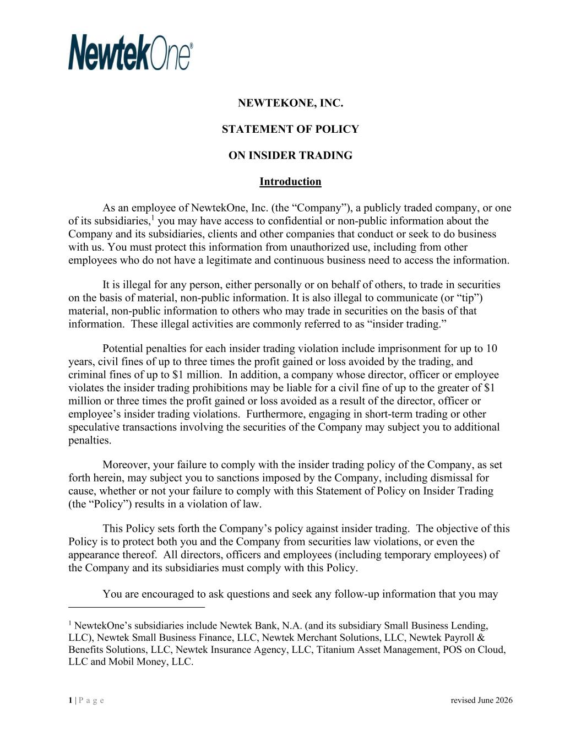
98
1 | P a g e revised June 2026 NEWTEKONE, INC. STATEMENT OF POLICY ON INSIDER TRADING Introduction As an employee of NewtekOne, Inc. (the “Company”), a publicly traded company, or one of its subsidiaries,1 you may have access to confidential or non-public information about the Company and its subsidiaries, clients and other companies that conduct or seek to do business with us. You must protect this information from unauthorized use, including from other employees who do not have a legitimate and continuous business need to access the information. It is illegal for any person, either personally or on behalf of others, to trade in securities on the basis of material, non-public information. It is also illegal to communicate (or “tip”) material, non-public information to others who may trade in securities on the basis of that information. These illegal activities are commonly referred to as “insider trading.” Potential penalties for each insider trading violation include imprisonment for up to 10 years, civil fines of up to three times the profit gained or loss avoided by the trading, and criminal fines of up to $1 million. In addition, a company whose director, officer or employee violates the insider trading prohibitions may be liable for a civil fine of up to the greater of $1 million or three times the profit gained or loss avoided as a result of the director, officer or employee’s insider trading violations. Furthermore, engaging in short-term trading or other speculative transactions involving the securities of the Company may subject you to additional penalties. Moreover, your failure to comply with the insider trading policy of the Company, as set forth herein, may subject you to sanctions imposed by the Company, including dismissal for cause, whether or not your failure to comply with this Statement of Policy on Insider Trading (the “Policy”) results in a violation of law. This Policy sets forth the Company’s policy against insider trading. The objective of this Policy is to protect both you and the Company from securities law violations, or even the appearance thereof. All directors, officers and employees (including temporary employees) of the Company and its subsidiaries must comply with this Policy. You are encouraged to ask questions and seek any follow-up information that you may 1 NewtekOne’s subsidiaries include Newtek Bank, N.A. (and its subsidiary Small Business Lending, LLC), Newtek Small Business Finance, LLC, Newtek Merchant Solutions, LLC, Newtek Payroll & Benefits Solutions, LLC, Newtek Insurance Agency, LLC, Titanium Asset Management, POS on Cloud, LLC and Mobil Money, LLC.

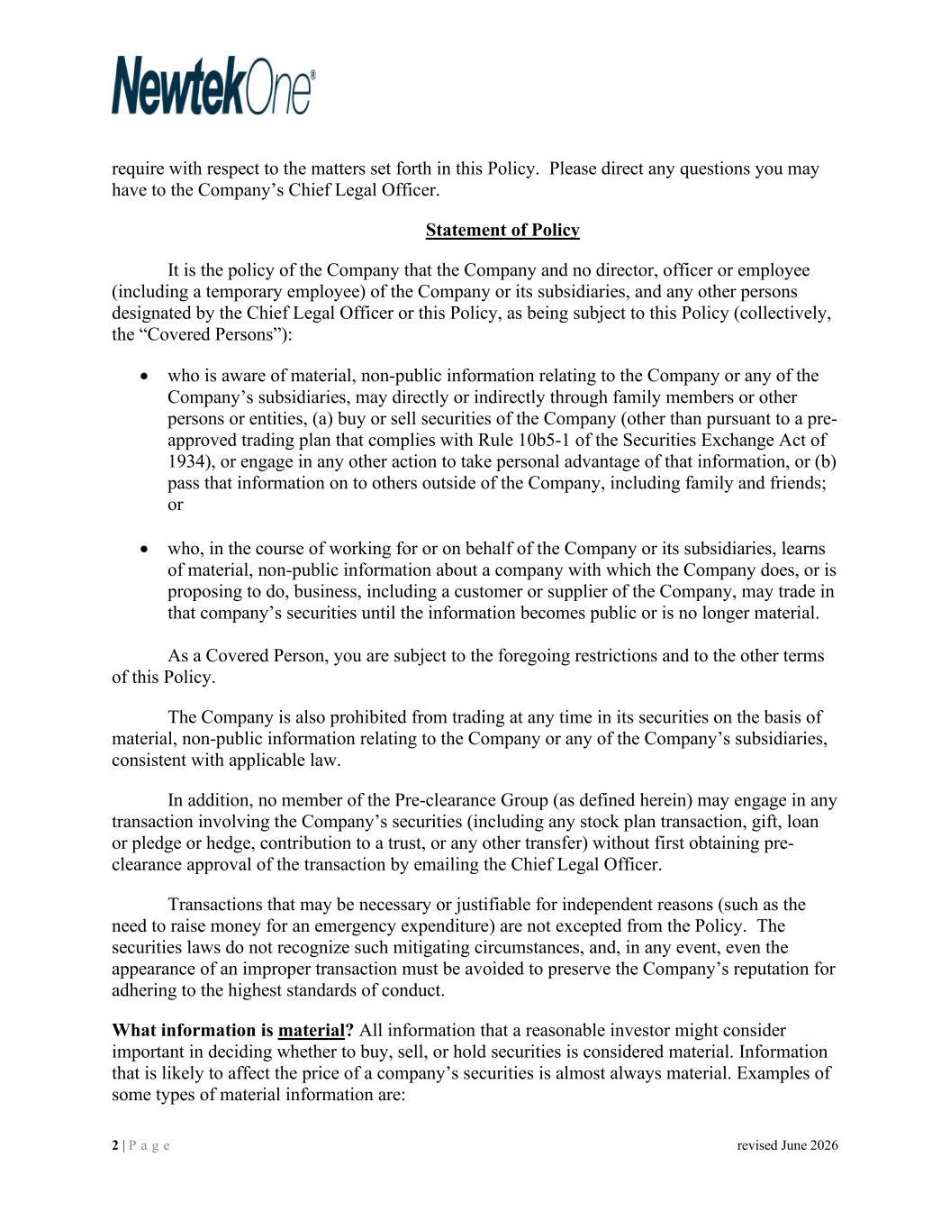
2 | P a g e revised June 2026 require with respect to the matters set forth in this Policy. Please direct any questions you may have to the Company’s Chief Legal Officer. Statement of Policy It is the policy of the Company that the Company and no director, officer or employee (including a temporary employee) of the Company or its subsidiaries, and any other persons designated by the Chief Legal Officer or this Policy, as being subject to this Policy (collectively, the “Covered Persons”): • who is aware of material, non-public information relating to the Company or any of the Company’s subsidiaries, may directly or indirectly through family members or other persons or entities, (a) buy or sell securities of the Company (other than pursuant to a pre- approved trading plan that complies with Rule 10b5-1 of the Securities Exchange Act of 1934), or engage in any other action to take personal advantage of that information, or (b) pass that information on to others outside of the Company, including family and friends; or • who, in the course of working for or on behalf of the Company or its subsidiaries, learns of material, non-public information about a company with which the Company does, or is proposing to do, business, including a customer or supplier of the Company, may trade in that company’s securities until the information becomes public or is no longer material. As a Covered Person, you are subject to the foregoing restrictions and to the other terms of this Policy. The Company is also prohibited from trading at any time in its securities on the basis of material, non-public information relating to the Company or any of the Company’s subsidiaries, consistent with applicable law. In addition, no member of the Pre-clearance Group (as defined herein) may engage in any transaction involving the Company’s securities (including any stock plan transaction, gift, loan or pledge or hedge, contribution to a trust, or any other transfer) without first obtaining pre- clearance approval of the transaction by emailing the Chief Legal Officer. Transactions that may be necessary or justifiable for independent reasons (such as the need to raise money for an emergency expenditure) are not excepted from the Policy. The securities laws do not recognize such mitigating circumstances, and, in any event, even the appearance of an improper transaction must be avoided to preserve the Company’s reputation for adhering to the highest standards of conduct. What information is material? All information that a reasonable investor might consider important in deciding whether to buy, sell, or hold securities is considered material. Information that is likely to affect the price of a company’s securities is almost always material. Examples of some types of material information are:

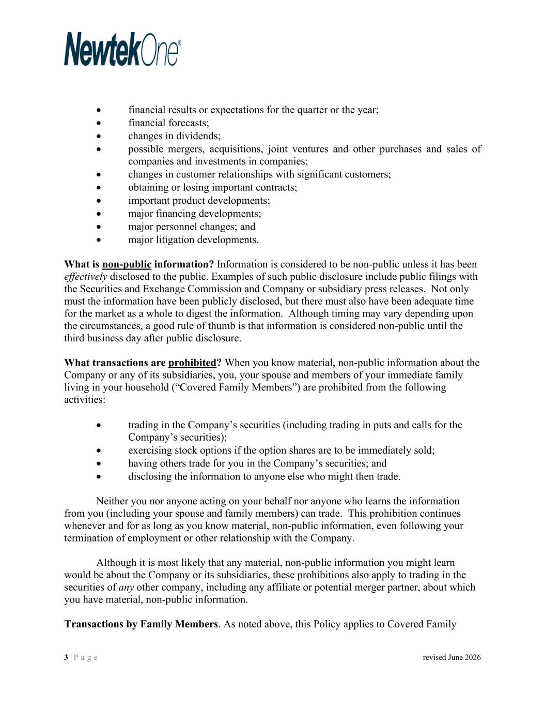
3 | P a g e revised June 2026 • financial results or expectations for the quarter or the year; • financial forecasts; • changes in dividends; • possible mergers, acquisitions, joint ventures and other purchases and sales of companies and investments in companies; • changes in customer relationships with significant customers; • obtaining or losing important contracts; • important product developments; • major financing developments; • major personnel changes; and • major litigation developments. What is non-public information? Information is considered to be non-public unless it has been effectively disclosed to the public. Examples of such public disclosure include public filings with the Securities and Exchange Commission and Company or subsidiary press releases. Not only must the information have been publicly disclosed, but there must also have been adequate time for the market as a whole to digest the information. Although timing may vary depending upon the circumstances, a good rule of thumb is that information is considered non-public until the third business day after public disclosure. What transactions are prohibited? When you know material, non-public information about the Company or any of its subsidiaries, you, your spouse and members of your immediate family living in your household (“Covered Family Members”) are prohibited from the following activities: • trading in the Company’s securities (including trading in puts and calls for the Company’s securities); • exercising stock options if the option shares are to be immediately sold; • having others trade for you in the Company’s securities; and • disclosing the information to anyone else who might then trade. Neither you nor anyone acting on your behalf nor anyone who learns the information from you (including your spouse and family members) can trade. This prohibition continues whenever and for as long as you know material, non-public information, even following your termination of employment or other relationship with the Company. Although it is most likely that any material, non-public information you might learn would be about the Company or its subsidiaries, these prohibitions also apply to trading in the securities of any other company, including any affiliate or potential merger partner, about which you have material, non-public information. Transactions by Family Members. As noted above, this Policy applies to Covered Family

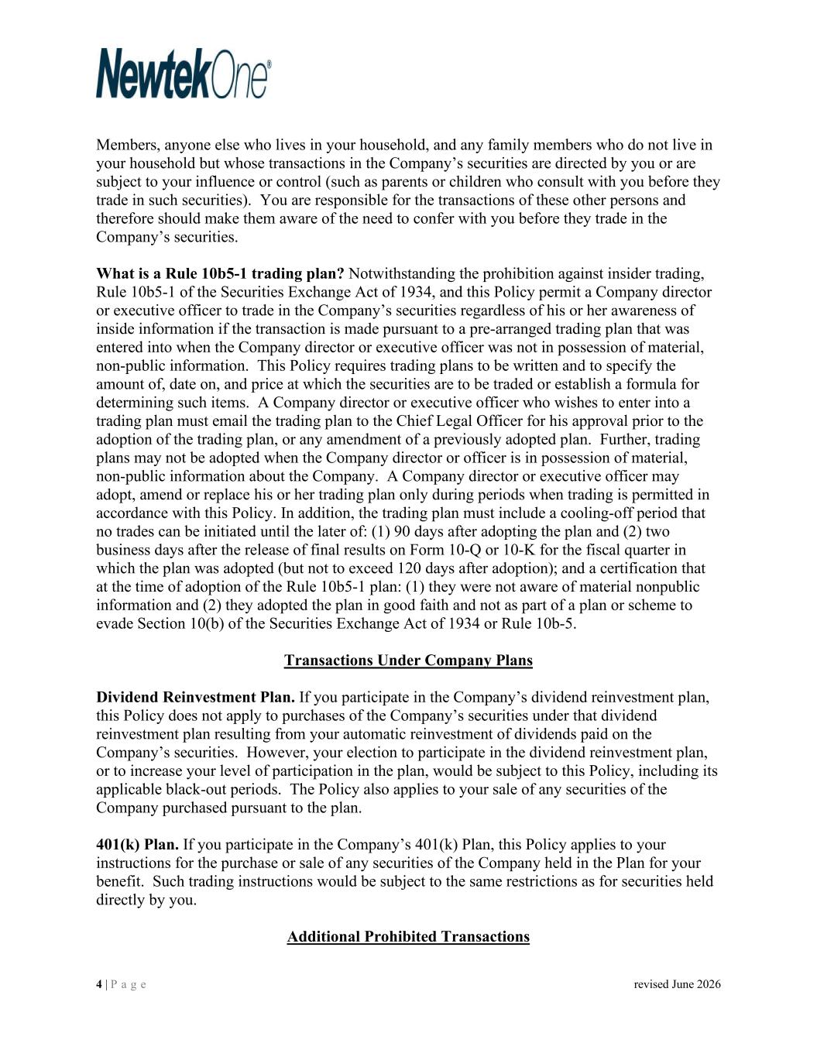
4 | P a g e revised June 2026 Members, anyone else who lives in your household, and any family members who do not live in your household but whose transactions in the Company’s securities are directed by you or are subject to your influence or control (such as parents or children who consult with you before they trade in such securities). You are responsible for the transactions of these other persons and therefore should make them aware of the need to confer with you before they trade in the Company’s securities. What is a Rule 10b5-1 trading plan? Notwithstanding the prohibition against insider trading, Rule 10b5-1 of the Securities Exchange Act of 1934, and this Policy permit a Company director or executive officer to trade in the Company’s securities regardless of his or her awareness of inside information if the transaction is made pursuant to a pre-arranged trading plan that was entered into when the Company director or executive officer was not in possession of material, non-public information. This Policy requires trading plans to be written and to specify the amount of, date on, and price at which the securities are to be traded or establish a formula for determining such items. A Company director or executive officer who wishes to enter into a trading plan must email the trading plan to the Chief Legal Officer for his approval prior to the adoption of the trading plan, or any amendment of a previously adopted plan. Further, trading plans may not be adopted when the Company director or officer is in possession of material, non-public information about the Company. A Company director or executive officer may adopt, amend or replace his or her trading plan only during periods when trading is permitted in accordance with this Policy. In addition, the trading plan must include a cooling-off period that no trades can be initiated until the later of: (1) 90 days after adopting the plan and (2) two business days after the release of final results on Form 10-Q or 10-K for the fiscal quarter in which the plan was adopted (but not to exceed 120 days after adoption); and a certification that at the time of adoption of the Rule 10b5-1 plan: (1) they were not aware of material nonpublic information and (2) they adopted the plan in good faith and not as part of a plan or scheme to evade Section 10(b) of the Securities Exchange Act of 1934 or Rule 10b-5. Transactions Under Company Plans Dividend Reinvestment Plan. If you participate in the Company’s dividend reinvestment plan, this Policy does not apply to purchases of the Company’s securities under that dividend reinvestment plan resulting from your automatic reinvestment of dividends paid on the Company’s securities. However, your election to participate in the dividend reinvestment plan, or to increase your level of participation in the plan, would be subject to this Policy, including its applicable black-out periods. The Policy also applies to your sale of any securities of the Company purchased pursuant to the plan. 401(k) Plan. If you participate in the Company’s 401(k) Plan, this Policy applies to your instructions for the purchase or sale of any securities of the Company held in the Plan for your benefit. Such trading instructions would be subject to the same restrictions as for securities held directly by you. Additional Prohibited Transactions

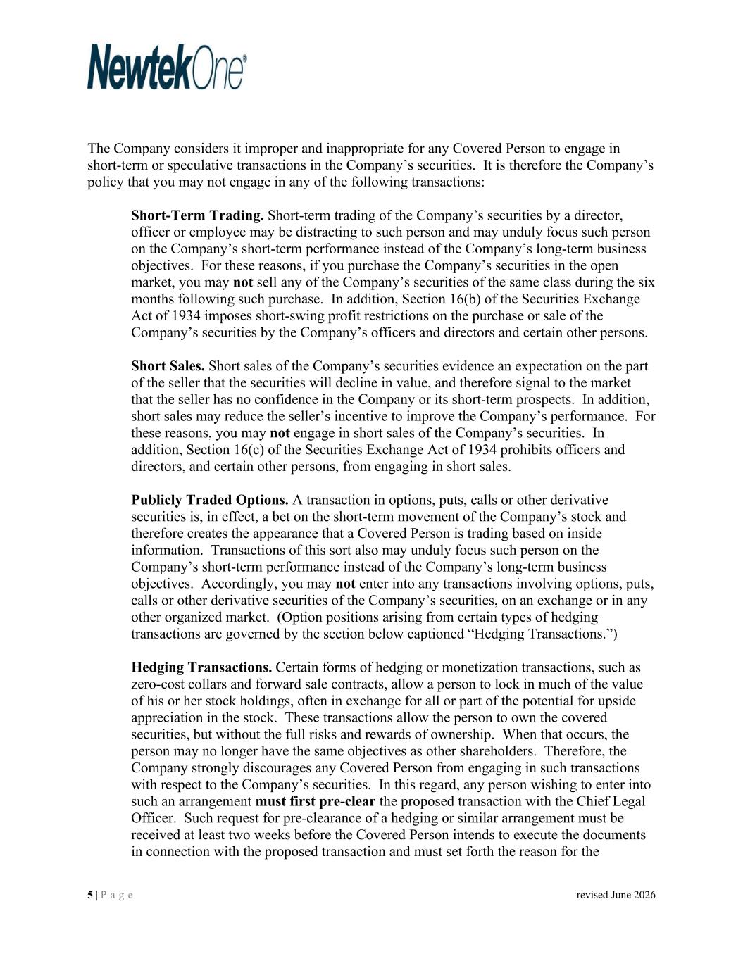
5 | P a g e revised June 2026 The Company considers it improper and inappropriate for any Covered Person to engage in short-term or speculative transactions in the Company’s securities. It is therefore the Company’s policy that you may not engage in any of the following transactions: Short-Term Trading. Short-term trading of the Company’s securities by a director, officer or employee may be distracting to such person and may unduly focus such person on the Company’s short-term performance instead of the Company’s long-term business objectives. For these reasons, if you purchase the Company’s securities in the open market, you may not sell any of the Company’s securities of the same class during the six months following such purchase. In addition, Section 16(b) of the Securities Exchange Act of 1934 imposes short-swing profit restrictions on the purchase or sale of the Company’s securities by the Company’s officers and directors and certain other persons. Short Sales. Short sales of the Company’s securities evidence an expectation on the part of the seller that the securities will decline in value, and therefore signal to the market that the seller has no confidence in the Company or its short-term prospects. In addition, short sales may reduce the seller’s incentive to improve the Company’s performance. For these reasons, you may not engage in short sales of the Company’s securities. In addition, Section 16(c) of the Securities Exchange Act of 1934 prohibits officers and directors, and certain other persons, from engaging in short sales. Publicly Traded Options. A transaction in options, puts, calls or other derivative securities is, in effect, a bet on the short-term movement of the Company’s stock and therefore creates the appearance that a Covered Person is trading based on inside information. Transactions of this sort also may unduly focus such person on the Company’s short-term performance instead of the Company’s long-term business objectives. Accordingly, you may not enter into any transactions involving options, puts, calls or other derivative securities of the Company’s securities, on an exchange or in any other organized market. (Option positions arising from certain types of hedging transactions are governed by the section below captioned “Hedging Transactions.”) Hedging Transactions. Certain forms of hedging or monetization transactions, such as zero-cost collars and forward sale contracts, allow a person to lock in much of the value of his or her stock holdings, often in exchange for all or part of the potential for upside appreciation in the stock. These transactions allow the person to own the covered securities, but without the full risks and rewards of ownership. When that occurs, the person may no longer have the same objectives as other shareholders. Therefore, the Company strongly discourages any Covered Person from engaging in such transactions with respect to the Company’s securities. In this regard, any person wishing to enter into such an arrangement must first pre-clear the proposed transaction with the Chief Legal Officer. Such request for pre-clearance of a hedging or similar arrangement must be received at least two weeks before the Covered Person intends to execute the documents in connection with the proposed transaction and must set forth the reason for the

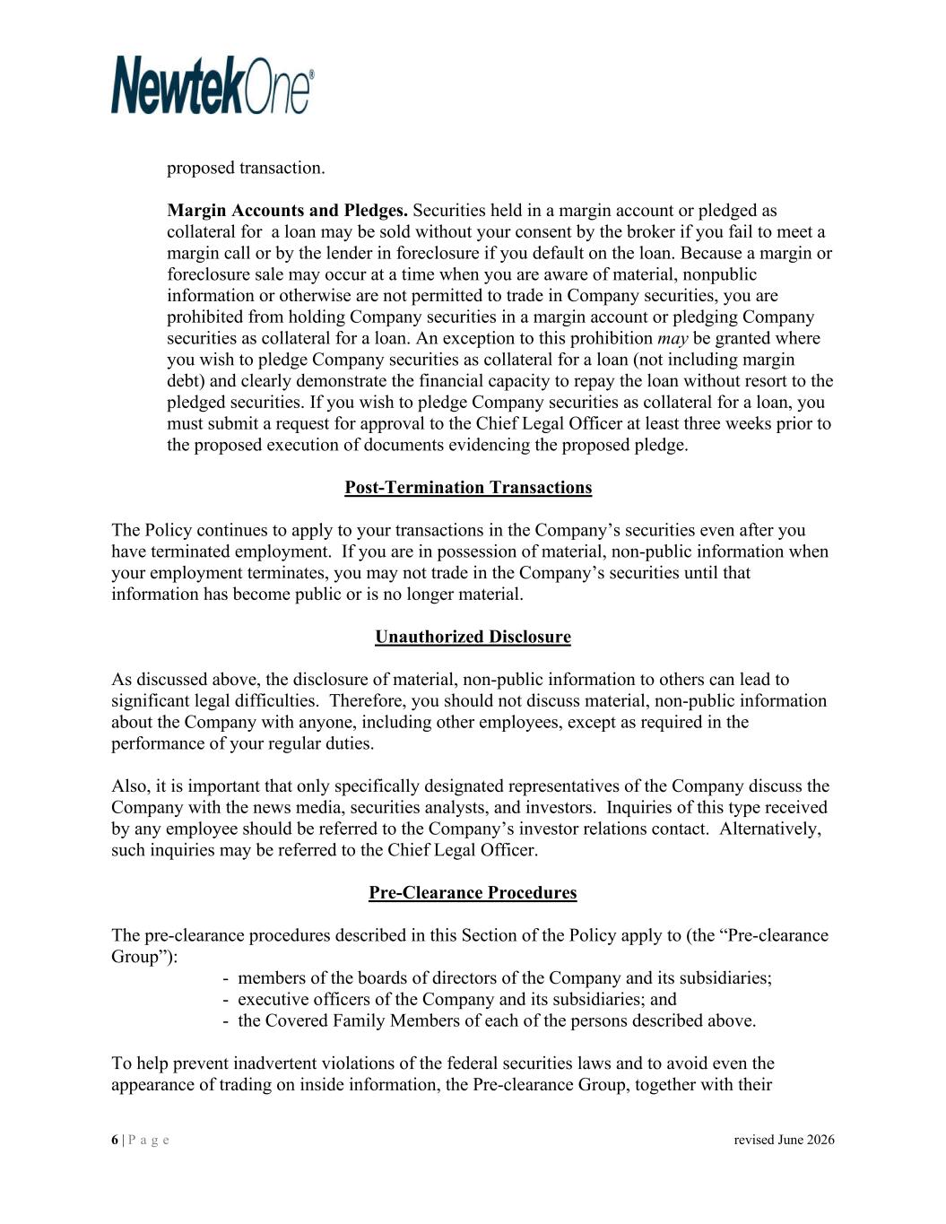
6 | P a g e revised June 2026 proposed transaction. Margin Accounts and Pledges. Securities held in a margin account or pledged as collateral for a loan may be sold without your consent by the broker if you fail to meet a margin call or by the lender in foreclosure if you default on the loan. Because a margin or foreclosure sale may occur at a time when you are aware of material, nonpublic information or otherwise are not permitted to trade in Company securities, you are prohibited from holding Company securities in a margin account or pledging Company securities as collateral for a loan. An exception to this prohibition may be granted where you wish to pledge Company securities as collateral for a loan (not including margin debt) and clearly demonstrate the financial capacity to repay the loan without resort to the pledged securities. If you wish to pledge Company securities as collateral for a loan, you must submit a request for approval to the Chief Legal Officer at least three weeks prior to the proposed execution of documents evidencing the proposed pledge. Post-Termination Transactions The Policy continues to apply to your transactions in the Company’s securities even after you have terminated employment. If you are in possession of material, non-public information when your employment terminates, you may not trade in the Company’s securities until that information has become public or is no longer material. Unauthorized Disclosure As discussed above, the disclosure of material, non-public information to others can lead to significant legal difficulties. Therefore, you should not discuss material, non-public information about the Company with anyone, including other employees, except as required in the performance of your regular duties. Also, it is important that only specifically designated representatives of the Company discuss the Company with the news media, securities analysts, and investors. Inquiries of this type received by any employee should be referred to the Company’s investor relations contact. Alternatively, such inquiries may be referred to the Chief Legal Officer. Pre-Clearance Procedures The pre-clearance procedures described in this Section of the Policy apply to (the “Pre-clearance Group”): - members of the boards of directors of the Company and its subsidiaries; - executive officers of the Company and its subsidiaries; and - the Covered Family Members of each of the persons described above. To help prevent inadvertent violations of the federal securities laws and to avoid even the appearance of trading on inside information, the Pre-clearance Group, together with their

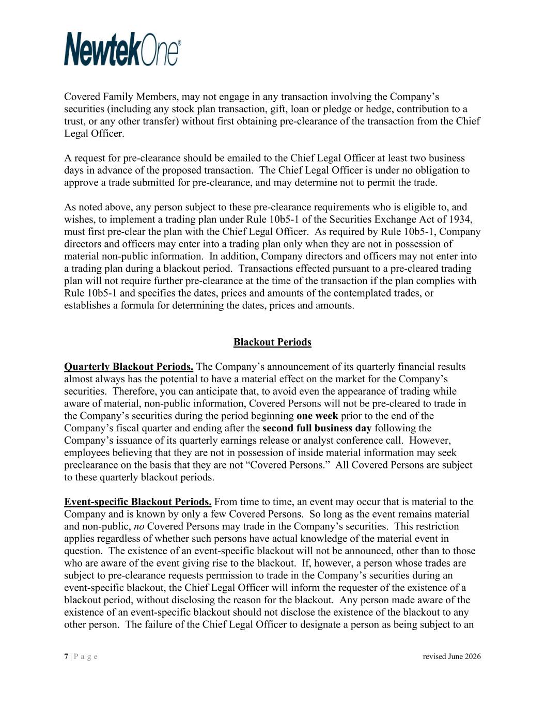
7 | P a g e revised June 2026 Covered Family Members, may not engage in any transaction involving the Company’s securities (including any stock plan transaction, gift, loan or pledge or hedge, contribution to a trust, or any other transfer) without first obtaining pre-clearance of the transaction from the Chief Legal Officer. A request for pre-clearance should be emailed to the Chief Legal Officer at least two business days in advance of the proposed transaction. The Chief Legal Officer is under no obligation to approve a trade submitted for pre-clearance, and may determine not to permit the trade. As noted above, any person subject to these pre-clearance requirements who is eligible to, and wishes, to implement a trading plan under Rule 10b5-1 of the Securities Exchange Act of 1934, must first pre-clear the plan with the Chief Legal Officer. As required by Rule 10b5-1, Company directors and officers may enter into a trading plan only when they are not in possession of material non-public information. In addition, Company directors and officers may not enter into a trading plan during a blackout period. Transactions effected pursuant to a pre-cleared trading plan will not require further pre-clearance at the time of the transaction if the plan complies with Rule 10b5-1 and specifies the dates, prices and amounts of the contemplated trades, or establishes a formula for determining the dates, prices and amounts. Blackout Periods Quarterly Blackout Periods. The Company’s announcement of its quarterly financial results almost always has the potential to have a material effect on the market for the Company’s securities. Therefore, you can anticipate that, to avoid even the appearance of trading while aware of material, non-public information, Covered Persons will not be pre-cleared to trade in the Company’s securities during the period beginning one week prior to the end of the Company’s fiscal quarter and ending after the second full business day following the Company’s issuance of its quarterly earnings release or analyst conference call. However, employees believing that they are not in possession of inside material information may seek preclearance on the basis that they are not “Covered Persons.” All Covered Persons are subject to these quarterly blackout periods. Event-specific Blackout Periods. From time to time, an event may occur that is material to the Company and is known by only a few Covered Persons. So long as the event remains material and non-public, no Covered Persons may trade in the Company’s securities. This restriction applies regardless of whether such persons have actual knowledge of the material event in question. The existence of an event-specific blackout will not be announced, other than to those who are aware of the event giving rise to the blackout. If, however, a person whose trades are subject to pre-clearance requests permission to trade in the Company’s securities during an event-specific blackout, the Chief Legal Officer will inform the requester of the existence of a blackout period, without disclosing the reason for the blackout. Any person made aware of the existence of an event-specific blackout should not disclose the existence of the blackout to any other person. The failure of the Chief Legal Officer to designate a person as being subject to an

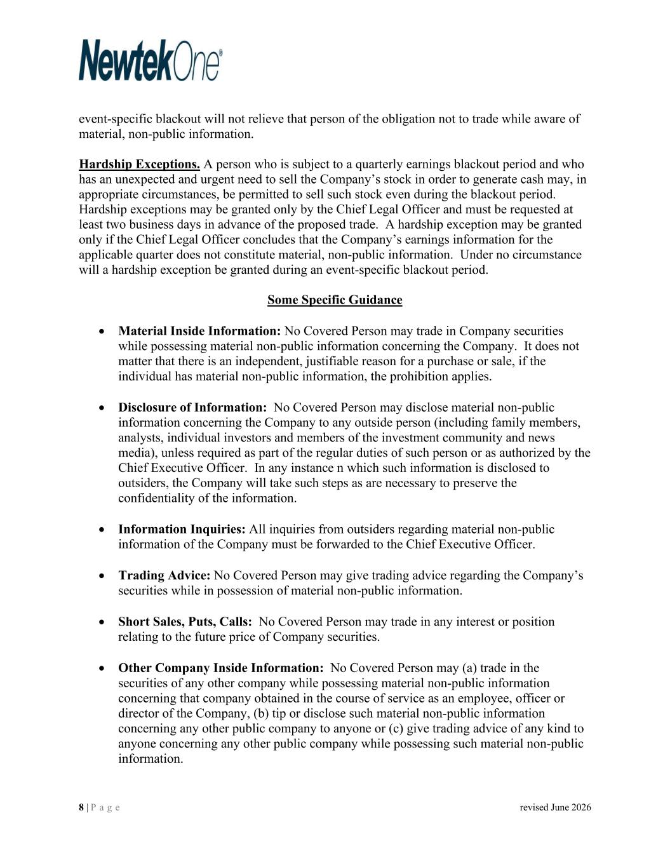
8 | P a g e revised June 2026 event-specific blackout will not relieve that person of the obligation not to trade while aware of material, non-public information. Hardship Exceptions. A person who is subject to a quarterly earnings blackout period and who has an unexpected and urgent need to sell the Company’s stock in order to generate cash may, in appropriate circumstances, be permitted to sell such stock even during the blackout period. Hardship exceptions may be granted only by the Chief Legal Officer and must be requested at least two business days in advance of the proposed trade. A hardship exception may be granted only if the Chief Legal Officer concludes that the Company’s earnings information for the applicable quarter does not constitute material, non-public information. Under no circumstance will a hardship exception be granted during an event-specific blackout period. Some Specific Guidance • Material Inside Information: No Covered Person may trade in Company securities while possessing material non-public information concerning the Company. It does not matter that there is an independent, justifiable reason for a purchase or sale, if the individual has material non-public information, the prohibition applies. • Disclosure of Information: No Covered Person may disclose material non-public information concerning the Company to any outside person (including family members, analysts, individual investors and members of the investment community and news media), unless required as part of the regular duties of such person or as authorized by the Chief Executive Officer. In any instance n which such information is disclosed to outsiders, the Company will take such steps as are necessary to preserve the confidentiality of the information. • Information Inquiries: All inquiries from outsiders regarding material non-public information of the Company must be forwarded to the Chief Executive Officer. • Trading Advice: No Covered Person may give trading advice regarding the Company’s securities while in possession of material non-public information. • Short Sales, Puts, Calls: No Covered Person may trade in any interest or position relating to the future price of Company securities. • Other Company Inside Information: No Covered Person may (a) trade in the securities of any other company while possessing material non-public information concerning that company obtained in the course of service as an employee, officer or director of the Company, (b) tip or disclose such material non-public information concerning any other public company to anyone or (c) give trading advice of any kind to anyone concerning any other public company while possessing such material non-public information.

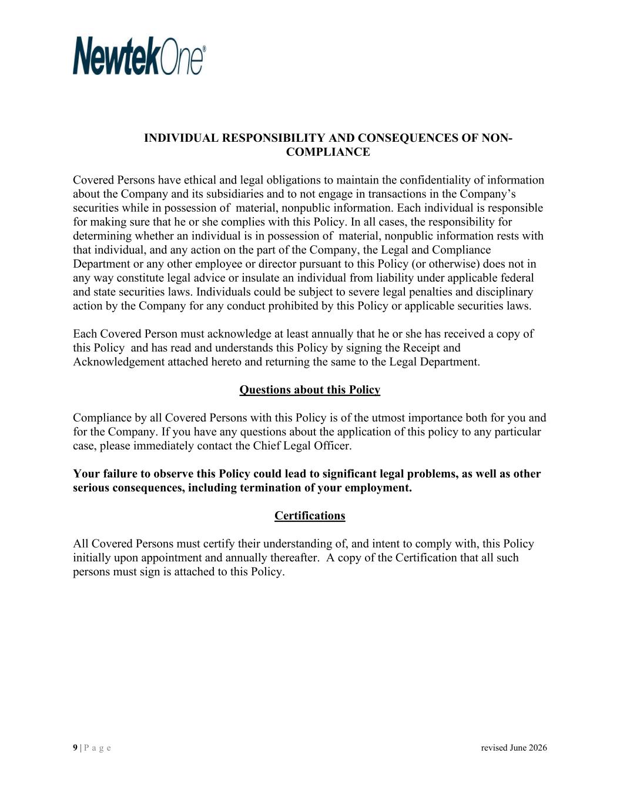
9 | P a g e revised June 2026 INDIVIDUAL RESPONSIBILITY AND CONSEQUENCES OF NON- COMPLIANCE Covered Persons have ethical and legal obligations to maintain the confidentiality of information about the Company and its subsidiaries and to not engage in transactions in the Company’s securities while in possession of material, nonpublic information. Each individual is responsible for making sure that he or she complies with this Policy. In all cases, the responsibility for determining whether an individual is in possession of material, nonpublic information rests with that individual, and any action on the part of the Company, the Legal and Compliance Department or any other employee or director pursuant to this Policy (or otherwise) does not in any way constitute legal advice or insulate an individual from liability under applicable federal and state securities laws. Individuals could be subject to severe legal penalties and disciplinary action by the Company for any conduct prohibited by this Policy or applicable securities laws. Each Covered Person must acknowledge at least annually that he or she has received a copy of this Policy and has read and understands this Policy by signing the Receipt and Acknowledgement attached hereto and returning the same to the Legal Department. Questions about this Policy Compliance by all Covered Persons with this Policy is of the utmost importance both for you and for the Company. If you have any questions about the application of this policy to any particular case, please immediately contact the Chief Legal Officer. Your failure to observe this Policy could lead to significant legal problems, as well as other serious consequences, including termination of your employment. Certifications All Covered Persons must certify their understanding of, and intent to comply with, this Policy initially upon appointment and annually thereafter. A copy of the Certification that all such persons must sign is attached to this Policy.


10 | P a g e revised June 2026 NEWTEKONE, INC. CERTIFICATION STATEMENT OF POLICY ON INSIDER TRADING This Certification must be signed and returned to the Company’s Human Resources department, and will be retained as part of your permanent personnel file. I hereby certify that I have received a copy of NewtekOne, Inc.’s Statement of Policy on Insider Trading, read it, and understand that the Statement of Policy on Insider Trading contains the expectations of NewtekOne. Inc. and its subsidiaries regarding my conduct. Furthermore, I agree to comply with the Statement of Policy on Insider Trading. Name (Printed) Signature Date The failure to read and sign this acknowledgment in no way relieves you of the responsibility to comply with NewtekOne, Inc.’s Statement of Policy on Insider Trading.

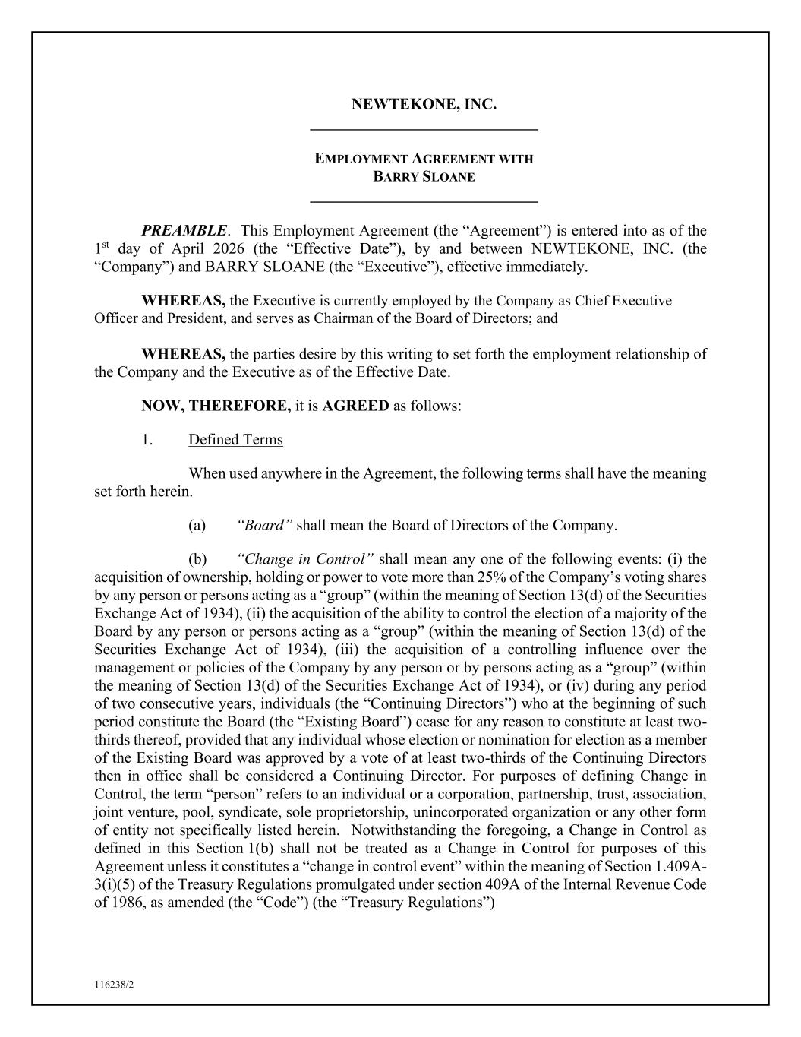
116238/2 NEWTEKONE, INC. _____________________________ EMPLOYMENT AGREEMENT WITH BARRY SLOANE _____________________________ PREAMBLE. This Employment Agreement (the “Agreement”) is entered into as of the 1st day of April 2026 (the “Effective Date”), by and between NEWTEKONE, INC. (the “Company”) and BARRY SLOANE (the “Executive”), effective immediately. WHEREAS, the Executive is currently employed by the Company as Chief Executive Officer and President, and serves as Chairman of the Board of Directors; and WHEREAS, the parties desire by this writing to set forth the employment relationship of the Company and the Executive as of the Effective Date. NOW, THEREFORE, it is AGREED as follows: 1. Defined Terms When used anywhere in the Agreement, the following terms shall have the meaning set forth herein. (a) “Board” shall mean the Board of Directors of the Company. (b) “Change in Control” shall mean any one of the following events: (i) the acquisition of ownership, holding or power to vote more than 25% of the Company’s voting shares by any person or persons acting as a “group” (within the meaning of Section 13(d) of the Securities Exchange Act of 1934), (ii) the acquisition of the ability to control the election of a majority of the Board by any person or persons acting as a “group” (within the meaning of Section 13(d) of the Securities Exchange Act of 1934), (iii) the acquisition of a controlling influence over the management or policies of the Company by any person or by persons acting as a “group” (within the meaning of Section 13(d) of the Securities Exchange Act of 1934), or (iv) during any period of two consecutive years, individuals (the “Continuing Directors”) who at the beginning of such period constitute the Board (the “Existing Board”) cease for any reason to constitute at least two- thirds thereof, provided that any individual whose election or nomination for election as a member of the Existing Board was approved by a vote of at least two-thirds of the Continuing Directors then in office shall be considered a Continuing Director. For purposes of defining Change in Control, the term “person” refers to an individual or a corporation, partnership, trust, association, joint venture, pool, syndicate, sole proprietorship, unincorporated organization or any other form of entity not specifically listed herein. Notwithstanding the foregoing, a Change in Control as defined in this Section 1(b) shall not be treated as a Change in Control for purposes of this Agreement unless it constitutes a “change in control event” within the meaning of Section 1.409A- 3(i)(5) of the Treasury Regulations promulgated under section 409A of the Internal Revenue Code of 1986, as amended (the “Code”) (the “Treasury Regulations”)

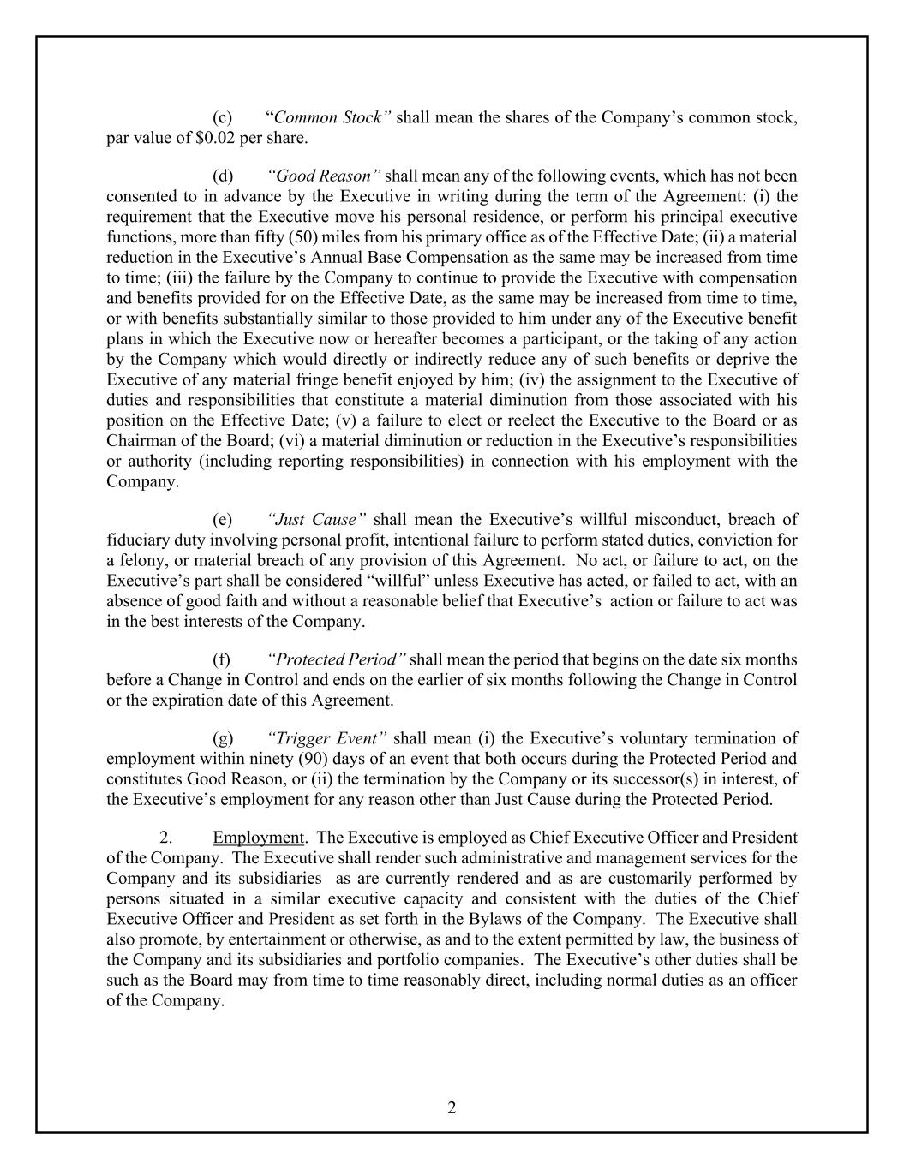
2 (c) “Common Stock” shall mean the shares of the Company’s common stock, par value of $0.02 per share. (d) “Good Reason” shall mean any of the following events, which has not been consented to in advance by the Executive in writing during the term of the Agreement: (i) the requirement that the Executive move his personal residence, or perform his principal executive functions, more than fifty (50) miles from his primary office as of the Effective Date; (ii) a material reduction in the Executive’s Annual Base Compensation as the same may be increased from time to time; (iii) the failure by the Company to continue to provide the Executive with compensation and benefits provided for on the Effective Date, as the same may be increased from time to time, or with benefits substantially similar to those provided to him under any of the Executive benefit plans in which the Executive now or hereafter becomes a participant, or the taking of any action by the Company which would directly or indirectly reduce any of such benefits or deprive the Executive of any material fringe benefit enjoyed by him; (iv) the assignment to the Executive of duties and responsibilities that constitute a material diminution from those associated with his position on the Effective Date; (v) a failure to elect or reelect the Executive to the Board or as Chairman of the Board; (vi) a material diminution or reduction in the Executive’s responsibilities or authority (including reporting responsibilities) in connection with his employment with the Company. (e) “Just Cause” shall mean the Executive’s willful misconduct, breach of fiduciary duty involving personal profit, intentional failure to perform stated duties, conviction for a felony, or material breach of any provision of this Agreement. No act, or failure to act, on the Executive’s part shall be considered “willful” unless Executive has acted, or failed to act, with an absence of good faith and without a reasonable belief that Executive’s action or failure to act was in the best interests of the Company. (f) “Protected Period” shall mean the period that begins on the date six months before a Change in Control and ends on the earlier of six months following the Change in Control or the expiration date of this Agreement. (g) “Trigger Event” shall mean (i) the Executive’s voluntary termination of employment within ninety (90) days of an event that both occurs during the Protected Period and constitutes Good Reason, or (ii) the termination by the Company or its successor(s) in interest, of the Executive’s employment for any reason other than Just Cause during the Protected Period. 2. Employment. The Executive is employed as Chief Executive Officer and President of the Company. The Executive shall render such administrative and management services for the Company and its subsidiaries as are currently rendered and as are customarily performed by persons situated in a similar executive capacity and consistent with the duties of the Chief Executive Officer and President as set forth in the Bylaws of the Company. The Executive shall also promote, by entertainment or otherwise, as and to the extent permitted by law, the business of the Company and its subsidiaries and portfolio companies. The Executive’s other duties shall be such as the Board may from time to time reasonably direct, including normal duties as an officer of the Company.

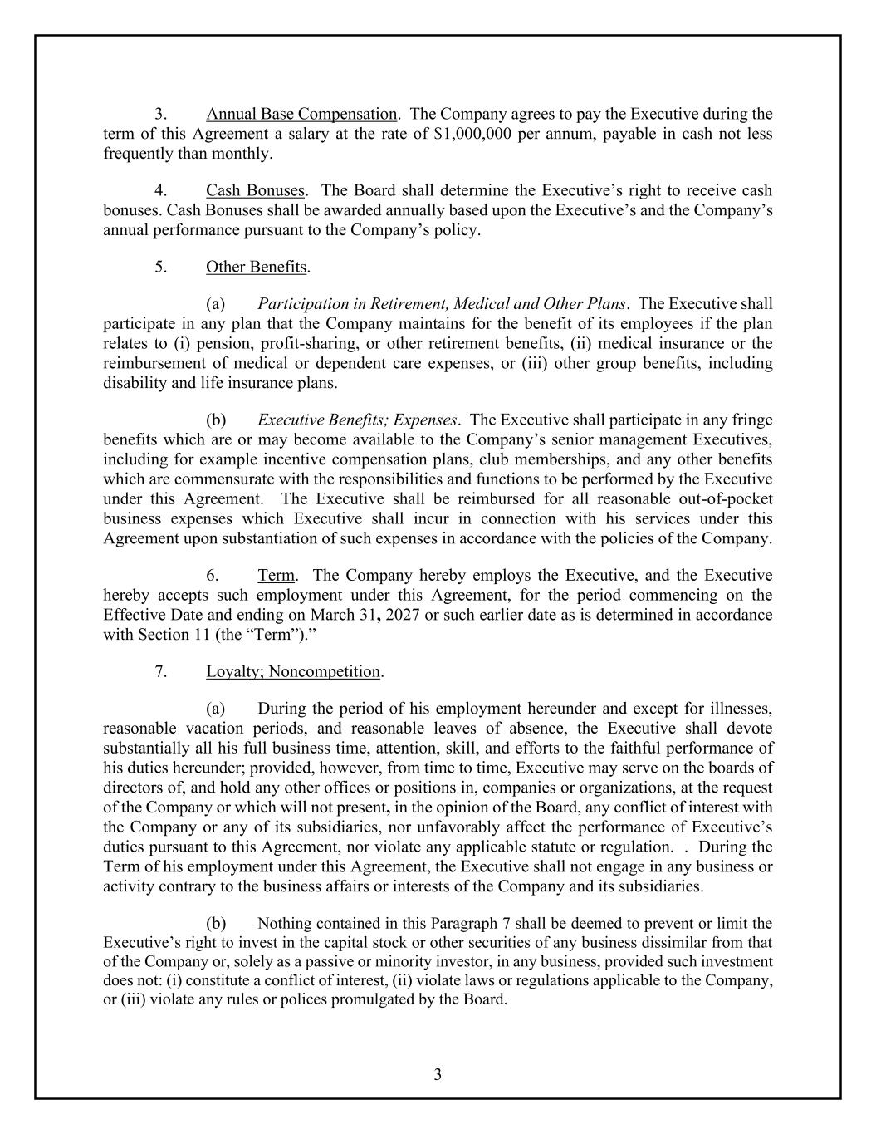
3 3. Annual Base Compensation. The Company agrees to pay the Executive during the term of this Agreement a salary at the rate of $1,000,000 per annum, payable in cash not less frequently than monthly. 4. Cash Bonuses. The Board shall determine the Executive’s right to receive cash bonuses. Cash Bonuses shall be awarded annually based upon the Executive’s and the Company’s annual performance pursuant to the Company’s policy. 5. Other Benefits. (a) Participation in Retirement, Medical and Other Plans. The Executive shall participate in any plan that the Company maintains for the benefit of its employees if the plan relates to (i) pension, profit-sharing, or other retirement benefits, (ii) medical insurance or the reimbursement of medical or dependent care expenses, or (iii) other group benefits, including disability and life insurance plans. (b) Executive Benefits; Expenses. The Executive shall participate in any fringe benefits which are or may become available to the Company’s senior management Executives, including for example incentive compensation plans, club memberships, and any other benefits which are commensurate with the responsibilities and functions to be performed by the Executive under this Agreement. The Executive shall be reimbursed for all reasonable out-of-pocket business expenses which Executive shall incur in connection with his services under this Agreement upon substantiation of such expenses in accordance with the policies of the Company. 6. Term. The Company hereby employs the Executive, and the Executive hereby accepts such employment under this Agreement, for the period commencing on the Effective Date and ending on March 31, 2027 or such earlier date as is determined in accordance with Section 11 (the “Term”).” 7. Loyalty; Noncompetition. (a) During the period of his employment hereunder and except for illnesses, reasonable vacation periods, and reasonable leaves of absence, the Executive shall devote substantially all his full business time, attention, skill, and efforts to the faithful performance of his duties hereunder; provided, however, from time to time, Executive may serve on the boards of directors of, and hold any other offices or positions in, companies or organizations, at the request of the Company or which will not present, in the opinion of the Board, any conflict of interest with the Company or any of its subsidiaries, nor unfavorably affect the performance of Executive’s duties pursuant to this Agreement, nor violate any applicable statute or regulation. . During the Term of his employment under this Agreement, the Executive shall not engage in any business or activity contrary to the business affairs or interests of the Company and its subsidiaries. (b) Nothing contained in this Paragraph 7 shall be deemed to prevent or limit the Executive’s right to invest in the capital stock or other securities of any business dissimilar from that of the Company or, solely as a passive or minority investor, in any business, provided such investment does not: (i) constitute a conflict of interest, (ii) violate laws or regulations applicable to the Company, or (iii) violate any rules or polices promulgated by the Board.

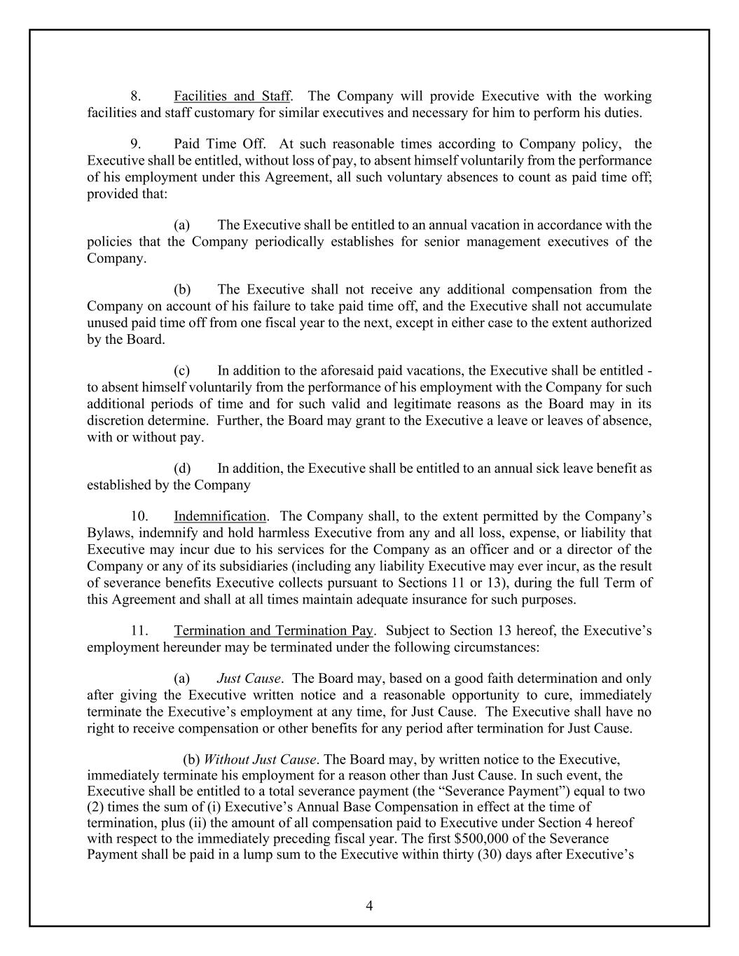
4 8. Facilities and Staff. The Company will provide Executive with the working facilities and staff customary for similar executives and necessary for him to perform his duties. 9. Paid Time Off. At such reasonable times according to Company policy, the Executive shall be entitled, without loss of pay, to absent himself voluntarily from the performance of his employment under this Agreement, all such voluntary absences to count as paid time off; provided that: (a) The Executive shall be entitled to an annual vacation in accordance with the policies that the Company periodically establishes for senior management executives of the Company. (b) The Executive shall not receive any additional compensation from the Company on account of his failure to take paid time off, and the Executive shall not accumulate unused paid time off from one fiscal year to the next, except in either case to the extent authorized by the Board. (c) In addition to the aforesaid paid vacations, the Executive shall be entitled - to absent himself voluntarily from the performance of his employment with the Company for such additional periods of time and for such valid and legitimate reasons as the Board may in its discretion determine. Further, the Board may grant to the Executive a leave or leaves of absence, with or without pay. (d) In addition, the Executive shall be entitled to an annual sick leave benefit as established by the Company 10. Indemnification. The Company shall, to the extent permitted by the Company’s Bylaws, indemnify and hold harmless Executive from any and all loss, expense, or liability that Executive may incur due to his services for the Company as an officer and or a director of the Company or any of its subsidiaries (including any liability Executive may ever incur, as the result of severance benefits Executive collects pursuant to Sections 11 or 13), during the full Term of this Agreement and shall at all times maintain adequate insurance for such purposes. 11. Termination and Termination Pay. Subject to Section 13 hereof, the Executive’s employment hereunder may be terminated under the following circumstances: (a) Just Cause. The Board may, based on a good faith determination and only after giving the Executive written notice and a reasonable opportunity to cure, immediately terminate the Executive’s employment at any time, for Just Cause. The Executive shall have no right to receive compensation or other benefits for any period after termination for Just Cause. (b) Without Just Cause. The Board may, by written notice to the Executive, immediately terminate his employment for a reason other than Just Cause. In such event, the Executive shall be entitled to a total severance payment (the “Severance Payment”) equal to two (2) times the sum of (i) Executive’s Annual Base Compensation in effect at the time of termination, plus (ii) the amount of all compensation paid to Executive under Section 4 hereof with respect to the immediately preceding fiscal year. The first $500,000 of the Severance Payment shall be paid in a lump sum to the Executive within thirty (30) days after Executive’s

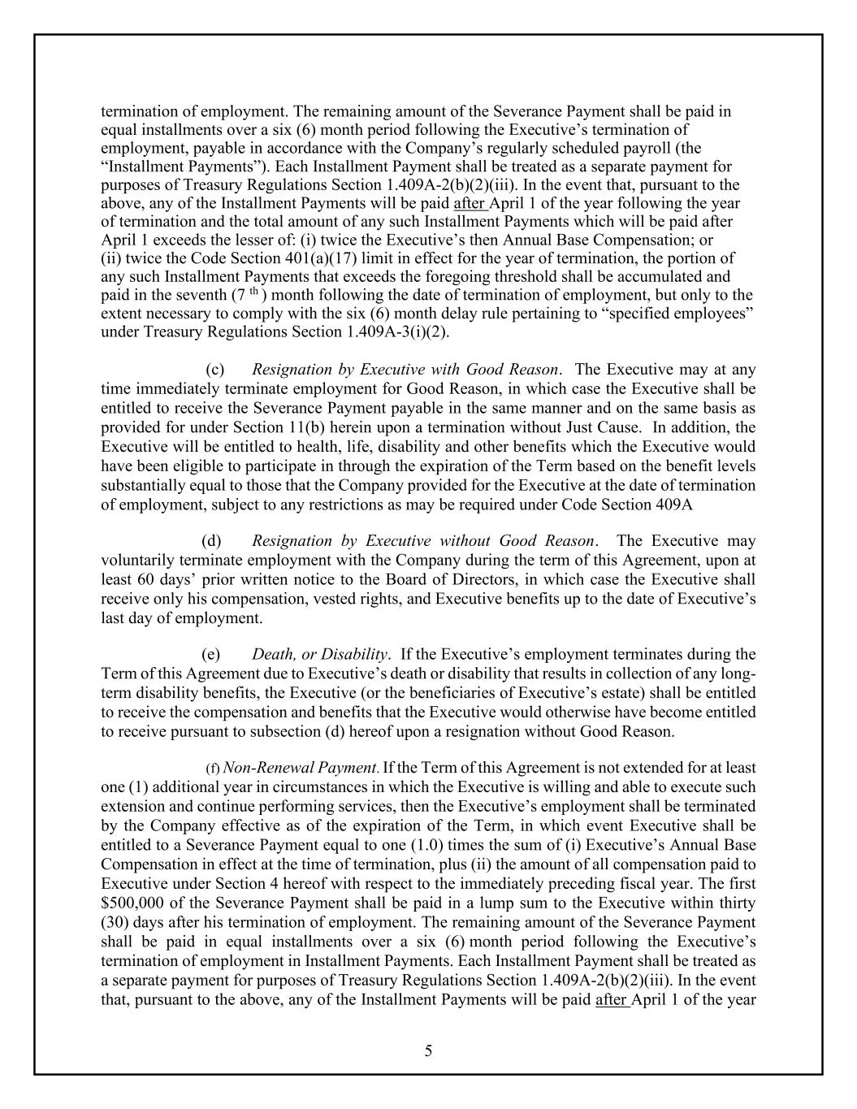
5 termination of employment. The remaining amount of the Severance Payment shall be paid in equal installments over a six (6) month period following the Executive’s termination of employment, payable in accordance with the Company’s regularly scheduled payroll (the “Installment Payments”). Each Installment Payment shall be treated as a separate payment for purposes of Treasury Regulations Section 1.409A-2(b)(2)(iii). In the event that, pursuant to the above, any of the Installment Payments will be paid after April 1 of the year following the year of termination and the total amount of any such Installment Payments which will be paid after April 1 exceeds the lesser of: (i) twice the Executive’s then Annual Base Compensation; or (ii) twice the Code Section 401(a)(17) limit in effect for the year of termination, the portion of any such Installment Payments that exceeds the foregoing threshold shall be accumulated and paid in the seventh (7 th ) month following the date of termination of employment, but only to the extent necessary to comply with the six (6) month delay rule pertaining to “specified employees” under Treasury Regulations Section 1.409A-3(i)(2). (c) Resignation by Executive with Good Reason. The Executive may at any time immediately terminate employment for Good Reason, in which case the Executive shall be entitled to receive the Severance Payment payable in the same manner and on the same basis as provided for under Section 11(b) herein upon a termination without Just Cause. In addition, the Executive will be entitled to health, life, disability and other benefits which the Executive would have been eligible to participate in through the expiration of the Term based on the benefit levels substantially equal to those that the Company provided for the Executive at the date of termination of employment, subject to any restrictions as may be required under Code Section 409A (d) Resignation by Executive without Good Reason. The Executive may voluntarily terminate employment with the Company during the term of this Agreement, upon at least 60 days’ prior written notice to the Board of Directors, in which case the Executive shall receive only his compensation, vested rights, and Executive benefits up to the date of Executive’s last day of employment. (e) Death, or Disability. If the Executive’s employment terminates during the Term of this Agreement due to Executive’s death or disability that results in collection of any long- term disability benefits, the Executive (or the beneficiaries of Executive’s estate) shall be entitled to receive the compensation and benefits that the Executive would otherwise have become entitled to receive pursuant to subsection (d) hereof upon a resignation without Good Reason. (f) Non-Renewal Payment. If the Term of this Agreement is not extended for at least one (1) additional year in circumstances in which the Executive is willing and able to execute such extension and continue performing services, then the Executive’s employment shall be terminated by the Company effective as of the expiration of the Term, in which event Executive shall be entitled to a Severance Payment equal to one (1.0) times the sum of (i) Executive’s Annual Base Compensation in effect at the time of termination, plus (ii) the amount of all compensation paid to Executive under Section 4 hereof with respect to the immediately preceding fiscal year. The first $500,000 of the Severance Payment shall be paid in a lump sum to the Executive within thirty (30) days after his termination of employment. The remaining amount of the Severance Payment shall be paid in equal installments over a six (6) month period following the Executive’s termination of employment in Installment Payments. Each Installment Payment shall be treated as a separate payment for purposes of Treasury Regulations Section 1.409A-2(b)(2)(iii). In the event that, pursuant to the above, any of the Installment Payments will be paid after April 1 of the year

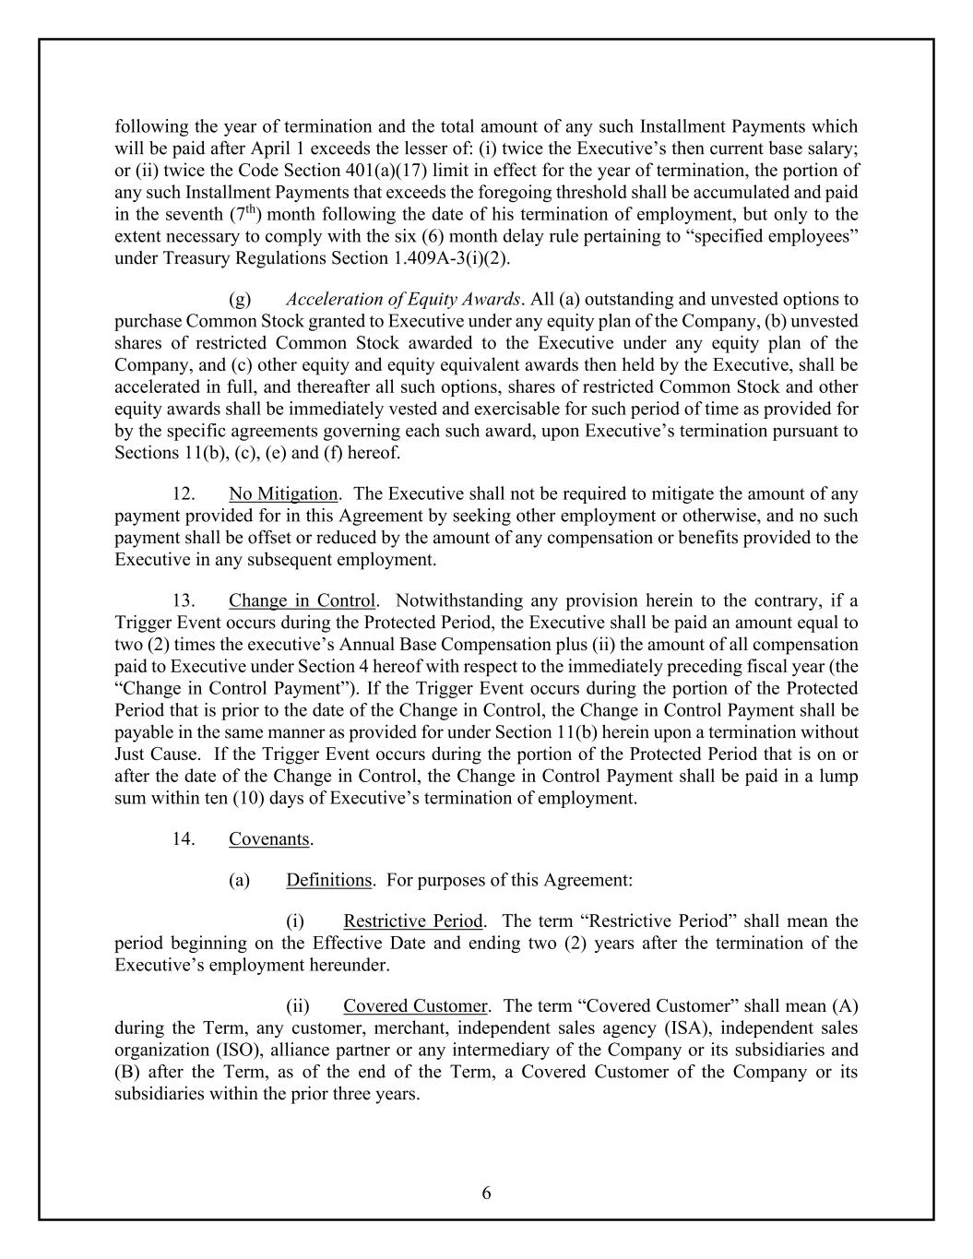
6 following the year of termination and the total amount of any such Installment Payments which will be paid after April 1 exceeds the lesser of: (i) twice the Executive’s then current base salary; or (ii) twice the Code Section 401(a)(17) limit in effect for the year of termination, the portion of any such Installment Payments that exceeds the foregoing threshold shall be accumulated and paid in the seventh (7th) month following the date of his termination of employment, but only to the extent necessary to comply with the six (6) month delay rule pertaining to “specified employees” under Treasury Regulations Section 1.409A-3(i)(2). (g) Acceleration of Equity Awards. All (a) outstanding and unvested options to purchase Common Stock granted to Executive under any equity plan of the Company, (b) unvested shares of restricted Common Stock awarded to the Executive under any equity plan of the Company, and (c) other equity and equity equivalent awards then held by the Executive, shall be accelerated in full, and thereafter all such options, shares of restricted Common Stock and other equity awards shall be immediately vested and exercisable for such period of time as provided for by the specific agreements governing each such award, upon Executive’s termination pursuant to Sections 11(b), (c), (e) and (f) hereof. 12. No Mitigation. The Executive shall not be required to mitigate the amount of any payment provided for in this Agreement by seeking other employment or otherwise, and no such payment shall be offset or reduced by the amount of any compensation or benefits provided to the Executive in any subsequent employment. 13. Change in Control. Notwithstanding any provision herein to the contrary, if a Trigger Event occurs during the Protected Period, the Executive shall be paid an amount equal to two (2) times the executive’s Annual Base Compensation plus (ii) the amount of all compensation paid to Executive under Section 4 hereof with respect to the immediately preceding fiscal year (the “Change in Control Payment”). If the Trigger Event occurs during the portion of the Protected Period that is prior to the date of the Change in Control, the Change in Control Payment shall be payable in the same manner as provided for under Section 11(b) herein upon a termination without Just Cause. If the Trigger Event occurs during the portion of the Protected Period that is on or after the date of the Change in Control, the Change in Control Payment shall be paid in a lump sum within ten (10) days of Executive’s termination of employment. 14. Covenants. (a) Definitions. For purposes of this Agreement: (i) Restrictive Period. The term “Restrictive Period” shall mean the period beginning on the Effective Date and ending two (2) years after the termination of the Executive’s employment hereunder. (ii) Covered Customer. The term “Covered Customer” shall mean (A) during the Term, any customer, merchant, independent sales agency (ISA), independent sales organization (ISO), alliance partner or any intermediary of the Company or its subsidiaries and (B) after the Term, as of the end of the Term, a Covered Customer of the Company or its subsidiaries within the prior three years.

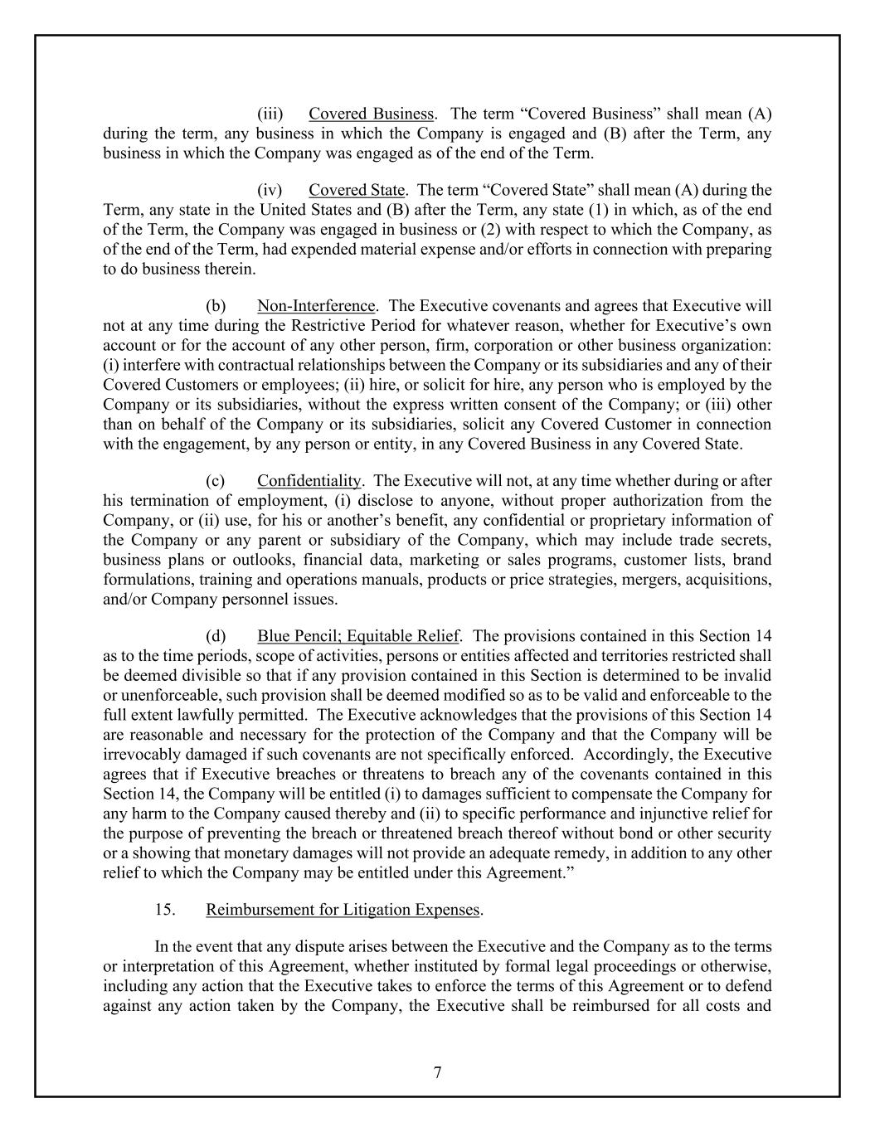
7 (iii) Covered Business. The term “Covered Business” shall mean (A) during the term, any business in which the Company is engaged and (B) after the Term, any business in which the Company was engaged as of the end of the Term. (iv) Covered State. The term “Covered State” shall mean (A) during the Term, any state in the United States and (B) after the Term, any state (1) in which, as of the end of the Term, the Company was engaged in business or (2) with respect to which the Company, as of the end of the Term, had expended material expense and/or efforts in connection with preparing to do business therein. (b) Non-Interference. The Executive covenants and agrees that Executive will not at any time during the Restrictive Period for whatever reason, whether for Executive’s own account or for the account of any other person, firm, corporation or other business organization: (i) interfere with contractual relationships between the Company or its subsidiaries and any of their Covered Customers or employees; (ii) hire, or solicit for hire, any person who is employed by the Company or its subsidiaries, without the express written consent of the Company; or (iii) other than on behalf of the Company or its subsidiaries, solicit any Covered Customer in connection with the engagement, by any person or entity, in any Covered Business in any Covered State. (c) Confidentiality. The Executive will not, at any time whether during or after his termination of employment, (i) disclose to anyone, without proper authorization from the Company, or (ii) use, for his or another’s benefit, any confidential or proprietary information of the Company or any parent or subsidiary of the Company, which may include trade secrets, business plans or outlooks, financial data, marketing or sales programs, customer lists, brand formulations, training and operations manuals, products or price strategies, mergers, acquisitions, and/or Company personnel issues. (d) Blue Pencil; Equitable Relief. The provisions contained in this Section 14 as to the time periods, scope of activities, persons or entities affected and territories restricted shall be deemed divisible so that if any provision contained in this Section is determined to be invalid or unenforceable, such provision shall be deemed modified so as to be valid and enforceable to the full extent lawfully permitted. The Executive acknowledges that the provisions of this Section 14 are reasonable and necessary for the protection of the Company and that the Company will be irrevocably damaged if such covenants are not specifically enforced. Accordingly, the Executive agrees that if Executive breaches or threatens to breach any of the covenants contained in this Section 14, the Company will be entitled (i) to damages sufficient to compensate the Company for any harm to the Company caused thereby and (ii) to specific performance and injunctive relief for the purpose of preventing the breach or threatened breach thereof without bond or other security or a showing that monetary damages will not provide an adequate remedy, in addition to any other relief to which the Company may be entitled under this Agreement.” 15. Reimbursement for Litigation Expenses. In the event that any dispute arises between the Executive and the Company as to the terms or interpretation of this Agreement, whether instituted by formal legal proceedings or otherwise, including any action that the Executive takes to enforce the terms of this Agreement or to defend against any action taken by the Company, the Executive shall be reimbursed for all costs and

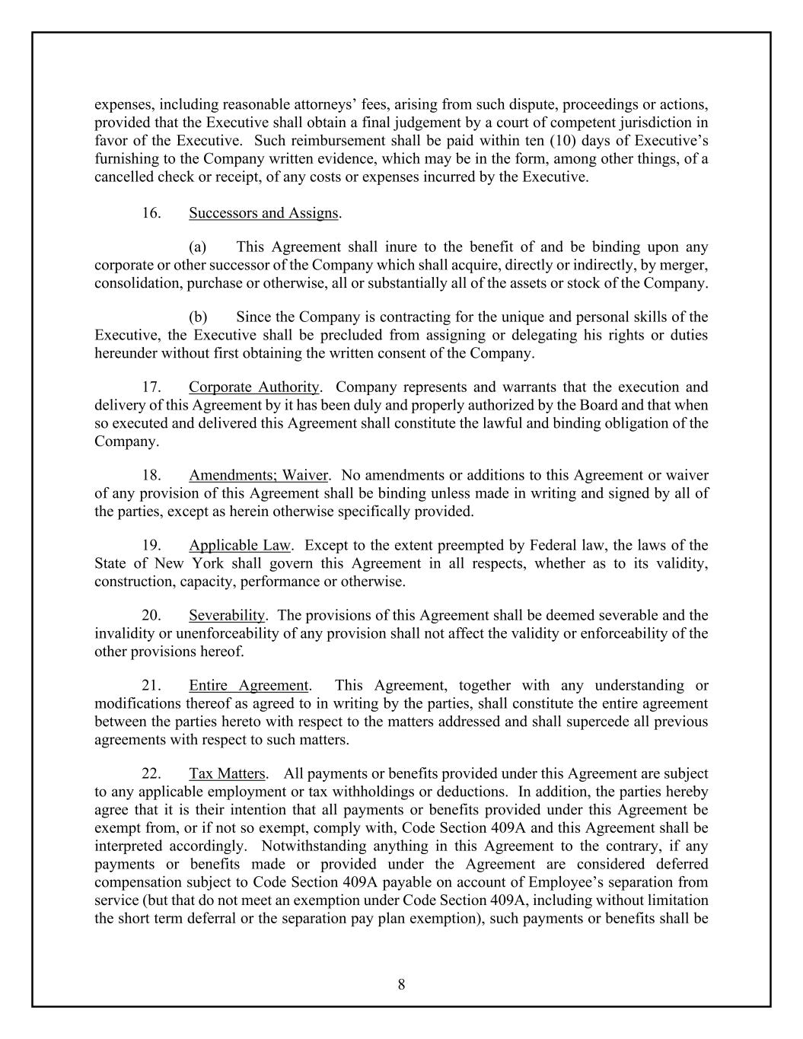
8 expenses, including reasonable attorneys’ fees, arising from such dispute, proceedings or actions, provided that the Executive shall obtain a final judgement by a court of competent jurisdiction in favor of the Executive. Such reimbursement shall be paid within ten (10) days of Executive’s furnishing to the Company written evidence, which may be in the form, among other things, of a cancelled check or receipt, of any costs or expenses incurred by the Executive. 16. Successors and Assigns. (a) This Agreement shall inure to the benefit of and be binding upon any corporate or other successor of the Company which shall acquire, directly or indirectly, by merger, consolidation, purchase or otherwise, all or substantially all of the assets or stock of the Company. (b) Since the Company is contracting for the unique and personal skills of the Executive, the Executive shall be precluded from assigning or delegating his rights or duties hereunder without first obtaining the written consent of the Company. 17. Corporate Authority. Company represents and warrants that the execution and delivery of this Agreement by it has been duly and properly authorized by the Board and that when so executed and delivered this Agreement shall constitute the lawful and binding obligation of the Company. 18. Amendments; Waiver. No amendments or additions to this Agreement or waiver of any provision of this Agreement shall be binding unless made in writing and signed by all of the parties, except as herein otherwise specifically provided. 19. Applicable Law. Except to the extent preempted by Federal law, the laws of the State of New York shall govern this Agreement in all respects, whether as to its validity, construction, capacity, performance or otherwise. 20. Severability. The provisions of this Agreement shall be deemed severable and the invalidity or unenforceability of any provision shall not affect the validity or enforceability of the other provisions hereof. 21. Entire Agreement. This Agreement, together with any understanding or modifications thereof as agreed to in writing by the parties, shall constitute the entire agreement between the parties hereto with respect to the matters addressed and shall supercede all previous agreements with respect to such matters. 22. Tax Matters. All payments or benefits provided under this Agreement are subject to any applicable employment or tax withholdings or deductions. In addition, the parties hereby agree that it is their intention that all payments or benefits provided under this Agreement be exempt from, or if not so exempt, comply with, Code Section 409A and this Agreement shall be interpreted accordingly. Notwithstanding anything in this Agreement to the contrary, if any payments or benefits made or provided under the Agreement are considered deferred compensation subject to Code Section 409A payable on account of Employee’s separation from service (but that do not meet an exemption under Code Section 409A, including without limitation the short term deferral or the separation pay plan exemption), such payments or benefits shall be

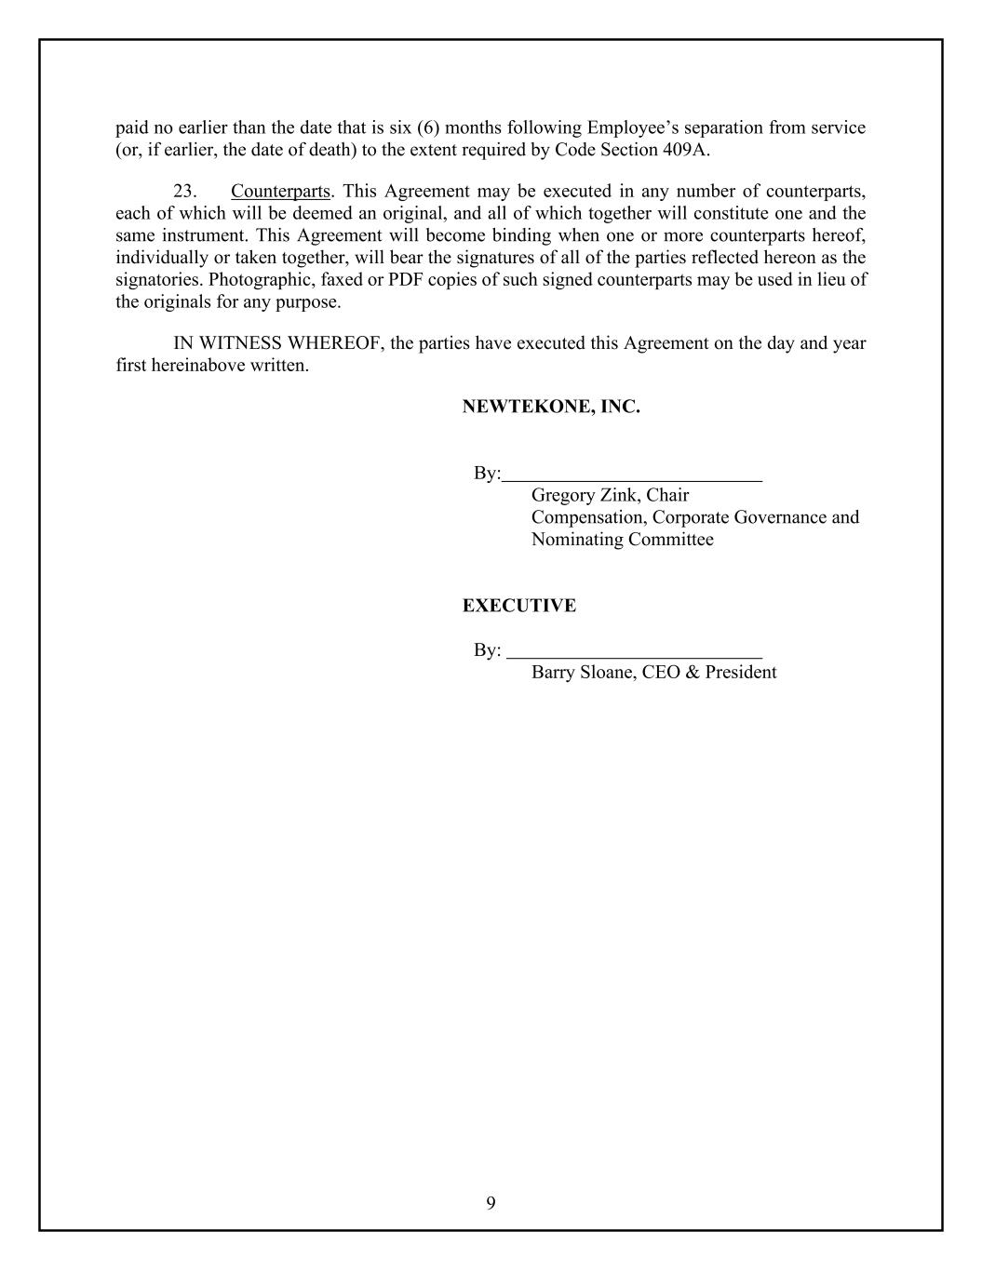
9 paid no earlier than the date that is six (6) months following Employee’s separation from service (or, if earlier, the date of death) to the extent required by Code Section 409A. 23. Counterparts. This Agreement may be executed in any number of counterparts, each of which will be deemed an original, and all of which together will constitute one and the same instrument. This Agreement will become binding when one or more counterparts hereof, individually or taken together, will bear the signatures of all of the parties reflected hereon as the signatories. Photographic, faxed or PDF copies of such signed counterparts may be used in lieu of the originals for any purpose. IN WITNESS WHEREOF, the parties have executed this Agreement on the day and year first hereinabove written. NEWTEKONE, INC. By: Gregory Zink, Chair Compensation, Corporate Governance and Nominating Committee EXECUTIVE By: Barry Sloane, CEO & President

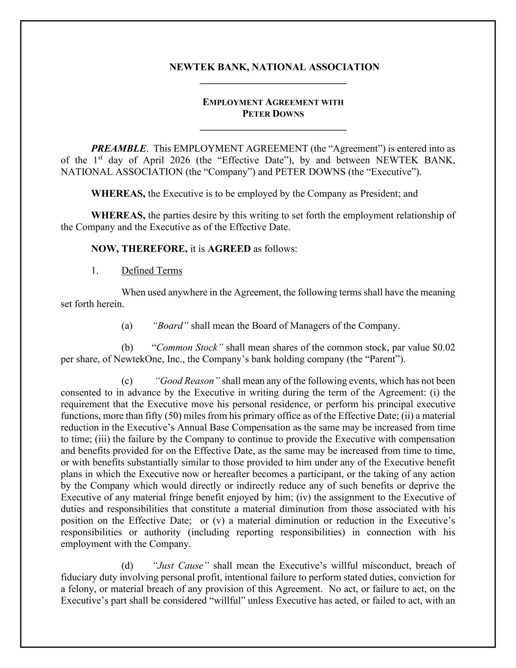
NEWTEK BANK, NATIONAL ASSOCIATION _____________________________ EMPLOYMENT AGREEMENT WITH PETER DOWNS _____________________________ PREAMBLE. This EMPLOYMENT AGREEMENT (the “Agreement”) is entered into as of the 1st day of April 2026 (the “Effective Date”), by and between NEWTEK BANK, NATIONAL ASSOCIATION (the “Company”) and PETER DOWNS (the “Executive”). WHEREAS, the Executive is to be employed by the Company as President; and WHEREAS, the parties desire by this writing to set forth the employment relationship of the Company and the Executive as of the Effective Date. NOW, THEREFORE, it is AGREED as follows: 1. Defined Terms When used anywhere in the Agreement, the following terms shall have the meaning set forth herein. (a) “Board” shall mean the Board of Managers of the Company. (b) “Common Stock” shall mean shares of the common stock, par value $0.02 per share, of NewtekOne, Inc., the Company’s bank holding company (the “Parent”). (c) “Good Reason” shall mean any of the following events, which has not been consented to in advance by the Executive in writing during the term of the Agreement: (i) the requirement that the Executive move his personal residence, or perform his principal executive functions, more than fifty (50) miles from his primary office as of the Effective Date; (ii) a material reduction in the Executive’s Annual Base Compensation as the same may be increased from time to time; (iii) the failure by the Company to continue to provide the Executive with compensation and benefits provided for on the Effective Date, as the same may be increased from time to time, or with benefits substantially similar to those provided to him under any of the Executive benefit plans in which the Executive now or hereafter becomes a participant, or the taking of any action by the Company which would directly or indirectly reduce any of such benefits or deprive the Executive of any material fringe benefit enjoyed by him; (iv) the assignment to the Executive of duties and responsibilities that constitute a material diminution from those associated with his position on the Effective Date; or (v) a material diminution or reduction in the Executive’s responsibilities or authority (including reporting responsibilities) in connection with his employment with the Company. (d) “Just Cause” shall mean the Executive’s willful misconduct, breach of fiduciary duty involving personal profit, intentional failure to perform stated duties, conviction for a felony, or material breach of any provision of this Agreement. No act, or failure to act, on the Executive’s part shall be considered “willful” unless Executive has acted, or failed to act, with an

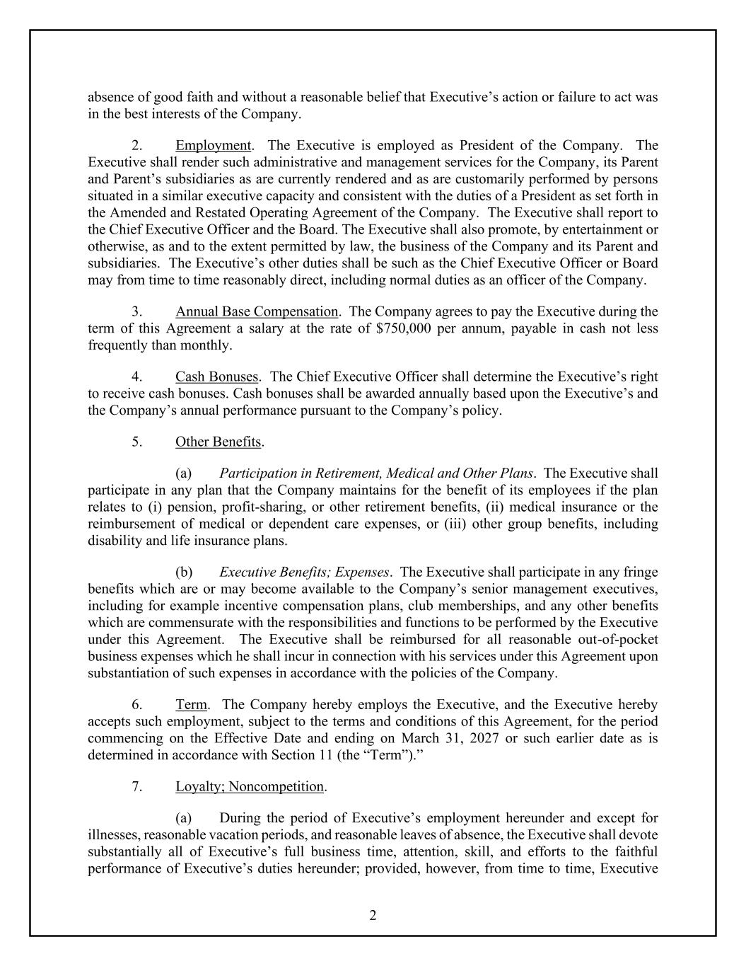
2 absence of good faith and without a reasonable belief that Executive’s action or failure to act was in the best interests of the Company. 2. Employment. The Executive is employed as President of the Company. The Executive shall render such administrative and management services for the Company, its Parent and Parent’s subsidiaries as are currently rendered and as are customarily performed by persons situated in a similar executive capacity and consistent with the duties of a President as set forth in the Amended and Restated Operating Agreement of the Company. The Executive shall report to the Chief Executive Officer and the Board. The Executive shall also promote, by entertainment or otherwise, as and to the extent permitted by law, the business of the Company and its Parent and subsidiaries. The Executive’s other duties shall be such as the Chief Executive Officer or Board may from time to time reasonably direct, including normal duties as an officer of the Company. 3. Annual Base Compensation. The Company agrees to pay the Executive during the term of this Agreement a salary at the rate of $750,000 per annum, payable in cash not less frequently than monthly. 4. Cash Bonuses. The Chief Executive Officer shall determine the Executive’s right to receive cash bonuses. Cash bonuses shall be awarded annually based upon the Executive’s and the Company’s annual performance pursuant to the Company’s policy. 5. Other Benefits. (a) Participation in Retirement, Medical and Other Plans. The Executive shall participate in any plan that the Company maintains for the benefit of its employees if the plan relates to (i) pension, profit-sharing, or other retirement benefits, (ii) medical insurance or the reimbursement of medical or dependent care expenses, or (iii) other group benefits, including disability and life insurance plans. (b) Executive Benefits; Expenses. The Executive shall participate in any fringe benefits which are or may become available to the Company’s senior management executives, including for example incentive compensation plans, club memberships, and any other benefits which are commensurate with the responsibilities and functions to be performed by the Executive under this Agreement. The Executive shall be reimbursed for all reasonable out-of-pocket business expenses which he shall incur in connection with his services under this Agreement upon substantiation of such expenses in accordance with the policies of the Company. 6. Term. The Company hereby employs the Executive, and the Executive hereby accepts such employment, subject to the terms and conditions of this Agreement, for the period commencing on the Effective Date and ending on March 31, 2027 or such earlier date as is determined in accordance with Section 11 (the “Term”).” 7. Loyalty; Noncompetition. (a) During the period of Executive’s employment hereunder and except for illnesses, reasonable vacation periods, and reasonable leaves of absence, the Executive shall devote substantially all of Executive’s full business time, attention, skill, and efforts to the faithful performance of Executive’s duties hereunder; provided, however, from time to time, Executive

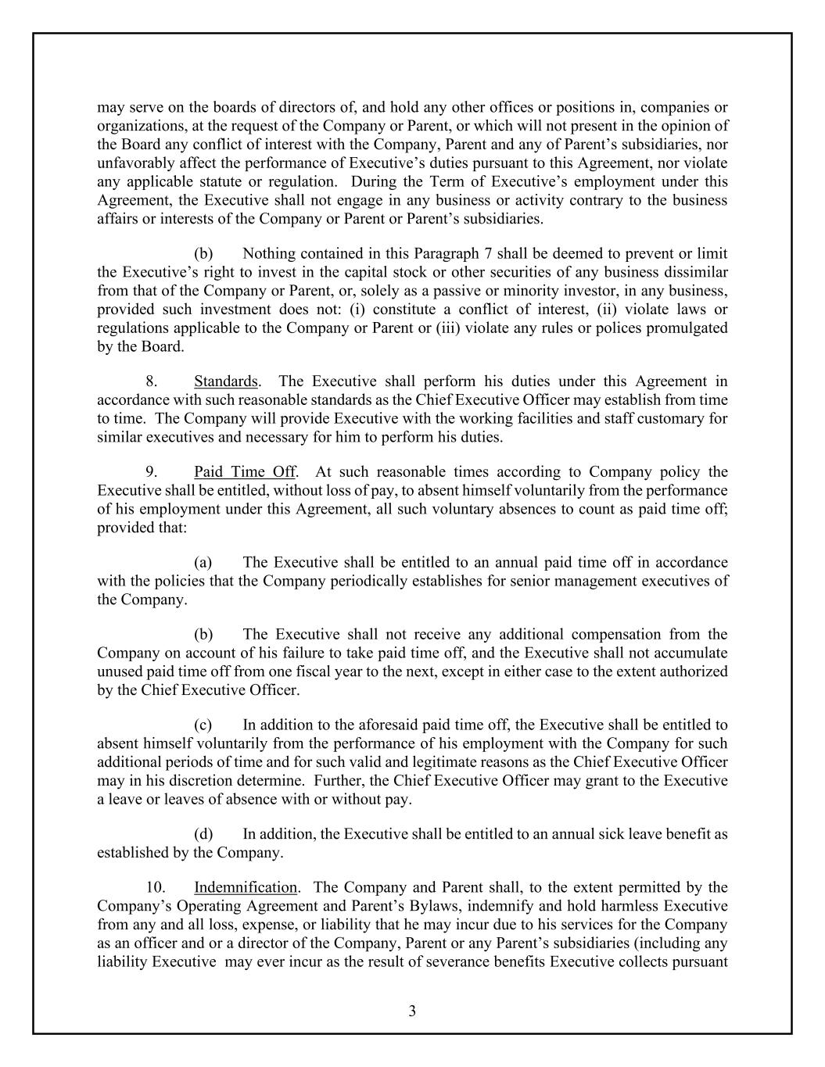
3 may serve on the boards of directors of, and hold any other offices or positions in, companies or organizations, at the request of the Company or Parent, or which will not present in the opinion of the Board any conflict of interest with the Company, Parent and any of Parent’s subsidiaries, nor unfavorably affect the performance of Executive’s duties pursuant to this Agreement, nor violate any applicable statute or regulation. During the Term of Executive’s employment under this Agreement, the Executive shall not engage in any business or activity contrary to the business affairs or interests of the Company or Parent or Parent’s subsidiaries. (b) Nothing contained in this Paragraph 7 shall be deemed to prevent or limit the Executive’s right to invest in the capital stock or other securities of any business dissimilar from that of the Company or Parent, or, solely as a passive or minority investor, in any business, provided such investment does not: (i) constitute a conflict of interest, (ii) violate laws or regulations applicable to the Company or Parent or (iii) violate any rules or polices promulgated by the Board. 8. Standards. The Executive shall perform his duties under this Agreement in accordance with such reasonable standards as the Chief Executive Officer may establish from time to time. The Company will provide Executive with the working facilities and staff customary for similar executives and necessary for him to perform his duties. 9. Paid Time Off. At such reasonable times according to Company policy the Executive shall be entitled, without loss of pay, to absent himself voluntarily from the performance of his employment under this Agreement, all such voluntary absences to count as paid time off; provided that: (a) The Executive shall be entitled to an annual paid time off in accordance with the policies that the Company periodically establishes for senior management executives of the Company. (b) The Executive shall not receive any additional compensation from the Company on account of his failure to take paid time off, and the Executive shall not accumulate unused paid time off from one fiscal year to the next, except in either case to the extent authorized by the Chief Executive Officer. (c) In addition to the aforesaid paid time off, the Executive shall be entitled to absent himself voluntarily from the performance of his employment with the Company for such additional periods of time and for such valid and legitimate reasons as the Chief Executive Officer may in his discretion determine. Further, the Chief Executive Officer may grant to the Executive a leave or leaves of absence with or without pay. (d) In addition, the Executive shall be entitled to an annual sick leave benefit as established by the Company. 10. Indemnification. The Company and Parent shall, to the extent permitted by the Company’s Operating Agreement and Parent’s Bylaws, indemnify and hold harmless Executive from any and all loss, expense, or liability that he may incur due to his services for the Company as an officer and or a director of the Company, Parent or any Parent’s subsidiaries (including any liability Executive may ever incur as the result of severance benefits Executive collects pursuant

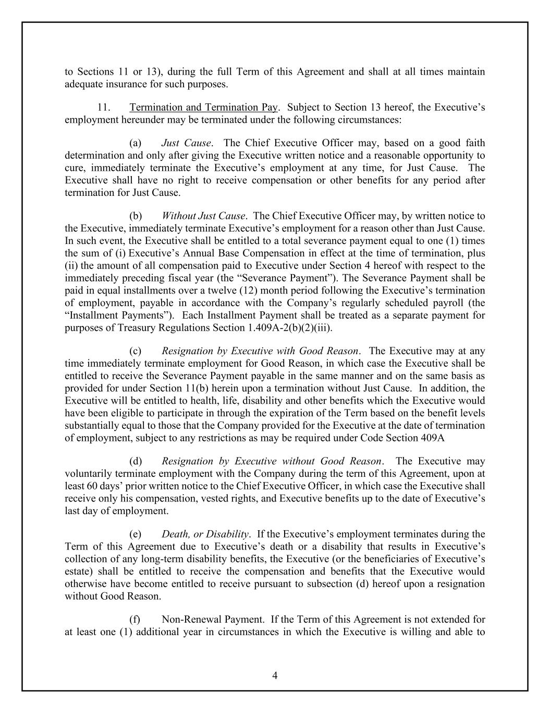
4 to Sections 11 or 13), during the full Term of this Agreement and shall at all times maintain adequate insurance for such purposes. 11. Termination and Termination Pay. Subject to Section 13 hereof, the Executive’s employment hereunder may be terminated under the following circumstances: (a) Just Cause. The Chief Executive Officer may, based on a good faith determination and only after giving the Executive written notice and a reasonable opportunity to cure, immediately terminate the Executive’s employment at any time, for Just Cause. The Executive shall have no right to receive compensation or other benefits for any period after termination for Just Cause. (b) Without Just Cause. The Chief Executive Officer may, by written notice to the Executive, immediately terminate Executive’s employment for a reason other than Just Cause. In such event, the Executive shall be entitled to a total severance payment equal to one (1) times the sum of (i) Executive’s Annual Base Compensation in effect at the time of termination, plus (ii) the amount of all compensation paid to Executive under Section 4 hereof with respect to the immediately preceding fiscal year (the “Severance Payment”). The Severance Payment shall be paid in equal installments over a twelve (12) month period following the Executive’s termination of employment, payable in accordance with the Company’s regularly scheduled payroll (the “Installment Payments”). Each Installment Payment shall be treated as a separate payment for purposes of Treasury Regulations Section 1.409A-2(b)(2)(iii). (c) Resignation by Executive with Good Reason. The Executive may at any time immediately terminate employment for Good Reason, in which case the Executive shall be entitled to receive the Severance Payment payable in the same manner and on the same basis as provided for under Section 11(b) herein upon a termination without Just Cause. In addition, the Executive will be entitled to health, life, disability and other benefits which the Executive would have been eligible to participate in through the expiration of the Term based on the benefit levels substantially equal to those that the Company provided for the Executive at the date of termination of employment, subject to any restrictions as may be required under Code Section 409A (d) Resignation by Executive without Good Reason. The Executive may voluntarily terminate employment with the Company during the term of this Agreement, upon at least 60 days’ prior written notice to the Chief Executive Officer, in which case the Executive shall receive only his compensation, vested rights, and Executive benefits up to the date of Executive’s last day of employment. (e) Death, or Disability. If the Executive’s employment terminates during the Term of this Agreement due to Executive’s death or a disability that results in Executive’s collection of any long-term disability benefits, the Executive (or the beneficiaries of Executive’s estate) shall be entitled to receive the compensation and benefits that the Executive would otherwise have become entitled to receive pursuant to subsection (d) hereof upon a resignation without Good Reason. (f) Non-Renewal Payment. If the Term of this Agreement is not extended for at least one (1) additional year in circumstances in which the Executive is willing and able to

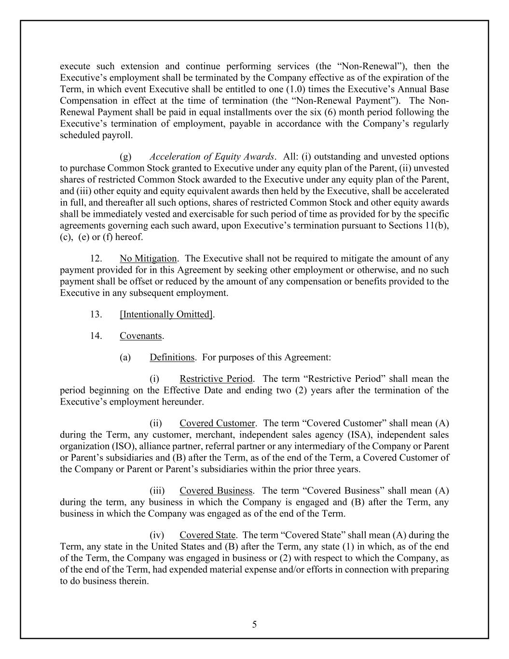
5 execute such extension and continue performing services (the “Non-Renewal”), then the Executive’s employment shall be terminated by the Company effective as of the expiration of the Term, in which event Executive shall be entitled to one (1.0) times the Executive’s Annual Base Compensation in effect at the time of termination (the “Non-Renewal Payment”). The Non- Renewal Payment shall be paid in equal installments over the six (6) month period following the Executive’s termination of employment, payable in accordance with the Company’s regularly scheduled payroll. (g) Acceleration of Equity Awards. All: (i) outstanding and unvested options to purchase Common Stock granted to Executive under any equity plan of the Parent, (ii) unvested shares of restricted Common Stock awarded to the Executive under any equity plan of the Parent, and (iii) other equity and equity equivalent awards then held by the Executive, shall be accelerated in full, and thereafter all such options, shares of restricted Common Stock and other equity awards shall be immediately vested and exercisable for such period of time as provided for by the specific agreements governing each such award, upon Executive’s termination pursuant to Sections 11(b), (c), (e) or (f) hereof. 12. No Mitigation. The Executive shall not be required to mitigate the amount of any payment provided for in this Agreement by seeking other employment or otherwise, and no such payment shall be offset or reduced by the amount of any compensation or benefits provided to the Executive in any subsequent employment. 13. [Intentionally Omitted]. 14. Covenants. (a) Definitions. For purposes of this Agreement: (i) Restrictive Period. The term “Restrictive Period” shall mean the period beginning on the Effective Date and ending two (2) years after the termination of the Executive’s employment hereunder. (ii) Covered Customer. The term “Covered Customer” shall mean (A) during the Term, any customer, merchant, independent sales agency (ISA), independent sales organization (ISO), alliance partner, referral partner or any intermediary of the Company or Parent or Parent’s subsidiaries and (B) after the Term, as of the end of the Term, a Covered Customer of the Company or Parent or Parent’s subsidiaries within the prior three years. (iii) Covered Business. The term “Covered Business” shall mean (A) during the term, any business in which the Company is engaged and (B) after the Term, any business in which the Company was engaged as of the end of the Term. (iv) Covered State. The term “Covered State” shall mean (A) during the Term, any state in the United States and (B) after the Term, any state (1) in which, as of the end of the Term, the Company was engaged in business or (2) with respect to which the Company, as of the end of the Term, had expended material expense and/or efforts in connection with preparing to do business therein.

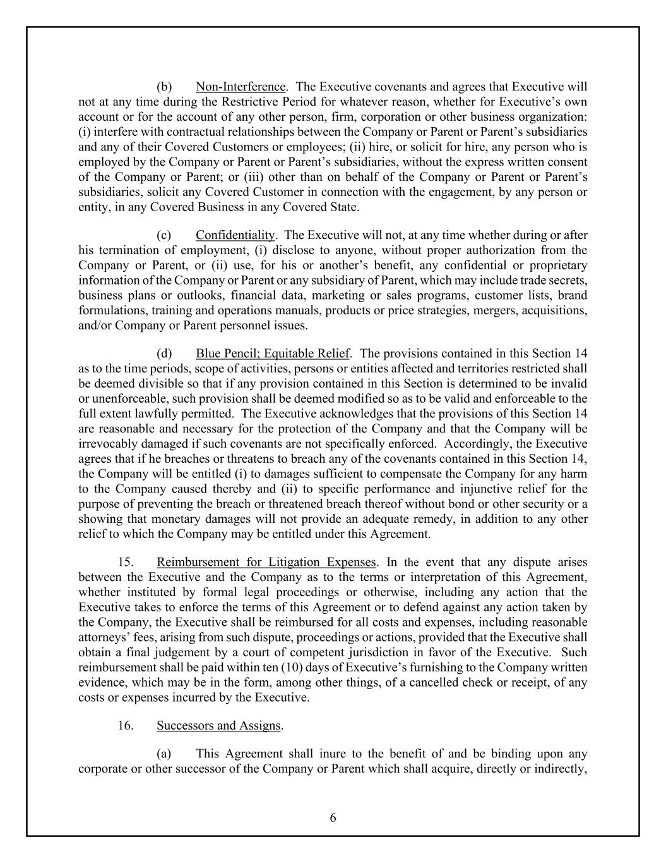
6 (b) Non-Interference. The Executive covenants and agrees that Executive will not at any time during the Restrictive Period for whatever reason, whether for Executive’s own account or for the account of any other person, firm, corporation or other business organization: (i) interfere with contractual relationships between the Company or Parent or Parent’s subsidiaries and any of their Covered Customers or employees; (ii) hire, or solicit for hire, any person who is employed by the Company or Parent or Parent’s subsidiaries, without the express written consent of the Company or Parent; or (iii) other than on behalf of the Company or Parent or Parent’s subsidiaries, solicit any Covered Customer in connection with the engagement, by any person or entity, in any Covered Business in any Covered State. (c) Confidentiality. The Executive will not, at any time whether during or after his termination of employment, (i) disclose to anyone, without proper authorization from the Company or Parent, or (ii) use, for his or another’s benefit, any confidential or proprietary information of the Company or Parent or any subsidiary of Parent, which may include trade secrets, business plans or outlooks, financial data, marketing or sales programs, customer lists, brand formulations, training and operations manuals, products or price strategies, mergers, acquisitions, and/or Company or Parent personnel issues. (d) Blue Pencil; Equitable Relief. The provisions contained in this Section 14 as to the time periods, scope of activities, persons or entities affected and territories restricted shall be deemed divisible so that if any provision contained in this Section is determined to be invalid or unenforceable, such provision shall be deemed modified so as to be valid and enforceable to the full extent lawfully permitted. The Executive acknowledges that the provisions of this Section 14 are reasonable and necessary for the protection of the Company and that the Company will be irrevocably damaged if such covenants are not specifically enforced. Accordingly, the Executive agrees that if he breaches or threatens to breach any of the covenants contained in this Section 14, the Company will be entitled (i) to damages sufficient to compensate the Company for any harm to the Company caused thereby and (ii) to specific performance and injunctive relief for the purpose of preventing the breach or threatened breach thereof without bond or other security or a showing that monetary damages will not provide an adequate remedy, in addition to any other relief to which the Company may be entitled under this Agreement. 15. Reimbursement for Litigation Expenses. In the event that any dispute arises between the Executive and the Company as to the terms or interpretation of this Agreement, whether instituted by formal legal proceedings or otherwise, including any action that the Executive takes to enforce the terms of this Agreement or to defend against any action taken by the Company, the Executive shall be reimbursed for all costs and expenses, including reasonable attorneys’ fees, arising from such dispute, proceedings or actions, provided that the Executive shall obtain a final judgement by a court of competent jurisdiction in favor of the Executive. Such reimbursement shall be paid within ten (10) days of Executive’s furnishing to the Company written evidence, which may be in the form, among other things, of a cancelled check or receipt, of any costs or expenses incurred by the Executive. 16. Successors and Assigns. (a) This Agreement shall inure to the benefit of and be binding upon any corporate or other successor of the Company or Parent which shall acquire, directly or indirectly,

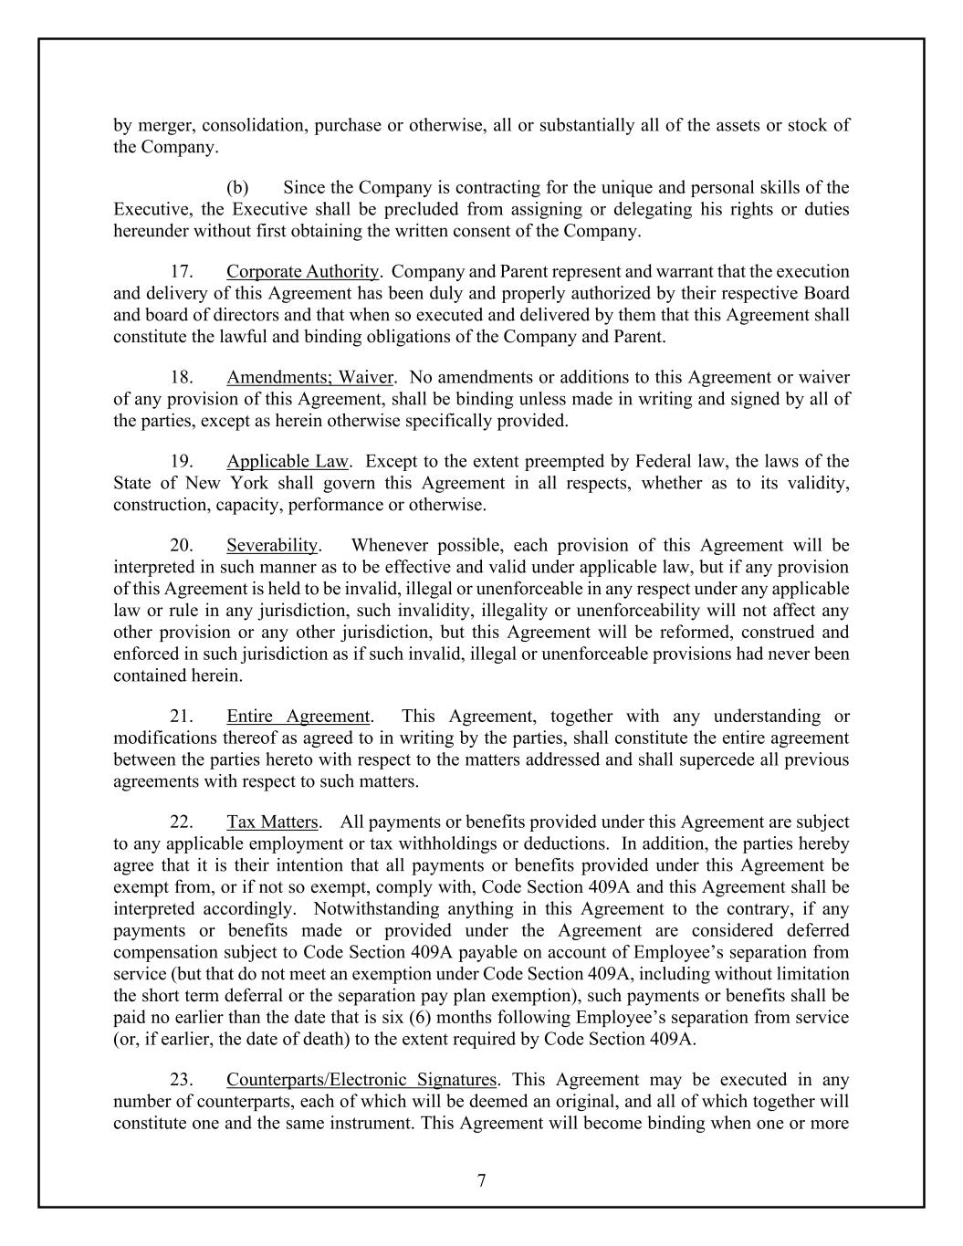
7 by merger, consolidation, purchase or otherwise, all or substantially all of the assets or stock of the Company. (b) Since the Company is contracting for the unique and personal skills of the Executive, the Executive shall be precluded from assigning or delegating his rights or duties hereunder without first obtaining the written consent of the Company. 17. Corporate Authority. Company and Parent represent and warrant that the execution and delivery of this Agreement has been duly and properly authorized by their respective Board and board of directors and that when so executed and delivered by them that this Agreement shall constitute the lawful and binding obligations of the Company and Parent. 18. Amendments; Waiver. No amendments or additions to this Agreement or waiver of any provision of this Agreement, shall be binding unless made in writing and signed by all of the parties, except as herein otherwise specifically provided. 19. Applicable Law. Except to the extent preempted by Federal law, the laws of the State of New York shall govern this Agreement in all respects, whether as to its validity, construction, capacity, performance or otherwise. 20. Severability. Whenever possible, each provision of this Agreement will be interpreted in such manner as to be effective and valid under applicable law, but if any provision of this Agreement is held to be invalid, illegal or unenforceable in any respect under any applicable law or rule in any jurisdiction, such invalidity, illegality or unenforceability will not affect any other provision or any other jurisdiction, but this Agreement will be reformed, construed and enforced in such jurisdiction as if such invalid, illegal or unenforceable provisions had never been contained herein. 21. Entire Agreement. This Agreement, together with any understanding or modifications thereof as agreed to in writing by the parties, shall constitute the entire agreement between the parties hereto with respect to the matters addressed and shall supercede all previous agreements with respect to such matters. 22. Tax Matters. All payments or benefits provided under this Agreement are subject to any applicable employment or tax withholdings or deductions. In addition, the parties hereby agree that it is their intention that all payments or benefits provided under this Agreement be exempt from, or if not so exempt, comply with, Code Section 409A and this Agreement shall be interpreted accordingly. Notwithstanding anything in this Agreement to the contrary, if any payments or benefits made or provided under the Agreement are considered deferred compensation subject to Code Section 409A payable on account of Employee’s separation from service (but that do not meet an exemption under Code Section 409A, including without limitation the short term deferral or the separation pay plan exemption), such payments or benefits shall be paid no earlier than the date that is six (6) months following Employee’s separation from service (or, if earlier, the date of death) to the extent required by Code Section 409A. 23. Counterparts/Electronic Signatures. This Agreement may be executed in any number of counterparts, each of which will be deemed an original, and all of which together will constitute one and the same instrument. This Agreement will become binding when one or more

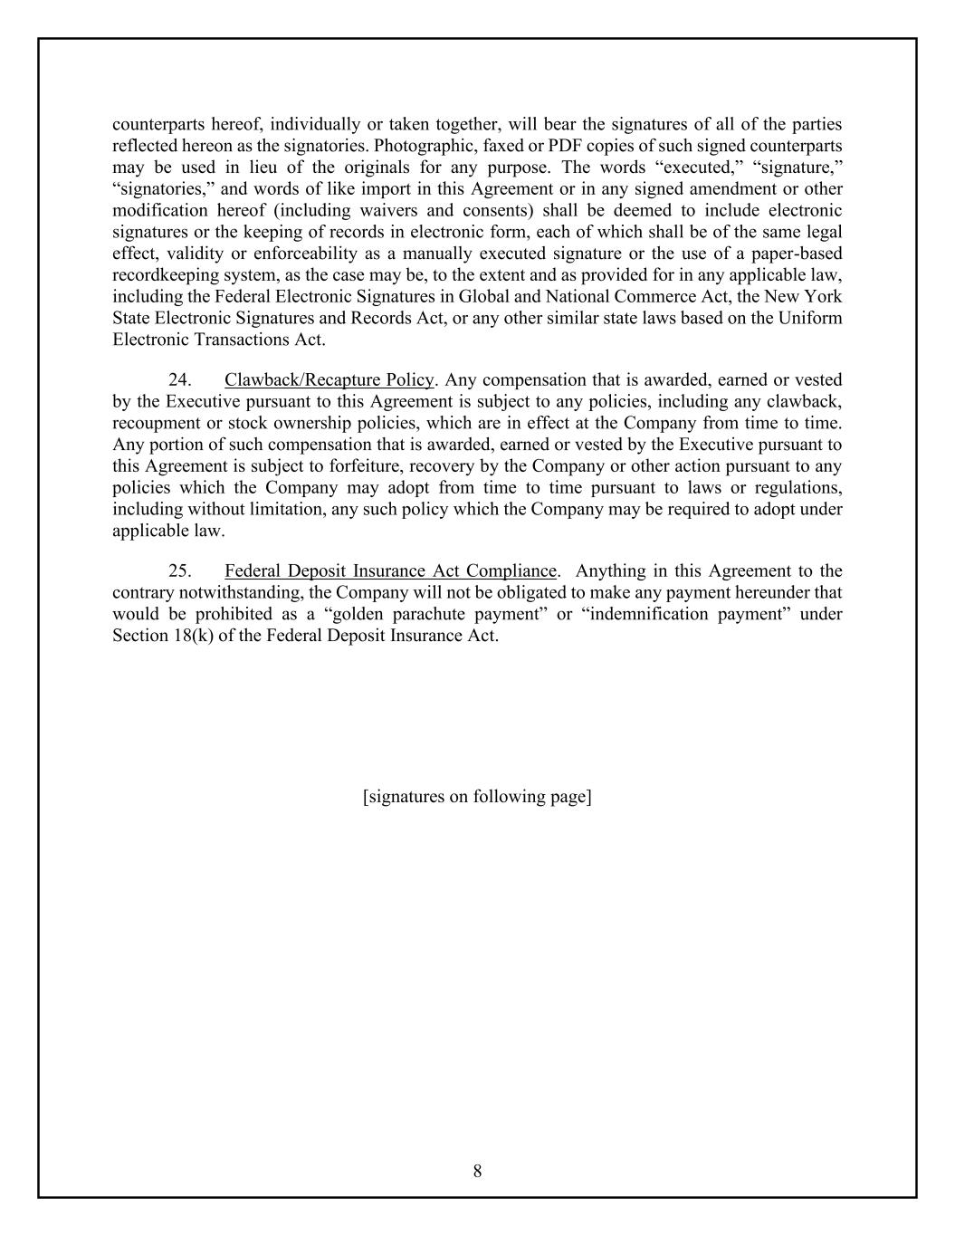
8 counterparts hereof, individually or taken together, will bear the signatures of all of the parties reflected hereon as the signatories. Photographic, faxed or PDF copies of such signed counterparts may be used in lieu of the originals for any purpose. The words “executed,” “signature,” “signatories,” and words of like import in this Agreement or in any signed amendment or other modification hereof (including waivers and consents) shall be deemed to include electronic signatures or the keeping of records in electronic form, each of which shall be of the same legal effect, validity or enforceability as a manually executed signature or the use of a paper-based recordkeeping system, as the case may be, to the extent and as provided for in any applicable law, including the Federal Electronic Signatures in Global and National Commerce Act, the New York State Electronic Signatures and Records Act, or any other similar state laws based on the Uniform Electronic Transactions Act. 24. Clawback/Recapture Policy. Any compensation that is awarded, earned or vested by the Executive pursuant to this Agreement is subject to any policies, including any clawback, recoupment or stock ownership policies, which are in effect at the Company from time to time. Any portion of such compensation that is awarded, earned or vested by the Executive pursuant to this Agreement is subject to forfeiture, recovery by the Company or other action pursuant to any policies which the Company may adopt from time to time pursuant to laws or regulations, including without limitation, any such policy which the Company may be required to adopt under applicable law. 25. Federal Deposit Insurance Act Compliance. Anything in this Agreement to the contrary notwithstanding, the Company will not be obligated to make any payment hereunder that would be prohibited as a “golden parachute payment” or “indemnification payment” under Section 18(k) of the Federal Deposit Insurance Act. [signatures on following page]

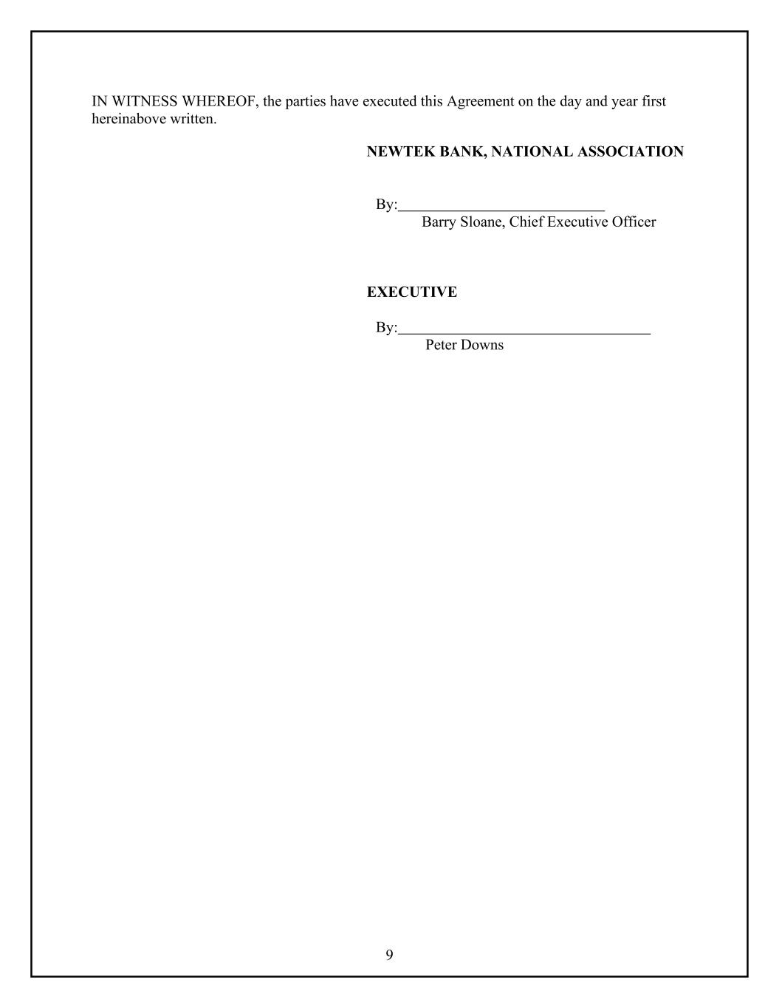
9 IN WITNESS WHEREOF, the parties have executed this Agreement on the day and year first hereinabove written. NEWTEK BANK, NATIONAL ASSOCIATION By: Barry Sloane, Chief Executive Officer EXECUTIVE By: Peter Downs

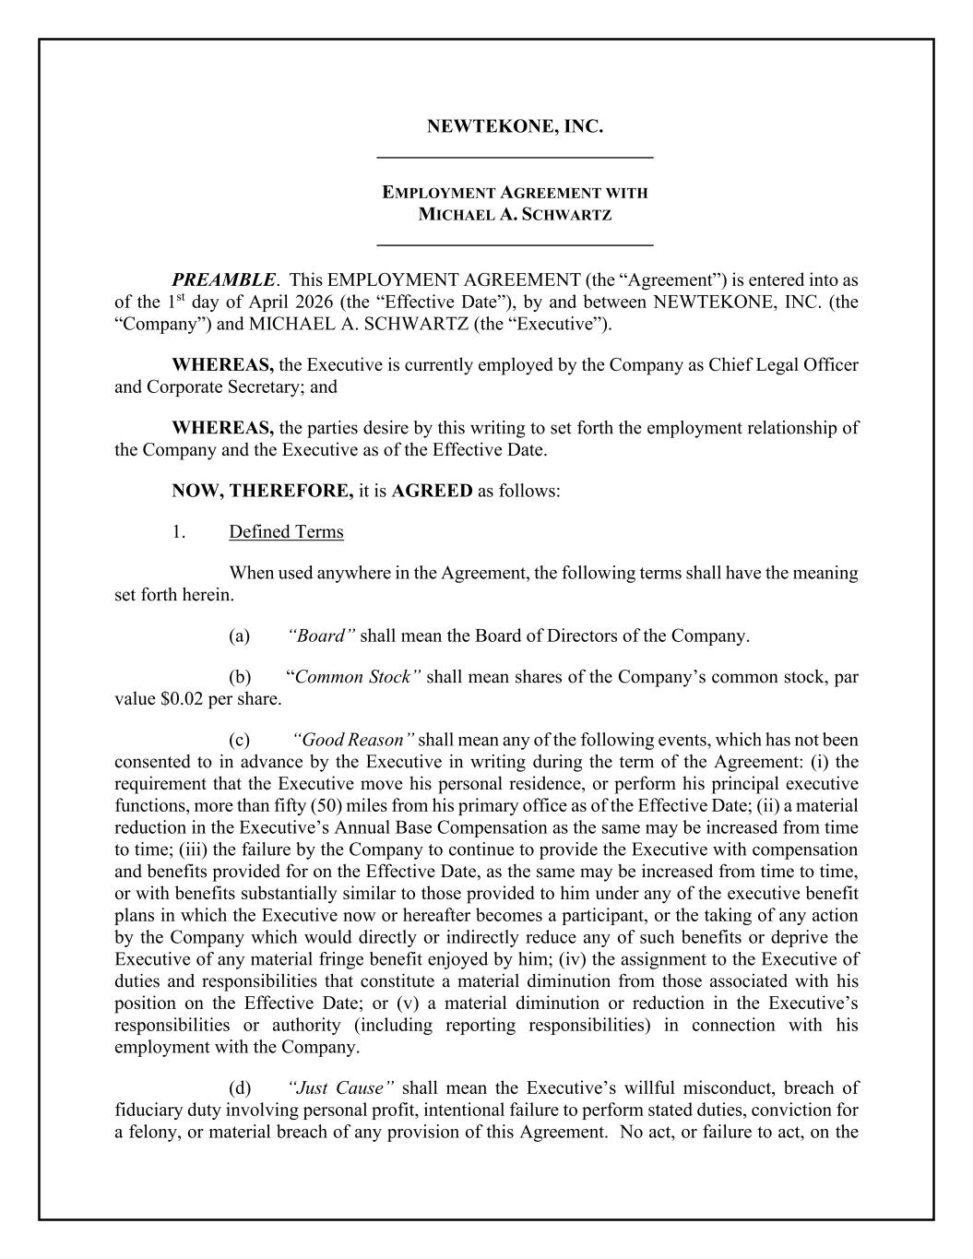
NEWTEKONE, INC. _____________________________ EMPLOYMENT AGREEMENT WITH MICHAEL A. SCHWARTZ _____________________________ PREAMBLE. This EMPLOYMENT AGREEMENT (the “Agreement”) is entered into as of the 1st day of April 2026 (the “Effective Date”), by and between NEWTEKONE, INC. (the “Company”) and MICHAEL A. SCHWARTZ (the “Executive”). WHEREAS, the Executive is currently employed by the Company as Chief Legal Officer and Corporate Secretary; and WHEREAS, the parties desire by this writing to set forth the employment relationship of the Company and the Executive as of the Effective Date. NOW, THEREFORE, it is AGREED as follows: 1. Defined Terms When used anywhere in the Agreement, the following terms shall have the meaning set forth herein. (a) “Board” shall mean the Board of Directors of the Company. (b) “Common Stock” shall mean shares of the Company’s common stock, par value $0.02 per share. (c) “Good Reason” shall mean any of the following events, which has not been consented to in advance by the Executive in writing during the term of the Agreement: (i) the requirement that the Executive move his personal residence, or perform his principal executive functions, more than fifty (50) miles from his primary office as of the Effective Date; (ii) a material reduction in the Executive’s Annual Base Compensation as the same may be increased from time to time; (iii) the failure by the Company to continue to provide the Executive with compensation and benefits provided for on the Effective Date, as the same may be increased from time to time, or with benefits substantially similar to those provided to him under any of the executive benefit plans in which the Executive now or hereafter becomes a participant, or the taking of any action by the Company which would directly or indirectly reduce any of such benefits or deprive the Executive of any material fringe benefit enjoyed by him; (iv) the assignment to the Executive of duties and responsibilities that constitute a material diminution from those associated with his position on the Effective Date; or (v) a material diminution or reduction in the Executive’s responsibilities or authority (including reporting responsibilities) in connection with his employment with the Company. (d) “Just Cause” shall mean the Executive’s willful misconduct, breach of fiduciary duty involving personal profit, intentional failure to perform stated duties, conviction for a felony, or material breach of any provision of this Agreement. No act, or failure to act, on the

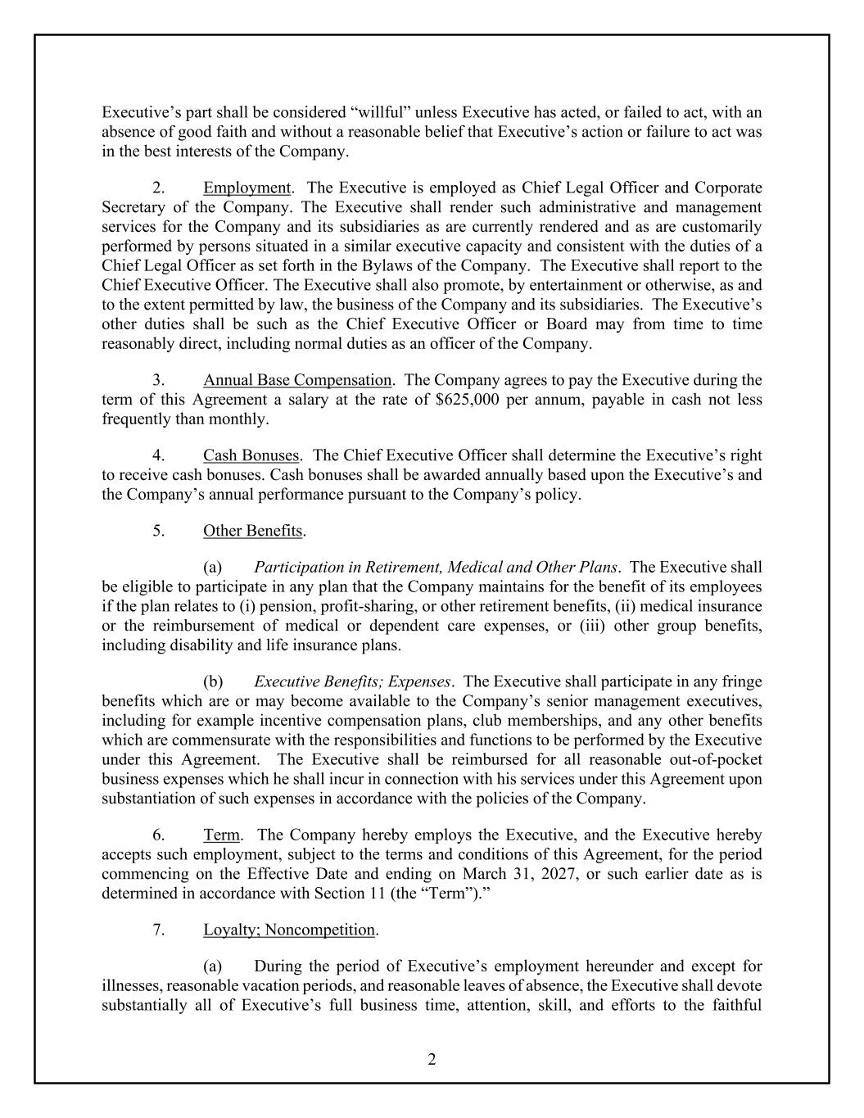
2 Executive’s part shall be considered “willful” unless Executive has acted, or failed to act, with an absence of good faith and without a reasonable belief that Executive’s action or failure to act was in the best interests of the Company. 2. Employment. The Executive is employed as Chief Legal Officer and Corporate Secretary of the Company. The Executive shall render such administrative and management services for the Company and its subsidiaries as are currently rendered and as are customarily performed by persons situated in a similar executive capacity and consistent with the duties of a Chief Legal Officer as set forth in the Bylaws of the Company. The Executive shall report to the Chief Executive Officer. The Executive shall also promote, by entertainment or otherwise, as and to the extent permitted by law, the business of the Company and its subsidiaries. The Executive’s other duties shall be such as the Chief Executive Officer or Board may from time to time reasonably direct, including normal duties as an officer of the Company. 3. Annual Base Compensation. The Company agrees to pay the Executive during the term of this Agreement a salary at the rate of $625,000 per annum, payable in cash not less frequently than monthly. 4. Cash Bonuses. The Chief Executive Officer shall determine the Executive’s right to receive cash bonuses. Cash bonuses shall be awarded annually based upon the Executive’s and the Company’s annual performance pursuant to the Company’s policy. 5. Other Benefits. (a) Participation in Retirement, Medical and Other Plans. The Executive shall be eligible to participate in any plan that the Company maintains for the benefit of its employees if the plan relates to (i) pension, profit-sharing, or other retirement benefits, (ii) medical insurance or the reimbursement of medical or dependent care expenses, or (iii) other group benefits, including disability and life insurance plans. (b) Executive Benefits; Expenses. The Executive shall participate in any fringe benefits which are or may become available to the Company’s senior management executives, including for example incentive compensation plans, club memberships, and any other benefits which are commensurate with the responsibilities and functions to be performed by the Executive under this Agreement. The Executive shall be reimbursed for all reasonable out-of-pocket business expenses which he shall incur in connection with his services under this Agreement upon substantiation of such expenses in accordance with the policies of the Company. 6. Term. The Company hereby employs the Executive, and the Executive hereby accepts such employment, subject to the terms and conditions of this Agreement, for the period commencing on the Effective Date and ending on March 31, 2027, or such earlier date as is determined in accordance with Section 11 (the “Term”).” 7. Loyalty; Noncompetition. (a) During the period of Executive’s employment hereunder and except for illnesses, reasonable vacation periods, and reasonable leaves of absence, the Executive shall devote substantially all of Executive’s full business time, attention, skill, and efforts to the faithful

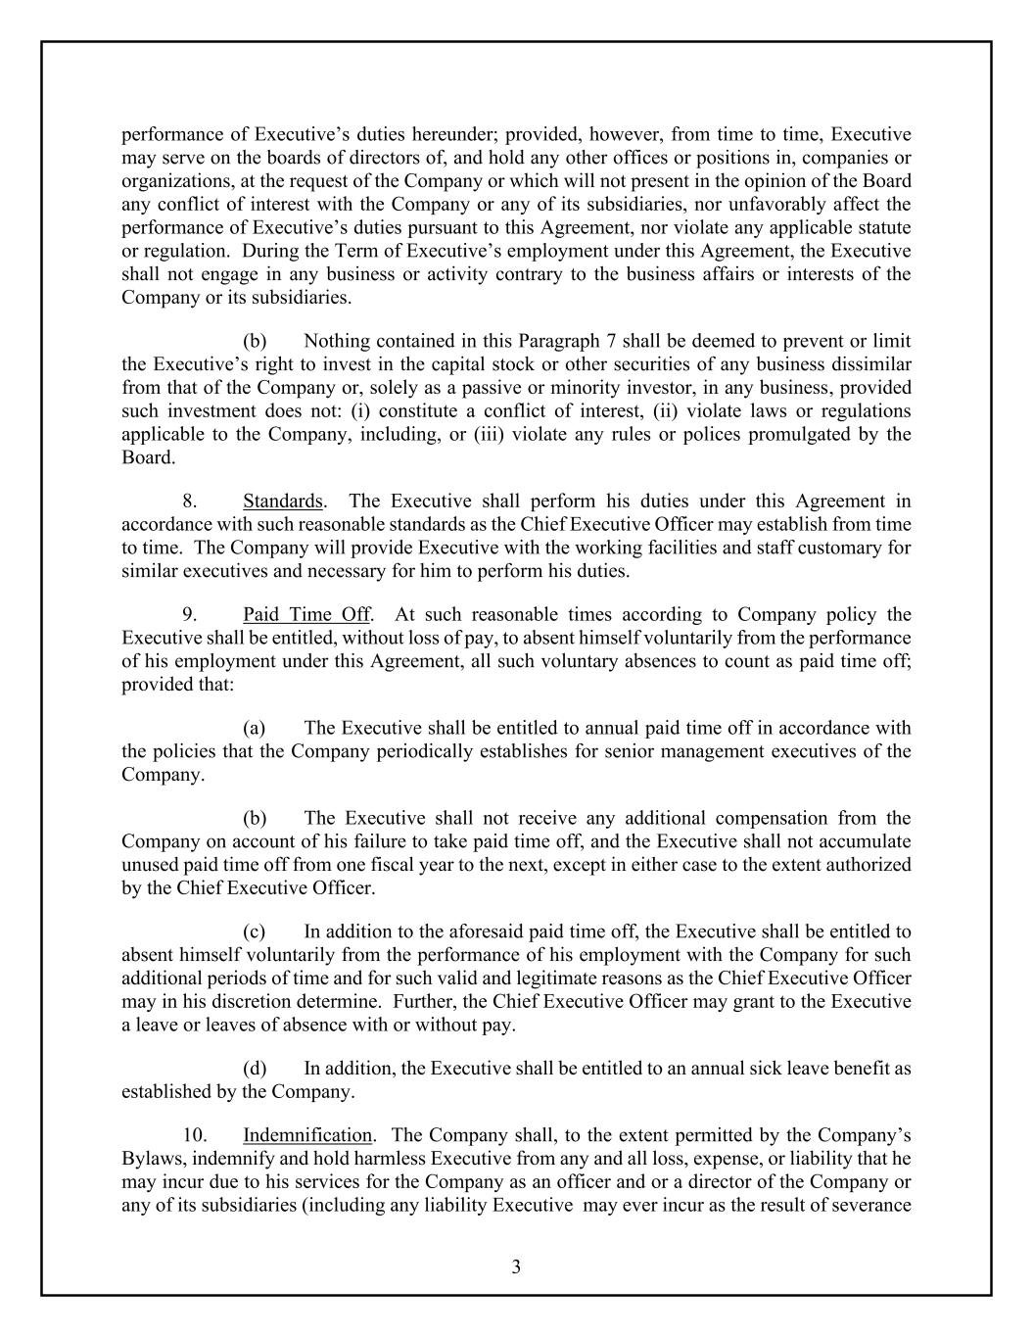
3 performance of Executive’s duties hereunder; provided, however, from time to time, Executive may serve on the boards of directors of, and hold any other offices or positions in, companies or organizations, at the request of the Company or which will not present in the opinion of the Board any conflict of interest with the Company or any of its subsidiaries, nor unfavorably affect the performance of Executive’s duties pursuant to this Agreement, nor violate any applicable statute or regulation. During the Term of Executive’s employment under this Agreement, the Executive shall not engage in any business or activity contrary to the business affairs or interests of the Company or its subsidiaries. (b) Nothing contained in this Paragraph 7 shall be deemed to prevent or limit the Executive’s right to invest in the capital stock or other securities of any business dissimilar from that of the Company or, solely as a passive or minority investor, in any business, provided such investment does not: (i) constitute a conflict of interest, (ii) violate laws or regulations applicable to the Company, including, or (iii) violate any rules or polices promulgated by the Board. 8. Standards. The Executive shall perform his duties under this Agreement in accordance with such reasonable standards as the Chief Executive Officer may establish from time to time. The Company will provide Executive with the working facilities and staff customary for similar executives and necessary for him to perform his duties. 9. Paid Time Off. At such reasonable times according to Company policy the Executive shall be entitled, without loss of pay, to absent himself voluntarily from the performance of his employment under this Agreement, all such voluntary absences to count as paid time off; provided that: (a) The Executive shall be entitled to annual paid time off in accordance with the policies that the Company periodically establishes for senior management executives of the Company. (b) The Executive shall not receive any additional compensation from the Company on account of his failure to take paid time off, and the Executive shall not accumulate unused paid time off from one fiscal year to the next, except in either case to the extent authorized by the Chief Executive Officer. (c) In addition to the aforesaid paid time off, the Executive shall be entitled to absent himself voluntarily from the performance of his employment with the Company for such additional periods of time and for such valid and legitimate reasons as the Chief Executive Officer may in his discretion determine. Further, the Chief Executive Officer may grant to the Executive a leave or leaves of absence with or without pay. (d) In addition, the Executive shall be entitled to an annual sick leave benefit as established by the Company. 10. Indemnification. The Company shall, to the extent permitted by the Company’s Bylaws, indemnify and hold harmless Executive from any and all loss, expense, or liability that he may incur due to his services for the Company as an officer and or a director of the Company or any of its subsidiaries (including any liability Executive may ever incur as the result of severance

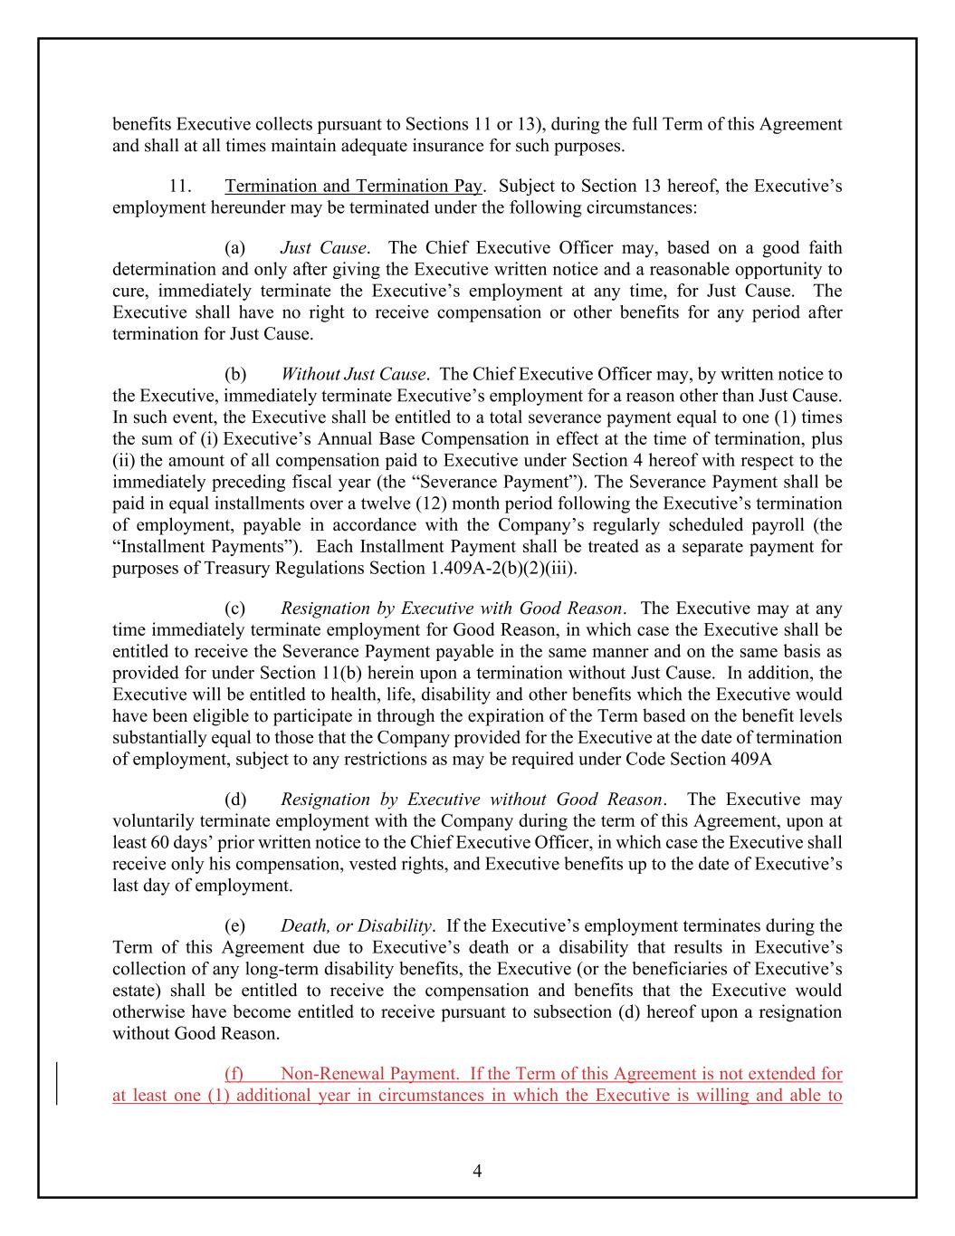
4 benefits Executive collects pursuant to Sections 11 or 13), during the full Term of this Agreement and shall at all times maintain adequate insurance for such purposes. 11. Termination and Termination Pay. Subject to Section 13 hereof, the Executive’s employment hereunder may be terminated under the following circumstances: (a) Just Cause. The Chief Executive Officer may, based on a good faith determination and only after giving the Executive written notice and a reasonable opportunity to cure, immediately terminate the Executive’s employment at any time, for Just Cause. The Executive shall have no right to receive compensation or other benefits for any period after termination for Just Cause. (b) Without Just Cause. The Chief Executive Officer may, by written notice to the Executive, immediately terminate Executive’s employment for a reason other than Just Cause. In such event, the Executive shall be entitled to a total severance payment equal to one (1) times the sum of (i) Executive’s Annual Base Compensation in effect at the time of termination, plus (ii) the amount of all compensation paid to Executive under Section 4 hereof with respect to the immediately preceding fiscal year (the “Severance Payment”). The Severance Payment shall be paid in equal installments over a twelve (12) month period following the Executive’s termination of employment, payable in accordance with the Company’s regularly scheduled payroll (the “Installment Payments”). Each Installment Payment shall be treated as a separate payment for purposes of Treasury Regulations Section 1.409A-2(b)(2)(iii). (c) Resignation by Executive with Good Reason. The Executive may at any time immediately terminate employment for Good Reason, in which case the Executive shall be entitled to receive the Severance Payment payable in the same manner and on the same basis as provided for under Section 11(b) herein upon a termination without Just Cause. In addition, the Executive will be entitled to health, life, disability and other benefits which the Executive would have been eligible to participate in through the expiration of the Term based on the benefit levels substantially equal to those that the Company provided for the Executive at the date of termination of employment, subject to any restrictions as may be required under Code Section 409A (d) Resignation by Executive without Good Reason. The Executive may voluntarily terminate employment with the Company during the term of this Agreement, upon at least 60 days’ prior written notice to the Chief Executive Officer, in which case the Executive shall receive only his compensation, vested rights, and Executive benefits up to the date of Executive’s last day of employment. (e) Death, or Disability. If the Executive’s employment terminates during the Term of this Agreement due to Executive’s death or a disability that results in Executive’s collection of any long-term disability benefits, the Executive (or the beneficiaries of Executive’s estate) shall be entitled to receive the compensation and benefits that the Executive would otherwise have become entitled to receive pursuant to subsection (d) hereof upon a resignation without Good Reason. (f) Non-Renewal Payment. If the Term of this Agreement is not extended for at least one (1) additional year in circumstances in which the Executive is willing and able to

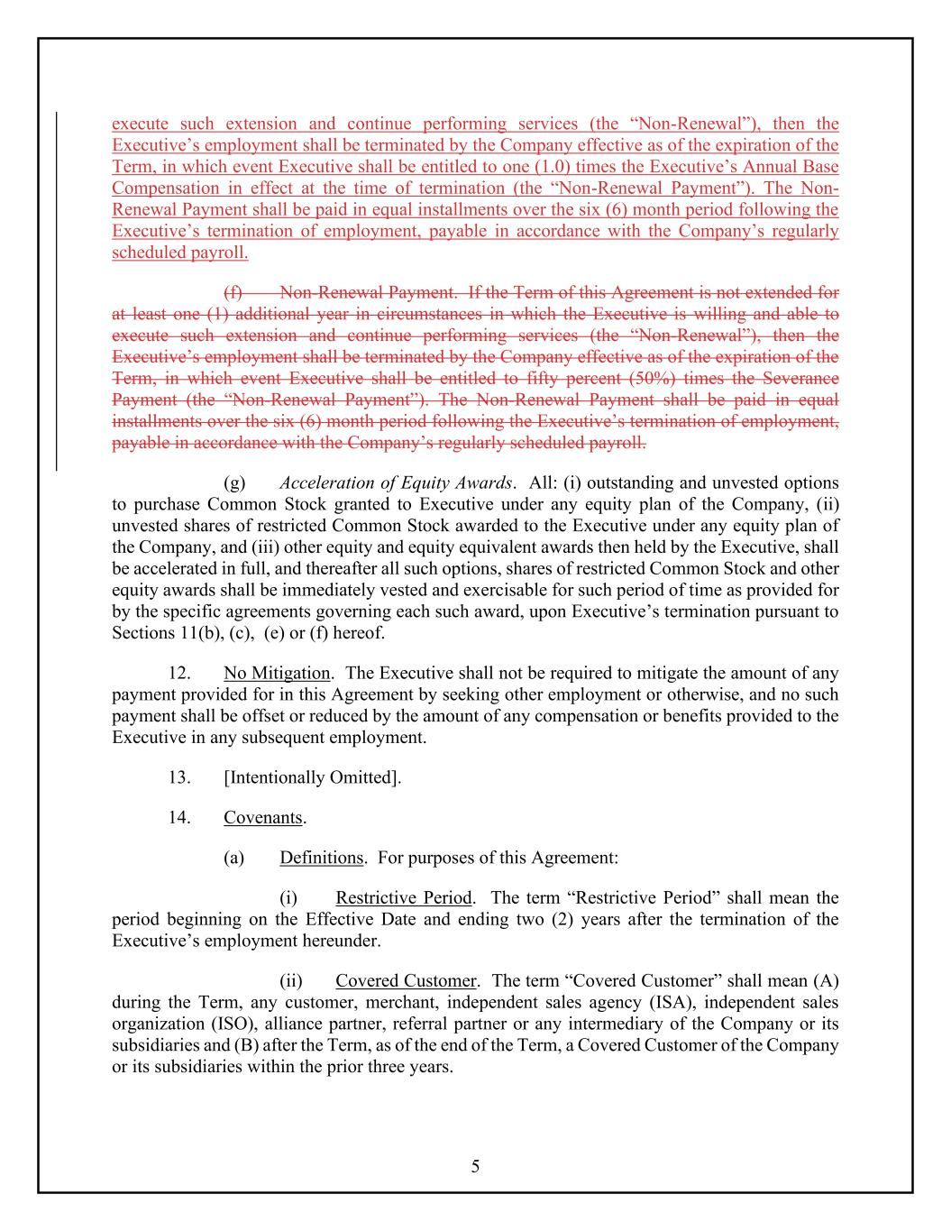
5 execute such extension and continue performing services (the “Non-Renewal”), then the Executive’s employment shall be terminated by the Company effective as of the expiration of the Term, in which event Executive shall be entitled to one (1.0) times the Executive’s Annual Base Compensation in effect at the time of termination (the “Non-Renewal Payment”). The Non- Renewal Payment shall be paid in equal installments over the six (6) month period following the Executive’s termination of employment, payable in accordance with the Company’s regularly scheduled payroll. (f) Non-Renewal Payment. If the Term of this Agreement is not extended for at least one (1) additional year in circumstances in which the Executive is willing and able to execute such extension and continue performing services (the “Non-Renewal”), then the Executive’s employment shall be terminated by the Company effective as of the expiration of the Term, in which event Executive shall be entitled to fifty percent (50%) times the Severance Payment (the “Non-Renewal Payment”). The Non-Renewal Payment shall be paid in equal installments over the six (6) month period following the Executive’s termination of employment, payable in accordance with the Company’s regularly scheduled payroll. (g) Acceleration of Equity Awards. All: (i) outstanding and unvested options to purchase Common Stock granted to Executive under any equity plan of the Company, (ii) unvested shares of restricted Common Stock awarded to the Executive under any equity plan of the Company, and (iii) other equity and equity equivalent awards then held by the Executive, shall be accelerated in full, and thereafter all such options, shares of restricted Common Stock and other equity awards shall be immediately vested and exercisable for such period of time as provided for by the specific agreements governing each such award, upon Executive’s termination pursuant to Sections 11(b), (c), (e) or (f) hereof. 12. No Mitigation. The Executive shall not be required to mitigate the amount of any payment provided for in this Agreement by seeking other employment or otherwise, and no such payment shall be offset or reduced by the amount of any compensation or benefits provided to the Executive in any subsequent employment. 13. [Intentionally Omitted]. 14. Covenants. (a) Definitions. For purposes of this Agreement: (i) Restrictive Period. The term “Restrictive Period” shall mean the period beginning on the Effective Date and ending two (2) years after the termination of the Executive’s employment hereunder. (ii) Covered Customer. The term “Covered Customer” shall mean (A) during the Term, any customer, merchant, independent sales agency (ISA), independent sales organization (ISO), alliance partner, referral partner or any intermediary of the Company or its subsidiaries and (B) after the Term, as of the end of the Term, a Covered Customer of the Company or its subsidiaries within the prior three years.

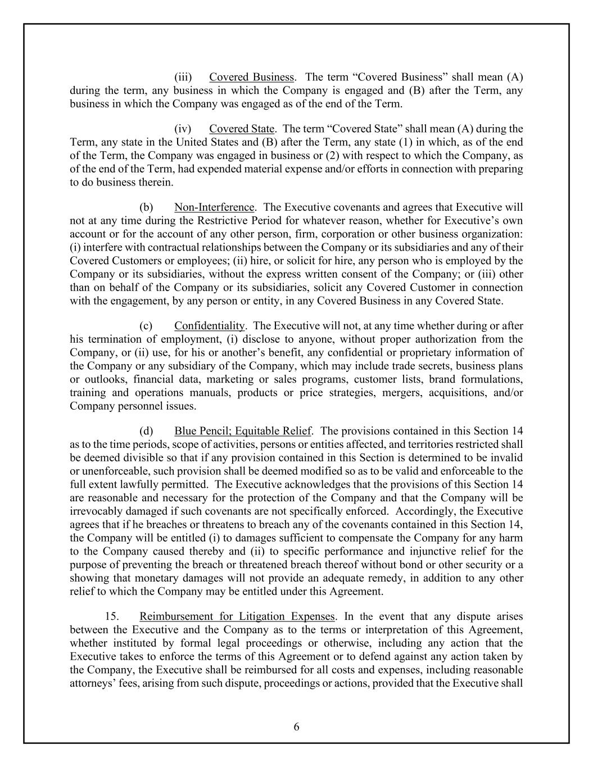
6 (iii) Covered Business. The term “Covered Business” shall mean (A) during the term, any business in which the Company is engaged and (B) after the Term, any business in which the Company was engaged as of the end of the Term. (iv) Covered State. The term “Covered State” shall mean (A) during the Term, any state in the United States and (B) after the Term, any state (1) in which, as of the end of the Term, the Company was engaged in business or (2) with respect to which the Company, as of the end of the Term, had expended material expense and/or efforts in connection with preparing to do business therein. (b) Non-Interference. The Executive covenants and agrees that Executive will not at any time during the Restrictive Period for whatever reason, whether for Executive’s own account or for the account of any other person, firm, corporation or other business organization: (i) interfere with contractual relationships between the Company or its subsidiaries and any of their Covered Customers or employees; (ii) hire, or solicit for hire, any person who is employed by the Company or its subsidiaries, without the express written consent of the Company; or (iii) other than on behalf of the Company or its subsidiaries, solicit any Covered Customer in connection with the engagement, by any person or entity, in any Covered Business in any Covered State. (c) Confidentiality. The Executive will not, at any time whether during or after his termination of employment, (i) disclose to anyone, without proper authorization from the Company, or (ii) use, for his or another’s benefit, any confidential or proprietary information of the Company or any subsidiary of the Company, which may include trade secrets, business plans or outlooks, financial data, marketing or sales programs, customer lists, brand formulations, training and operations manuals, products or price strategies, mergers, acquisitions, and/or Company personnel issues. (d) Blue Pencil; Equitable Relief. The provisions contained in this Section 14 as to the time periods, scope of activities, persons or entities affected, and territories restricted shall be deemed divisible so that if any provision contained in this Section is determined to be invalid or unenforceable, such provision shall be deemed modified so as to be valid and enforceable to the full extent lawfully permitted. The Executive acknowledges that the provisions of this Section 14 are reasonable and necessary for the protection of the Company and that the Company will be irrevocably damaged if such covenants are not specifically enforced. Accordingly, the Executive agrees that if he breaches or threatens to breach any of the covenants contained in this Section 14, the Company will be entitled (i) to damages sufficient to compensate the Company for any harm to the Company caused thereby and (ii) to specific performance and injunctive relief for the purpose of preventing the breach or threatened breach thereof without bond or other security or a showing that monetary damages will not provide an adequate remedy, in addition to any other relief to which the Company may be entitled under this Agreement. 15. Reimbursement for Litigation Expenses. In the event that any dispute arises between the Executive and the Company as to the terms or interpretation of this Agreement, whether instituted by formal legal proceedings or otherwise, including any action that the Executive takes to enforce the terms of this Agreement or to defend against any action taken by the Company, the Executive shall be reimbursed for all costs and expenses, including reasonable attorneys’ fees, arising from such dispute, proceedings or actions, provided that the Executive shall

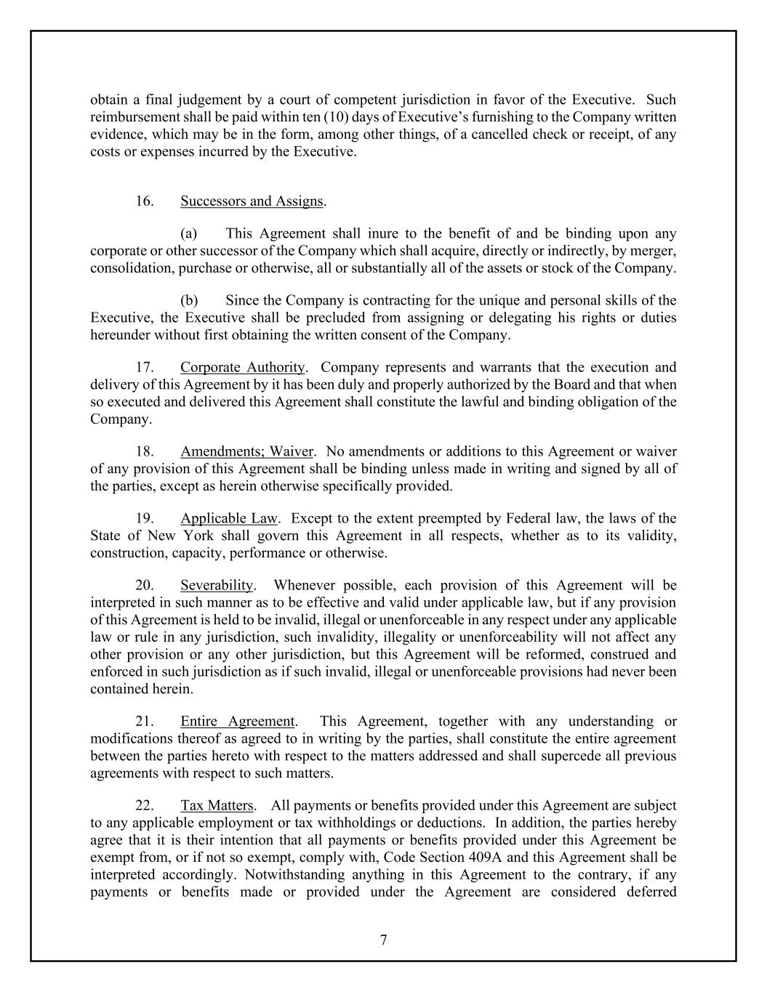
7 obtain a final judgement by a court of competent jurisdiction in favor of the Executive. Such reimbursement shall be paid within ten (10) days of Executive’s furnishing to the Company written evidence, which may be in the form, among other things, of a cancelled check or receipt, of any costs or expenses incurred by the Executive. 16. Successors and Assigns. (a) This Agreement shall inure to the benefit of and be binding upon any corporate or other successor of the Company which shall acquire, directly or indirectly, by merger, consolidation, purchase or otherwise, all or substantially all of the assets or stock of the Company. (b) Since the Company is contracting for the unique and personal skills of the Executive, the Executive shall be precluded from assigning or delegating his rights or duties hereunder without first obtaining the written consent of the Company. 17. Corporate Authority. Company represents and warrants that the execution and delivery of this Agreement by it has been duly and properly authorized by the Board and that when so executed and delivered this Agreement shall constitute the lawful and binding obligation of the Company. 18. Amendments; Waiver. No amendments or additions to this Agreement or waiver of any provision of this Agreement shall be binding unless made in writing and signed by all of the parties, except as herein otherwise specifically provided. 19. Applicable Law. Except to the extent preempted by Federal law, the laws of the State of New York shall govern this Agreement in all respects, whether as to its validity, construction, capacity, performance or otherwise. 20. Severability. Whenever possible, each provision of this Agreement will be interpreted in such manner as to be effective and valid under applicable law, but if any provision of this Agreement is held to be invalid, illegal or unenforceable in any respect under any applicable law or rule in any jurisdiction, such invalidity, illegality or unenforceability will not affect any other provision or any other jurisdiction, but this Agreement will be reformed, construed and enforced in such jurisdiction as if such invalid, illegal or unenforceable provisions had never been contained herein. 21. Entire Agreement. This Agreement, together with any understanding or modifications thereof as agreed to in writing by the parties, shall constitute the entire agreement between the parties hereto with respect to the matters addressed and shall supercede all previous agreements with respect to such matters. 22. Tax Matters. All payments or benefits provided under this Agreement are subject to any applicable employment or tax withholdings or deductions. In addition, the parties hereby agree that it is their intention that all payments or benefits provided under this Agreement be exempt from, or if not so exempt, comply with, Code Section 409A and this Agreement shall be interpreted accordingly. Notwithstanding anything in this Agreement to the contrary, if any payments or benefits made or provided under the Agreement are considered deferred

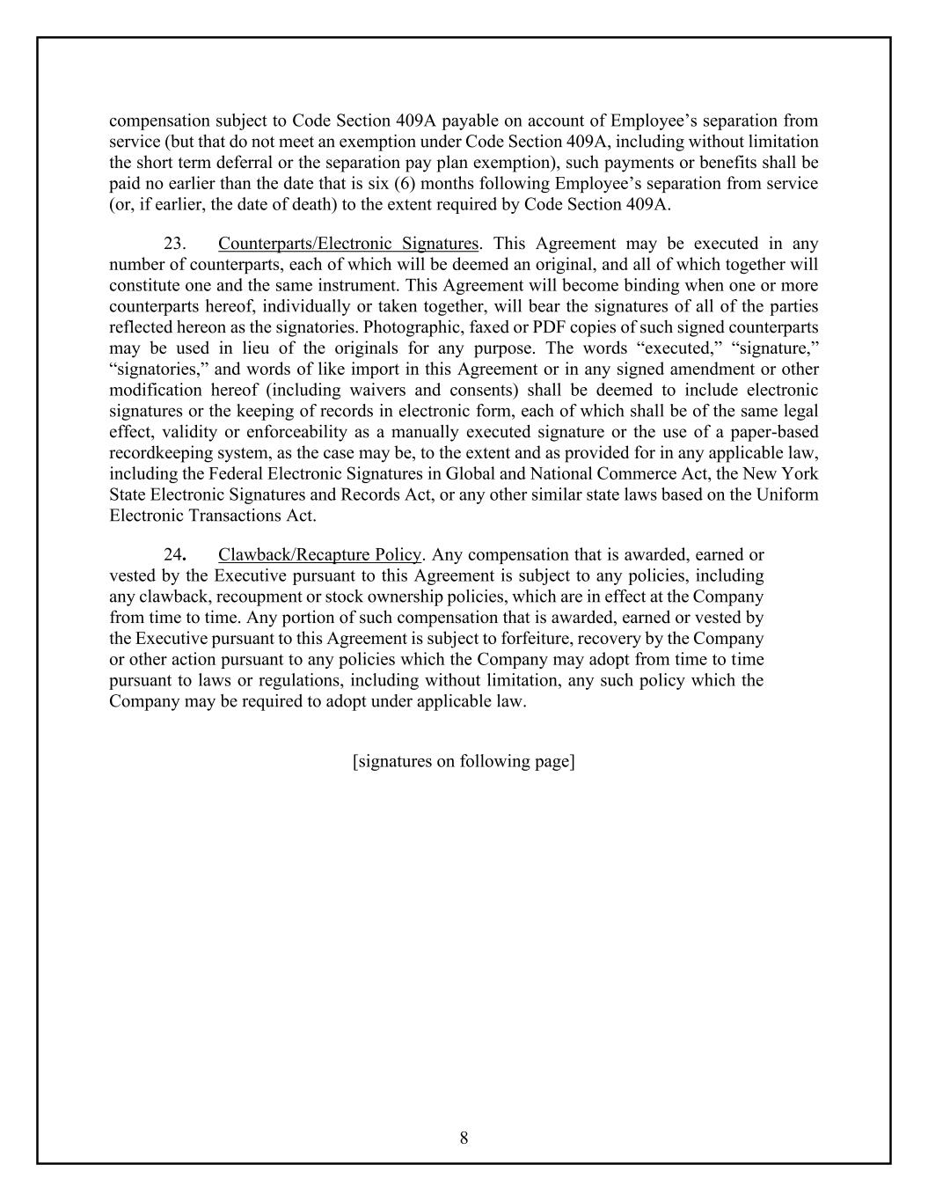
8 compensation subject to Code Section 409A payable on account of Employee’s separation from service (but that do not meet an exemption under Code Section 409A, including without limitation the short term deferral or the separation pay plan exemption), such payments or benefits shall be paid no earlier than the date that is six (6) months following Employee’s separation from service (or, if earlier, the date of death) to the extent required by Code Section 409A. 23. Counterparts/Electronic Signatures. This Agreement may be executed in any number of counterparts, each of which will be deemed an original, and all of which together will constitute one and the same instrument. This Agreement will become binding when one or more counterparts hereof, individually or taken together, will bear the signatures of all of the parties reflected hereon as the signatories. Photographic, faxed or PDF copies of such signed counterparts may be used in lieu of the originals for any purpose. The words “executed,” “signature,” “signatories,” and words of like import in this Agreement or in any signed amendment or other modification hereof (including waivers and consents) shall be deemed to include electronic signatures or the keeping of records in electronic form, each of which shall be of the same legal effect, validity or enforceability as a manually executed signature or the use of a paper-based recordkeeping system, as the case may be, to the extent and as provided for in any applicable law, including the Federal Electronic Signatures in Global and National Commerce Act, the New York State Electronic Signatures and Records Act, or any other similar state laws based on the Uniform Electronic Transactions Act. 24. Clawback/Recapture Policy. Any compensation that is awarded, earned or vested by the Executive pursuant to this Agreement is subject to any policies, including any clawback, recoupment or stock ownership policies, which are in effect at the Company from time to time. Any portion of such compensation that is awarded, earned or vested by the Executive pursuant to this Agreement is subject to forfeiture, recovery by the Company or other action pursuant to any policies which the Company may adopt from time to time pursuant to laws or regulations, including without limitation, any such policy which the Company may be required to adopt under applicable law. [signatures on following page]

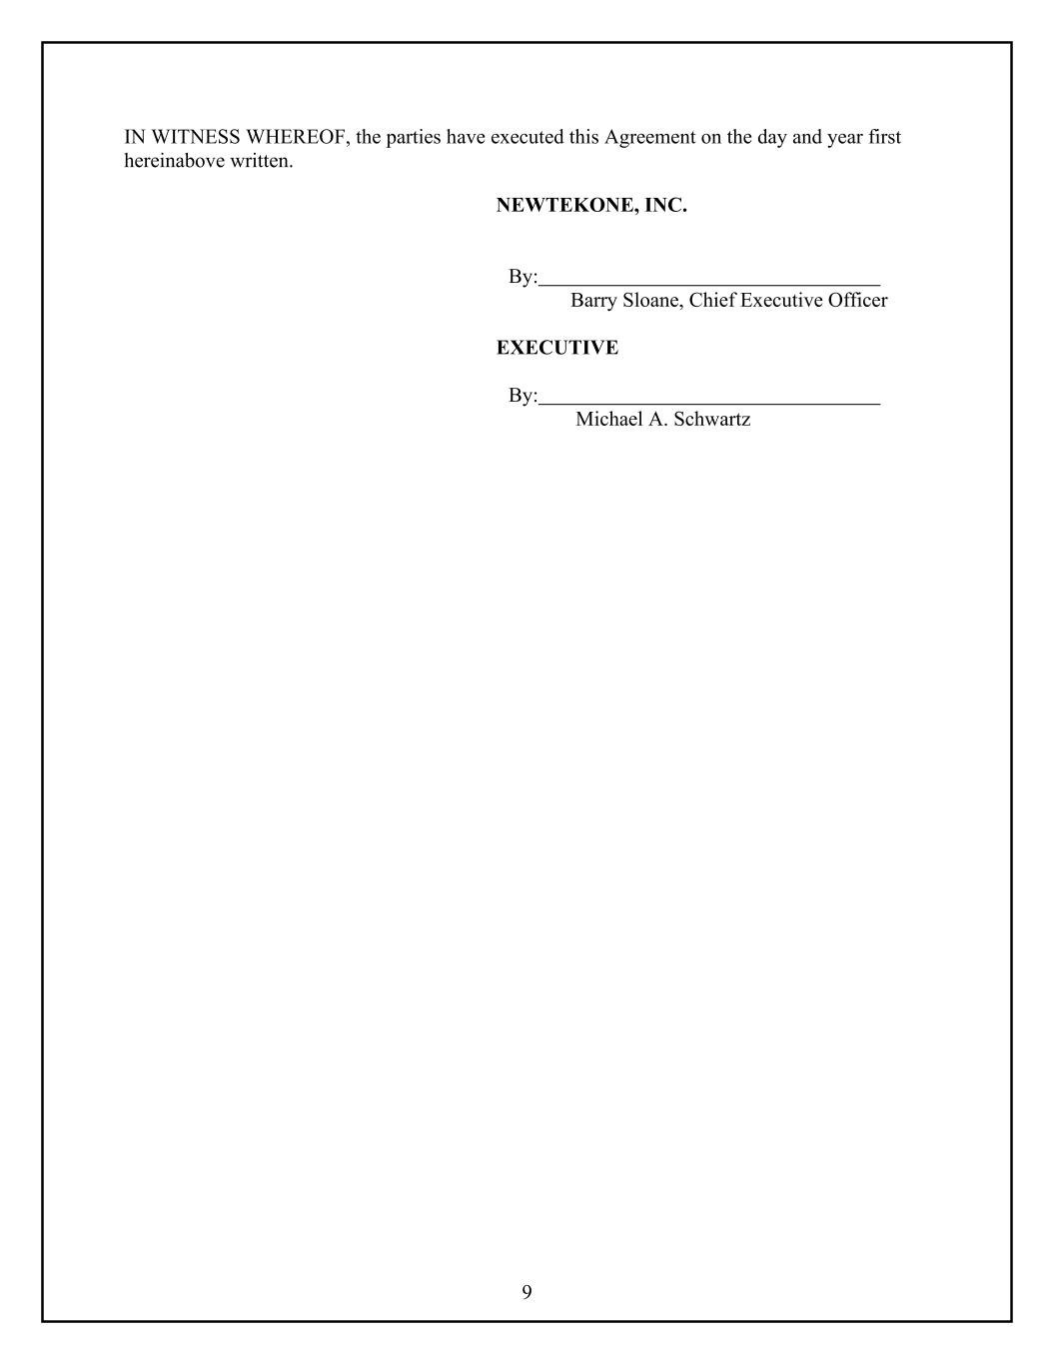
9 IN WITNESS WHEREOF, the parties have executed this Agreement on the day and year first hereinabove written. NEWTEKONE, INC. By: Barry Sloane, Chief Executive Officer EXECUTIVE By: Michael A. Schwartz

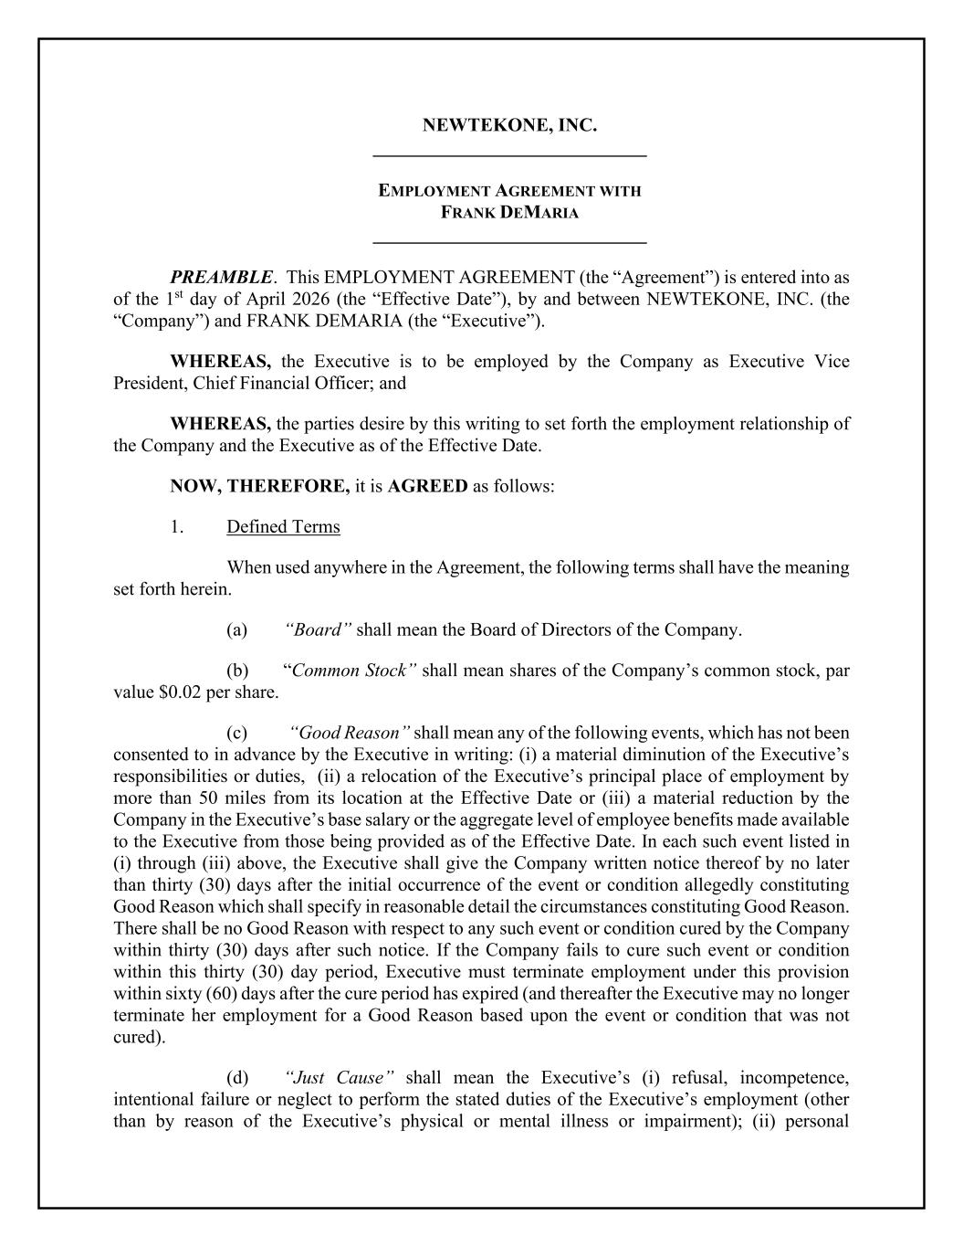
NEWTEKONE, INC. _____________________________ EMPLOYMENT AGREEMENT WITH FRANK DEMARIA _____________________________ PREAMBLE. This EMPLOYMENT AGREEMENT (the “Agreement”) is entered into as of the 1st day of April 2026 (the “Effective Date”), by and between NEWTEKONE, INC. (the “Company”) and FRANK DEMARIA (the “Executive”). WHEREAS, the Executive is to be employed by the Company as Executive Vice President, Chief Financial Officer; and WHEREAS, the parties desire by this writing to set forth the employment relationship of the Company and the Executive as of the Effective Date. NOW, THEREFORE, it is AGREED as follows: 1. Defined Terms When used anywhere in the Agreement, the following terms shall have the meaning set forth herein. (a) “Board” shall mean the Board of Directors of the Company. (b) “Common Stock” shall mean shares of the Company’s common stock, par value $0.02 per share. (c) “Good Reason” shall mean any of the following events, which has not been consented to in advance by the Executive in writing: (i) a material diminution of the Executive’s responsibilities or duties, (ii) a relocation of the Executive’s principal place of employment by more than 50 miles from its location at the Effective Date or (iii) a material reduction by the Company in the Executive’s base salary or the aggregate level of employee benefits made available to the Executive from those being provided as of the Effective Date. In each such event listed in (i) through (iii) above, the Executive shall give the Company written notice thereof by no later than thirty (30) days after the initial occurrence of the event or condition allegedly constituting Good Reason which shall specify in reasonable detail the circumstances constituting Good Reason. There shall be no Good Reason with respect to any such event or condition cured by the Company within thirty (30) days after such notice. If the Company fails to cure such event or condition within this thirty (30) day period, Executive must terminate employment under this provision within sixty (60) days after the cure period has expired (and thereafter the Executive may no longer terminate her employment for a Good Reason based upon the event or condition that was not cured). (d) “Just Cause” shall mean the Executive’s (i) refusal, incompetence, intentional failure or neglect to perform the stated duties of the Executive’s employment (other than by reason of the Executive’s physical or mental illness or impairment); (ii) personal

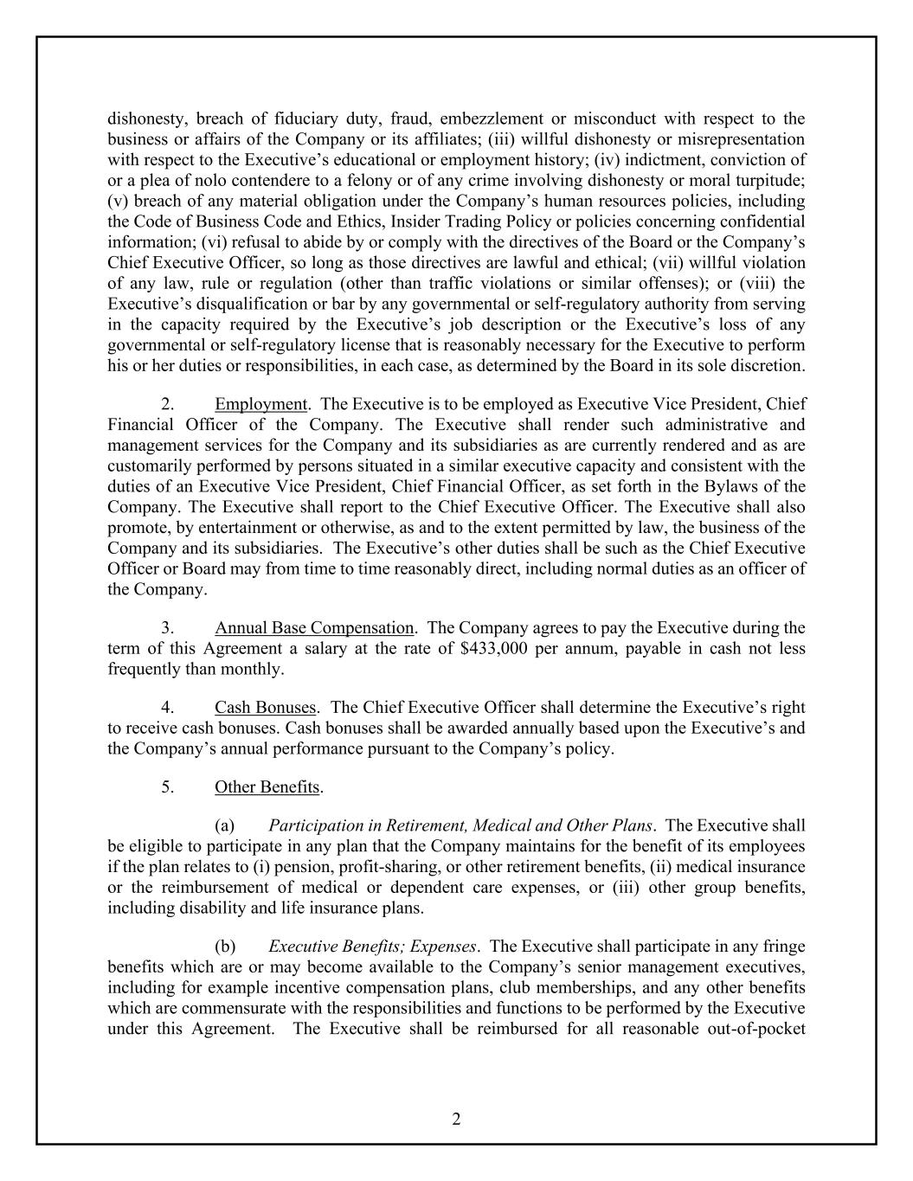
2 dishonesty, breach of fiduciary duty, fraud, embezzlement or misconduct with respect to the business or affairs of the Company or its affiliates; (iii) willful dishonesty or misrepresentation with respect to the Executive’s educational or employment history; (iv) indictment, conviction of or a plea of nolo contendere to a felony or of any crime involving dishonesty or moral turpitude; (v) breach of any material obligation under the Company’s human resources policies, including the Code of Business Code and Ethics, Insider Trading Policy or policies concerning confidential information; (vi) refusal to abide by or comply with the directives of the Board or the Company’s Chief Executive Officer, so long as those directives are lawful and ethical; (vii) willful violation of any law, rule or regulation (other than traffic violations or similar offenses); or (viii) the Executive’s disqualification or bar by any governmental or self-regulatory authority from serving in the capacity required by the Executive’s job description or the Executive’s loss of any governmental or self-regulatory license that is reasonably necessary for the Executive to perform his or her duties or responsibilities, in each case, as determined by the Board in its sole discretion. 2. Employment. The Executive is to be employed as Executive Vice President, Chief Financial Officer of the Company. The Executive shall render such administrative and management services for the Company and its subsidiaries as are currently rendered and as are customarily performed by persons situated in a similar executive capacity and consistent with the duties of an Executive Vice President, Chief Financial Officer, as set forth in the Bylaws of the Company. The Executive shall report to the Chief Executive Officer. The Executive shall also promote, by entertainment or otherwise, as and to the extent permitted by law, the business of the Company and its subsidiaries. The Executive’s other duties shall be such as the Chief Executive Officer or Board may from time to time reasonably direct, including normal duties as an officer of the Company. 3. Annual Base Compensation. The Company agrees to pay the Executive during the term of this Agreement a salary at the rate of $433,000 per annum, payable in cash not less frequently than monthly. 4. Cash Bonuses. The Chief Executive Officer shall determine the Executive’s right to receive cash bonuses. Cash bonuses shall be awarded annually based upon the Executive’s and the Company’s annual performance pursuant to the Company’s policy. 5. Other Benefits. (a) Participation in Retirement, Medical and Other Plans. The Executive shall be eligible to participate in any plan that the Company maintains for the benefit of its employees if the plan relates to (i) pension, profit-sharing, or other retirement benefits, (ii) medical insurance or the reimbursement of medical or dependent care expenses, or (iii) other group benefits, including disability and life insurance plans. (b) Executive Benefits; Expenses. The Executive shall participate in any fringe benefits which are or may become available to the Company’s senior management executives, including for example incentive compensation plans, club memberships, and any other benefits which are commensurate with the responsibilities and functions to be performed by the Executive under this Agreement. The Executive shall be reimbursed for all reasonable out-of-pocket

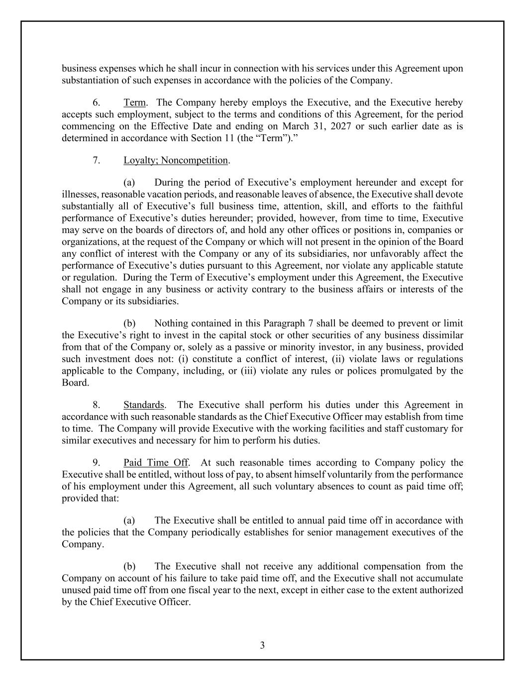
3 business expenses which he shall incur in connection with his services under this Agreement upon substantiation of such expenses in accordance with the policies of the Company. 6. Term. The Company hereby employs the Executive, and the Executive hereby accepts such employment, subject to the terms and conditions of this Agreement, for the period commencing on the Effective Date and ending on March 31, 2027 or such earlier date as is determined in accordance with Section 11 (the “Term”).” 7. Loyalty; Noncompetition. (a) During the period of Executive’s employment hereunder and except for illnesses, reasonable vacation periods, and reasonable leaves of absence, the Executive shall devote substantially all of Executive’s full business time, attention, skill, and efforts to the faithful performance of Executive’s duties hereunder; provided, however, from time to time, Executive may serve on the boards of directors of, and hold any other offices or positions in, companies or organizations, at the request of the Company or which will not present in the opinion of the Board any conflict of interest with the Company or any of its subsidiaries, nor unfavorably affect the performance of Executive’s duties pursuant to this Agreement, nor violate any applicable statute or regulation. During the Term of Executive’s employment under this Agreement, the Executive shall not engage in any business or activity contrary to the business affairs or interests of the Company or its subsidiaries. (b) Nothing contained in this Paragraph 7 shall be deemed to prevent or limit the Executive’s right to invest in the capital stock or other securities of any business dissimilar from that of the Company or, solely as a passive or minority investor, in any business, provided such investment does not: (i) constitute a conflict of interest, (ii) violate laws or regulations applicable to the Company, including, or (iii) violate any rules or polices promulgated by the Board. 8. Standards. The Executive shall perform his duties under this Agreement in accordance with such reasonable standards as the Chief Executive Officer may establish from time to time. The Company will provide Executive with the working facilities and staff customary for similar executives and necessary for him to perform his duties. 9. Paid Time Off. At such reasonable times according to Company policy the Executive shall be entitled, without loss of pay, to absent himself voluntarily from the performance of his employment under this Agreement, all such voluntary absences to count as paid time off; provided that: (a) The Executive shall be entitled to annual paid time off in accordance with the policies that the Company periodically establishes for senior management executives of the Company. (b) The Executive shall not receive any additional compensation from the Company on account of his failure to take paid time off, and the Executive shall not accumulate unused paid time off from one fiscal year to the next, except in either case to the extent authorized by the Chief Executive Officer.

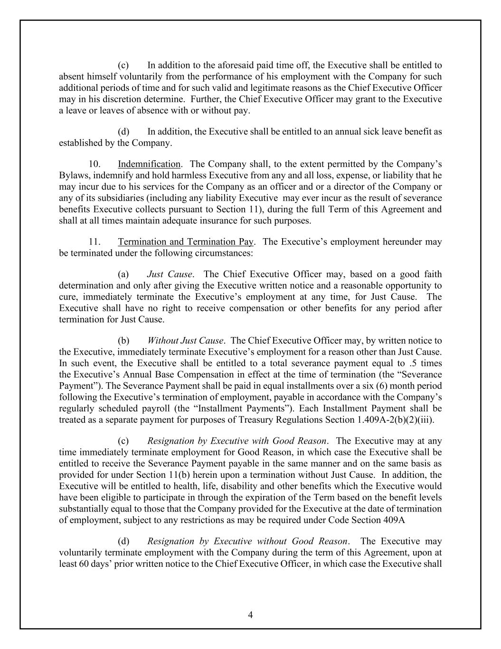
4 (c) In addition to the aforesaid paid time off, the Executive shall be entitled to absent himself voluntarily from the performance of his employment with the Company for such additional periods of time and for such valid and legitimate reasons as the Chief Executive Officer may in his discretion determine. Further, the Chief Executive Officer may grant to the Executive a leave or leaves of absence with or without pay. (d) In addition, the Executive shall be entitled to an annual sick leave benefit as established by the Company. 10. Indemnification. The Company shall, to the extent permitted by the Company’s Bylaws, indemnify and hold harmless Executive from any and all loss, expense, or liability that he may incur due to his services for the Company as an officer and or a director of the Company or any of its subsidiaries (including any liability Executive may ever incur as the result of severance benefits Executive collects pursuant to Section 11), during the full Term of this Agreement and shall at all times maintain adequate insurance for such purposes. 11. Termination and Termination Pay. The Executive’s employment hereunder may be terminated under the following circumstances: (a) Just Cause. The Chief Executive Officer may, based on a good faith determination and only after giving the Executive written notice and a reasonable opportunity to cure, immediately terminate the Executive’s employment at any time, for Just Cause. The Executive shall have no right to receive compensation or other benefits for any period after termination for Just Cause. (b) Without Just Cause. The Chief Executive Officer may, by written notice to the Executive, immediately terminate Executive’s employment for a reason other than Just Cause. In such event, the Executive shall be entitled to a total severance payment equal to .5 times the Executive’s Annual Base Compensation in effect at the time of termination (the “Severance Payment”). The Severance Payment shall be paid in equal installments over a six (6) month period following the Executive’s termination of employment, payable in accordance with the Company’s regularly scheduled payroll (the “Installment Payments”). Each Installment Payment shall be treated as a separate payment for purposes of Treasury Regulations Section 1.409A-2(b)(2)(iii). (c) Resignation by Executive with Good Reason. The Executive may at any time immediately terminate employment for Good Reason, in which case the Executive shall be entitled to receive the Severance Payment payable in the same manner and on the same basis as provided for under Section 11(b) herein upon a termination without Just Cause. In addition, the Executive will be entitled to health, life, disability and other benefits which the Executive would have been eligible to participate in through the expiration of the Term based on the benefit levels substantially equal to those that the Company provided for the Executive at the date of termination of employment, subject to any restrictions as may be required under Code Section 409A (d) Resignation by Executive without Good Reason. The Executive may voluntarily terminate employment with the Company during the term of this Agreement, upon at least 60 days’ prior written notice to the Chief Executive Officer, in which case the Executive shall

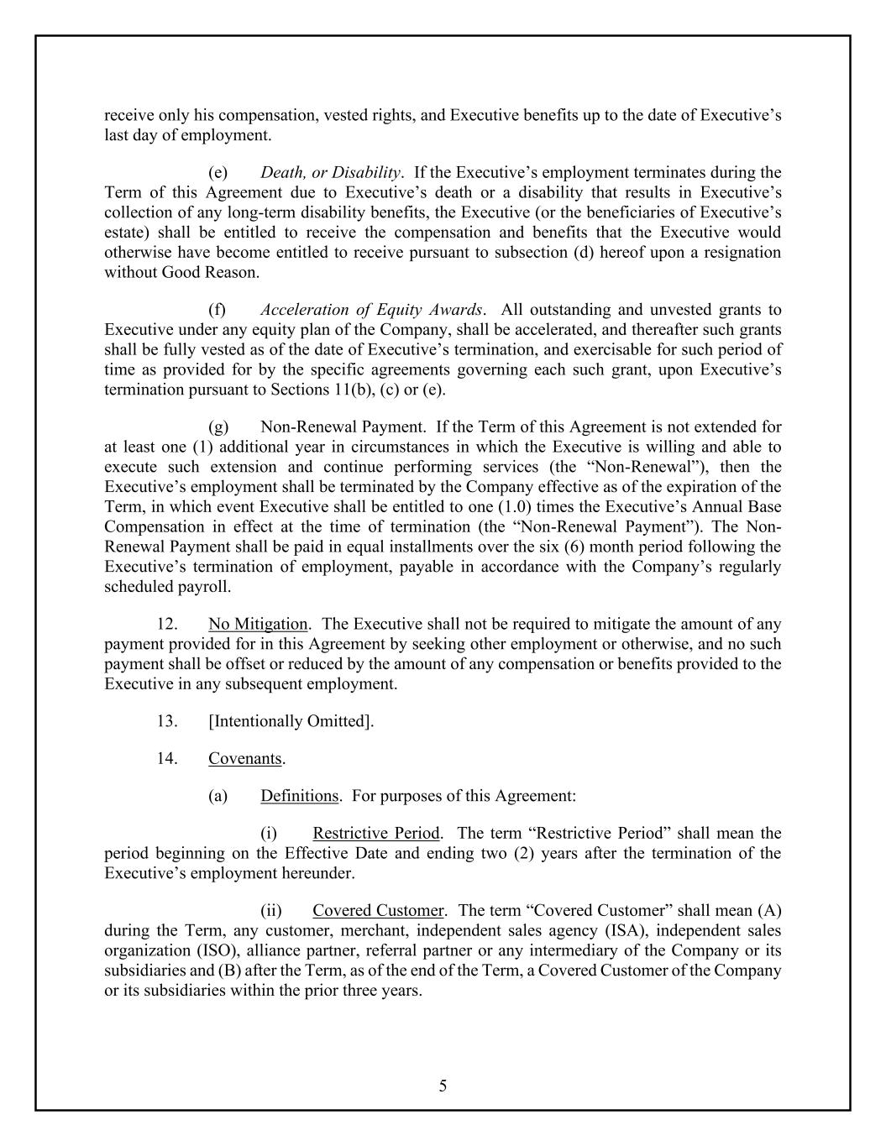
5 receive only his compensation, vested rights, and Executive benefits up to the date of Executive’s last day of employment. (e) Death, or Disability. If the Executive’s employment terminates during the Term of this Agreement due to Executive’s death or a disability that results in Executive’s collection of any long-term disability benefits, the Executive (or the beneficiaries of Executive’s estate) shall be entitled to receive the compensation and benefits that the Executive would otherwise have become entitled to receive pursuant to subsection (d) hereof upon a resignation without Good Reason. (f) Acceleration of Equity Awards. All outstanding and unvested grants to Executive under any equity plan of the Company, shall be accelerated, and thereafter such grants shall be fully vested as of the date of Executive’s termination, and exercisable for such period of time as provided for by the specific agreements governing each such grant, upon Executive’s termination pursuant to Sections 11(b), (c) or (e). (g) Non-Renewal Payment. If the Term of this Agreement is not extended for at least one (1) additional year in circumstances in which the Executive is willing and able to execute such extension and continue performing services (the “Non-Renewal”), then the Executive’s employment shall be terminated by the Company effective as of the expiration of the Term, in which event Executive shall be entitled to one (1.0) times the Executive’s Annual Base Compensation in effect at the time of termination (the “Non-Renewal Payment”). The Non- Renewal Payment shall be paid in equal installments over the six (6) month period following the Executive’s termination of employment, payable in accordance with the Company’s regularly scheduled payroll. 12. No Mitigation. The Executive shall not be required to mitigate the amount of any payment provided for in this Agreement by seeking other employment or otherwise, and no such payment shall be offset or reduced by the amount of any compensation or benefits provided to the Executive in any subsequent employment. 13. [Intentionally Omitted]. 14. Covenants. (a) Definitions. For purposes of this Agreement: (i) Restrictive Period. The term “Restrictive Period” shall mean the period beginning on the Effective Date and ending two (2) years after the termination of the Executive’s employment hereunder. (ii) Covered Customer. The term “Covered Customer” shall mean (A) during the Term, any customer, merchant, independent sales agency (ISA), independent sales organization (ISO), alliance partner, referral partner or any intermediary of the Company or its subsidiaries and (B) after the Term, as of the end of the Term, a Covered Customer of the Company or its subsidiaries within the prior three years.

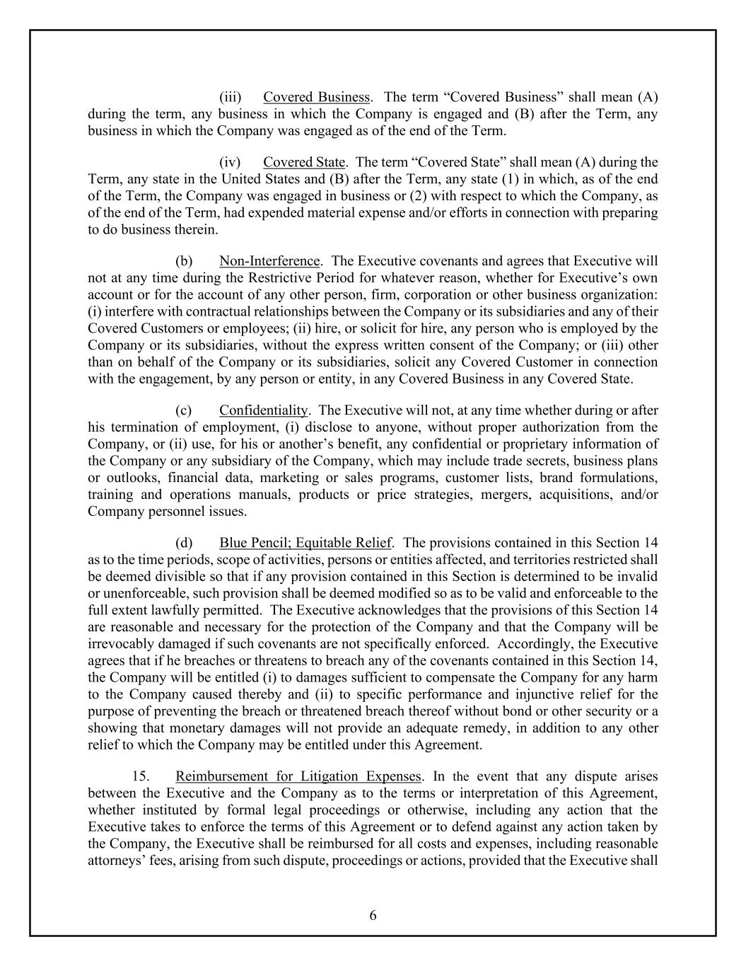
6 (iii) Covered Business. The term “Covered Business” shall mean (A) during the term, any business in which the Company is engaged and (B) after the Term, any business in which the Company was engaged as of the end of the Term. (iv) Covered State. The term “Covered State” shall mean (A) during the Term, any state in the United States and (B) after the Term, any state (1) in which, as of the end of the Term, the Company was engaged in business or (2) with respect to which the Company, as of the end of the Term, had expended material expense and/or efforts in connection with preparing to do business therein. (b) Non-Interference. The Executive covenants and agrees that Executive will not at any time during the Restrictive Period for whatever reason, whether for Executive’s own account or for the account of any other person, firm, corporation or other business organization: (i) interfere with contractual relationships between the Company or its subsidiaries and any of their Covered Customers or employees; (ii) hire, or solicit for hire, any person who is employed by the Company or its subsidiaries, without the express written consent of the Company; or (iii) other than on behalf of the Company or its subsidiaries, solicit any Covered Customer in connection with the engagement, by any person or entity, in any Covered Business in any Covered State. (c) Confidentiality. The Executive will not, at any time whether during or after his termination of employment, (i) disclose to anyone, without proper authorization from the Company, or (ii) use, for his or another’s benefit, any confidential or proprietary information of the Company or any subsidiary of the Company, which may include trade secrets, business plans or outlooks, financial data, marketing or sales programs, customer lists, brand formulations, training and operations manuals, products or price strategies, mergers, acquisitions, and/or Company personnel issues. (d) Blue Pencil; Equitable Relief. The provisions contained in this Section 14 as to the time periods, scope of activities, persons or entities affected, and territories restricted shall be deemed divisible so that if any provision contained in this Section is determined to be invalid or unenforceable, such provision shall be deemed modified so as to be valid and enforceable to the full extent lawfully permitted. The Executive acknowledges that the provisions of this Section 14 are reasonable and necessary for the protection of the Company and that the Company will be irrevocably damaged if such covenants are not specifically enforced. Accordingly, the Executive agrees that if he breaches or threatens to breach any of the covenants contained in this Section 14, the Company will be entitled (i) to damages sufficient to compensate the Company for any harm to the Company caused thereby and (ii) to specific performance and injunctive relief for the purpose of preventing the breach or threatened breach thereof without bond or other security or a showing that monetary damages will not provide an adequate remedy, in addition to any other relief to which the Company may be entitled under this Agreement. 15. Reimbursement for Litigation Expenses. In the event that any dispute arises between the Executive and the Company as to the terms or interpretation of this Agreement, whether instituted by formal legal proceedings or otherwise, including any action that the Executive takes to enforce the terms of this Agreement or to defend against any action taken by the Company, the Executive shall be reimbursed for all costs and expenses, including reasonable attorneys’ fees, arising from such dispute, proceedings or actions, provided that the Executive shall

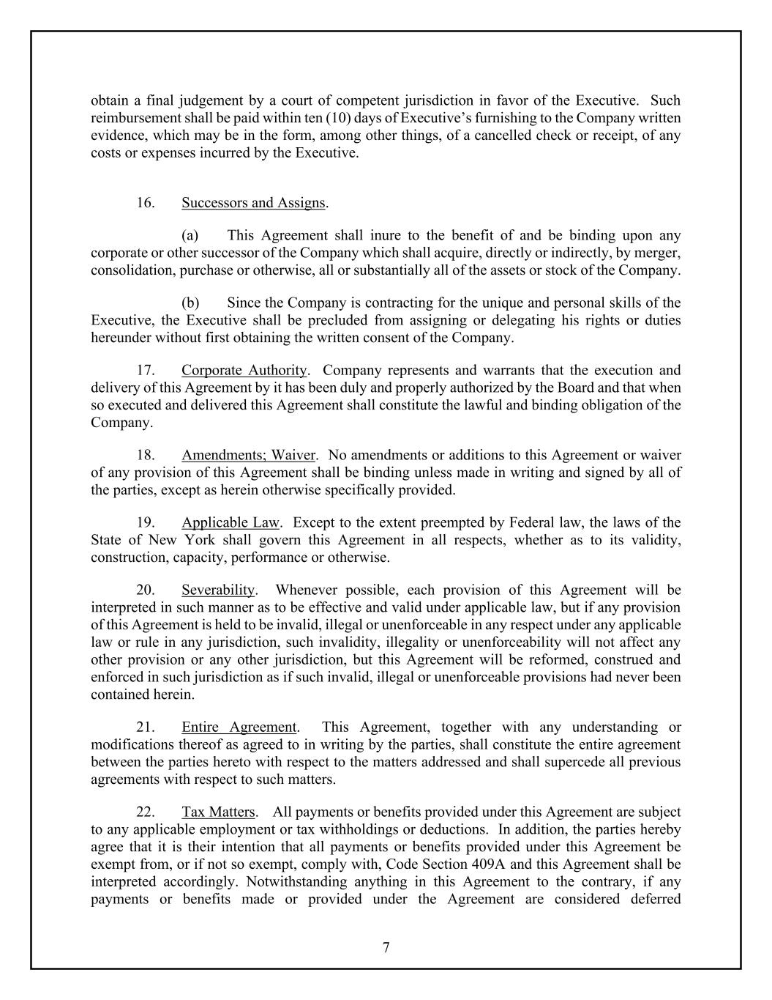
7 obtain a final judgement by a court of competent jurisdiction in favor of the Executive. Such reimbursement shall be paid within ten (10) days of Executive’s furnishing to the Company written evidence, which may be in the form, among other things, of a cancelled check or receipt, of any costs or expenses incurred by the Executive. 16. Successors and Assigns. (a) This Agreement shall inure to the benefit of and be binding upon any corporate or other successor of the Company which shall acquire, directly or indirectly, by merger, consolidation, purchase or otherwise, all or substantially all of the assets or stock of the Company. (b) Since the Company is contracting for the unique and personal skills of the Executive, the Executive shall be precluded from assigning or delegating his rights or duties hereunder without first obtaining the written consent of the Company. 17. Corporate Authority. Company represents and warrants that the execution and delivery of this Agreement by it has been duly and properly authorized by the Board and that when so executed and delivered this Agreement shall constitute the lawful and binding obligation of the Company. 18. Amendments; Waiver. No amendments or additions to this Agreement or waiver of any provision of this Agreement shall be binding unless made in writing and signed by all of the parties, except as herein otherwise specifically provided. 19. Applicable Law. Except to the extent preempted by Federal law, the laws of the State of New York shall govern this Agreement in all respects, whether as to its validity, construction, capacity, performance or otherwise. 20. Severability. Whenever possible, each provision of this Agreement will be interpreted in such manner as to be effective and valid under applicable law, but if any provision of this Agreement is held to be invalid, illegal or unenforceable in any respect under any applicable law or rule in any jurisdiction, such invalidity, illegality or unenforceability will not affect any other provision or any other jurisdiction, but this Agreement will be reformed, construed and enforced in such jurisdiction as if such invalid, illegal or unenforceable provisions had never been contained herein. 21. Entire Agreement. This Agreement, together with any understanding or modifications thereof as agreed to in writing by the parties, shall constitute the entire agreement between the parties hereto with respect to the matters addressed and shall supercede all previous agreements with respect to such matters. 22. Tax Matters. All payments or benefits provided under this Agreement are subject to any applicable employment or tax withholdings or deductions. In addition, the parties hereby agree that it is their intention that all payments or benefits provided under this Agreement be exempt from, or if not so exempt, comply with, Code Section 409A and this Agreement shall be interpreted accordingly. Notwithstanding anything in this Agreement to the contrary, if any payments or benefits made or provided under the Agreement are considered deferred

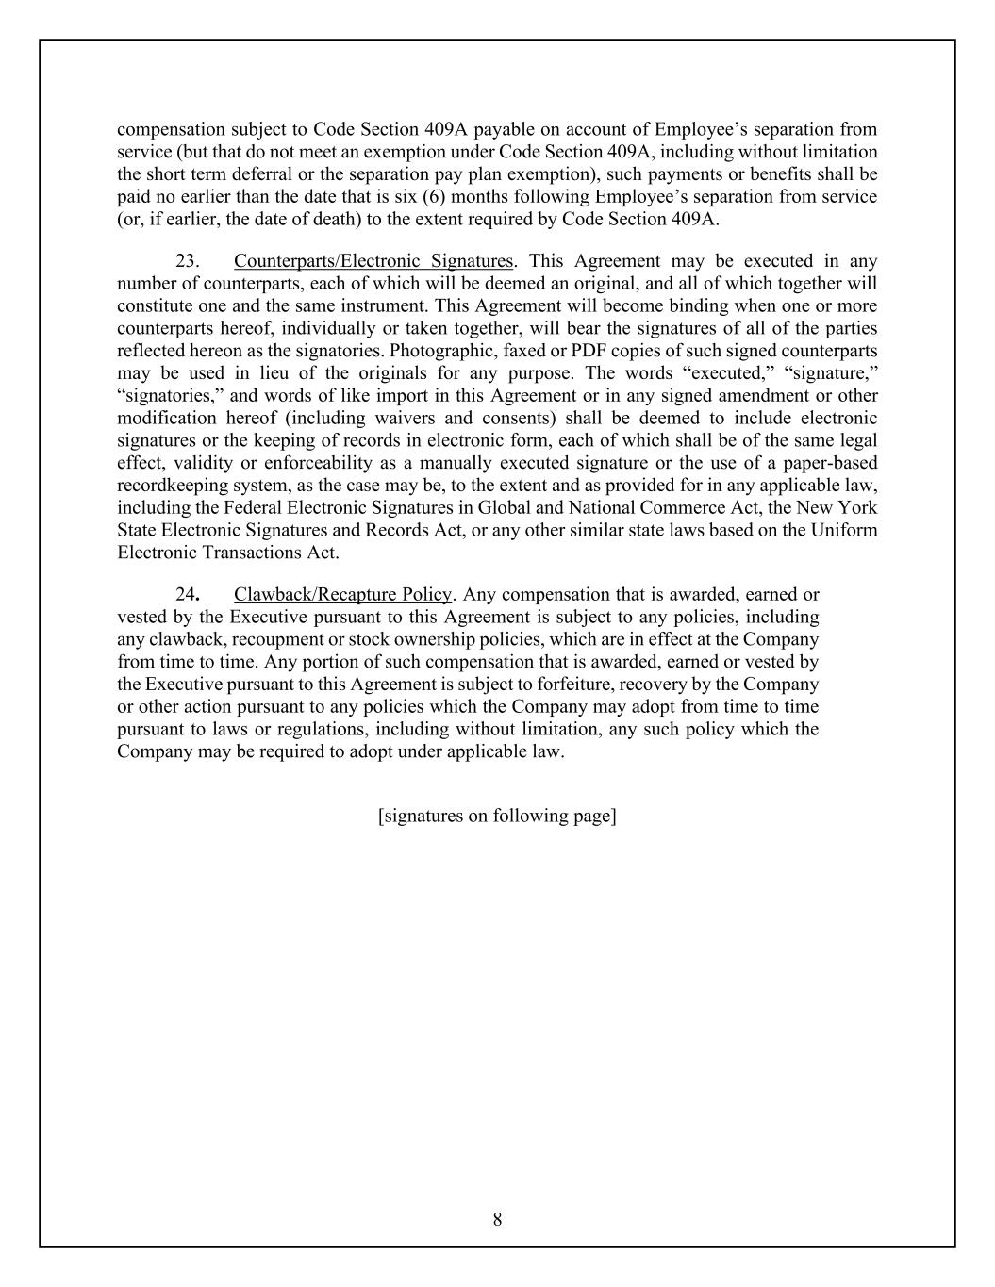
8 compensation subject to Code Section 409A payable on account of Employee’s separation from service (but that do not meet an exemption under Code Section 409A, including without limitation the short term deferral or the separation pay plan exemption), such payments or benefits shall be paid no earlier than the date that is six (6) months following Employee’s separation from service (or, if earlier, the date of death) to the extent required by Code Section 409A. 23. Counterparts/Electronic Signatures. This Agreement may be executed in any number of counterparts, each of which will be deemed an original, and all of which together will constitute one and the same instrument. This Agreement will become binding when one or more counterparts hereof, individually or taken together, will bear the signatures of all of the parties reflected hereon as the signatories. Photographic, faxed or PDF copies of such signed counterparts may be used in lieu of the originals for any purpose. The words “executed,” “signature,” “signatories,” and words of like import in this Agreement or in any signed amendment or other modification hereof (including waivers and consents) shall be deemed to include electronic signatures or the keeping of records in electronic form, each of which shall be of the same legal effect, validity or enforceability as a manually executed signature or the use of a paper-based recordkeeping system, as the case may be, to the extent and as provided for in any applicable law, including the Federal Electronic Signatures in Global and National Commerce Act, the New York State Electronic Signatures and Records Act, or any other similar state laws based on the Uniform Electronic Transactions Act. 24. Clawback/Recapture Policy. Any compensation that is awarded, earned or vested by the Executive pursuant to this Agreement is subject to any policies, including any clawback, recoupment or stock ownership policies, which are in effect at the Company from time to time. Any portion of such compensation that is awarded, earned or vested by the Executive pursuant to this Agreement is subject to forfeiture, recovery by the Company or other action pursuant to any policies which the Company may adopt from time to time pursuant to laws or regulations, including without limitation, any such policy which the Company may be required to adopt under applicable law. [signatures on following page]

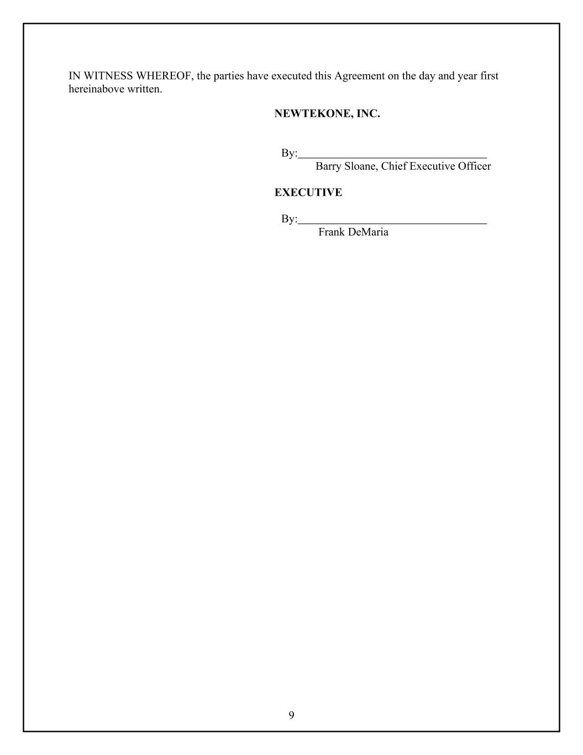
9 IN WITNESS WHEREOF, the parties have executed this Agreement on the day and year first hereinabove written. NEWTEKONE, INC. By: Barry Sloane, Chief Executive Officer EXECUTIVE By: Frank DeMaria

Exhibit 31.1
CERTIFICATION PURSUANT TO 18 U.S.C. SECTION 1350,
AS ADOPTED PURSUANT TO SECTION 302 OF THE
SARBANES-OXLEY ACT OF 2002
I, Barry Sloane, certify that:
1. I have reviewed this quarterly report on Form 10-Q of NewtekOne, Inc. (the “registrant”).
2. Based on my knowledge, this report does not contain any untrue statement of a material fact or omit to state a material fact necessary to make the statements made, in light of the circumstances under which such statements were made, not misleading with respect to the period covered by this report;
3. Based on my knowledge, the financial statements, and other financial information included in this report, fairly present in all material respects the financial condition, results of operations and cash flows of the registrant as of, and for, the periods presented in this annual report;
4. The registrant’s other certifying officers and I are responsible for establishing and maintaining disclosure controls and procedures (as defined in Exchange Act Rules 13a-15(e) and 15d-15(e)) and internal control over financial reporting (as defined in Exchange Act Rules 13a-15(f) and 15d-15(f) for the registrant and have:
a) designed such disclosure controls and procedures, or caused such disclosure controls and procedures to be designed under our supervision, to ensure that material information relating to the registrant, including its consolidated subsidiaries, is made known to us by others within those entities, particularly during the period in which this report is being prepared;
b) designed such internal control over financial reporting, or caused such internal control over financial reporting to be designed under our supervision, to provide reasonable assurance regarding the reliability of financial reporting and the preparation of financial statements for external purposes in accordance with generally accepted accounting principles;
c) evaluated the effectiveness of the registrant’s disclosure controls and procedures and presented in this report our conclusions about the effectiveness of the disclosure controls and procedures, as of the end of the period covered by this report based on such evaluation; and
d) disclosed in this report any change in the registrant’s internal control over financial reporting that occurred during the registrant’s most recent fiscal quarter (the registrant’s fourth fiscal quarter in the case of an annual report) that has materially affected, or is reasonably likely to materially affect, the registrant’s internal control over financial reporting.
5. The registrant’s other certifying officers and I have disclosed, based on our most recent evaluation of internal control over financial reporting, to the registrant’s auditors and the audit committee of the registrant’s board of directors (or persons performing the equivalent functions):
a) all significant deficiencies and material weaknesses in the design or operation of internal control over financial reporting which are reasonably likely to adversely affect the registrant’s ability to record, process, summarize and report financial information; and
b) any fraud, whether or not material, that involves management or other employees who have a significant role in the registrant’s internal control over financial reporting.

Date: August 10, 2026 |  |  | /S/ BARRY SLOANE
 |  |  | Barry Sloane
 |  |  | Principal Executive Officer

Exhibit 31.2
CERTIFICATION PURSUANT TO 18 U.S.C. SECTION 1350,
AS ADOPTED PURSUANT TO SECTION 302 OF THE
SARBANES-OXLEY ACT OF 2002
I, Frank M. DeMaria, certify that:
1. I have reviewed this quarterly report on Form 10-Q of NewtekOne, Inc. (the “registrant”).
2. Based on my knowledge, this report does not contain any untrue statement of a material fact or omit to state a material fact necessary to make the statements made, in light of the circumstances under which such statements were made, not misleading with respect to the period covered by this annual report;
3. Based on my knowledge, the financial statements, and other financial information included in this report, fairly present in all material respects the financial condition, results of operations and cash flows of the registrant as of, and for, the periods presented in this report;
4. The registrant’s other certifying officers and I are responsible for establishing and maintaining disclosure controls and procedures (as defined in Exchange Act Rules 13a-15(e) and 15d-15(e)) and internal control over financial reporting (as defined in Exchange Act Rules 13a-15(f) and 15d-15(f) for the registrant and have:
a) designed such disclosure controls and procedures, or caused such disclosure controls and procedures to be designed under our supervision, to ensure that material information relating to the registrant, including its consolidated subsidiaries, is made known to us by others within those entities, particularly during the period in which this report is being prepared;
b) designed such internal control over financial reporting, or caused such internal control over financial reporting to be designed under our supervision, to provide reasonable assurance regarding the reliability of financial reporting and the preparation of financial statements for external purposes in accordance with generally accepted accounting principles;
c) evaluated the effectiveness of the registrant’s disclosure controls and procedures and presented in this report our conclusions about the effectiveness of the disclosure controls and procedures, as of the end of the period covered by this report based on such evaluation; and
d) disclosed in this report any change in the registrant’s internal control over financial reporting that occurred during the registrant’s most recent fiscal quarter (the registrant’s fourth fiscal quarter in the case of an annual report) that has materially affected, or is reasonably likely to materially affect, the registrant’s internal control over financial reporting.
5. The registrant’s other certifying officers and I have disclosed, based on our most recent evaluation of internal control over financial reporting, to the registrant’s auditors and the audit committee of the registrant’s board of directors (or persons performing the equivalent functions):
a) all significant deficiencies and material weaknesses in the design or operation of internal control over financial reporting which are reasonably likely to adversely affect the registrant’s ability to record, process, summarize and report financial information; and
b) any fraud, whether or not material, that involves management or other employees who have a significant role in the registrant’s internal control over financial reporting.

Date: August 10, 2026 |  |  | /S/ FRANK M. DEMARIA
 |  |  | Frank M. DeMaria
 |  |  | Principal Financial Officer

Exhibit 32.1
CERTIFICATION PURSUANT TO 18 U.S.C. SECTION 1350,
AS ADOPTED PURSUANT TO
SECTION 906 OF THE SARBANES-OXLEY ACT OF 2002

In connection with the Quarterly Report on Form 10-Q for the period ended June 30, 2026 (the “Report”) of NewtekOne Inc.(the “Company”), as filed with the Securities and Exchange Commission on the date hereof, I, Barry Sloane, as Principal Executive Officer of the Company, certify, pursuant to 18 U.S.C. §1350, as adopted pursuant to §906 of the Sarbanes-Oxley Act of 2002, that, to the best of my knowledge:
(1) The Report fully complies with the requirements of Section 13(a) or 15(d) of the Securities Exchange Act of 1934; and
(2) The information contained in the Report fairly presents, in all material respects, the financial condition and results of the operations of the Company.

Date: August 10, 2026 |  |  | /S/ BARRY SLOANE
 |  |  | Barry Sloane,
 |  |  | Principal Executive Officer

Exhibit 32.2
CERTIFICATION PURSUANT TO 18 U.S.C. SECTION 1350,
AS ADOPTED PURSUANT TO
SECTION 906 OF THE SARBANES-OXLEY ACT OF 2002

In connection with the Quarterly Report on Form 10-Q for the period ended June 30, 2026 (the “Report”) of NewtekOne, Inc. (the “Company”), as filed with the Securities and Exchange Commission on the date hereof, I, Frank M. DeMaria, as Principal Financial Officer of the Company, hereby certify pursuant to 18 U.S.C. §1350, as adopted pursuant to §906 of the Sarbanes-Oxley Act of 2002, that, to the best of my knowledge:
(1) The Report fully complies with the requirements of Section 13(a) or 15(d) of the Securities Exchange Act of 1934; and
(2) The information contained in the Report fairly presents, in all material respects, the financial condition and results of the operations of the Company.

Date: August 10, 2026 |  |  | /S/ FRANK M. DEMARIA
 |  |  | Frank M. DeMaria
 |  |  | Principal Financial Officer

