UNITED STATES
SECURITIES AND EXCHANGE COMMISSION
Washington, D.C. 20549

FORM 8-K
CURRENT REPORT
Pursuant to Section 13 or 15(d) of the Securities Exchange Act of 1934
September 14, 2026
Date of Report (date of Earliest Event Reported)
NEWTEKONE, INC.
(Exact Name of Company as Specified in its Charter)
Maryland |  |  | 814-01035 |  |  | 46-3755188
(State or Other Jurisdiction of Incorporation or Organization) |  |  | (Commission File No.) |  |  | (I.R.S. Employer Identification No.)

4800 T Rex Avenue, Suite 120, Boca Raton, Florida 33431
(Address of principal executive offices and zip code)

(212) 356-9500
(Company’s telephone number, including area code)

(Former name or former address, if changed from last report)

Securities registered pursuant to Section 12(b) of the Act:
Title of each class |  |  |  |  |  | Trading Symbol(s) |  |  |  |  |  | Name of each exchange on which registered
Common Stock, par value $0.02 per share |  |  |  |  |  | NEWT |  |  |  |  |  | Nasdaq Global Market LLC
8.00% Notes due 2028 |  |  |  |  |  | NEWTI |  |  |  |  |  | Nasdaq Global Market LLC
8.50% Notes due 2029 |  |  |  |  |  | NEWTG |  |  |  |  |  | Nasdaq Global Market LLC
8.625% Notes due 2029 |  |  |  |  |  | NEWTH |  |  |  |  |  | Nasdaq Global Market LLC
8.50% Notes due 2031 |  |  |  |  |  | NEWTO |  |  |  |  |  | Nasdaq Global Market LLC
Depositary Shares, each representing a 1/40th interest in a share of 8.500% Fixed-Rate Reset Non-Cumulative Perpetual Preferred Stock, Series B |  |  |  |  |  | NEWTP |  |  |  |  |  | Nasdaq Global Market LLC

Check the appropriate box below if the Form 8-K filing is intended to simultaneously satisfy the filing obligation of the registrant under any of the following provisions (see General Instruction A.2. below):
☐ Written communications pursuant to Rule 425 under the Securities Act (17 CFR 230.425)
☐ Soliciting material pursuant to Rule 14a-12 under the Exchange Act (17 CFR 240.14a-12)
☐ Pre-commencement communications pursuant to Rule 14d-2(b) under the Exchange Act (17 CFR 240.14d-2(b))
☐ Pre-commencement communications pursuant to Rule 13e-4(c) under the Exchange Act (17 CFR 240.13e-4(c))

Indicate by check mark whether the registrant is an emerging growth company as defined in Rule 405 of the Securities Act of 1933 (§230.405 of this chapter) or Rule 12b-2 of the Securities Exchange Act of 1934 (§240.12b-2 of this chapter).

Emerging growth company o

If an emerging growth company, indicate by check mark if the registrant has elected not to use the extended transition period for complying with any new or revised financial accounting standards provided pursuant to Section 13(a) of the Exchange Act. o

Forward-Looking Statements
Statements in NewtekOne, Inc.’s (“NewtekOne” or the “Company”) Current Report on Form 8-K and the Exhibit thereto contain forward-looking statements within the meaning of the Private Securities Litigation Reform Act of 1995. These statements are based on management’s current expectations and beliefs and are subject to significant risks and uncertainties. Actual results may differ materially from those set forth in the forward-looking statements. See “Note Regarding Forward-Looking Statements” and the sections entitled “Risk Factors” in the Company's filings with the Securities and Exchange Commission which are available on NewtekOne's website (https://investor.newtekbusinessservices.com/sec-filings) and on the Securities and Exchange Commission’s website (www.sec.gov). Any forward-looking statements made by or on behalf of NewtekOne speak only as to the date they are made, and NewtekOne does not undertake to update forward-looking statements to reflect the impact of circumstances or events that arise after the date the forward-looking statements were made.

Item 2.02. Results of Operations and Financial Condition.
On September 14, 2026, the Company issued a press release entitled “NewtekOne, Inc. Declares Dividends on Common Stock and Series B Preferred Shares” (the “Press Release”). A copy of the Press Release is furnished as Exhibit 99.1 to this Current Report on Form 8-K. The information in this report and Exhibit 99.1 hereto shall not be deemed “filed” for purposes of Section 18 of the Securities Exchange Act of 1934, as amended, or otherwise subject to the liabilities of that Section, and shall not be incorporated by reference into any registration statement pursuant to the Securities Act of 1933, as amended, except as shall be expressly set forth by specific reference in such filing.

Item 9.01 Financial Statement and Exhibits
(d) Exhibit.

Exhibit Number |  |  |  |  |  | Description
99.1 |  |  |  |  |  | NewtekOne, Inc. Press Release dated September 14, 2026
104 |  |  |  |  |  | Cover Page Interactive Data File

SIGNATURES

In accordance with the requirements of the Securities Exchange Act of 1934, the registrant has caused this report to be signed on its behalf by the undersigned, thereunto duly authorized.

 |  |  | NEWTEKONE, INC.
Date: September 14, 2026 |  |  | By: |  |  | /S/ BARRY SLOANE
 |  |  |  |  |  | Barry Sloane
 |  |  |  |  |  | Chief Executive Officer, President and Chairman of the Board

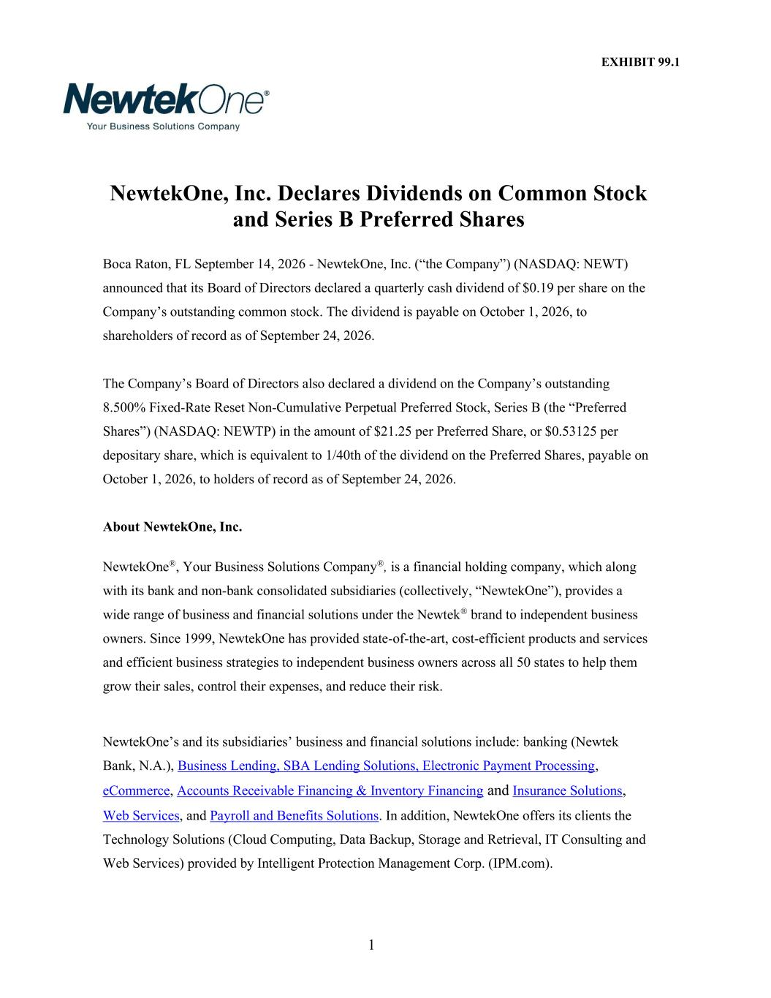

1 EXHIBIT 99.1 NewtekOne, Inc. Declares Dividends on Common Stock and Series B Preferred Shares Boca Raton, FL September 14, 2026 - NewtekOne, Inc. (“the Company”) (NASDAQ: NEWT) announced that its Board of Directors declared a quarterly cash dividend of $0.19 per share on the Company’s outstanding common stock. The dividend is payable on October 1, 2026, to shareholders of record as of September 24, 2026. The Company’s Board of Directors also declared a dividend on the Company’s outstanding 8.500% Fixed-Rate Reset Non-Cumulative Perpetual Preferred Stock, Series B (the “Preferred Shares”) (NASDAQ: NEWTP) in the amount of $21.25 per Preferred Share, or $0.53125 per depositary share, which is equivalent to 1/40th of the dividend on the Preferred Shares, payable on October 1, 2026, to holders of record as of September 24, 2026. About NewtekOne, Inc. NewtekOne®, Your Business Solutions Company®, is a financial holding company, which along with its bank and non-bank consolidated subsidiaries (collectively, “NewtekOne”), provides a wide range of business and financial solutions under the Newtek® brand to independent business owners. Since 1999, NewtekOne has provided state-of-the-art, cost-efficient products and services and efficient business strategies to independent business owners across all 50 states to help them grow their sales, control their expenses, and reduce their risk. NewtekOne’s and its subsidiaries’ business and financial solutions include: banking (Newtek Bank, N.A.), Business Lending, SBA Lending Solutions, Electronic Payment Processing, eCommerce, Accounts Receivable Financing & Inventory Financing and Insurance Solutions, Web Services, and Payroll and Benefits Solutions. In addition, NewtekOne offers its clients the Technology Solutions (Cloud Computing, Data Backup, Storage and Retrieval, IT Consulting and Web Services) provided by Intelligent Protection Management Corp. (IPM.com).

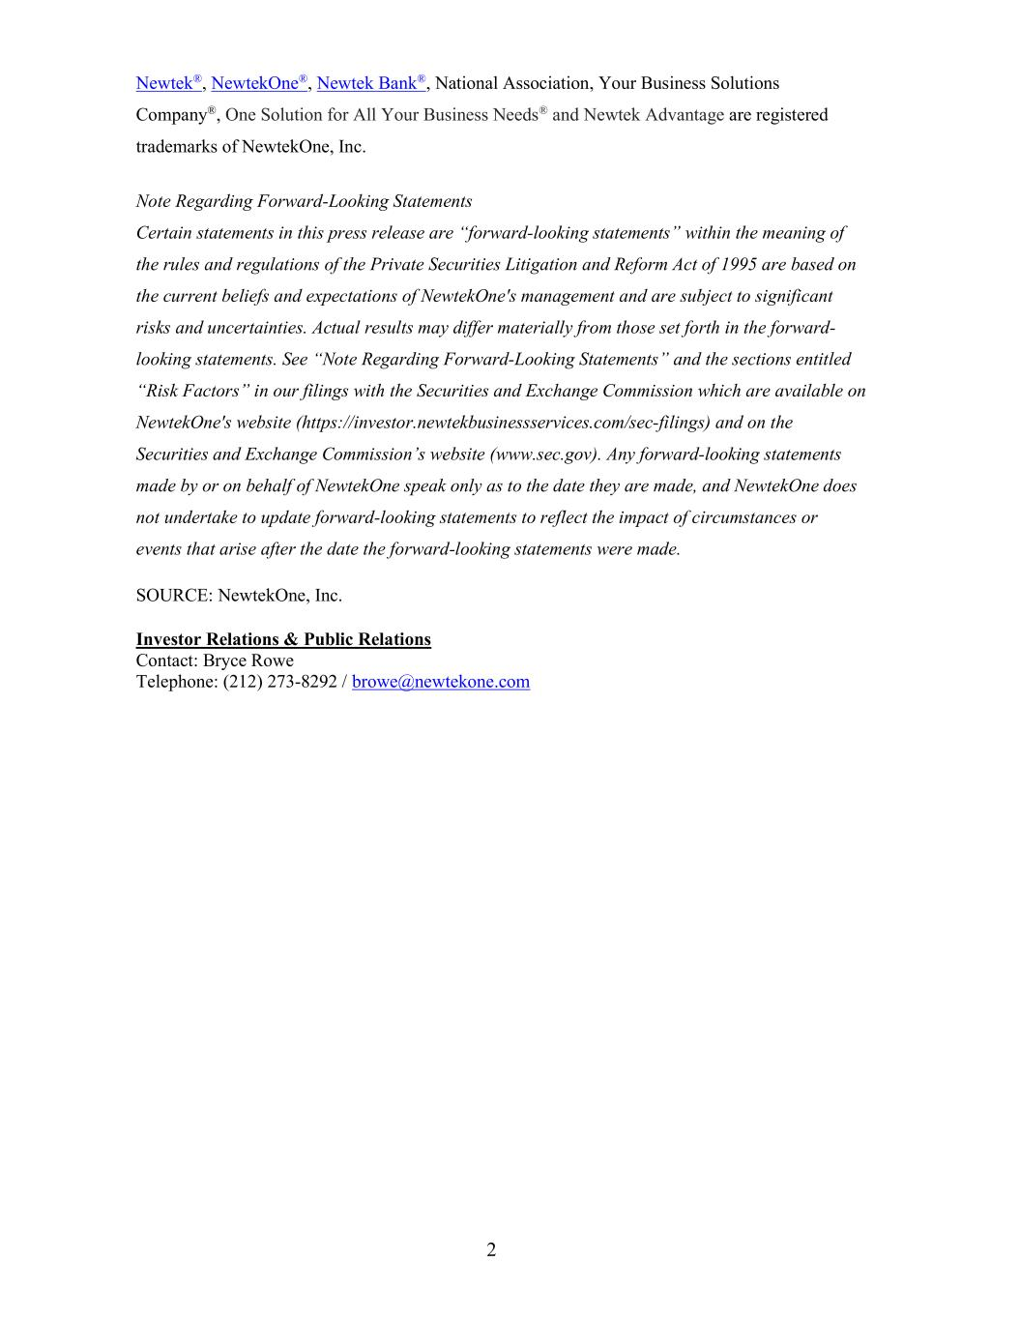
2 Newtek®, NewtekOne®, Newtek Bank®, National Association, Your Business Solutions Company®, One Solution for All Your Business Needs® and Newtek Advantage are registered trademarks of NewtekOne, Inc. Note Regarding Forward-Looking Statements Certain statements in this press release are “forward-looking statements” within the meaning of the rules and regulations of the Private Securities Litigation and Reform Act of 1995 are based on the current beliefs and expectations of NewtekOne's management and are subject to significant risks and uncertainties. Actual results may differ materially from those set forth in the forward- looking statements. See “Note Regarding Forward-Looking Statements” and the sections entitled “Risk Factors” in our filings with the Securities and Exchange Commission which are available on NewtekOne's website (https://investor.newtekbusinessservices.com/sec-filings) and on the Securities and Exchange Commission’s website (www.sec.gov). Any forward-looking statements made by or on behalf of NewtekOne speak only as to the date they are made, and NewtekOne does not undertake to update forward-looking statements to reflect the impact of circumstances or events that arise after the date the forward-looking statements were made. SOURCE: NewtekOne, Inc. Investor Relations & Public Relations Contact: Bryce Rowe Telephone: (212) 273-8292 / browe@newtekone.com

